**Aim:** Design Interactive Dashboards and Storytelling using Tableau / Power BI / R (Shiny) / Python (Streamlit/Flask) / D3.js to be performed on the dataset - Disease spread / Healthcare

**To-do**

* (Advanced - Word chart, Box and whisker plot, Violin plot, Regression plot (linear and nonlinear), 3D chart, Jitter, Line, Area, Waterfall, Donut, Treemap, Funnel
* Basic - Bar chart, Pie chart, Histogram, Timeline chart, Scatter plot, Bubble plot)

*Charts that were compatible with the dataset have been implemented.*

*All the charts were not included in the dashboard due to potential cluttering*

**Procedure :**

Connect to a data source

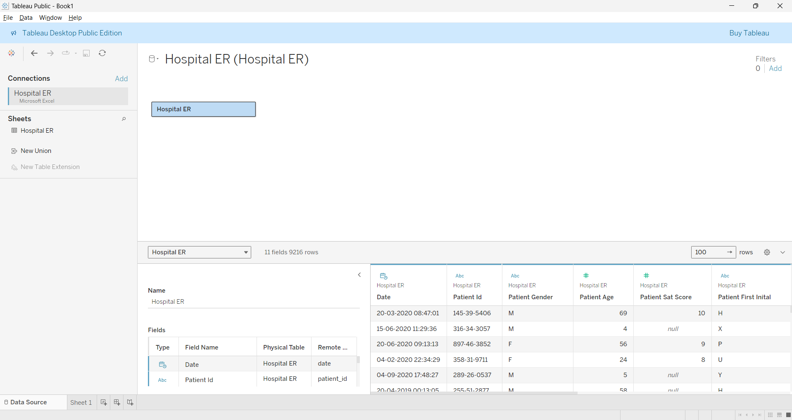

Columns

* Date
* Patient ID
* Patient Gender
* Patient Age
* Patient Satisfaction Score
* Patient First Name Initials
* Patient Last Name
* Patient Race
* Patient Wait Time
* Department Referral
* Age groupings

Line chart depicting the variation in patients’ satisfaction levels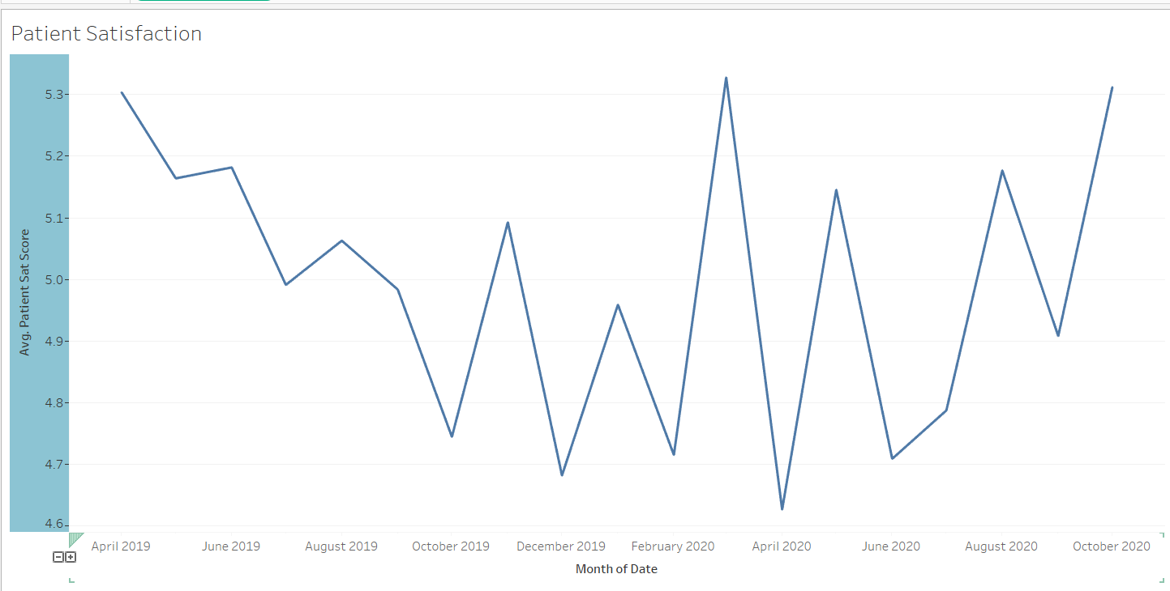

Line chart depicting the change in average waiting time (minutes) for a patient

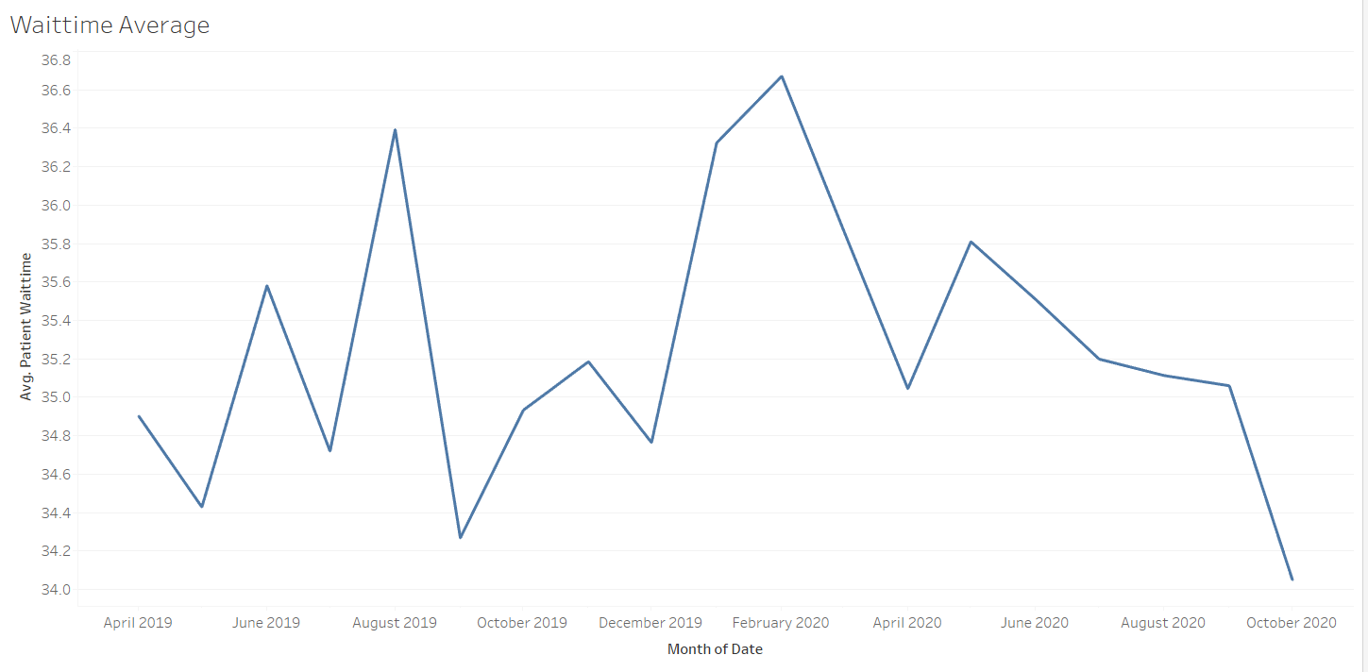

Area chart with age-wise grouping of patients in the ER

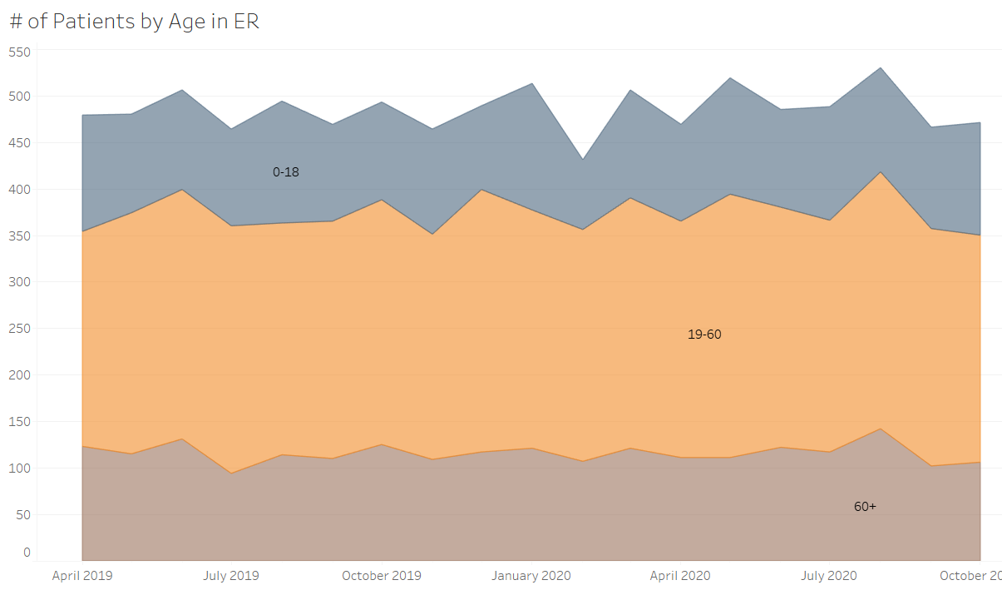

Bar chart showcasing which department has referred the patients 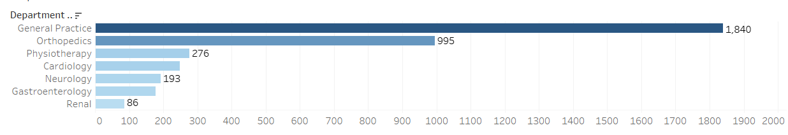

Bar chart showcasing race of patients

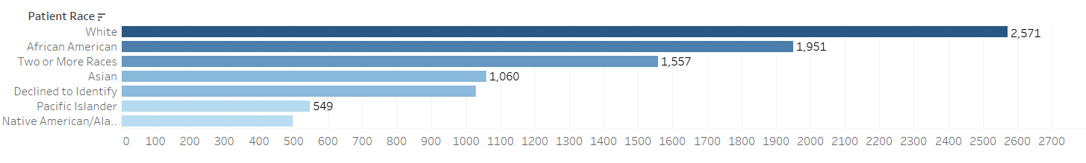

Pie chart showing the gender distribution of ER patients

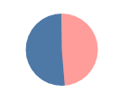

Word cloud for race of patients

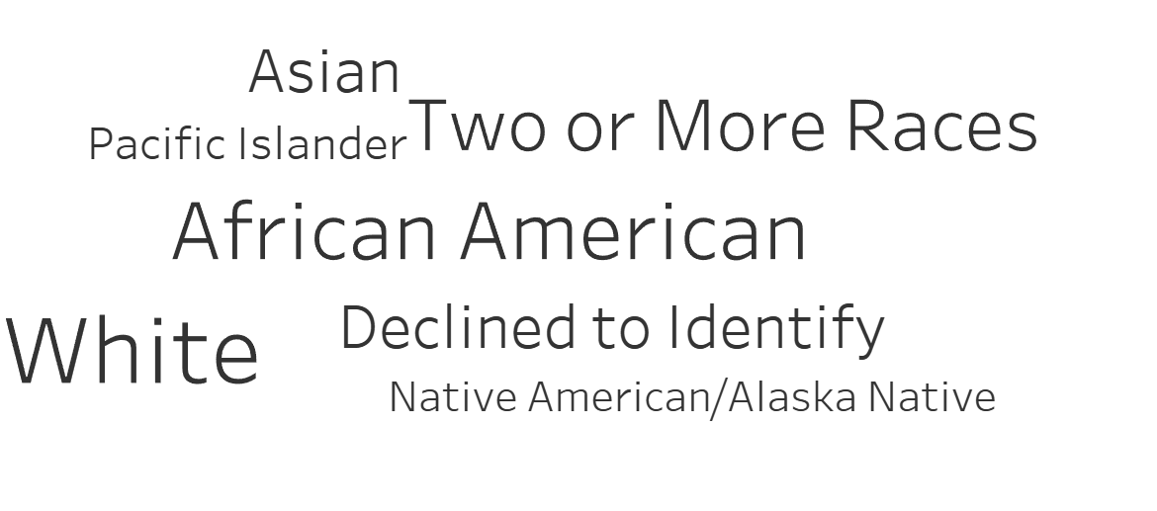

Bar showing number of patients each month

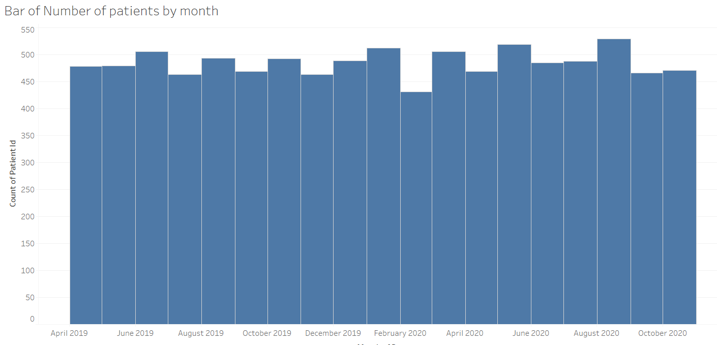

Dashboard showing status of ER in a hospital

