|  |  |
| --- | --- |
| **NAME:** | Shubham Vishwakarma |
| **UID No.** | 2021700071 |
| **BRANCH:** | B.E CSE-DS |
| **BATCH:** | D |
| **SUBJECT** | Advanced Data Visualization |
| **EXPERIMENT No.** | 8 |
| **DATE:** | 3/11/2024 |

**AIM:** Designing Interactive Dashboards and Storytelling using D3.js on Environment/Forest Cover Dataset

**DATASET:** The dataset contains information on forest cover across various states/UTs in India, detailing geographical area and forest area distribution into reserved, protected, and unclassed categories. It also includes the percentage of forest cover relative to each state's geographical area.

[**https://data.globalforestwatch.org/search?collection=Dataset&q=forest%20cover%20dataset**](https://data.globalforestwatch.org/search?collection=Dataset&q=forest%20cover%20dataset)

**ANALYSIS:**

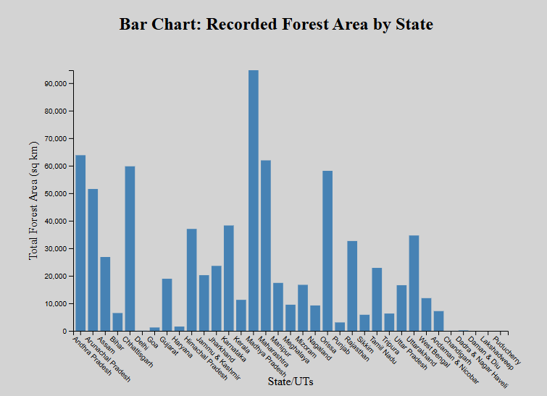

The above bar graph shows the total forest area covered by each state and it shows that Maharashtra has the highest total forest area above 90000 sq. kms.

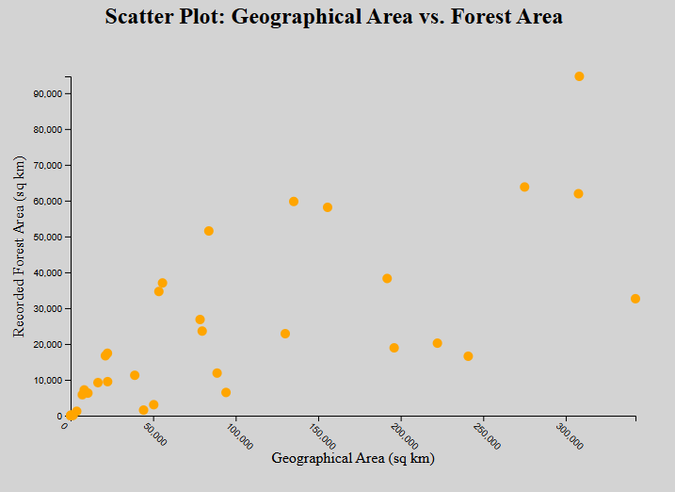

The above scatter plot shows that there is a positive correlation between Geographical Area and Recorded Forest Area.

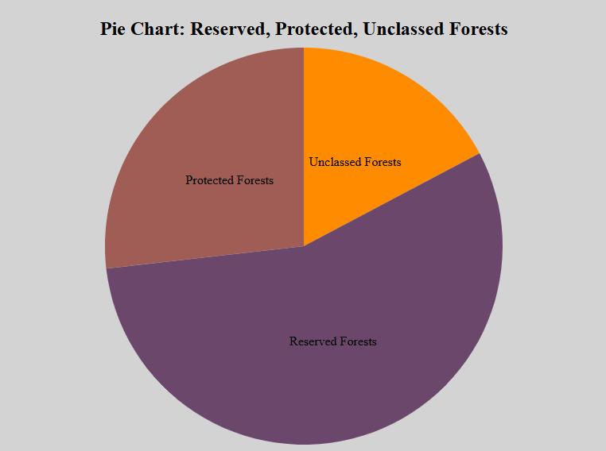

The above pie chart shows the distribution of types of forest areas found in India. We see three types with Reserved Forest found to be highest.

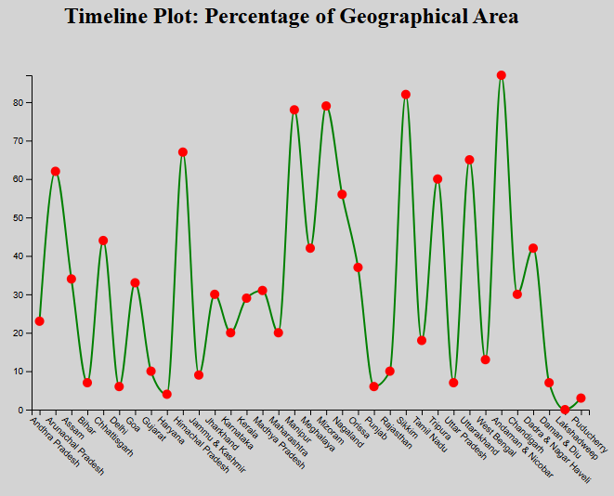

The above timeline graph shows the timeline of percentage of geographical area covered in each state, with Chandigarh having the highest percentage of growth.

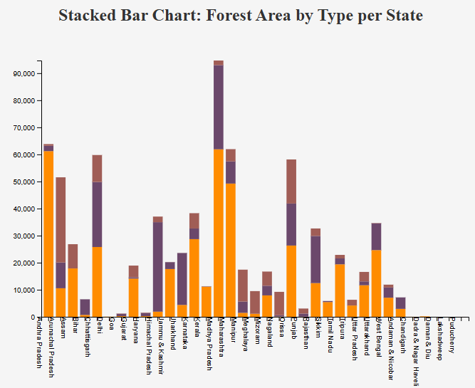

The above stacked bar graph shows the forest types covered by each state. The reserved forests are present in almost all the states. There are few places that do not have the all the three forest types.

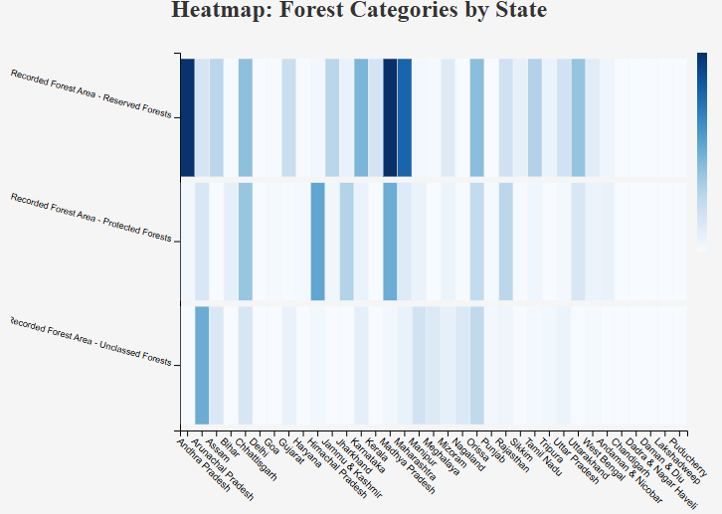

The above Heatmap shows the relation between states and forest type. It can be seen that, Reserved Forests are present in high amount in Maharashtra, Madhya Pradesh and Andhra Pradesh.

**Dashboard:**

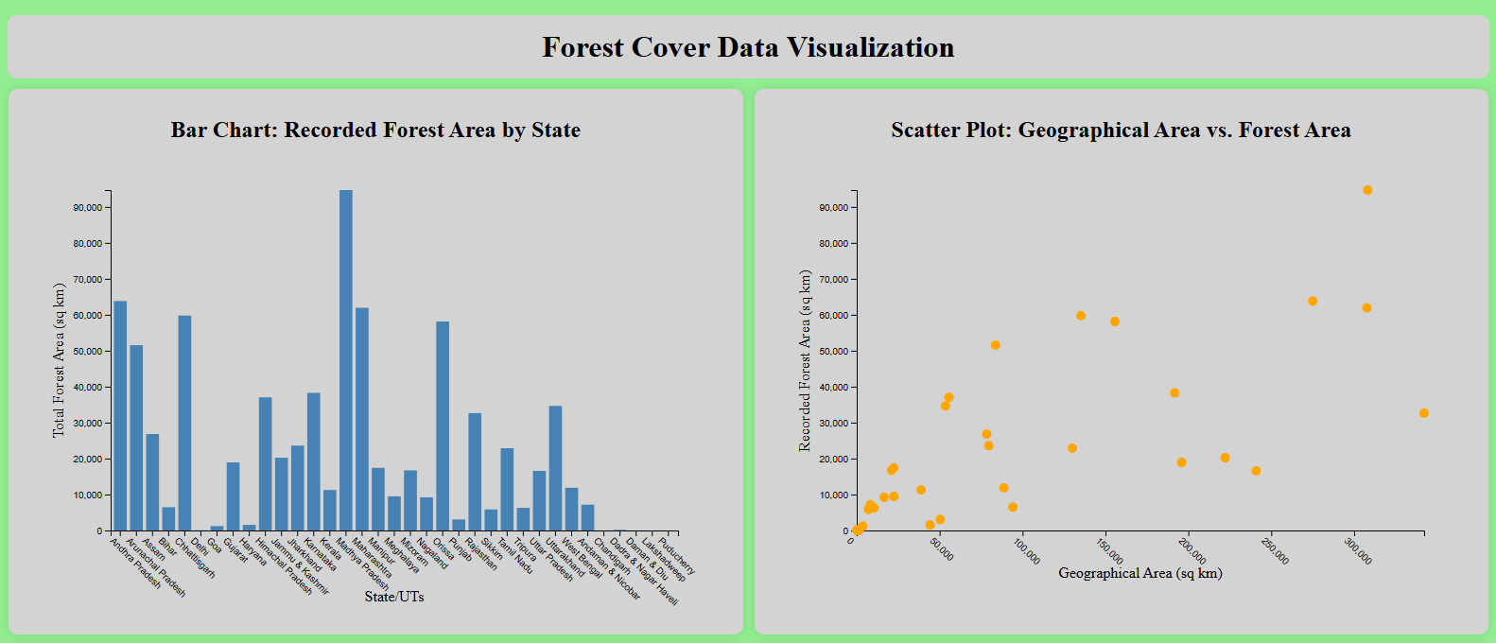

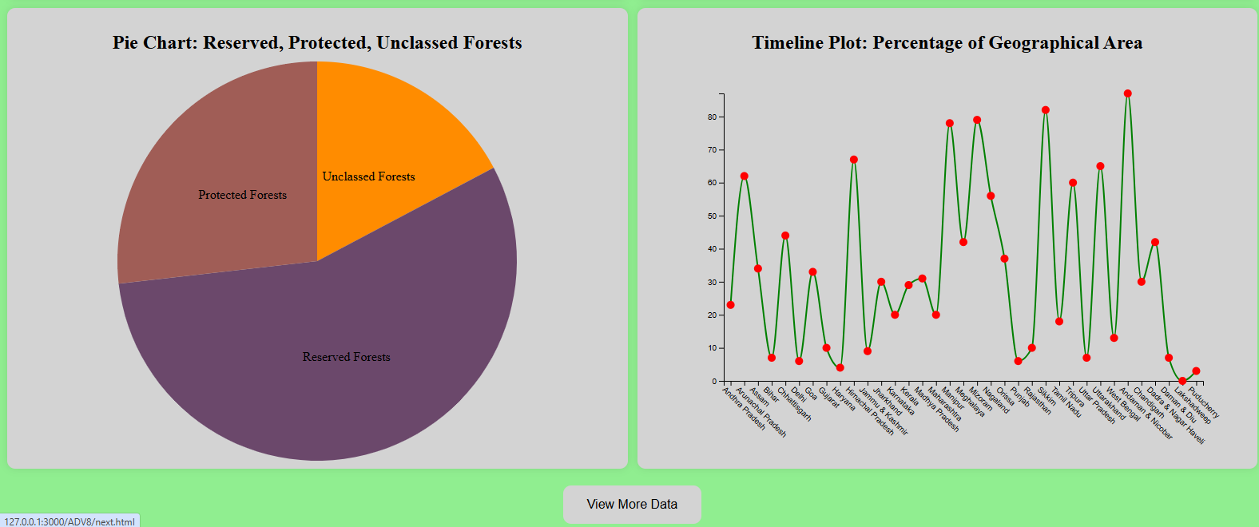

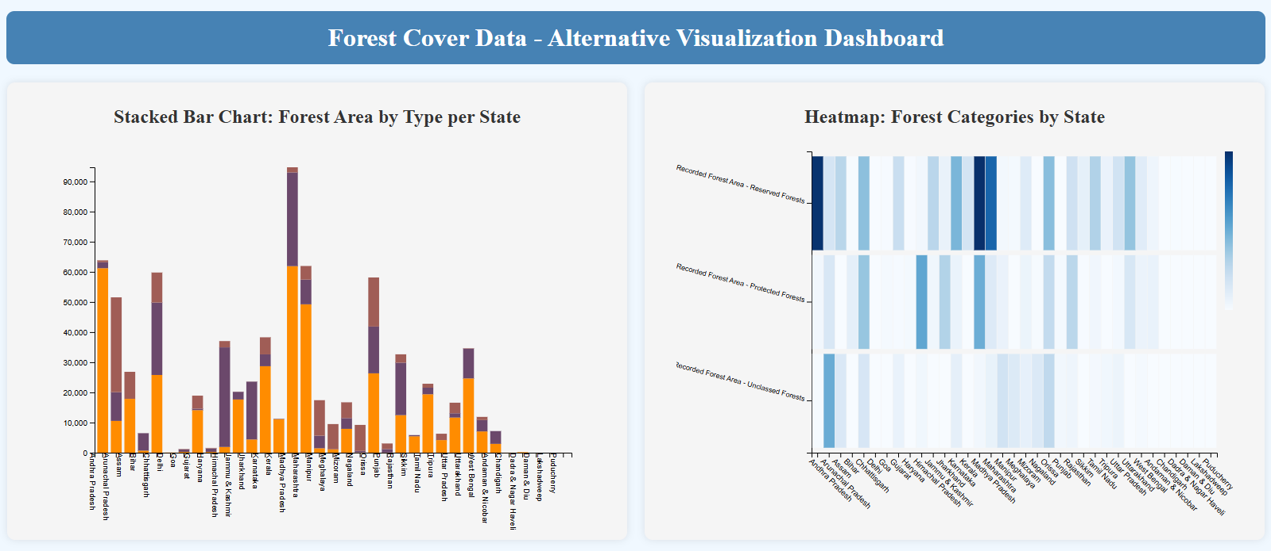

This dashboard offers a detailed look at forest cover across Indian states and union territories, emphasizing both the extent and types of forested areas. The bar chart highlights Maharashtra as the state with the largest forest area, covering over 90,000 square kilometers. The scatter plot complements this by showing a positive correlation between geographical area and recorded forest area, indicating that states with more land area generally have larger forest coverage.

In terms of forest composition, the pie chart shows that reserved forests make up the largest portion of forest areas in India, signifying a focus on conservation. The stacked bar chart further illustrates that while most states have substantial reserved forest cover, some lack all three types (reserved, protected, and unclassed). The timeline graph offers insight into growth trends, with Chandigarh leading in the percentage of geographical area covered by forest. The heatmap reinforces regional patterns, showing that states like Maharashtra, Madhya Pradesh, and Andhra Pradesh have particularly high levels of reserved forests. Altogether, the dashboard provides a nuanced view of India's forest landscape, highlighting state-specific trends and the importance of reserved forests across the country.