Les limites de la démocratie athénienne

Compared to that of our society, the Athenian democracy presented several limits. These limits can be categorized into two groups: how a citizen is defined and direct participation.

In Canada, everyone born here gets to vote at the age of eighteen. Further, immigrants also get to vote after living here for three years. In Athens, only free, of-age men of Athenian descent could vote. This group makes up around fifteen percent of the population, meaning 15% of the Athenian population governed the other 85%, without them getting a say in the matter.

Further, to participate in the ecclesia, you needed to be at the location in the city of Athens. This meant that while many citizens outside the city were permitted to vote, doing so was out of the question. For this reason, only around 10 000 of the 40 000 citizens were considered active, while the rest were inactive.

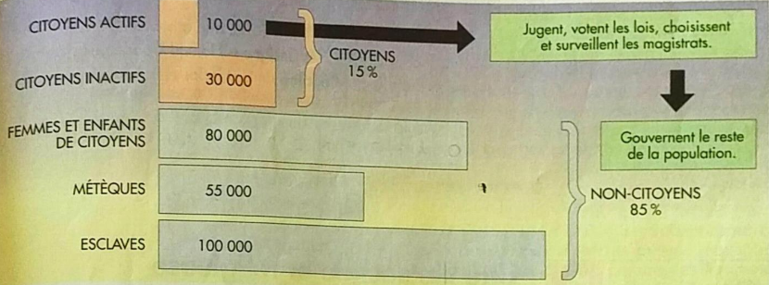

Despite these limits, Athens was still a very powerful state in its time.

|  |  |
| --- | --- |
| % des habitants sont les citoyens athéniens | 15% |
| Nombre des citoyens actifs | 10 000 |
| Pourquoi est-ce qu’il y avait assez des citoyens inactifs? | Beaucoup des citoyens étant occupés ou vivaient loin d’Athènes |