This laboratory assignment accompanies the book, Embedded Systems: Real-Time Interfacing to ARM Cortex M Microcontrollers, ISBN-13: 978-1463590154, by Jonathan W. Valvano, copyright © 2021.
NOTE: Students will create and submit their Lab 6 PCBs INDIVIDUALLY
Team members must do different DACs and op amp.

Goals • PCB Layout using Eagle
• Systems level approach to embedded system design
- Mechanical considerations
- Availability of parts (second source)
- Cost considerations
- Power considerations
• Design for Test

Review Data sheets for the TM4C123GH6PM microcontroller (review layout for 64 pin LQFP)
Eagle Setup Tutorial
EE319K Spring break PCB camp

Starter files at Lab Assignments http://users.ece.utexas.edu/%7Evalvano/EE445L/
Lab_6.sch
Lab_6.pcb
Lab6BOM.xlsx
EE445L library

Videos:
Importing Eagle library for new part https://youtu.be/7MNkIBrr_UA
Editing the Eagle schematic https://youtu.be/ZneKCLUWy_I
Changing PCB size to fit in box https://youtu.be/yPVYe-lXOEI
Placing the parts on PCB https://youtu.be/a9Aywr4wLSE
Routing the traces

Requirements Document
The objective of this lab is to perform a PCB layout for an embedded system. You are asked to create a PCB layout for an embedded system that implements an analog signal generator. The user inputs must include
a momentary switch (to change modes)
a reset switch
a potentiometer (to set frequency and/or amplitude)
The output of the system must include
one analog output (buffered with an op amp in voltage follower mode)
The debugging features must include
three power test points (battery, 3.3V and ground),
two analog test points (DAC output and signal output),
one logic analyzer connector (eight appropriately connected digital signals),
one heartbeat LED
one power LED
The system will be powered with a single 3.7V 2600mAh battery, see Figure 6.1.

The requirements for the Schematic include
- No dangling pins
- Meaningful net names
- Grounds are tied, voltage levels are specified
- Versioning comment, what they changed from base schematic to V0.1.1
- Passes ERC
The requirements for the PCB include
- No ground pour (but they should understand what a ground pour is and why to use it)
- Component references are visible and positioned well
- Silkscreen text is useful
- No auto-routing
- 45-degree angles (miter)
- All signals are routed and make sense
- An attempt has been made to segregate power, analog, and digital signals
- Board has board name, designer, date, TA/section, version number
- Passes DRC

You will deliver two pieces of paper (top and bottom) glued to cardboard like Figures 6.2 and 6.3, which could be mounted in the Pactec XP, the Hammond 1593Y, or Serpec 151 enclosure, see Figure 6.4. You will complete the Lab6BOM.xlsx bill of materials, calculating the material costs for manufacturing. You will perform power budget estimations. The operator buttons and LEDs will be placed directly on the PCB but positioned so they protrude outside the box.

Figure 6.1. Tenergy Li-ion 18650 Cylindrical 3.7V 2600mAh Flat Top Rechargeable Battery.
Weight: 46.5±1 g, Height: 65.2mm, Diameter: 18.4mm.

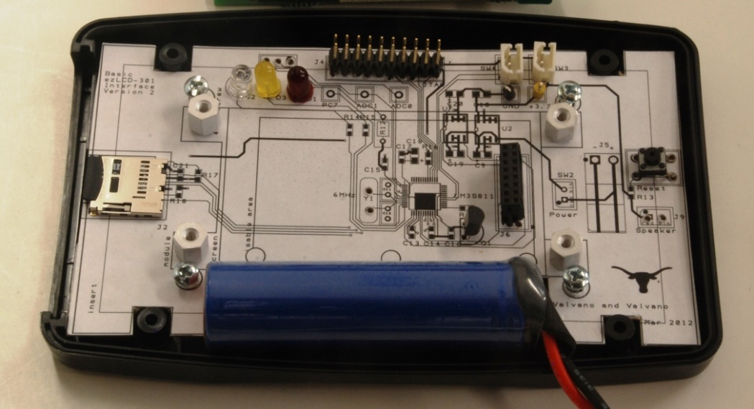
Figure 6.2. Mockup for an LM3S811 system using a PacTec enclosure.

Figure 6.3. Top and bottom of PCB layout for a TM4C123 system (Lab 6 does not include a ST7735).
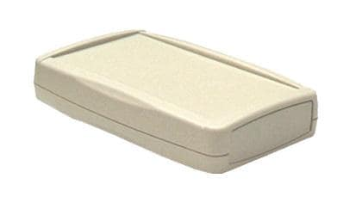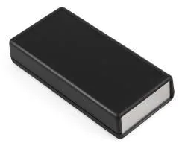
Figure 6.4. PacTec XP, Hammond 1593YALBK, and Serpac 151 enclosures

Constraints
Your system will include an LP2950-33 (low dropout linear voltage regulator), an LM4041 (if the DAC needs it), a DAC (SPI interface, voltage output), an op amp (in voltage follower mode), and a surface mount TM4C123. You will have a different DAC and op amp from your partner(s). Contact your TA to find out which DAC and which op amp you have been assigned. We choose your DAC.
AD5061BRJZ-1500RL7 or AD5061BRJZ-2500RL7 (last choice)
AD5300BRMZ
AD8300ARZ
AD5541JRZ

We choose your rail-to-rail single-supply op amp.
AD8604WARZ or AD8604ARQZ-R7 or AD8604ARQZ-RL (last choice)
AD822ARZ
AD823ARZ
AD8542ARZ
All the components will be on the same PCB, and the PCB will be placed in a box with four mounting screws. In Labs 7, 8, and 11, you will design, build, and test a real PCB, but in this lab, you will just create the design with a cardboard mockup without buying or soldering the PCB.

Background
Considering the design cycle presented in Section 1.3 of the book, one starts by analyzing a problem, and then one generates a requirements document describing what the system must do. The output of the analysis phase is a list of specifications and constraints. The requirements document for Lab 4 is given above. The Preparation and Procedure sections of lab assignments address the design and implementation phases of the project. The lab assignment and your solution to it represents analysis and initial design, just part way through the design cycle in Figure 6.5. You will build no circuits and write no software.

Figure 6.5. Product development cycle.

As you know, commercial products are not manufactured using solder-less breadboards like the ones we use in EE319K and EE445L. Furthermore, commercial products do not include microcontroller boards like the LaunchPad. Implementing the embedded system on a PCB, which includes both the microcontroller and the external circuitry, will improve maintainability, testability and reliability. It will also reduce the size, weight and cost of the system. In this lab, we will also consider power.

There are no specific requirements for this lab to minimize size, cost, or power. On the other hand, you will be asked to estimate these parameters in your system. There are three considerations when designing a power efficient system. First, we need to make a Power Budget. This means we determine the maximum amount of power that can be supported by the power source. Second, we need to identify and analyze required system tasks. This means we determine the tasks that need to be performed by the system and estimate the power required to perform these tasks. It is important to consider timing of the tasks and synchronization to I/O events. For example, executing about once a second (e.g., smoke detector checking for fires) will require less power than executing exactly once a second (digital watch). One way the TI MSP430 family achieves very low power is it can run with no crystal oscillator, and the rate at which the microcontroller runs can only be approximately set. For example, the 40-pin MSP430F2274 running at 1 MHz requires only 400 µA of supply current, whereas a Cortex M requires 10 to 100 times more current. The third consideration is to develop a power strategy. Having a strategy for power helps the power needed to perform the required system tasks to fit within the power budget. A Power Budget is a first order calculation that gives you a ballpark figure of the “total average current” supported by your power source. From the system specifications we are given how long the system must operate without replacing batteries, tlife in hours (tlife is 24 hours in this lab). From the battery datasheet we determine the storage capacity of the battery, E in mA-hours. Be aware, however, that for many batteries the storage capacity depends also on current, time and temperature. The power budget is
Average Current must be less than E/tlife

Preparation (show this to the TA at the start of Lab)
- Download the EE445L.lbr file again to make sure you have the newest version.
- Download the EE445L_LAB_6_Starter_EAGLE.zip file which contains an eagle.epf project file, the Lab6BOM.xlsx file, Lab_6.sch schematic, and Lab_6.brd board file. The SCH and PCB files are connected, so their names should only differ in their extensions. Make sure you can open the SCH and PCB files in Eagle.
- Find out which DAC and which op amp you are to use from your TA. Create an account on Analog Devices,
https://www.analog.com/en/index.html .
Use the account to login to their sampling web site,
https://www.samplecomponents.com/scripts/samplecenter.dll?hittite
Find your DAC and op amp. Optionally, you may actually sample the parts. You will not need the parts, so sampling them is optional.
- Find availability and price on octopart.com, mouser.com, or digikey.com for your DAC and op amp. It does not matter if the parts are not available, because you will not actually build Lab 6. Place the ordering information and price into the Lab6BOM.xlsx spreadsheet.
- Find the data sheets for your DAC and op amp on Analog Devices, Mouser, or Digikey
- Find the Eagle design files for your DAC and op amp. We do not anticipate you will need to create the parts from scratch. Eagle design files can be found on www.Mouser.com and https://www.snapeda.com
- Add your DAC and op amp to Lab 6 starter SCH. You will eventually finish the schematic, but for the preparation, simply add your DAC and op amp. You may add other hardware beyond what was needed for the lab if you choose, but it is not necessary to add more I/O functionality than what is listed in the requirements document.

Procedure (do this during your lab period)
1. Choose a box in which to enclose the system, see Figure 6.4. You may choose a bigger or prettier box. There is no specific requirement in this lab to minimize cost or size. A bigger box will allow a bigger PCB, making layout simpler. To get the price, you can search a parts distributor (like www.mouser.com or www.digikey.com) or a parts search engine like http://octopart.com/. You will need layout dimensions for placing a PCB board into the box, like Figure 6.5. Adjust the PCB outline so it fits into the enclosure with room for the battery, see Figure 6.2. If you choose a box different from the two suggested, you will have to procure the box, so you can demonstrate the PCB fits into the box with the switches and LEDs accessible.

Figure 6.5a. Mechanical drawings for the Pactec XP enclosure.

Figure 6.5b. Mechanical drawings for the Hammond 1593Y enclosure.
Figure 6.5c. Mechanical drawings for Serpac 151 enclosure.

- Complete the schematic to satisfy the requirements. Any component you add to the schematic should be documented in the Lab6BOM.xlsx file. Add a column called estimated current. To get the price, you can search http://octopart.com/. It doesn’t matter whether you use quantity 1 pricing or quantity 1000 prices. Estimate the total cost of the system. For more information on resistors and capacitors, see
http://users.ece.utexas.edu/~valvano/Datasheets/CarbonFilmResistors.pdf
http://users.ece.utexas.edu/~valvano/Datasheets/CarbonFilmresistors2.pdf
http://users.ece.utexas.edu/~valvano/Datasheets/CapacitorC0G.pdf
and http://users.ece.utexas.edu/~valvano/Datasheets/TantalumCap.pdf
- If you were asked to make 1000 copies of the system, think about how you would test each system during manufacturing. The JTAG port allows you to download and run software on the microcontroller. The test points allow for electrical testing of analog signals. The 16-pin logic analyzer allows for electrical testing of the digital signals. Attach eight digital signals to the connector (the other 8 pins are ground). The logic analyzer connector would attach directly to the logic analyzers we have in lab.
- Within the SCH editor, execute an Electrical Rules Check (ERC). Some warnings are unwarranted and may be “Approved”. An example is this button having no value. Because many components like resistors and capacitors should have a value specified, EAGLE will warn you when a value is missing. We tell EAGLE the button doesn’t need a value by hitting approve. Your final schematic should pass ERC with no unapproved warnings. EAGLE catches common mistakes, like placing two lines so close to each other, that they look connected on the computer screen, when they are not actually connected.

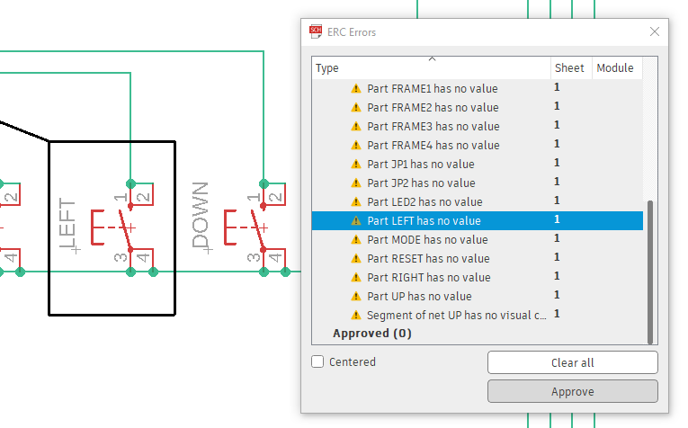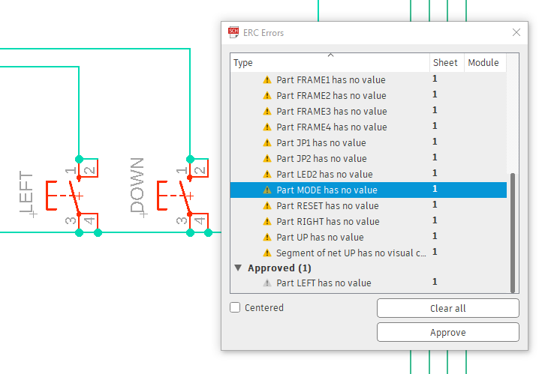

Figure 6.6. Approving ERC warnings

- A ‘net’ describes a network of connections pattern on the schematic/PCB. You need to label all your nets with descriptive names. There should be ZERO nets with the name format like N$0. Within the SCH editor, go to Design Manager -> Net Classes/Busses -> Select All Nets to see all Nets. Double click on a net in the menu to jump to its position. To rename a net, right click it-> Properties -> Name
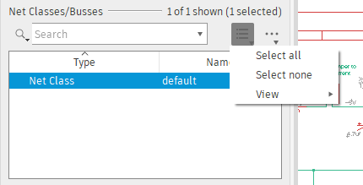
Figure 6.7. Selecting all nets in EAGLE

- There is no need to minimize size, cost or weight. So, except for the TM4C123GH6PM, it is ok to use the larger footprint through-hole parts. To begin working on the PCB hit the button in eagle to switch to the PCB. ONCE YOU START WORKING ON THE PCB, KEEP BOTH EDITORS OPEN AT ALL TIMES. Closing either editor may cause a desync between the PCB and Schematic, meaning that you will need to either manually sync them or delete your work on the PCB. Changes in the schematic/PCB will be synced in the PCB/Schematic if both editors are open. When creating the PCB, place the fixed objects first (e.g., drill holes for mounting in the box, LEDs, and switches soldered to the PCB.) The next step is to place all remaining components inside the PCB area. Give careful thought when placing component to minimize trace lengths. Put parts next to each other that connect to each other. If possible, position polarized parts (i.e. diodes, and electrolytic caps) with the positive leads all having the same orientation. Many of the components use a square pad to mark the positive leads of these components. Doing a good job here will make laying the traces much easier. You cannot use AutoPlace or AutoRoute for this lab. You will save a lot of time by leaving generous space between ICs for traces. Frequently the beginner runs out of room when routing traces. Leave 0.350" to 0.500" between ICs, for large ICs allow even more. Once all components are placed, print out the PCB top layers. Using a ruler make sure the large components (LEDs, switches, and connectors) will fit in the box.

- Once you are sure everything fits; you will route the nets. I like to route power and ground first. Avoid loops in the signals because loops can pickup EM field noise. Because ground/power planes can impact visibility, increase the difficulty of soldering, and make it harder to fix mistakes with jumpers on the board once it is produced you are not supposed to use ground/power planes or copper pours. As you get more experience (after your 4th PCB design) you can use ground planes as they are great for low noise or high frequency circuits, an example is shown in figure 6.3. However, in this class, place ground and power paths in the shape of a capital E. Most of the signals in this class can be 7 to 10 mils wide. Use 20 to 30 mil wide signals for power, ground and signals carrying large currents. Whenever possible increase the power and ground paths as will fit. Here are some guidelines.

Make sure the Snap to Grid mode is active (experiment with different settings of the snap)
Add Top Silk labels for your initials, your TA’s initials, the date, and the purpose of the board,
Place all though-hole components on the top side (surface mount components can go on either side),
If possible align all chips in the same direction,
Configure the board so that all though-hole soldering occurs on the bottom side,
Add Top Silk labeling to assist in construction and debugging, add bottom silk to add more information
Add test points at strategic points to assist in debugging,
Either by placing two holes 0.1 in apart then soldering a U wire into it,
or adding a test point, which is a 0.090 in pad with 0.043 in hole
Each IC should have a bypass capacitor, placed as close to the chip as possible,
All components need labels (e.g., U1 R1 C1 J1 etc.), shown both on the board and the circuit diagram,
Avoid 90-degree turns, convert them to two 45 degree turns,
One way to make it all fit is to go left-right on one side and up-down on the other side (Figure 6.8)

Traces that carry significant current should be wider than signal traces. To determine trace width, one needs to know the maximum current, the length of the trace, the thickness (1 oz/ft²), ambient temperature, and the maximum allowable temperature rise in the trace. For traces much longer than they are wide, and currents less than 35 amps, you can use the following calculators based on the IPC-2221 standard (formerly IPC-D-275). The second link can be used to calculate sizes of vias.

http://www.circuitcalculator.com/wordpress/2006/01/31/pcb-trace-width-calculator/
http://circuitcalculator.com/wordpress/2006/03/12/pcb-via-calculator/

Figure 6.8. Notice the left-right traces are on top, and the up-down traces are on bottom.

- When you think you are done, execute a Design Rules Check (DRC) using the button. This will inform you, among other things, if any wires/holes/vias are too close, and if any connections are not routed. Fix any errors. Lastly, you should experience the process of ordering the board described.
  - Download the cam file https://raw.githubusercontent.com/JLCPCBofficial/jlcpcb-eagle/master/cam/jlcpcb_2_layer_v9.cam The cam file tells EAGLE how to generate the GERBER file for the PCB Manufacturer
  - Hit the CAM processor button in EAGLE PCB editor
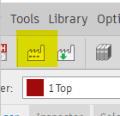

  - Select the cam File then hit “Process JOB”

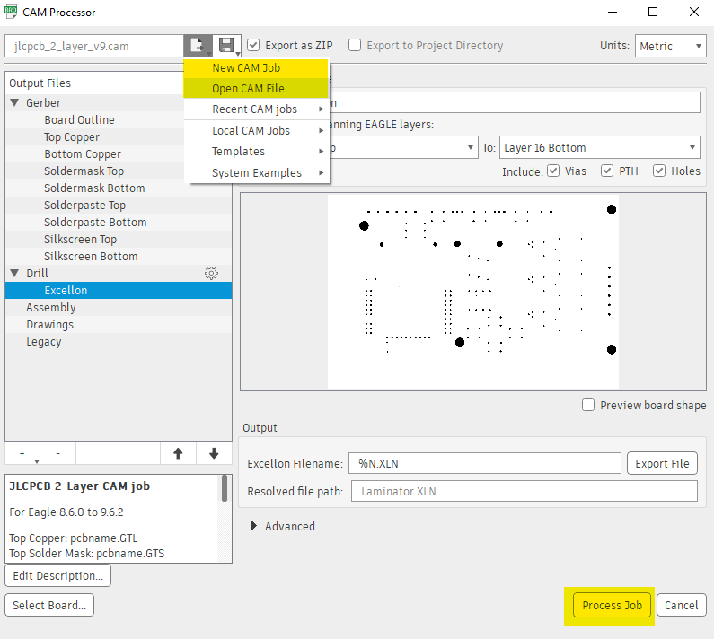

  - Navigate to https://cart.jlcpcb.com/quote? and upload the zip file (The zip file is filled with the Gerber produced by the cam job). The Zip file should be in your project directory. Once the website parses the Zip file of Gerbers you should see a preview and estimated pricing. DO NOT ORDER/BUY THE PCB. Simply take a screenshot for your report.

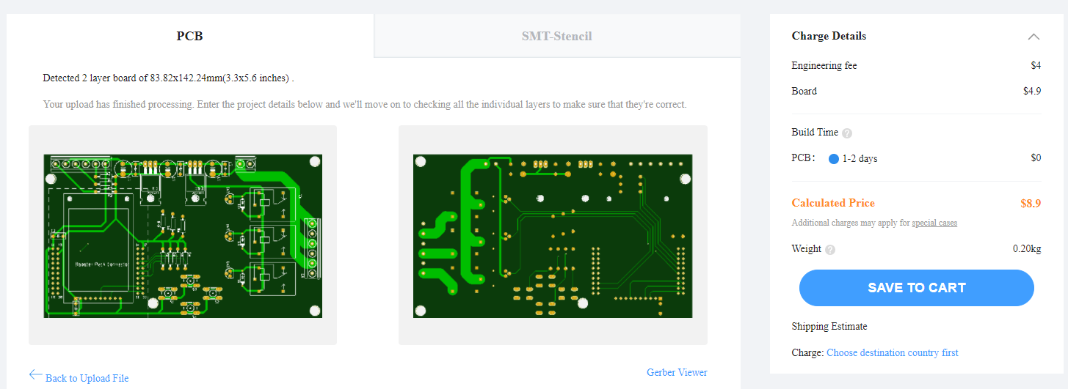

- Make four printouts
1) Just top copper to be judged for layout style
2) Just bottom copper to be judged for layout style
3) Top copper and top silk, glue to top of cardboard, print at 100%
4) Bottom copper and bottom silk, glue to bottom of cardboard (print mirrored), print at 100%.

Cut out a piece of cardboard or wood about the thickness of a PCB board and glue the last two printouts to it, similar to Figure 6.8. Your mockup should fit nicely in the box.

Deliverables (exact components of the lab report)
A) Objectives (Requirements document copied from this Lab document)
B) Hardware Design
One page description of the box (if different from PacTec XP or Hammond 1593Y)
Final circuit diagram of the embedded system, SCH file
Cardboard mockup of the PCB layout (with top copper/silk on top and bottom copper/silk on bottom)
Screenshot of order screen on JLC with preview of your design
C) Software Design none
D) Measurement Data
Bill of Materials (quantity, package type, cost, and supply current)
E) Analysis and Discussion (1/2 page maximum)
Estimate how long the system would run on the 2600mA battery.

Checkout (show this to the TA)
You execute the commands listed in Procedures 4, 5, 6, 7, and 8 to verify project completion. You will be given a part number and asked to search for its data sheet and find the cheapest place to buy one (www.octopart.com). You should be prepared to discuss alternative approaches and be able to justify your solution. Show the pdf files for your DAC and op amp.

A software and report files must be uploaded as instructed by your TA.
Your SCH and PCB files
Lab report
Bill of Materials of all your parts

