# Winters’s Site Plan

## Talmage Winters

## WDD 130

## Overview

### Purpose

Explain the basic principles of song composition. Explain how to read chord charts in music.

### Audience

Beginner song writers.

## Branding

### Website Logo



## Style Guide

### Color Palette

|  |  |  |  |
| --- | --- | --- | --- |
| **Primary** | **Secondary** | **Accent 1** | **Accent 2** |
| #B0E0E6 | #FFB6C1 | #E00BEA | #00008B |

### Typography

### <style>

### @import url('https://fonts.googleapis.com/css2?family=Nunito:ital,wght@0,200..1000;1,200..1000&family=Parisienne&display=swap');

### </style>

#### Heading Font: Parisienne

#### Paragraph Font: Nunito

### Navigation

Home Song Anatomy Chords

**Content**

Home Page:

**Scales**

Just what is a scale? A scale in music is a group of notes that are arranged in ascending or descending order by pitch. They are the basic building blocks in song composition. There are major scales and minor scales. Major scales consist of eight notes. It starts and ends on the **Tonic** note. It consists of 5 whole steps and 2 half steps. A half step is the smallest interval between two notes, and it refers to notes that are directly next to each other. A whole step is equal to two half steps or two notes that have one note in between them.

Songs written with major scales are associated with bright and happy sounds. Songs written with minor scales have more somber and introspective sounds. The first step in composing a song is to decide what type of feeling you want the song to convey.

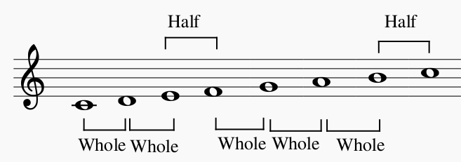

**Tonic and Dominant**

A major component in music theory are the **Tonic(I)** and **Dominant(V)** degrees. The **Tonic** degree is the first degree in any scale. The **Dominant** degree is the fifth degree in any scale. Using the **Dominant** degree in a song creates a feeling of tension in the music. Don’t use it as the last note in a song because it will sound unfinished.

The **Tonic** degree is often use to start and end a song. This degree creates a sense of resolution and stability. It is also the note upon which all other notes are based upon. Other notes will refer to the **Tonic**. The circled notes are the **Tonic** notes in the C major scale.



**Song Anatomy Page:**

A good song consists of a **Melody** and a **Harmony**. The **Melody** is the “main dish” in a song. It is often repeated, and it is usually made to be “catchy.” The **Harmony** is kind of like a “side dish.” The **Harmony** complements the **Melody** and allows for the song to have more texture.

**Melody**

There are a few factors to consider when writing a melody: the scale, pitch, rhythm, and phrasing. When writing a melody, it is important to know which scale or key signature the song will be written in. Each scale and key signature have a distinct sound to it. For example, the D major scale conveys a feeling of triumph, and the C minor scale evokes feelings of sadness.



***Pitch***

Higher pitch is associated with happiness, tension, or anxiety. Use higher pitch when composing a fast-paced song. Lower pitch is associated with calm or sad feelings. Lower pitch can also be used to express serious feelings.



***Rhythm***

Different rhythms add more flavor to a song. Use a variety of rhythms to keep the song interesting.

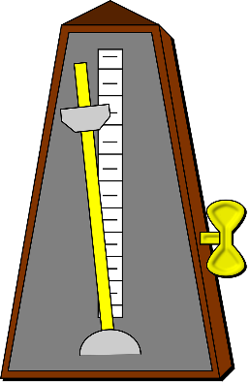

***Phrasing***

Phrasing is the direction the melody moves in. Static motion, descending motion, and ascending motion are different types of phrasing. There can be a mixture of phrases in a song.

**Harmony**

The harmony part of songs contains chords that support the melody. There are a few types of chords: the tonic chord, the dominant chord, and the subdominant chord. The tonic chord is the basic chord that includes the root, third, and fifth notes of the scale. It often serves as the starting and ending note of compositions. The dominant chord focuses on the fifth degree of the scales. This chord creates a sense of suspension, and it usually waits for the tonic cord to finish it off. The subdominant chord is built on the fourth degree of the scale. This chord adds a sense of progression to a composition.

**Chords Page:**

**C Chords**

Here are some examples of different chords you can use in your composition. Each has a different feel to it. For example, the C major chord is basic and stable. The minor chord creates a more sad sound. Experiment with these different types of chords to find what sounds good.

**C Chord**

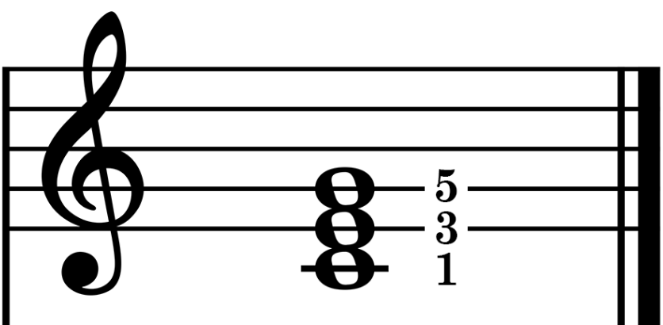

**C minor Chord (Cm)**

**C 5th Chord**

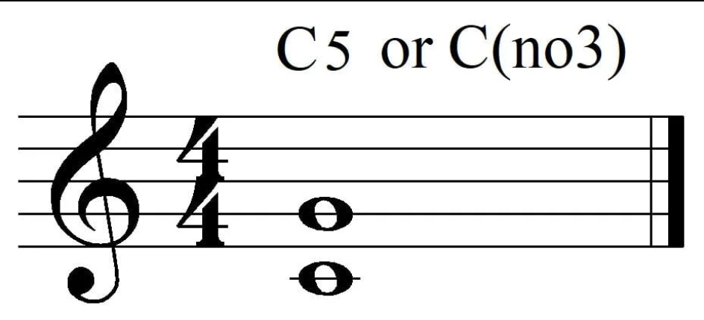

**C 6th Chord**

**C dim Chord**

**Csus2 Chord (C2)**

**Wireframes**

### Home

<https://app.moqups.com/F4VKCYdNTCVFPCRvosYB7NlSI5bH0LZU/view/page/aef4b8283>

Has the link to main page and the two child pages.