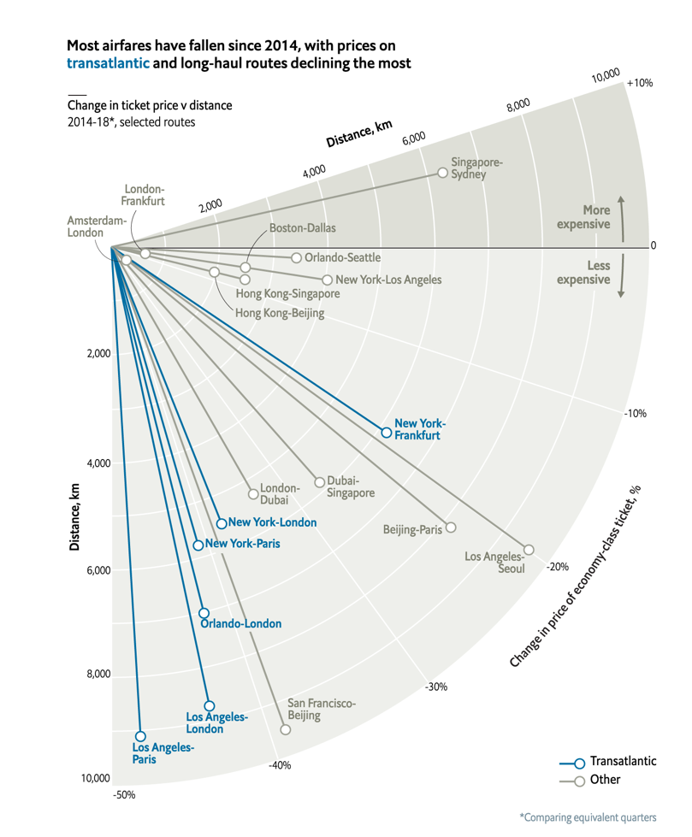The visualization examined in this taken from the Economist December 2018 edition. The figure shows distance a flight travels, the ports of those flights, the change in price since 2014, and whether the flight is transatlantic. Distance is encoded as length of a line. The ports are labeled with text at the end of the line. The change in price is encoded as an angle. An increase in price is a positive angle with respect to the x-axis, and a decrease is a negative angle. Whether the flight was transatlantic is encoded with color: blue for transatlantic, gray otherwise.

As the text above the graphic says: "most airfares have fallen since 2014, with prices on transatlantic and long-haul routes declining the most". The point seems to be that the prices on certain types of flights have declined. It wishes to show that there is a possible correlation between price change and long-haul routes, and a possible correlation between price change and transatlantic routes. I believe the visualization also wishes the reader to be able to get more specific information out by labeling each of the lines. Perhaps the reader often flies New York to London on business. The label allows the reader to quickly pick out their route, and see how it fits into the overall story of this visualization.

The main type of graphic used is a "lollipop" plot, which is a type of bar chart. The lines are "sorted" by cost change, where the sorting is displayed by a change in angle. It also uses color encoding to denote two classes of flights.

The most effective aspect of the visualization is the length of the lines denoting the distance the flight travels. One can tell immediately which flights travel the farthest. The transatlantic flights also "pop" out of the page at the reader.

However, I would argue that the encoding of change in price as an angle is ineffective, or at least not as effective as it could be. It makes it slightly harder to notice the two trends that the author wants to make evident.

If we apply the Gestalt Principles of Visual perception in the area of quantitative encoding, the best tools for encoding visual information are points, lines, and bars, and some combinations of those. The author is already encoding distance as the length of lines, which I think works well. However, humans are not as good at decoding angles; see the pie-chart versus bar-chart discussion. If instead we sort by price change and display them as a simple vertical or horizontal bar chart, I think the visualization would be greatly improved. There is another option as well: we know that the chart is trying to tell us that there are some correlations in the data. Scatter plots are excellent for showing correlation. We could plot distance on the x-axis, price change on the y-axis, and color the points in the same manner as they are on the current plot. If there is indeed a correlation between long-distance flights and price decreases, a scatter plot will make it more obvious. I believe the coloring will have about the same effect as it does in the current plot.

Source:

<https://www.economist.com/graphic-detail/2018/12/08/why-ticket-prices-on-long-haul-flights-have-plummeted>