**INDUSTRIAL FARM TANK, INC.**

|  |
| --- |
| * **IFT started out manufacturing polyethylene tanks primarily targeted to the agricultural industry** |
| * **Recently became family owned, management consists of both parents and two older brothers (a lot riding on this project & business)** |
| * **Brother recently entered the business and helped setup a basic website with some product information as well as information about the company** |
| * **Quotations are sometimes time delayed due to the fact that it is a very manual process that relies on father punching in some numbers into a calculator and then calling the customer back at a later time** |
| * **Customer has no way to order online (they currently fax their own purchase order to IFT). Ordering process needs to be easier for the customer.** |
| * **No way for customers to view & pay their invoice online.** |
| * **Quickbooks has been implemented for some tasks but not widely adopted by all of management (mostly likely due to be complicated and bloated with non-relevant features)** |
| * **Several complex business rules need to be integrated into the system. e.g. prices are sometimes different depending on who the customer is.** |
| * **Current website is a good start but could be improved (see next page).** |

* **Improvements needed in current website:**

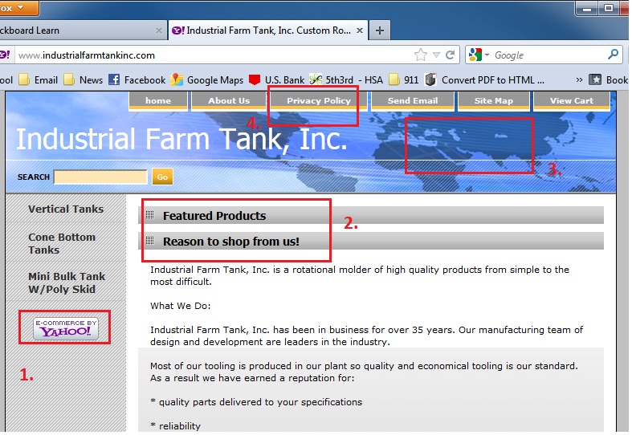

1. Eliminate Yahoo e-commerce branding.

2. Featured Products link non-functional

3. Different picture needed. Current picture is a map of planet earth. IFT is not a global company.

4. Privacy Policy link takes customers to information about Yahoo. Not needed

|  |  |
| --- | --- |
|  | * It does have a pretty good method for displaying some of the more popular items however there is no option to purchase the item. * Large customer complained that wholesale prices were being displayed for anyone to see instead of retail prices. |

Conclusion / Executive summary:

* IFT needs a website where customers with an approved login can view wholesale prices as well as order online. Ordering process needs to be quick and easy for customer in hopes that they will spend more money with IFT
* An electronic payment method needs to be offered to the customer. America runs on credit and this available option will hopefully generate more orders, improve likelihood of payment, as well as improve the speed of payment.
* Price increases are a painful process that was once explained to me as snail mailing new price lists out to all customers. Brother has informed me that this process right here takes 40-60 man hours and is typically done 2-3 times a year. In addition this process needs to happen with a click of a button because costs (propane, labor, etc.) fluctuate frequently.
* Hopefully the site will impress customers and add additional level of professionalism.

Project Goals

1. Build out database structure (6 hours).
   1. This database will need to keep track of customer information like addresses and contact information.
   2. Needs to keep track of as many available products as possible.
      1. Category, Type, & Items
   3. Also need to be able to track Quote & Order History
   4. Membership schema
   5. History tables (modifications of prices, etc.)
2. Design site layout (2 hours)
   1. Incorporate picture of shop/office as well as color scheme (1 hour)
   2. About Us page, profiles of management & history of company (1 hour)
3. Build Registration page (username, contact info, etc.) (2 hours)
   1. Once logged in, (by default) user will be able to see retail prices and place order.
   2. Build option for user to request Distributor or wholesaler roles. (Send email to administrator for access)
4. Build Administration Pages (14 Hours)
   1. Functionality for administrator to add new Items as well as editing existing items. This includes Category, Type, Item, & description. As well as pricing and pictures. (6 hours)
   2. Page to view all orders. This include options to see pending, fulfilled (by company), as well unpaid. (4 hours)
   3. A page to do a bulk edit on prices (by a specified percentage). Ability to view bulk edit history (1 hour)
   4. A page for viewing and editing of all registered customers (1 hour)
   5. A page for viewing pending quotes/orders by company (2 hours)
   6. A page for completing quotes on new products
5. Populate tables with some usable data (4 hours)
   1. Administrator accounts will need to be setup (1 hour)
   2. Setup accounts for good customer for them (1 hour)
   3. Populate product tables (2 hours)
6. Build Product Ordering Page (10 Hours)
   1. Navigation tree on left side that dynamically pulls from CTI table (2 hours)
   2. Main content page that displays all items in navigation selection (6 hours)
   3. Will also need the option for customer to request a quote for a new or unlisted product. Certain information will need to be filled out (4 hours)
7. Shopping cart page that display items, quantity, & totals (6 Hours)
   1. Need to be able to remove items from order
   2. Shopping cart will empty after 30 days
8. Checkout page (6 Hours)
   1. Give customer option to pay by credit card (4 hours)
   2. Also options to pay with net terms
   3. Email notifications to IFT distribution list (1 hour)
   4. Order review and confirmation page (1 hour)
9. Full Audit trail (2 hours)
   1. Build triggers into the database to track changes to pricing
10. Reporting Capabilities (4 hours)
    1. Dollar amounts in regard to customers that have not paid
    2. Reporting capabilities based on number of times each product has been viewed
11. Testing and Meetings (6 hours)
    1. Testing the Product for bugs (3 hours)
    2. Meetings with “client” during the design phase to ensure usability (3 hours)
12. Implementation (8 hours)
    1. Scrub test data and deploy to hosting provider (2 hours)
    2. Driving time for onsite visit (4 hours)
    3. Training of the staff (2 hours)

Design elements that I plan on simulating:

* Below is a shopping that I like from a yahoo ecommerce site
* 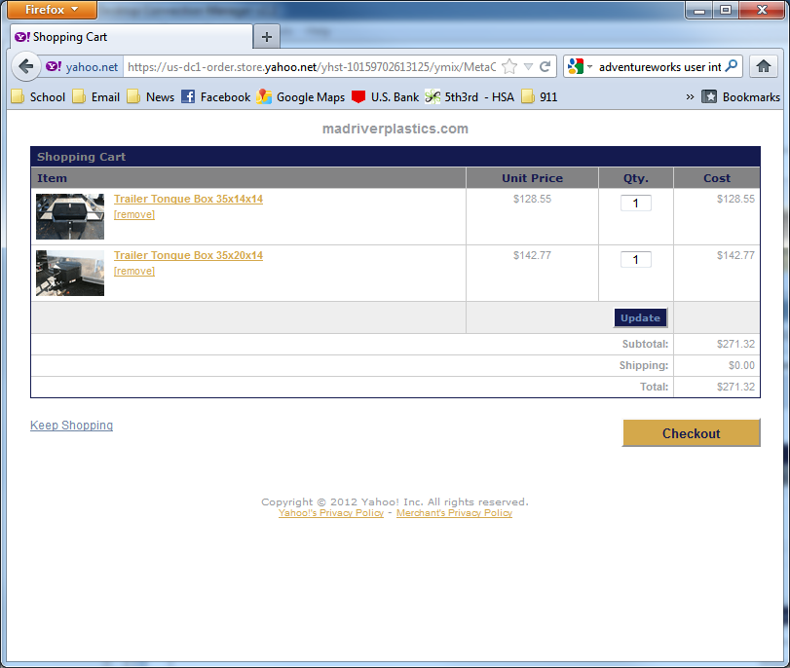
* Here is a style of site navigation that I like:
* 