LAB 4 – PVS using LINQ

Nathan O’Connor

OOTAP

Software Development Year 2

K00252751

# TEST DATA

**Patients**

|  |  |  |  |
| --- | --- | --- | --- |
| **Number** | **Name** | **DOB** | **Vaccines taken** |
| 001 | Nathan O'Connor | 28/02/1999 | covid19  sars  swineflu |
| 002 | Oleg Vladimirovich | 23/03/1983 | measles |
| 003 | Keith Kelly | 09/05/2001 | memB |
| 004 | Micheal D. Higgens | 18/04/1941 | covid19 |
| 005 | Mary McAleese | 27/06/1951 | memC |
| 006 | Patrick Hillery | 02/05/1923 | covid19 |
| 007 | Cearbhall Ó Dálaigh | 12/02/1911 | covid19 |
| 008 | Erskine H. Childers | 11/12/1905 | covid19  sars |
| 009 | Éamon de Velera | 14/10/1882 | rotavirus |
| 010 | Seán T. O'Kelly | 25/08/1882 | --- |
| 011 | Douglas Hyde | 17/01/1945 | --- |
| 012 | Tony Hawk | 12/05/1968 | covid19 |
| 013 | John Cena | 23/04/1977 | sars  swineflu |
| 014 | Mary Kelly | 09/11/1888 | sars  swineflu  mumps  chickenpox  whooping cough  measles  memB  memC  covid19  polio  rotavirus |
| 015 | Johnny Nitro | 03/10/1979 | covid19 |
| 016 | Rey Mysterio | 11/12/1974 | covid19 |
| 017 | Peter Parker | 10/08/2001 | polio |
| 018 | Mike Murphy | 20/10/1941 | whooping cough |
| 019 | Pádrig J. O'Leprosy | 01/01/1941 | mumps |
| 020 | Rodraig S. O'Leprosy | 01/01/1941 | mumps |

**Vaccinees**

|  |  |
| --- | --- |
| **Name** | **System frequency** |
| covid19 | 9 |
| sars | 4 |
| swineflu | 2 |
| measles | 2 |
| chickenpox | 1 |
| mumps | 3 |
| whooping cough | 2 |
| polio | 2 |
| memB | 2 |
| memC | 2 |
| rotavirus | 2 |
| tetanus | 0 |

# Testing

## Apply sample data

**Expected output**

Initialise system with sample data for patients and vaccines.

**Actual output**

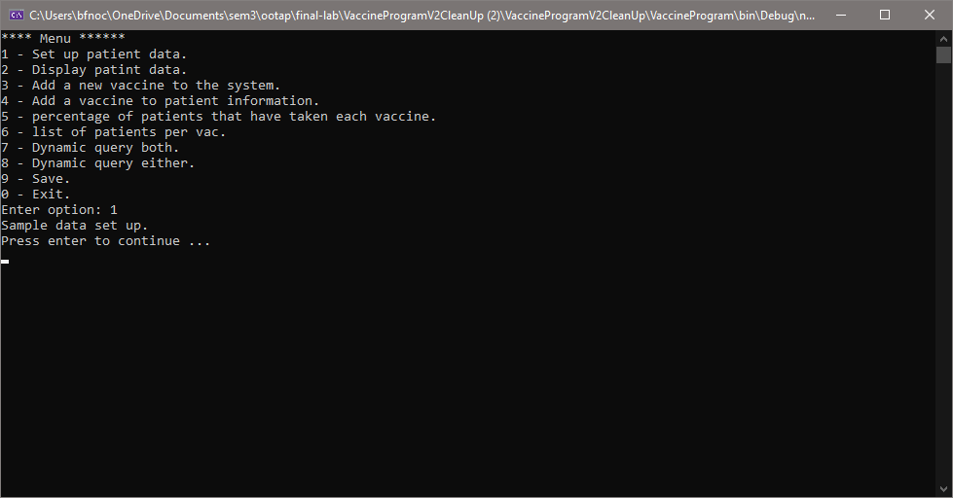

## Display patient data

Expected output

List all patient information on the console.

Actual output

Output worked as expected, below is a sample of the output.

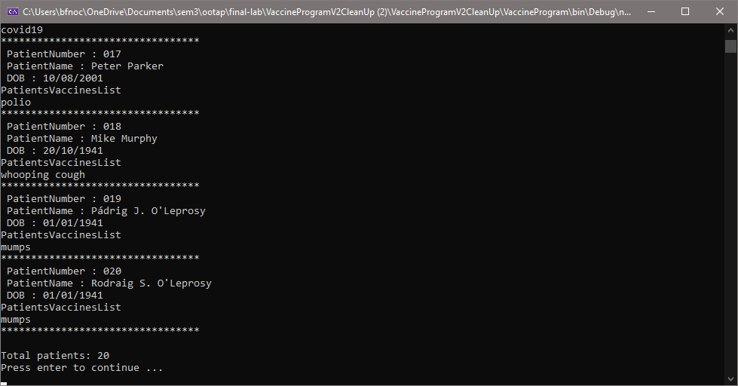

## Add new vaccine to system

**Expected output**

Input “rubella”, the new vaccine is then saved onto the system.

**Actual output ** Note, next page proves that this vaccine has been added to the system by adding the vaccine to a patient.**

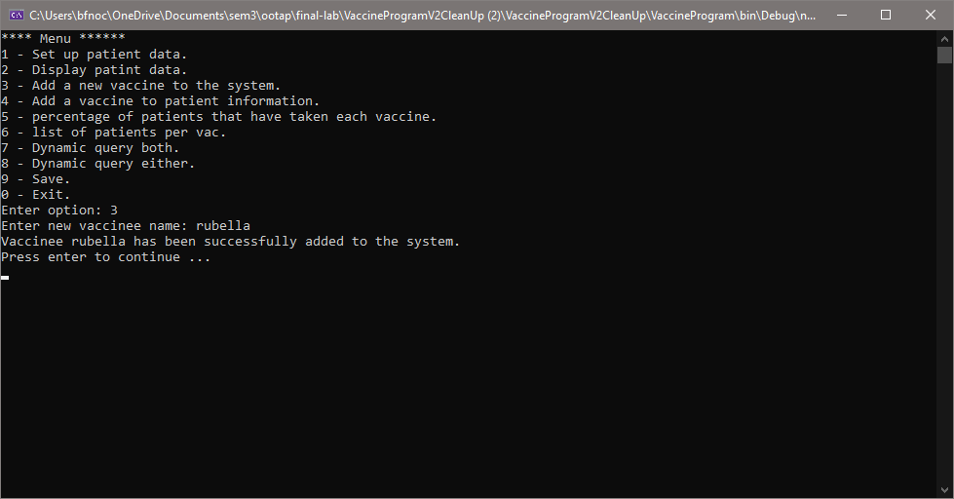

## Add a vaccine to a patient

**Expected output**

Input vaccine “rubella” and input patient number 001.

**Actual output**

Top shows adding a vaccine to patient, bottom shows the vaccine has been added to the patients history.

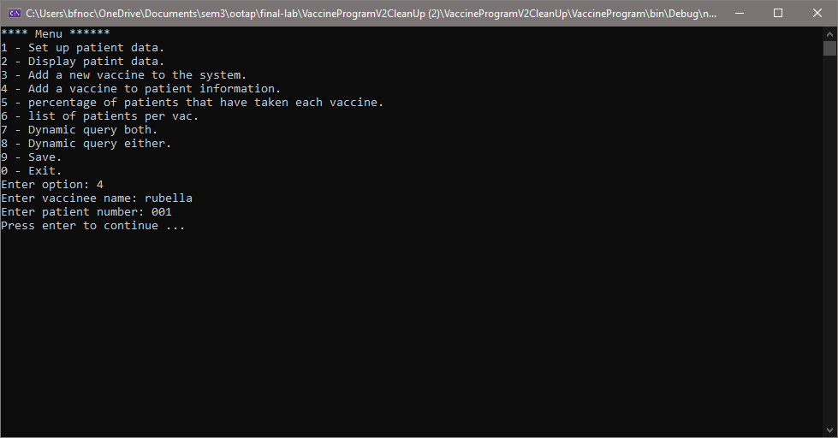

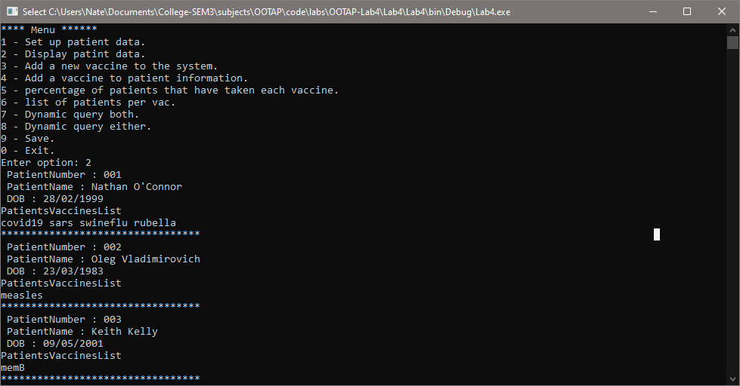

## Vaccine frequency

**Expected output**

|  |  |
| --- | --- |
| **Name** | **System frequency** |
| covid19 | 45% |
| sars | 20% |
| swineflu | 15% |
| measles | 10% |
| chickenpox | 5% |
| mumps | 15% |
| whooping cough | 10% |
| polio | 10% |
| memB | 10% |
| memC | 10% |
| rotavirus | 10% |
| tetanus | 0% |

**Actual output**

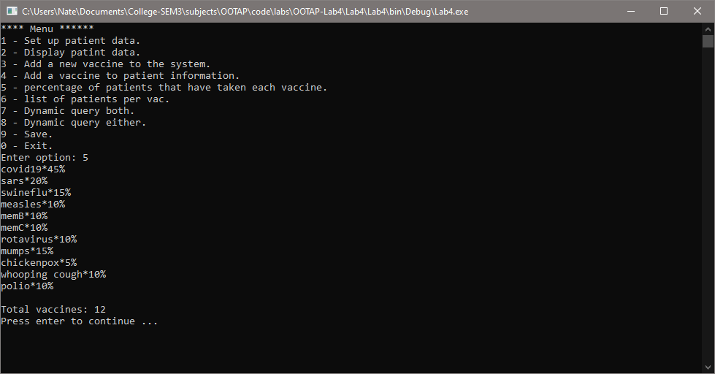

## Display patient vaccine pairs

**Expected output**

Display each vaccine followed by a list of all the patient numbers who have taken each vaccine.

|  |  |
| --- | --- |
| covid19 | 1,  4,  6,  7,  8,  12,  14,  15,  16 |
| sars | 1,  8,  13,  14 |
| swineflu | 1,  13,  14 |
| measles | 2,  14 |
| chickenpox | 14 |
| mumps | 14,  19,  20 |
| whooping cough | 14,  18 |
| polio | 14,  17 |
| memb | 3,  14 |
| memc | 5,  14 |
| rotavirus | 9,  14 |

**Output on next page**

**Actual output**

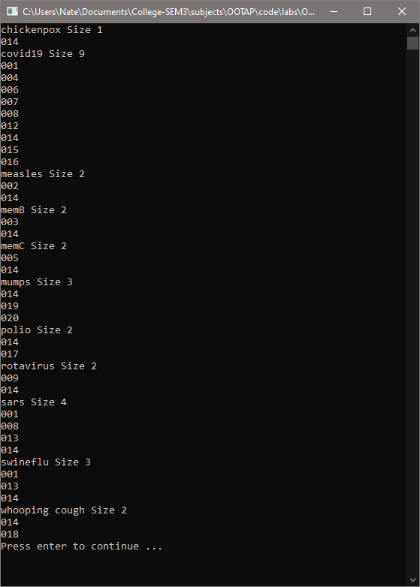

## Dynamic query both

**Expected output**

Input “covid19” and “sars” and the system should return patient numbers

001,

008,

014

**Actual output**

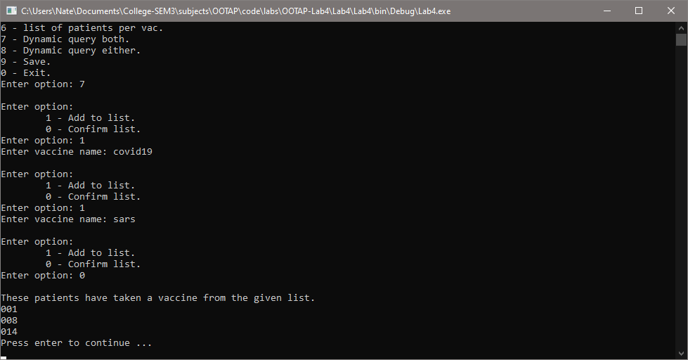

## Dynamic query either

**Expected output**

Input “covid19” and “sars” and the system should return patient numbers

001,

004,

006,

007,

008,

012,

013,

014,

015,

016

**Actual output**

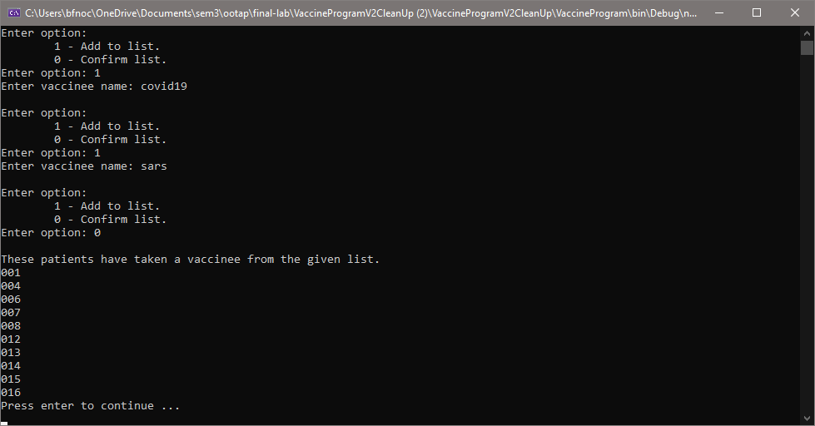

## Save information to file

**Expected output**

Save all objects in the system to a text file (one for patients and one for vaccines). File location displayed on screen.

**Actual output**

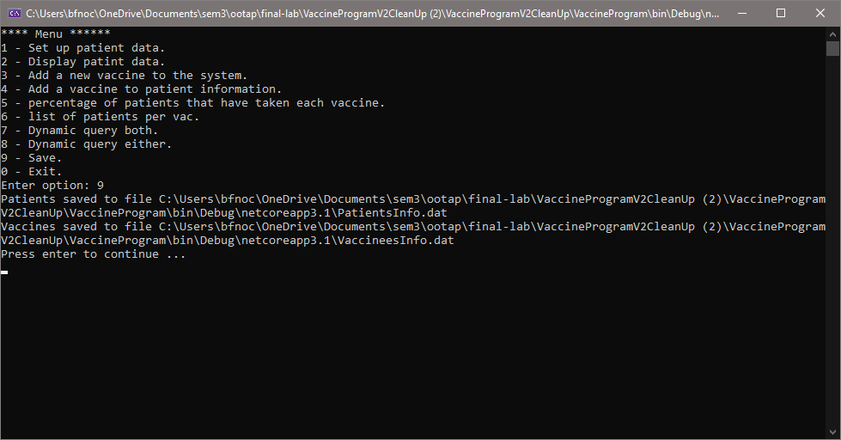

**File info on next page.**

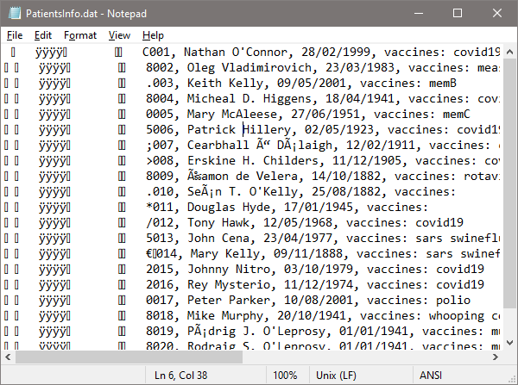

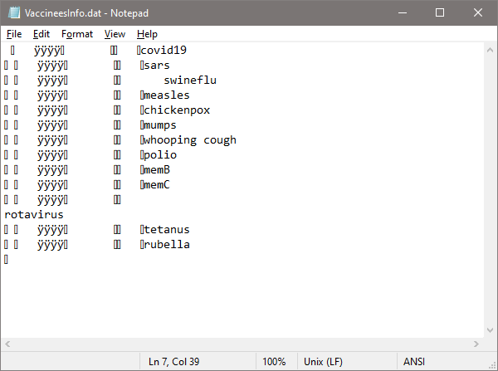

## Exit

**Expected output**

Program will terminate.

**Actual output**

