Lab 3 – Patient Vaccine System

Nathan O’Connor

OOTAP

Software Development Year 2

K00252751

# Sample data used for testing

**Patients**

|  |  |  |  |
| --- | --- | --- | --- |
| **Number** | **Name** | **DOB** | **Vaccines taken** |
| 1 | Nathan O'Connor | 28/02/1999 | Covid19  Sars  swineflu |
| 2 | Oleg Vladimirovich | 23/03/1983 | measles |
| 3 | Keith Kelly | 09/05/2001 | memB |
| 4 | Micheal D. Higgens | 18/04/1941 | Covid19 |
| 5 | Mary McAleese | 27/06/1951 | memC |
| 6 | Patrick Hillery | 02/05/1923 | Covid19 |
| 7 | Cearbhall Ó Dálaigh | 12/02/1911 | Covid19 |
| 8 | Erskine H. Childers | 11/12/1905 | Covid19  sars |
| 9 | Éamon de Velera | 14/10/1882 | rotavirus |
| 10 | Seán T. O'Kelly | 25/08/1882 | --- |
| 11 | Douglas Hyde | 17/01/1945 | --- |
| 12 | Tony Hawk | 12/05/1968 | Covid19 |
| 13 | John Cena | 23/04/1977 | Sars  Swine fu |
| 14 | Mary Kelly | 09/11/1888 | Sars  Swine flue  Mumps  Chickenpox  Whooping cough  Measles  Memb  Memc  Covid19  Polio  rotavirus |
| 15 | Johnny Nitro | 03/10/1979 | Covid19 |
| 16 | Rey Mysterio | 11/12/1974 | Covid19 |
| 17 | Peter Parker | 10/08/2001 | Polio |
| 18 | Mike Murphy | 20/10/1941 | Whooping cough |
| 19 | Pádrig J. O'Leprosy | 01/01/1941 | Mumps |
| 20 | Rodraig S. O'Leprosy | 01/01/1941 | Mumps |

**Vacines**

|  |  |
| --- | --- |
| **Name** | **System frequency** |
| Covid19 | 9 |
| Sars | 4 |
| Swineflu | 2 |
| measles | 2 |
| Chickenpox | 1 |
| Mumps | 3 |
| Whooping cough | 2 |
| Polio | 2 |
| Memb | 2 |
| memc | 2 |
| Rotavirus | 2 |
| Tetanus | 0 |

# Sample data used for testing

**1 – Set up data**

Expected output

Initialise system with sample data for patients and vaccines.

Actual output

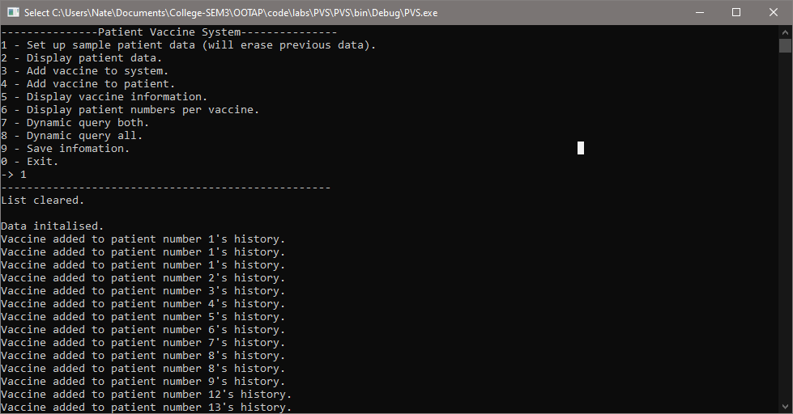

**2 – Display patient data**

Expected output

List all patient information on the console.

Actual output

Output worked as expected, below is a sample of the output.

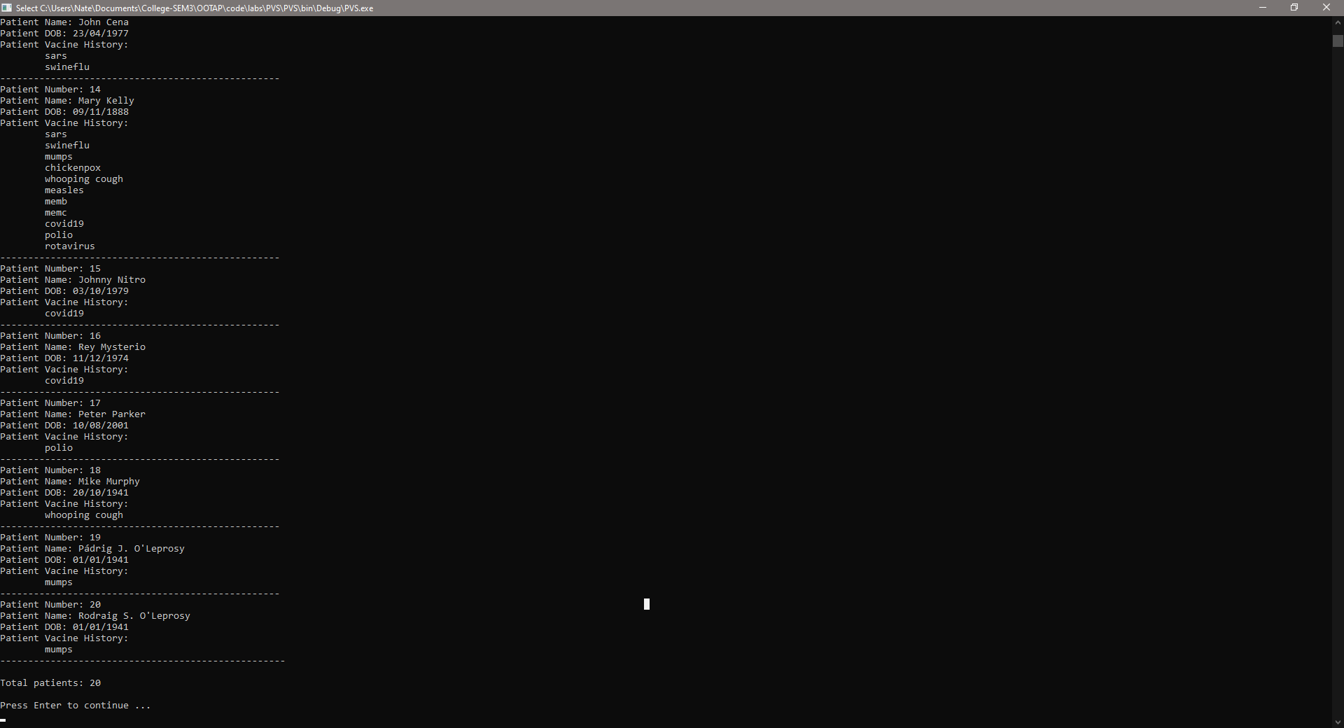

**3 – Add new vaccine to the system**

Expected output

Input “rubella”, the new vaccine is then saved onto the system.

Actual output

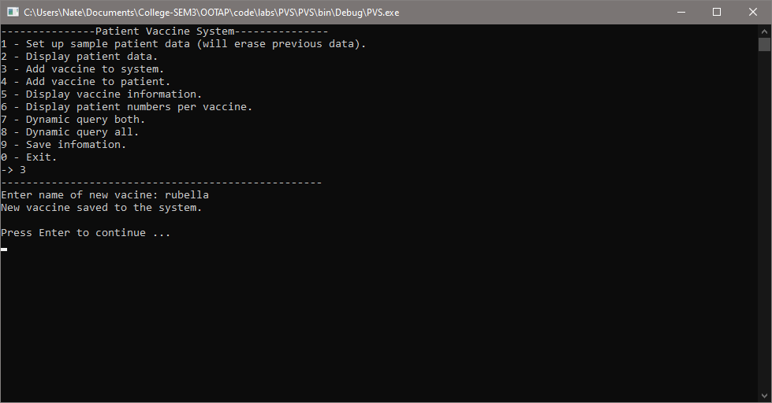

**4 – Add new vaccine to patient**

Expected output

Input vaccine “rubella” and input patient number 1. Vaccine “rubella” is added to patient 1’s history.

Actual output

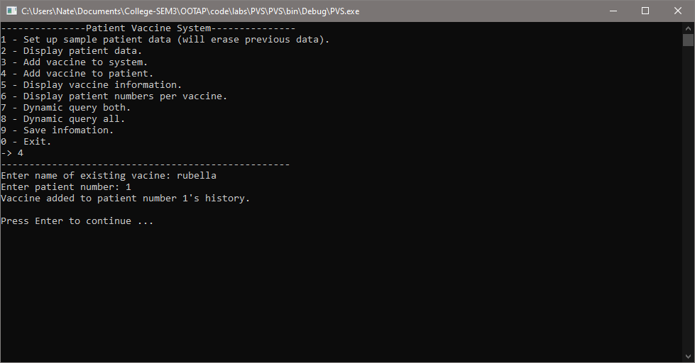

**5 – Vaccine frequency**

Expected output

Display each vaccine in the system followed by its use frequency.

* Note: rubella is not part of the test data as it was added during runtime.

|  |  |
| --- | --- |
| Covid19 | 9 |
| Sars | 4 |
| Swineflu | 2 |
| measles | 2 |
| Chickenpox | 1 |
| Mumps | 3 |
| Whooping cough | 2 |
| Polio | 2 |
| Memb | 2 |
| memc | 2 |
| Rotavirus | 2 |
| Tetanus | 0 |

Actual output

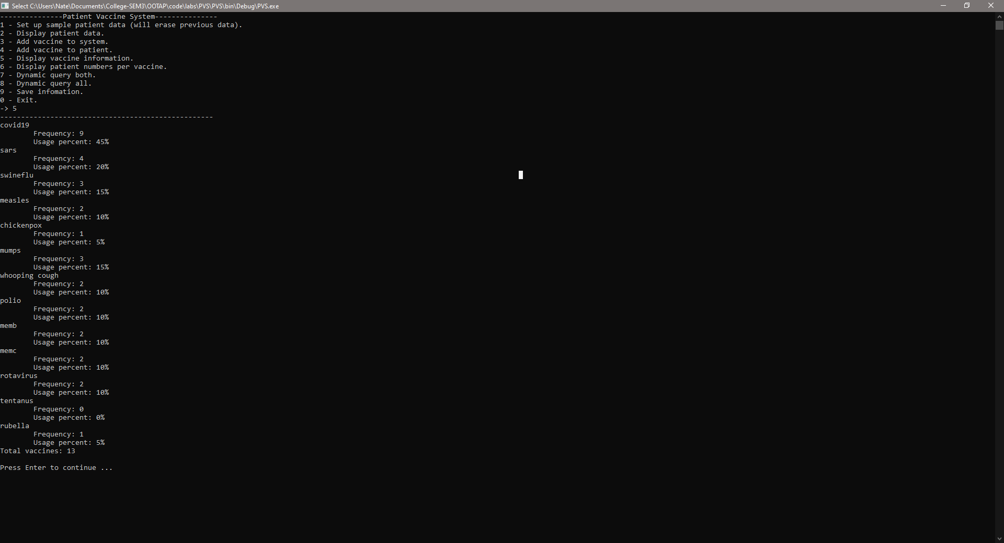

**6 – Display each patient number associated with each vaccine**

* Note: rubella is not part of the test data as it was added during runtime.

Expected output

|  |  |
| --- | --- |
| Covid19 | 1,  4,  6,  7,  8,  12,  14,  15,  16 |
| Sars | 1,  8,  13,  14 |
| Swineflu | 1,  13,  14 |
| Measles | 2,  14 |
| Chickenpox | 14 |
| Mumps | 14,  19,  20 |
| Whooping cough | 14,  18 |
| Polio | 14,  17 |
| Memb | 3,  14 |
| Memc | 5,  14 |
| Rotavirus | 9,  14 |

Output on next page …

Actual output

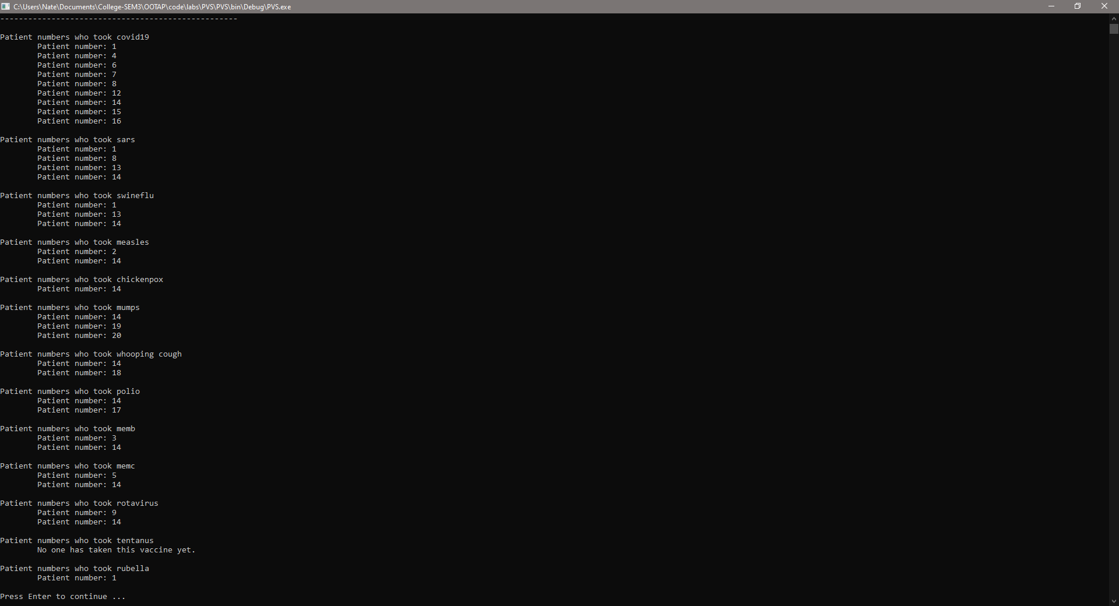

**7 – Dynamic query both**

Expected output

Input “covid19” and “sars” and the system should return patient numbers 1, 8 and 14.

Actual output

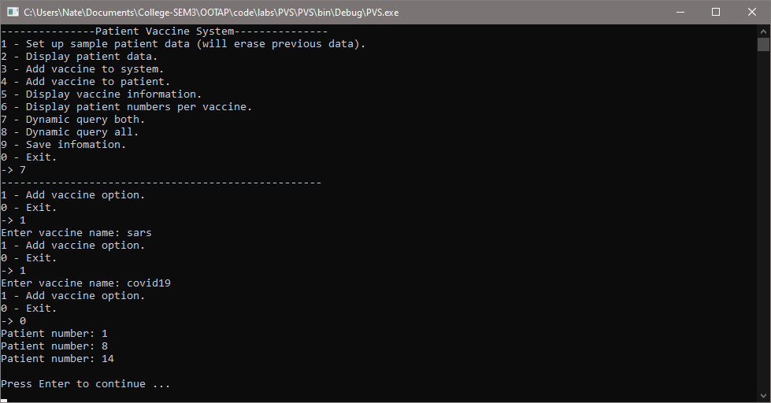

**8 – Dynamic query either**

Expected output

Input “covid19” and “sars” and the system should return patient numbers 1, 4, 6, 7, 8, 12, 13, 14, 15 and 16.

Actual output

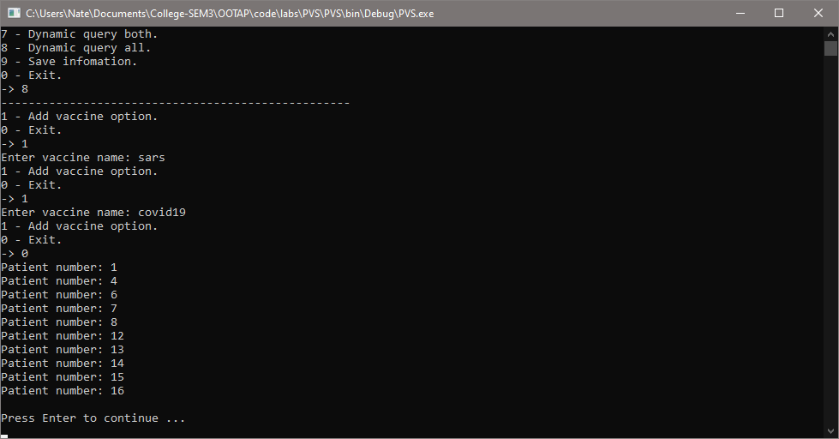

**9 – Save information to file**

* Note: data used is the same as the sample data from page 1 and 2.

Expected output

Save all objects in the system to a text file (one for patients and one for vaccines).

Actual output

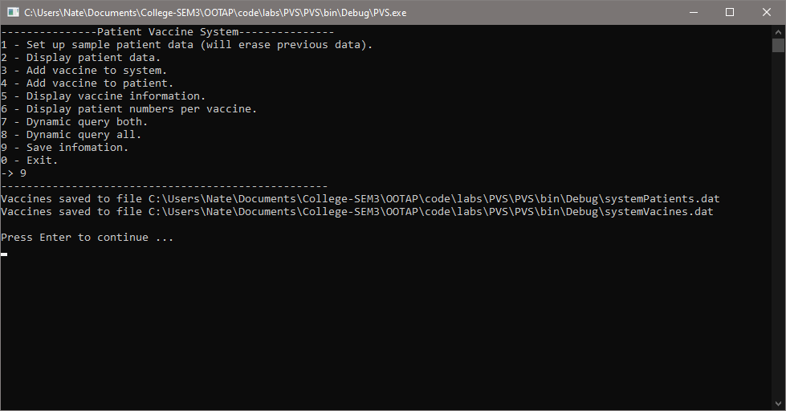

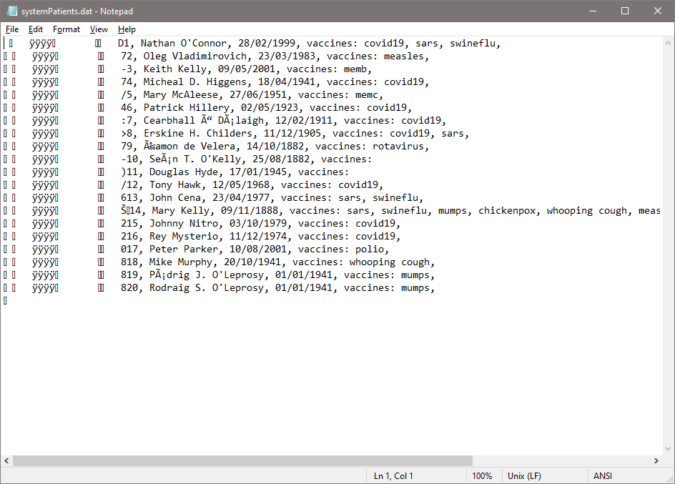

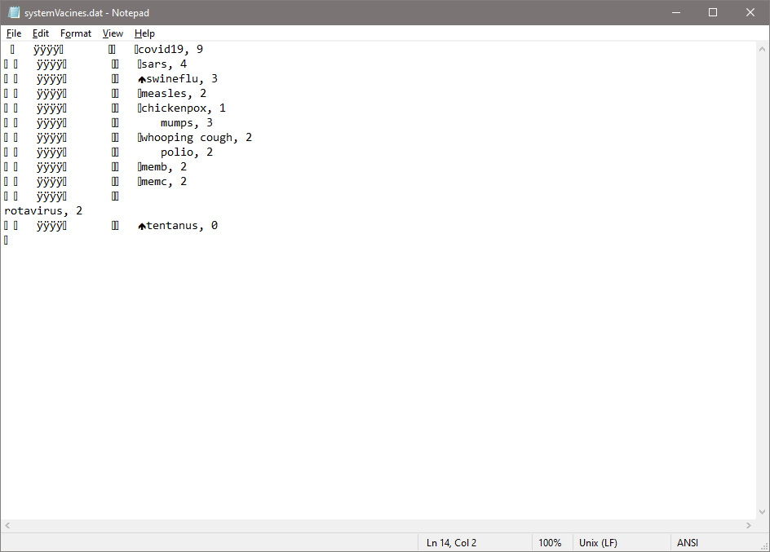

**0 – Exit**

Expected output

Program will terminate.

Actual output

