# Description

The Tachometer project is a MCU that measures the RPM of a spinning propeller and logs data to a connected Host.

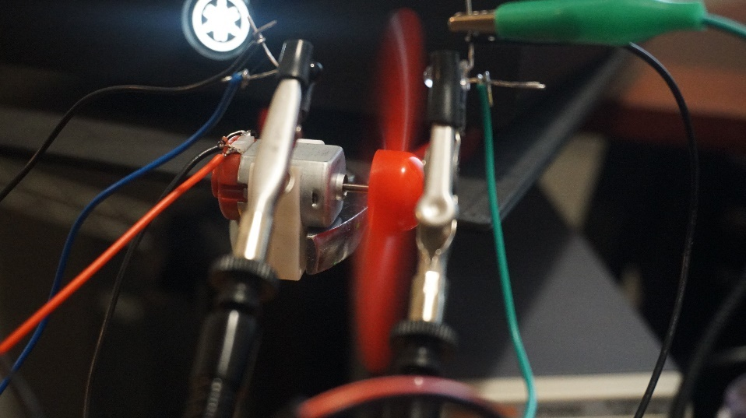

Figure – Tachometer

# Requirements

The following requirements describes the functionality set forth by the Tachometer project:

* The MCU shall read the RPM of a driven propeller using an IR transmitter and receiver pair.
* The MCU shall transmit the RPM data to the Host via Serial.
* The MCU may drive propeller motor.
* The MCU may drive an LCD to display live data.
* The MCU shall implement a Round Robin scheduling algorithm with Interrupts.

# Design

The following sections describes the hardware, software, and configuration design decisions for the Tachometer project.

## Hardware

The Arduino UNO was used as the MCU for this project. In addition, the following materials were used:

* 1x IR LED Emitter
* 1x IR Phototransistor
* 1x DC Motor
* 1x Arduino LCD Keypad Shield
* 1x 10 kOhm Resistor
* 1x 220 Ohm Resistor
* 1x 100 Ohm Resistor
* 1x 1N4148 Diode
* 1x BC337 NPN Transistor
* 1x 5v Power Supply
* Various Wire Cables

The following diagram describes the project circuitry. Note that the +5V rail that the motor connects to MUST NOT be from the 5V output of the Arduino and must supplied by an external source. The motor may draw up to 1 Amp of current which may overload the Arduino/Host USB circuity.

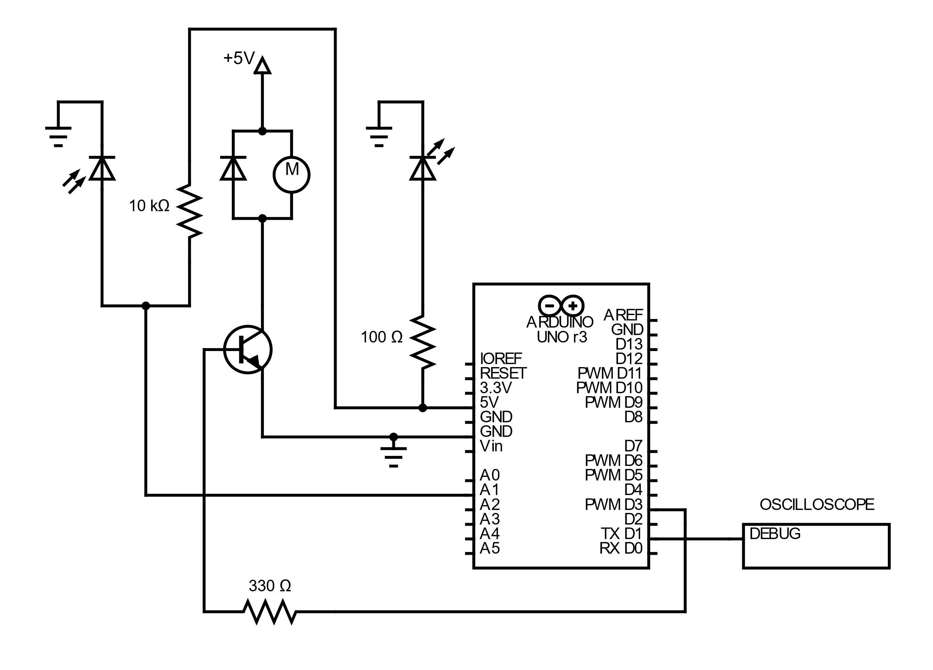

Figure – Schematic

It is highly recommended that the resistors, the transistor, and flyback diode are populated in a PCB board. The IR receiver and transistors will need to be mounted securely as depicted in . Some adjustments may be needed to align the IR pair. An oscilloscope or a multimeter can be used to calibrate IR position. A good position would be indicated by a voltage drop between the 10 kOhm resistor and the IR receiver. It is necessary that the propeller blades intersect with the IR light path during operation.

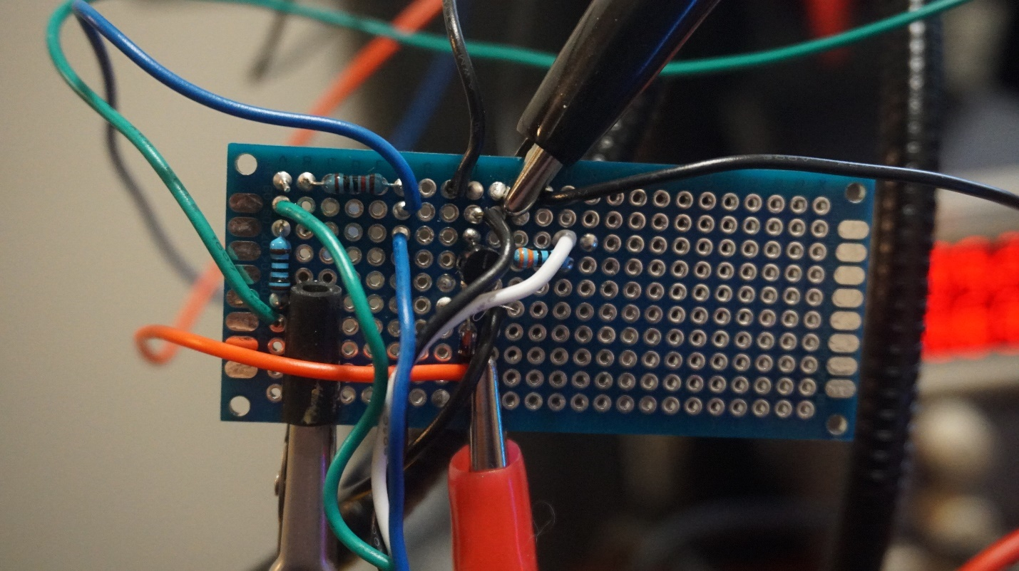

Figure – PCB Surrogate Board

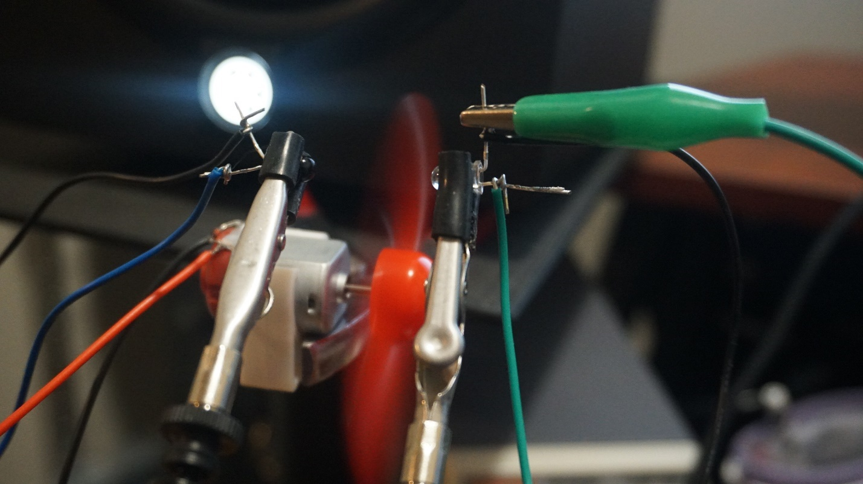

Figure – IR Pair Mount

## Software

The software language for the Arduino UNO is C++ using the built in Arduino libraries. In addition, the following library(ies) where used:

* LiquidCrystal (Optional: for driving the LCD: <https://www.arduino.cc/reference/en/libraries/liquidcrystal/>)

There are three sections of the software: the Main Driver and Interval ISR. The following sections describes each section.

### Main Driver

The Main Driver contains the setup for the LCD, Motor and Tachometer Sensor. Various variables are set to initial values.

During the loop phase, the main driver ramps up the motor via PWM control. The ramp up sequence starts the motor, ramps up to the max duty cycle then decreases. This is continued in a cycle and the rate of acceleration is determined with the RAMP_DELAY variable. At every increase of motor power, the MCU calculates the RPM by the following operations:

1. Assign current_phase the value of measured_phase between an interrupt enable/disable.
2. Multiply current_phase by the number of propeller blades and delay time of the timer ISR (150 microseconds)
3. Divide 60,000,000 (the number of microseconds in a minute) by the current_phase. This yields the RPM.

After calculating the RPM, the MCU logs out the current time in milliseconds, the applied speed, and the measured RPM.

If the lcd_flag is set true, the LCD is updated the current information and the lcd_flag is set false.

### Interval ISR

The Interval ISR software contains the operations to setup a timer hardware interrupt and operations during an interrupt.

The configuration of setting up a timer interrupt is based off the example implementation from <https://www.instructables.com/Arduino-Timer-Interrupts/> . The OCR1A hardware register at a 8kHz frequency from the hardware clock. Other register operations are performed to ensure that the timer interrupt is enabled.

The ISR() interrupt vector points to the OCR1A triggered interrupt via TIMER1_COMPA_vect event. The following operations occur:

1. If a blade is detected, the measured_phase is assigned the frame counter.
2. Otherwise, if a blade is not detected the frame counter increments.
3. The LCD_DELAY time has elapsed, the lcd_flag is set true to update the LCD in the Main thread.

# Implementation

The source code of the Tachometer project is as follows:

## p2_tachometer.ino

/*

  Tachometer

  Author: Nate Lao (nlao1@jh.edu)

  Designed for Arduino UNO

*/

#include <LiquidCrystal.h>

#include "isr_timer.hpp"

// Debug Pin

const uint8_t PIN_DEBUG = 1; // Optional debugger pin. Indicates blade detection

// LCD Variables

const int pin_RS = 8;

const int pin_EN = 9;

const int pin_d4 = 4;

const int pin_d5 = 5;

const int pin_d6 = 6;

const int pin_d7 = 7;

const int pin_BL = 10;

const unsigned long LCD_DELAY = 1000;   // LCD Delay Time in milliseconds

const unsigned long DELAY_FACTOR = 8;   // Do not modify, LCD_DELAY multiplier

volatile unsigned long lcd_time;        // Tracks the update LCD frame

volatile bool lcd_flag;                 // Indicates LCD update

LiquidCrystal *lcd = 0;

// Motor Variables

const uint8_t PIN_MOTOR = 3;            // Motor Pin

const unsigned int RAMP_DELAY = 200;    // Ramp Speed delay in Milliseconds

const unsigned char MIN_SPEED = 50;     // Minimal Speed (duty cycle)

const unsigned char MAX_SPEED = 0xFF;   // Maximum Speed (duty cycle)

unsigned char speed;                    // Current Speed

bool ramp_up;                           // Ramp Up flag

unsigned int time;                  // Current Time in Milliseconds

// Tachometer Variables

const uint8_t PIN_IR = A1;                            // IR Phototransitor Pin

const int IR_THRESHOLD = 650;                         // Threshold: Blade Detected=Above Threshold, Otherwise=Below Threshold

const unsigned long PROP_BLADES = 3;                  // Number of Propeller Blades

const unsigned long FRAME_USEC = 125;                 // Frame delay for 8kHz Interrupt

const unsigned long RPM_FACTOR_USEC = (60 * 1000000); // Minutes * Microseconds

volatile unsigned long frames;                        // Tachometer frame counter

volatile unsigned long measured_phase;                // Delta between two rising frames

unsigned long current_phase;                          // Current Phase Measurement

unsigned long rpm;                                    // Revolutions per minute

void setup()

{

    // Setup Interrupt Timer

    cli();

    TIMER::setISRTimer_1kH();

    sei();

    // Setup Debug Pin

    pinMode(PIN_DEBUG, OUTPUT);

    // Setup Motor PWM Pin

    pinMode(PIN_MOTOR, OUTPUT);

    // Setup Serial

    Serial.begin(9600);

    Serial.println("time,speed,rpm");

    // Setup LCD

    lcd = new LiquidCrystal(pin_RS, pin_EN, pin_d4, pin_d5, pin_d6, pin_d7);

    lcd->begin(16, 2); // 16 col, 2 rows

    lcd->setCursor(0, 0);

    lcd->print("SPEED");

    lcd->setCursor(8, 0);

    lcd->print("RPM");

    // Setup LCD variables

    lcd_time = 0;

    lcd_flag = false;

    // Setup Motor to Ramp Up

    ramp_up = true;

    speed = MIN_SPEED;

    time = 0;

    // Setup tachometer variables

    frames = 0;

    measured_phase = 0;

    current_phase = 0;

    rpm = 0;

}

ISR(TIMER1_COMPA_vect)

{

    // Blade is detected

    if (analogRead(PIN_IR) > IR_THRESHOLD)

    {

        // Record the number of frames detected since last reset

        if (frames > 0)

            measured_phase = frames;

        // Reset frames

        frames = 0;

        // Set debug pin high for detection

        digitalWrite(PIN_DEBUG, HIGH);

    }

    else

    {

        // Increment frames between blades

        frames++;

        // Set debug pin low for off frames

        digitalWrite(PIN_DEBUG, LOW);

    }

    // Issue LCD update

    if (lcd_time == LCD_DELAY * DELAY_FACTOR)

    {

        lcd_flag = true;

        lcd_time = 0;

    }

    lcd_time++;

}

void loop()

{

    // Determine ramp phase if at limits

    if (speed == MIN_SPEED)

        ramp_up = true;

    if (speed == MAX_SPEED)

        ramp_up = false;

    // Apply acceleration

    if (ramp_up) speed++;

    else speed--;

    // Set duty cycle to control speed

    analogWrite(PIN_MOTOR, speed);

    // Poll the measured phase delta

    cli();

    current_phase = measured_phase;

    sei();

    // Calculate RPM

    current_phase = (current_phase * PROP_BLADES) * FRAME_USEC;

    rpm = RPM_FACTOR_USEC / current_phase;

    // Log out to host

    Serial.print(time);

    Serial.print(",");

    Serial.print(speed);

    Serial.print(",");

    Serial.println(rpm);

    // Display RPM at 1 second intervals

    if (lcd_flag)

    {

        // Display LCD

        lcd->setCursor(0, 1);

        lcd->print(speed);

        lcd->print("    ");

        lcd->setCursor(8, 1);

        lcd->print(rpm);

        lcd->print("    ");

        lcd_flag = false;

    }

    // Ramp Delay

    delay(RAMP_DELAY);

    time += RAMP_DELAY;

}

## isr_timer.hpp

/*

  Tachometer

  Author: Nate Lao (nlao1@jh.edu)

  Designed for Arduino UNO

*/

#ifndef __TIMER_HPP__

#define __TIMER_HPP__

#include <Arduino.h>

namespace TIMER

{

    void setISRTimer(const unsigned long hertz);

    void setISRTimer_1kH();

}

#endif

## isr_timer.cpp

/*

  Tachometer

  Author: Nate Lao (nlao1@jh.edu)

  Designed for Arduino UNO

  Based on implementation from https://www.instructables.com/Arduino-Timer-Interrupts/

*/

#include "isr_timer.hpp"

void TIMER::setISRTimer(const unsigned long hertz)

{

    // Enables the TIMER1_COMPA_vect Interrupt Service Routine

    // The base value of the OCR1A timer compare register

    // for 1 Hz. To increase rate divide by the desired

    // frequency (input:hertz).

    const unsigned long TIMER_COMPARE_REGISTER_1HZ = 15624;

    TCCR1A = 0; // set entire TCCR1A register to 0

    TCCR1B = 0; // same for TCCR1B

    TCNT1 = 0;  // initialize counter value to 0

    // set compare match register for x hz increments

    OCR1A = TIMER_COMPARE_REGISTER_1HZ / hertz;

    // turn on CTC mode

    TCCR1B |= (1 << WGM12);

    // Set CS10 and CS12 bits for 1024 prescaler

    TCCR1B |= (1 << CS12) | (1 << CS10);

    // enable timer compare interrupt

    TIMSK1 |= (1 << OCIE1A);

}

void TIMER::setISRTimer_1kH()

{

//set timer2 interrupt at 8kHz = 0.125us

  TCCR1A = 0;// set entire TCCR2A register to 0

  TCCR1B = 0;// same for TCCR2B

  TCNT1  = 0;//initialize counter value to 0

  // set compare match register for 8khz increments

  OCR1A = 249;// = (16*10^6) / (8000*8) - 1 (must be <256)

  // turn on CTC mode

  TCCR1B |= (1 << WGM12);

  // Set CS21 bit for 8 prescaler

  TCCR1B |= (1 << CS21);

  // enable timer compare interrupt

  TIMSK1 |= (1 << OCIE1A);

}

# Usage

The following instructions describes the steps to use the Tachometer project:

1. Implement the circuit as described in Section 3.1.
2. Connect the Arduino UNO to a Host computer with a Serial interface program installed.
3. Using an Arduino IDE, load the Tachometer software to the Arduino UNO.
4. Using a Serial interface program, such as PuTTY.
   1. Ensure that logging to a file is enabled prior to starting the connection. It is recommended that the output file is saved to a .csv.
   2. Open a serial port to the UNO with baud rate of 9600.
5. After the desired amount of time, the serial output file defined in Step 4.a will contain the recorded RPM measurements. This can be used for post processing analysis.
   1. Note: Depending on your host and serial application you use/settings, you may need to “clean up” csv file.
6. To exit the program, simply disconnect the UNO from any power supplies.

# Results

The following graph shows the change of applied speed and RPM over time. The raw data may be found in the Appendix.

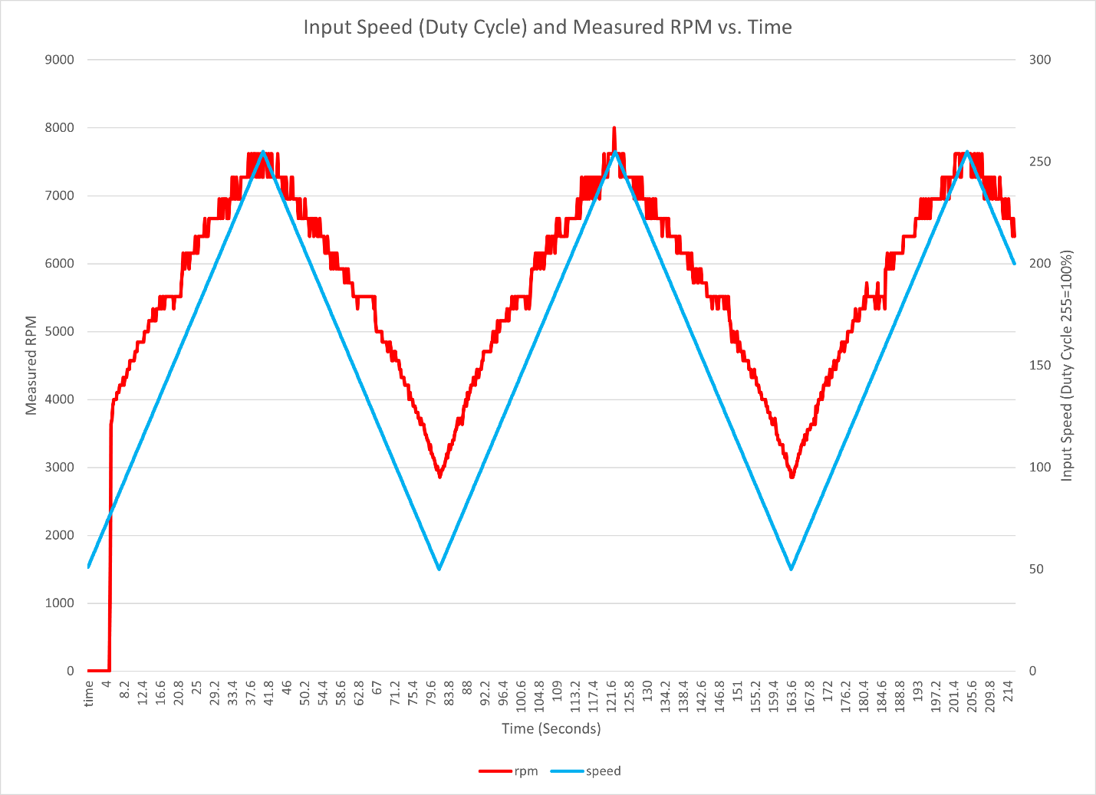

# DEMO

A demonstration of the Tachometer project can be found here:

<https://youtu.be/_2AzHBInPC0>

# Appendix

|  |  |  |
| --- | --- | --- |
| time | speed | rpm |
| 0 | 51 | 0 |
| 0.2 | 52 | 0 |
| 0.4 | 53 | 0 |
| 0.6 | 54 | 0 |
| 0.8 | 55 | 0 |
| 1 | 56 | 0 |
| 1.2 | 57 | 0 |
| 1.4 | 58 | 0 |
| 1.6 | 59 | 0 |
| 1.8 | 60 | 0 |
| 2 | 61 | 0 |
| 2.2 | 62 | 0 |
| 2.4 | 63 | 0 |
| 2.6 | 64 | 0 |
| 2.8 | 65 | 0 |
| 3 | 66 | 0 |
| 3.2 | 67 | 0 |
| 3.4 | 68 | 0 |
| 3.6 | 69 | 0 |
| 3.8 | 70 | 0 |
| 4 | 71 | 0 |
| 4.2 | 72 | 0 |
| 4.4 | 73 | 0 |
| 4.6 | 74 | 0 |
| 4.8 | 75 | 0 |
| 5 | 76 | 0 |
| 5.2 | 77 | 1632 |
| 5.4 | 78 | 3636 |
| 5.6 | 79 | 3720 |
| 5.8 | 80 | 3902 |
| 6 | 81 | 4000 |
| 6.2 | 82 | 4000 |
| 6.4 | 83 | 4000 |
| 6.6 | 84 | 4000 |
| 6.8 | 85 | 4102 |
| 7 | 86 | 4102 |
| 7.2 | 87 | 4102 |
| 7.4 | 88 | 4210 |
| 7.6 | 89 | 4210 |
| 7.8 | 90 | 4210 |
| 8 | 91 | 4210 |
| 8.2 | 92 | 4324 |
| 8.4 | 93 | 4210 |
| 8.6 | 94 | 4324 |
| 8.8 | 95 | 4324 |
| 9 | 96 | 4324 |
| 9.2 | 97 | 4444 |
| 9.4 | 98 | 4444 |
| 9.6 | 99 | 4444 |
| 9.8 | 100 | 4571 |
| 10 | 101 | 4571 |
| 10.2 | 102 | 4571 |
| 10.4 | 103 | 4571 |
| 10.6 | 104 | 4571 |
| 10.8 | 105 | 4571 |
| 11 | 106 | 4705 |
| 11.2 | 107 | 4705 |
| 11.4 | 108 | 4705 |
| 11.6 | 109 | 4848 |
| 11.8 | 110 | 4848 |
| 12 | 111 | 4848 |
| 12.2 | 112 | 4848 |
| 12.4 | 113 | 4848 |
| 12.6 | 114 | 4848 |
| 12.8 | 115 | 4848 |
| 13 | 116 | 4848 |
| 13.2 | 117 | 5000 |
| 13.4 | 118 | 5000 |
| 13.6 | 119 | 5000 |
| 13.8 | 120 | 5000 |
| 14 | 121 | 5000 |
| 14.2 | 122 | 5161 |
| 14.4 | 123 | 5161 |
| 14.6 | 124 | 5161 |
| 14.8 | 125 | 5161 |
| 15 | 126 | 5161 |
| 15.2 | 127 | 5333 |
| 15.4 | 128 | 5161 |
| 15.6 | 129 | 5161 |
| 15.8 | 130 | 5161 |
| 16 | 131 | 5333 |
| 16.2 | 132 | 5333 |
| 16.4 | 133 | 5333 |
| 16.6 | 134 | 5333 |
| 16.8 | 135 | 5517 |
| 17 | 136 | 5333 |
| 17.2 | 137 | 5333 |
| 17.4 | 138 | 5517 |
| 17.6 | 139 | 5517 |
| 17.8 | 140 | 5333 |
| 18 | 141 | 5517 |
| 18.2 | 142 | 5517 |
| 18.4 | 143 | 5517 |
| 18.6 | 144 | 5517 |
| 18.8 | 145 | 5517 |
| 19 | 146 | 5517 |
| 19.2 | 147 | 5517 |
| 19.4 | 148 | 5517 |
| 19.6 | 149 | 5517 |
| 19.8 | 150 | 5517 |
| 20 | 151 | 5333 |
| 20.2 | 152 | 5517 |
| 20.4 | 153 | 5517 |
| 20.6 | 154 | 5517 |
| 20.8 | 155 | 5517 |
| 21 | 156 | 5517 |
| 21.2 | 157 | 5517 |
| 21.4 | 158 | 5517 |
| 21.6 | 159 | 5517 |
| 21.8 | 160 | 5714 |
| 22 | 161 | 5925 |
| 22.2 | 162 | 6153 |
| 22.4 | 163 | 5925 |
| 22.6 | 164 | 5925 |
| 22.8 | 165 | 6153 |
| 23 | 166 | 6153 |
| 23.2 | 167 | 6153 |
| 23.4 | 168 | 6153 |
| 23.6 | 169 | 5925 |
| 23.8 | 170 | 6153 |
| 24 | 171 | 6153 |
| 24.2 | 172 | 6153 |
| 24.4 | 173 | 6153 |
| 24.6 | 174 | 6153 |
| 24.8 | 175 | 6153 |
| 25 | 176 | 6400 |
| 25.2 | 177 | 6153 |
| 25.4 | 178 | 6153 |
| 25.6 | 179 | 6153 |
| 25.8 | 180 | 6400 |
| 26 | 181 | 6400 |
| 26.2 | 182 | 6400 |
| 26.4 | 183 | 6400 |
| 26.6 | 184 | 6400 |
| 26.8 | 185 | 6400 |
| 27 | 186 | 6400 |
| 27.2 | 187 | 6666 |
| 27.4 | 188 | 6400 |
| 27.6 | 189 | 6400 |
| 27.8 | 190 | 6400 |
| 28 | 191 | 6400 |
| 28.2 | 192 | 6666 |
| 28.4 | 193 | 6666 |
| 28.6 | 194 | 6666 |
| 28.8 | 195 | 6666 |
| 29 | 196 | 6666 |
| 29.2 | 197 | 6666 |
| 29.4 | 198 | 6666 |
| 29.6 | 199 | 6666 |
| 29.8 | 200 | 6666 |
| 30 | 201 | 6666 |
| 30.2 | 202 | 6666 |
| 30.4 | 203 | 6666 |
| 30.6 | 204 | 6956 |
| 30.8 | 205 | 6666 |
| 31 | 206 | 6666 |
| 31.2 | 207 | 6956 |
| 31.4 | 208 | 6666 |
| 31.6 | 209 | 6956 |
| 31.8 | 210 | 6956 |
| 32 | 211 | 6956 |
| 32.2 | 212 | 6956 |
| 32.4 | 213 | 6666 |
| 32.6 | 214 | 6666 |
| 32.8 | 215 | 6666 |
| 33 | 216 | 6956 |
| 33.2 | 217 | 6956 |
| 33.4 | 218 | 6956 |
| 33.6 | 219 | 7272 |
| 33.8 | 220 | 6956 |
| 34 | 221 | 7272 |
| 34.2 | 222 | 6956 |
| 34.4 | 223 | 6956 |
| 34.6 | 224 | 7272 |
| 34.8 | 225 | 6956 |
| 35 | 226 | 6956 |
| 35.2 | 227 | 6956 |
| 35.4 | 228 | 6956 |
| 35.6 | 229 | 7272 |
| 35.8 | 230 | 7272 |
| 36 | 231 | 7272 |
| 36.2 | 232 | 7272 |
| 36.4 | 233 | 7272 |
| 36.6 | 234 | 7272 |
| 36.8 | 235 | 7272 |
| 37 | 236 | 7272 |
| 37.2 | 237 | 7272 |
| 37.4 | 238 | 7619 |
| 37.6 | 239 | 7272 |
| 37.8 | 240 | 7272 |
| 38 | 241 | 7619 |
| 38.2 | 242 | 7619 |
| 38.4 | 243 | 7272 |
| 38.6 | 244 | 7619 |
| 38.8 | 245 | 7619 |
| 39 | 246 | 7619 |
| 39.2 | 247 | 7272 |
| 39.4 | 248 | 7619 |
| 39.6 | 249 | 7272 |
| 39.8 | 250 | 7619 |
| 40 | 251 | 7272 |
| 40.2 | 252 | 7619 |
| 40.4 | 253 | 7619 |
| 40.6 | 254 | 7272 |
| 40.8 | 255 | 7272 |
| 41 | 254 | 7619 |
| 41.2 | 253 | 7619 |
| 41.4 | 252 | 7619 |
| 41.6 | 251 | 7619 |
| 41.8 | 250 | 7272 |
| 42 | 249 | 7619 |
| 42.2 | 248 | 7619 |
| 42.4 | 247 | 7272 |
| 42.6 | 246 | 7619 |
| 42.8 | 245 | 7619 |
| 43 | 244 | 7272 |
| 43.2 | 243 | 7272 |
| 43.4 | 242 | 7272 |
| 43.6 | 241 | 7272 |
| 43.8 | 240 | 7272 |
| 44 | 239 | 7272 |
| 44.2 | 238 | 7619 |
| 44.4 | 237 | 7272 |
| 44.6 | 236 | 7272 |
| 44.8 | 235 | 7272 |
| 45 | 234 | 7272 |
| 45.2 | 233 | 7272 |
| 45.4 | 232 | 6956 |
| 45.6 | 231 | 7272 |
| 45.8 | 230 | 6956 |
| 46 | 229 | 7272 |
| 46.2 | 228 | 7272 |
| 46.4 | 227 | 6956 |
| 46.6 | 226 | 6956 |
| 46.8 | 225 | 6956 |
| 47 | 224 | 6956 |
| 47.2 | 223 | 6956 |
| 47.4 | 222 | 7272 |
| 47.6 | 221 | 7272 |
| 47.8 | 220 | 6956 |
| 48 | 219 | 6956 |
| 48.2 | 218 | 6956 |
| 48.4 | 217 | 6956 |
| 48.6 | 216 | 6956 |
| 48.8 | 215 | 6956 |
| 49 | 214 | 6666 |
| 49.2 | 213 | 6956 |
| 49.4 | 212 | 6956 |
| 49.6 | 211 | 6666 |
| 49.8 | 210 | 6666 |
| 50 | 209 | 6666 |
| 50.2 | 208 | 6666 |
| 50.4 | 207 | 6666 |
| 50.6 | 206 | 6956 |
| 50.8 | 205 | 6666 |
| 51 | 204 | 6666 |
| 51.2 | 203 | 6666 |
| 51.4 | 202 | 6666 |
| 51.6 | 201 | 6400 |
| 51.8 | 200 | 6666 |
| 52 | 199 | 6666 |
| 52.2 | 198 | 6666 |
| 52.4 | 197 | 6666 |
| 52.6 | 196 | 6400 |
| 52.8 | 195 | 6666 |
| 53 | 194 | 6666 |
| 53.2 | 193 | 6666 |
| 53.4 | 192 | 6400 |
| 53.6 | 191 | 6400 |
| 53.8 | 190 | 6400 |
| 54 | 189 | 6666 |
| 54.2 | 188 | 6400 |
| 54.4 | 187 | 6400 |
| 54.6 | 186 | 6400 |
| 54.8 | 185 | 6400 |
| 55 | 184 | 6400 |
| 55.2 | 183 | 6153 |
| 55.4 | 182 | 6153 |
| 55.6 | 181 | 6153 |
| 55.8 | 180 | 6400 |
| 56 | 179 | 6153 |
| 56.2 | 178 | 6153 |
| 56.4 | 177 | 6153 |
| 56.6 | 176 | 5925 |
| 56.8 | 175 | 6153 |
| 57 | 174 | 6153 |
| 57.2 | 173 | 5925 |
| 57.4 | 172 | 6153 |
| 57.6 | 171 | 6153 |
| 57.8 | 170 | 5925 |
| 58 | 169 | 6153 |
| 58.2 | 168 | 5925 |
| 58.4 | 167 | 5925 |
| 58.6 | 166 | 5925 |
| 58.8 | 165 | 5925 |
| 59 | 164 | 5925 |
| 59.2 | 163 | 5925 |
| 59.4 | 162 | 5925 |
| 59.6 | 161 | 5925 |
| 59.8 | 160 | 5714 |
| 60 | 159 | 5925 |
| 60.2 | 158 | 5925 |
| 60.4 | 157 | 5714 |
| 60.6 | 156 | 5925 |
| 60.8 | 155 | 5714 |
| 61 | 154 | 5714 |
| 61.2 | 153 | 5714 |
| 61.4 | 152 | 5714 |
| 61.6 | 151 | 5714 |
| 61.8 | 150 | 5517 |
| 62 | 149 | 5517 |
| 62.2 | 148 | 5517 |
| 62.4 | 147 | 5517 |
| 62.6 | 146 | 5517 |
| 62.8 | 145 | 5333 |
| 63 | 144 | 5517 |
| 63.2 | 143 | 5517 |
| 63.4 | 142 | 5517 |
| 63.6 | 141 | 5517 |
| 63.8 | 140 | 5517 |
| 64 | 139 | 5517 |
| 64.2 | 138 | 5517 |
| 64.4 | 137 | 5517 |
| 64.6 | 136 | 5517 |
| 64.8 | 135 | 5517 |
| 65 | 134 | 5517 |
| 65.2 | 133 | 5517 |
| 65.4 | 132 | 5517 |
| 65.6 | 131 | 5517 |
| 65.8 | 130 | 5517 |
| 66 | 129 | 5517 |
| 66.2 | 128 | 5517 |
| 66.4 | 127 | 5517 |
| 66.6 | 126 | 5333 |
| 66.8 | 125 | 5517 |
| 67 | 124 | 5161 |
| 67.2 | 123 | 5000 |
| 67.4 | 122 | 5000 |
| 67.6 | 121 | 5000 |
| 67.8 | 120 | 5000 |
| 68 | 119 | 5000 |
| 68.2 | 118 | 5000 |
| 68.4 | 117 | 5000 |
| 68.6 | 116 | 4848 |
| 68.8 | 115 | 4848 |
| 69 | 114 | 4848 |
| 69.2 | 113 | 4848 |
| 69.4 | 112 | 4848 |
| 69.6 | 111 | 4848 |
| 69.8 | 110 | 4705 |
| 70 | 109 | 4705 |
| 70.2 | 108 | 4848 |
| 70.4 | 107 | 4848 |
| 70.6 | 106 | 4705 |
| 70.8 | 105 | 4571 |
| 71 | 104 | 4571 |
| 71.2 | 103 | 4705 |
| 71.4 | 102 | 4705 |
| 71.6 | 101 | 4705 |
| 71.8 | 100 | 4571 |
| 72 | 99 | 4571 |
| 72.2 | 98 | 4571 |
| 72.4 | 97 | 4571 |
| 72.6 | 96 | 4444 |
| 72.8 | 95 | 4444 |
| 73 | 94 | 4324 |
| 73.2 | 93 | 4324 |
| 73.4 | 92 | 4324 |
| 73.6 | 91 | 4324 |
| 73.8 | 90 | 4210 |
| 74 | 89 | 4210 |
| 74.2 | 88 | 4210 |
| 74.4 | 87 | 4210 |
| 74.6 | 86 | 4210 |
| 74.8 | 85 | 4000 |
| 75 | 84 | 4102 |
| 75.2 | 83 | 4000 |
| 75.4 | 82 | 4000 |
| 75.6 | 81 | 4000 |
| 75.8 | 80 | 3902 |
| 76 | 79 | 3902 |
| 76.2 | 78 | 3902 |
| 76.4 | 77 | 3809 |
| 76.6 | 76 | 3809 |
| 76.8 | 75 | 3809 |
| 77 | 74 | 3720 |
| 77.2 | 73 | 3720 |
| 77.4 | 72 | 3636 |
| 77.6 | 71 | 3720 |
| 77.8 | 70 | 3636 |
| 78 | 69 | 3636 |
| 78.2 | 68 | 3636 |
| 78.4 | 67 | 3555 |
| 78.6 | 66 | 3478 |
| 78.8 | 65 | 3478 |
| 79 | 64 | 3404 |
| 79.2 | 63 | 3404 |
| 79.4 | 62 | 3333 |
| 79.6 | 61 | 3265 |
| 79.8 | 60 | 3333 |
| 80 | 59 | 3200 |
| 80.2 | 58 | 3200 |
| 80.4 | 57 | 3137 |
| 80.6 | 56 | 3137 |
| 80.8 | 55 | 3076 |
| 81 | 54 | 3018 |
| 81.2 | 53 | 2962 |
| 81.4 | 52 | 3018 |
| 81.6 | 51 | 2962 |
| 81.8 | 50 | 2909 |
| 82 | 51 | 2857 |
| 82.2 | 52 | 2909 |
| 82.4 | 53 | 2962 |
| 82.6 | 54 | 2962 |
| 82.8 | 55 | 3018 |
| 83 | 56 | 3018 |
| 83.2 | 57 | 3076 |
| 83.4 | 58 | 3137 |
| 83.6 | 59 | 3200 |
| 83.8 | 60 | 3137 |
| 84 | 61 | 3265 |
| 84.2 | 62 | 3333 |
| 84.4 | 63 | 3265 |
| 84.6 | 64 | 3333 |
| 84.8 | 65 | 3333 |
| 85 | 66 | 3404 |
| 85.2 | 67 | 3404 |
| 85.4 | 68 | 3478 |
| 85.6 | 69 | 3555 |
| 85.8 | 70 | 3555 |
| 86 | 71 | 3636 |
| 86.2 | 72 | 3720 |
| 86.4 | 73 | 3636 |
| 86.6 | 74 | 3720 |
| 86.8 | 75 | 3720 |
| 87 | 76 | 3720 |
| 87.2 | 77 | 3636 |
| 87.4 | 78 | 3809 |
| 87.6 | 79 | 3902 |
| 87.8 | 80 | 3902 |
| 88 | 81 | 4000 |
| 88.2 | 82 | 3902 |
| 88.4 | 83 | 4102 |
| 88.6 | 84 | 4000 |
| 88.8 | 85 | 4102 |
| 89 | 86 | 4102 |
| 89.2 | 87 | 4210 |
| 89.4 | 88 | 4210 |
| 89.6 | 89 | 4210 |
| 89.8 | 90 | 4324 |
| 90 | 91 | 4324 |
| 90.2 | 92 | 4210 |
| 90.4 | 93 | 4324 |
| 90.6 | 94 | 4444 |
| 90.8 | 95 | 4324 |
| 91 | 96 | 4324 |
| 91.2 | 97 | 4444 |
| 91.4 | 98 | 4444 |
| 91.6 | 99 | 4444 |
| 91.8 | 100 | 4571 |
| 92 | 101 | 4571 |
| 92.2 | 102 | 4705 |
| 92.4 | 103 | 4705 |
| 92.6 | 104 | 4705 |
| 92.8 | 105 | 4705 |
| 93 | 106 | 4705 |
| 93.2 | 107 | 4705 |
| 93.4 | 108 | 4705 |
| 93.6 | 109 | 4705 |
| 93.8 | 110 | 4705 |
| 94 | 111 | 4848 |
| 94.2 | 112 | 4848 |
| 94.4 | 113 | 5000 |
| 94.6 | 114 | 4848 |
| 94.8 | 115 | 5000 |
| 95 | 116 | 4848 |
| 95.2 | 117 | 4848 |
| 95.4 | 118 | 5161 |
| 95.6 | 119 | 5000 |
| 95.8 | 120 | 5000 |
| 96 | 121 | 5161 |
| 96.2 | 122 | 5161 |
| 96.4 | 123 | 5161 |
| 96.6 | 124 | 5161 |
| 96.8 | 125 | 5161 |
| 97 | 126 | 5161 |
| 97.2 | 127 | 5161 |
| 97.4 | 128 | 5161 |
| 97.6 | 129 | 5333 |
| 97.8 | 130 | 5161 |
| 98 | 131 | 5161 |
| 98.2 | 132 | 5333 |
| 98.4 | 133 | 5333 |
| 98.6 | 134 | 5333 |
| 98.8 | 135 | 5517 |
| 99 | 136 | 5333 |
| 99.2 | 137 | 5333 |
| 99.4 | 138 | 5517 |
| 99.6 | 139 | 5517 |
| 99.8 | 140 | 5333 |
| 100 | 141 | 5517 |
| 100.2 | 142 | 5517 |
| 100.4 | 143 | 5517 |
| 100.6 | 144 | 5517 |
| 100.8 | 145 | 5517 |
| 101 | 146 | 5517 |
| 101.2 | 147 | 5517 |
| 101.4 | 148 | 5517 |
| 101.6 | 149 | 5517 |
| 101.8 | 150 | 5517 |
| 102 | 151 | 5333 |
| 102.2 | 152 | 5517 |
| 102.4 | 153 | 5517 |
| 102.6 | 154 | 5517 |
| 102.8 | 155 | 5333 |
| 103 | 156 | 5517 |
| 103.2 | 157 | 5714 |
| 103.4 | 158 | 5925 |
| 103.6 | 159 | 5925 |
| 103.8 | 160 | 5925 |
| 104 | 161 | 5925 |
| 104.2 | 162 | 6153 |
| 104.4 | 163 | 6153 |
| 104.6 | 164 | 5925 |
| 104.8 | 165 | 6153 |
| 105 | 166 | 6153 |
| 105.2 | 167 | 6153 |
| 105.4 | 168 | 5925 |
| 105.6 | 169 | 6153 |
| 105.8 | 170 | 6153 |
| 106 | 171 | 6153 |
| 106.2 | 172 | 5925 |
| 106.4 | 173 | 6153 |
| 106.6 | 174 | 6153 |
| 106.8 | 175 | 6153 |
| 107 | 176 | 6400 |
| 107.2 | 177 | 6153 |
| 107.4 | 178 | 6400 |
| 107.6 | 179 | 6153 |
| 107.8 | 180 | 6153 |
| 108 | 181 | 6400 |
| 108.2 | 182 | 6400 |
| 108.4 | 183 | 6400 |
| 108.6 | 184 | 6400 |
| 108.8 | 185 | 6153 |
| 109 | 186 | 6400 |
| 109.2 | 187 | 6666 |
| 109.4 | 188 | 6400 |
| 109.6 | 189 | 6666 |
| 109.8 | 190 | 6666 |
| 110 | 191 | 6400 |
| 110.2 | 192 | 6400 |
| 110.4 | 193 | 6400 |
| 110.6 | 194 | 6400 |
| 110.8 | 195 | 6400 |
| 111 | 196 | 6400 |
| 111.2 | 197 | 6400 |
| 111.4 | 198 | 6666 |
| 111.6 | 199 | 6400 |
| 111.8 | 200 | 6666 |
| 112 | 201 | 6666 |
| 112.2 | 202 | 6666 |
| 112.4 | 203 | 6666 |
| 112.6 | 204 | 6666 |
| 112.8 | 205 | 6666 |
| 113 | 206 | 6666 |
| 113.2 | 207 | 6666 |
| 113.4 | 208 | 6666 |
| 113.6 | 209 | 6666 |
| 113.8 | 210 | 6666 |
| 114 | 211 | 6956 |
| 114.2 | 212 | 6666 |
| 114.4 | 213 | 6956 |
| 114.6 | 214 | 6666 |
| 114.8 | 215 | 6956 |
| 115 | 216 | 7272 |
| 115.2 | 217 | 6956 |
| 115.4 | 218 | 6956 |
| 115.6 | 219 | 6956 |
| 115.8 | 220 | 7272 |
| 116 | 221 | 6956 |
| 116.2 | 222 | 7272 |
| 116.4 | 223 | 6956 |
| 116.6 | 224 | 7272 |
| 116.8 | 225 | 6956 |
| 117 | 226 | 7272 |
| 117.2 | 227 | 7272 |
| 117.4 | 228 | 7272 |
| 117.6 | 229 | 6956 |
| 117.8 | 230 | 7272 |
| 118 | 231 | 7272 |
| 118.2 | 232 | 6956 |
| 118.4 | 233 | 7272 |
| 118.6 | 234 | 7272 |
| 118.8 | 235 | 7272 |
| 119 | 236 | 7272 |
| 119.2 | 237 | 6956 |
| 119.4 | 238 | 7272 |
| 119.6 | 239 | 7272 |
| 119.8 | 240 | 7272 |
| 120 | 241 | 7272 |
| 120.2 | 242 | 7619 |
| 120.4 | 243 | 7272 |
| 120.6 | 244 | 7272 |
| 120.8 | 245 | 7272 |
| 121 | 246 | 7272 |
| 121.2 | 247 | 7619 |
| 121.4 | 248 | 7619 |
| 121.6 | 249 | 7619 |
| 121.8 | 250 | 7619 |
| 122 | 251 | 7619 |
| 122.2 | 252 | 7619 |
| 122.4 | 253 | 7619 |
| 122.6 | 254 | 8000 |
| 122.8 | 255 | 7619 |
| 123 | 254 | 7619 |
| 123.2 | 253 | 7619 |
| 123.4 | 252 | 7619 |
| 123.6 | 251 | 7619 |
| 123.8 | 250 | 7619 |
| 124 | 249 | 7272 |
| 124.2 | 248 | 7272 |
| 124.4 | 247 | 7619 |
| 124.6 | 246 | 7619 |
| 124.8 | 245 | 7619 |
| 125 | 244 | 7272 |
| 125.2 | 243 | 7272 |
| 125.4 | 242 | 7272 |
| 125.6 | 241 | 7272 |
| 125.8 | 240 | 7272 |
| 126 | 239 | 7272 |
| 126.2 | 238 | 7272 |
| 126.4 | 237 | 7272 |
| 126.6 | 236 | 7272 |
| 126.8 | 235 | 7272 |
| 127 | 234 | 7272 |
| 127.2 | 233 | 6956 |
| 127.4 | 232 | 7272 |
| 127.6 | 231 | 7272 |
| 127.8 | 230 | 7272 |
| 128 | 229 | 6956 |
| 128.2 | 228 | 7272 |
| 128.4 | 227 | 6956 |
| 128.6 | 226 | 7272 |
| 128.8 | 225 | 6956 |
| 129 | 224 | 7272 |
| 129.2 | 223 | 6956 |
| 129.4 | 222 | 6956 |
| 129.6 | 221 | 6956 |
| 129.8 | 220 | 6956 |
| 130 | 219 | 6956 |
| 130.2 | 218 | 6666 |
| 130.4 | 217 | 6956 |
| 130.6 | 216 | 6666 |
| 130.8 | 215 | 6956 |
| 131 | 214 | 6666 |
| 131.2 | 213 | 6666 |
| 131.4 | 212 | 6666 |
| 131.6 | 211 | 6956 |
| 131.8 | 210 | 6956 |
| 132 | 209 | 6666 |
| 132.2 | 208 | 6956 |
| 132.4 | 207 | 6666 |
| 132.6 | 206 | 6666 |
| 132.8 | 205 | 6666 |
| 133 | 204 | 6666 |
| 133.2 | 203 | 6666 |
| 133.4 | 202 | 6666 |
| 133.6 | 201 | 6666 |
| 133.8 | 200 | 6400 |
| 134 | 199 | 6666 |
| 134.2 | 198 | 6666 |
| 134.4 | 197 | 6666 |
| 134.6 | 196 | 6666 |
| 134.8 | 195 | 6666 |
| 135 | 194 | 6400 |
| 135.2 | 193 | 6666 |
| 135.4 | 192 | 6400 |
| 135.6 | 191 | 6400 |
| 135.8 | 190 | 6400 |
| 136 | 189 | 6400 |
| 136.2 | 188 | 6400 |
| 136.4 | 187 | 6400 |
| 136.6 | 186 | 6400 |
| 136.8 | 185 | 6400 |
| 137 | 184 | 6400 |
| 137.2 | 183 | 6153 |
| 137.4 | 182 | 6153 |
| 137.6 | 181 | 6400 |
| 137.8 | 180 | 6400 |
| 138 | 179 | 6153 |
| 138.2 | 178 | 6153 |
| 138.4 | 177 | 6153 |
| 138.6 | 176 | 6153 |
| 138.8 | 175 | 6153 |
| 139 | 174 | 6153 |
| 139.2 | 173 | 6153 |
| 139.4 | 172 | 6153 |
| 139.6 | 171 | 6153 |
| 139.8 | 170 | 5925 |
| 140 | 169 | 6153 |
| 140.2 | 168 | 5925 |
| 140.4 | 167 | 5925 |
| 140.6 | 166 | 6153 |
| 140.8 | 165 | 5925 |
| 141 | 164 | 5714 |
| 141.2 | 163 | 5714 |
| 141.4 | 162 | 5925 |
| 141.6 | 161 | 5925 |
| 141.8 | 160 | 5925 |
| 142 | 159 | 5714 |
| 142.2 | 158 | 5714 |
| 142.4 | 157 | 5925 |
| 142.6 | 156 | 5925 |
| 142.8 | 155 | 5925 |
| 143 | 154 | 5714 |
| 143.2 | 153 | 5714 |
| 143.4 | 152 | 5714 |
| 143.6 | 151 | 5714 |
| 143.8 | 150 | 5714 |
| 144 | 149 | 5714 |
| 144.2 | 148 | 5517 |
| 144.4 | 147 | 5517 |
| 144.6 | 146 | 5517 |
| 144.8 | 145 | 5517 |
| 145 | 144 | 5517 |
| 145.2 | 143 | 5517 |
| 145.4 | 142 | 5333 |
| 145.6 | 141 | 5517 |
| 145.8 | 140 | 5517 |
| 146 | 139 | 5517 |
| 146.2 | 138 | 5517 |
| 146.4 | 137 | 5517 |
| 146.6 | 136 | 5333 |
| 146.8 | 135 | 5333 |
| 147 | 134 | 5517 |
| 147.2 | 133 | 5517 |
| 147.4 | 132 | 5517 |
| 147.6 | 131 | 5517 |
| 147.8 | 130 | 5517 |
| 148 | 129 | 5517 |
| 148.2 | 128 | 5333 |
| 148.4 | 127 | 5517 |
| 148.6 | 126 | 5517 |
| 148.8 | 125 | 5333 |
| 149 | 124 | 5517 |
| 149.2 | 123 | 5517 |
| 149.4 | 122 | 5161 |
| 149.6 | 121 | 5161 |
| 149.8 | 120 | 5000 |
| 150 | 119 | 4848 |
| 150.2 | 118 | 5000 |
| 150.4 | 117 | 5000 |
| 150.6 | 116 | 4848 |
| 150.8 | 115 | 4848 |
| 151 | 114 | 4848 |
| 151.2 | 113 | 5000 |
| 151.4 | 112 | 4705 |
| 151.6 | 111 | 4848 |
| 151.8 | 110 | 4848 |
| 152 | 109 | 4705 |
| 152.2 | 108 | 4705 |
| 152.4 | 107 | 4705 |
| 152.6 | 106 | 4571 |
| 152.8 | 105 | 4705 |
| 153 | 104 | 4571 |
| 153.2 | 103 | 4571 |
| 153.4 | 102 | 4571 |
| 153.6 | 101 | 4571 |
| 153.8 | 100 | 4571 |
| 154 | 99 | 4444 |
| 154.2 | 98 | 4444 |
| 154.4 | 97 | 4444 |
| 154.6 | 96 | 4324 |
| 154.8 | 95 | 4324 |
| 155 | 94 | 4324 |
| 155.2 | 93 | 4444 |
| 155.4 | 92 | 4324 |
| 155.6 | 91 | 4324 |
| 155.8 | 90 | 4210 |
| 156 | 89 | 4210 |
| 156.2 | 88 | 4210 |
| 156.4 | 87 | 4102 |
| 156.6 | 86 | 4102 |
| 156.8 | 85 | 4102 |
| 157 | 84 | 4000 |
| 157.2 | 83 | 4000 |
| 157.4 | 82 | 4000 |
| 157.6 | 81 | 4000 |
| 157.8 | 80 | 4000 |
| 158 | 79 | 3902 |
| 158.2 | 78 | 3902 |
| 158.4 | 77 | 3809 |
| 158.6 | 76 | 3809 |
| 158.8 | 75 | 3809 |
| 159 | 74 | 3720 |
| 159.2 | 73 | 3720 |
| 159.4 | 72 | 3636 |
| 159.6 | 71 | 3636 |
| 159.8 | 70 | 3636 |
| 160 | 69 | 3720 |
| 160.2 | 68 | 3636 |
| 160.4 | 67 | 3478 |
| 160.6 | 66 | 3478 |
| 160.8 | 65 | 3404 |
| 161 | 64 | 3404 |
| 161.2 | 63 | 3333 |
| 161.4 | 62 | 3333 |
| 161.6 | 61 | 3333 |
| 161.8 | 60 | 3333 |
| 162 | 59 | 3200 |
| 162.2 | 58 | 3200 |
| 162.4 | 57 | 3137 |
| 162.6 | 56 | 3200 |
| 162.8 | 55 | 3076 |
| 163 | 54 | 3018 |
| 163.2 | 53 | 3018 |
| 163.4 | 52 | 2962 |
| 163.6 | 51 | 2962 |
| 163.8 | 50 | 2857 |
| 164 | 51 | 2857 |
| 164.2 | 52 | 2857 |
| 164.4 | 53 | 2909 |
| 164.6 | 54 | 2962 |
| 164.8 | 55 | 3018 |
| 165 | 56 | 3018 |
| 165.2 | 57 | 3076 |
| 165.4 | 58 | 3137 |
| 165.6 | 59 | 3200 |
| 165.8 | 60 | 3200 |
| 166 | 61 | 3265 |
| 166.2 | 62 | 3333 |
| 166.4 | 63 | 3333 |
| 166.6 | 64 | 3404 |
| 166.8 | 65 | 3333 |
| 167 | 66 | 3478 |
| 167.2 | 67 | 3478 |
| 167.4 | 68 | 3404 |
| 167.6 | 69 | 3555 |
| 167.8 | 70 | 3555 |
| 168 | 71 | 3555 |
| 168.2 | 72 | 3555 |
| 168.4 | 73 | 3636 |
| 168.6 | 74 | 3636 |
| 168.8 | 75 | 3636 |
| 169 | 76 | 3636 |
| 169.2 | 77 | 3720 |
| 169.4 | 78 | 3636 |
| 169.6 | 79 | 3902 |
| 169.8 | 80 | 3809 |
| 170 | 81 | 3902 |
| 170.2 | 82 | 4000 |
| 170.4 | 83 | 4000 |
| 170.6 | 84 | 4000 |
| 170.8 | 85 | 4102 |
| 171 | 86 | 4000 |
| 171.2 | 87 | 4102 |
| 171.4 | 88 | 4210 |
| 171.6 | 89 | 4210 |
| 171.8 | 90 | 4210 |
| 172 | 91 | 4324 |
| 172.2 | 92 | 4210 |
| 172.4 | 93 | 4324 |
| 172.6 | 94 | 4210 |
| 172.8 | 95 | 4444 |
| 173 | 96 | 4324 |
| 173.2 | 97 | 4324 |
| 173.4 | 98 | 4444 |
| 173.6 | 99 | 4444 |
| 173.8 | 100 | 4571 |
| 174 | 101 | 4444 |
| 174.2 | 102 | 4444 |
| 174.4 | 103 | 4571 |
| 174.6 | 104 | 4571 |
| 174.8 | 105 | 4571 |
| 175 | 106 | 4705 |
| 175.2 | 107 | 4705 |
| 175.4 | 108 | 4705 |
| 175.6 | 109 | 4848 |
| 175.8 | 110 | 4848 |
| 176 | 111 | 4848 |
| 176.2 | 112 | 4705 |
| 176.4 | 113 | 4848 |
| 176.6 | 114 | 4848 |
| 176.8 | 115 | 4848 |
| 177 | 116 | 5000 |
| 177.2 | 117 | 5000 |
| 177.4 | 118 | 5000 |
| 177.6 | 119 | 5000 |
| 177.8 | 120 | 5000 |
| 178 | 121 | 5000 |
| 178.2 | 122 | 5161 |
| 178.4 | 123 | 5161 |
| 178.6 | 124 | 5161 |
| 178.8 | 125 | 5333 |
| 179 | 126 | 5161 |
| 179.2 | 127 | 5161 |
| 179.4 | 128 | 5161 |
| 179.6 | 129 | 5161 |
| 179.8 | 130 | 5333 |
| 180 | 131 | 5333 |
| 180.2 | 132 | 5333 |
| 180.4 | 133 | 5333 |
| 180.6 | 134 | 5333 |
| 180.8 | 135 | 5517 |
| 181 | 136 | 5333 |
| 181.2 | 137 | 5517 |
| 181.4 | 138 | 5714 |
| 181.6 | 139 | 5517 |
| 181.8 | 140 | 5517 |
| 182 | 141 | 5517 |
| 182.2 | 142 | 5517 |
| 182.4 | 143 | 5517 |
| 182.6 | 144 | 5517 |
| 182.8 | 145 | 5517 |
| 183 | 146 | 5517 |
| 183.2 | 147 | 5517 |
| 183.4 | 148 | 5333 |
| 183.6 | 149 | 5517 |
| 183.8 | 150 | 5517 |
| 184 | 151 | 5714 |
| 184.2 | 152 | 5333 |
| 184.4 | 153 | 5517 |
| 184.6 | 154 | 5517 |
| 184.8 | 155 | 5517 |
| 185 | 156 | 5517 |
| 185.2 | 157 | 5517 |
| 185.4 | 158 | 5517 |
| 185.6 | 159 | 5333 |
| 185.8 | 160 | 5925 |
| 186 | 161 | 5925 |
| 186.2 | 162 | 6153 |
| 186.4 | 163 | 5925 |
| 186.6 | 164 | 5925 |
| 186.8 | 165 | 5925 |
| 187 | 166 | 6153 |
| 187.2 | 167 | 5925 |
| 187.4 | 168 | 6153 |
| 187.6 | 169 | 5925 |
| 187.8 | 170 | 6153 |
| 188 | 171 | 6153 |
| 188.2 | 172 | 6153 |
| 188.4 | 173 | 6153 |
| 188.6 | 174 | 6153 |
| 188.8 | 175 | 6153 |
| 189 | 176 | 6153 |
| 189.2 | 177 | 6153 |
| 189.4 | 178 | 6153 |
| 189.6 | 179 | 6153 |
| 189.8 | 180 | 6153 |
| 190 | 181 | 6400 |
| 190.2 | 182 | 6400 |
| 190.4 | 183 | 6400 |
| 190.6 | 184 | 6400 |
| 190.8 | 185 | 6400 |
| 191 | 186 | 6400 |
| 191.2 | 187 | 6400 |
| 191.4 | 188 | 6400 |
| 191.6 | 189 | 6400 |
| 191.8 | 190 | 6400 |
| 192 | 191 | 6400 |
| 192.2 | 192 | 6400 |
| 192.4 | 193 | 6400 |
| 192.6 | 194 | 6400 |
| 192.8 | 195 | 6666 |
| 193 | 196 | 6666 |
| 193.2 | 197 | 6666 |
| 193.4 | 198 | 6666 |
| 193.6 | 199 | 6666 |
| 193.8 | 200 | 6666 |
| 194 | 201 | 6956 |
| 194.2 | 202 | 6666 |
| 194.4 | 203 | 6666 |
| 194.6 | 204 | 6956 |
| 194.8 | 205 | 6666 |
| 195 | 206 | 6666 |
| 195.2 | 207 | 6956 |
| 195.4 | 208 | 6666 |
| 195.6 | 209 | 6666 |
| 195.8 | 210 | 6956 |
| 196 | 211 | 6666 |
| 196.2 | 212 | 6666 |
| 196.4 | 213 | 6956 |
| 196.6 | 214 | 6956 |
| 196.8 | 215 | 6956 |
| 197 | 216 | 6956 |
| 197.2 | 217 | 6956 |
| 197.4 | 218 | 6956 |
| 197.6 | 219 | 6956 |
| 197.8 | 220 | 6956 |
| 198 | 221 | 6956 |
| 198.2 | 222 | 6956 |
| 198.4 | 223 | 6956 |
| 198.6 | 224 | 6956 |
| 198.8 | 225 | 6956 |
| 199 | 226 | 7272 |
| 199.2 | 227 | 7272 |
| 199.4 | 228 | 6956 |
| 199.6 | 229 | 7272 |
| 199.8 | 230 | 7272 |
| 200 | 231 | 7272 |
| 200.2 | 232 | 7272 |
| 200.4 | 233 | 7272 |
| 200.6 | 234 | 6956 |
| 200.8 | 235 | 7272 |
| 201 | 236 | 7272 |
| 201.2 | 237 | 7272 |
| 201.4 | 238 | 7272 |
| 201.6 | 239 | 7272 |
| 201.8 | 240 | 7272 |
| 202 | 241 | 7619 |
| 202.2 | 242 | 7619 |
| 202.4 | 243 | 7619 |
| 202.6 | 244 | 7619 |
| 202.8 | 245 | 7619 |
| 203 | 246 | 7619 |
| 203.2 | 247 | 7272 |
| 203.4 | 248 | 7272 |
| 203.6 | 249 | 7619 |
| 203.8 | 250 | 7619 |
| 204 | 251 | 7619 |
| 204.2 | 252 | 7619 |
| 204.4 | 253 | 7619 |
| 204.6 | 254 | 7619 |
| 204.8 | 255 | 7619 |
| 205 | 254 | 7619 |
| 205.2 | 253 | 7619 |
| 205.4 | 252 | 7619 |
| 205.6 | 251 | 7619 |
| 205.8 | 250 | 7272 |
| 206 | 249 | 7272 |
| 206.2 | 248 | 7272 |
| 206.4 | 247 | 7619 |
| 206.6 | 246 | 7619 |
| 206.8 | 245 | 7272 |
| 207 | 244 | 7272 |
| 207.2 | 243 | 7619 |
| 207.4 | 242 | 7272 |
| 207.6 | 241 | 7619 |
| 207.8 | 240 | 7272 |
| 208 | 239 | 7272 |
| 208.2 | 238 | 7619 |
| 208.4 | 237 | 7272 |
| 208.6 | 236 | 7272 |
| 208.8 | 235 | 6956 |
| 209 | 234 | 7272 |
| 209.2 | 233 | 6956 |
| 209.4 | 232 | 7272 |
| 209.6 | 231 | 7272 |
| 209.8 | 230 | 7272 |
| 210 | 229 | 6956 |
| 210.2 | 228 | 7272 |
| 210.4 | 227 | 7272 |
| 210.6 | 226 | 6956 |
| 210.8 | 225 | 6956 |
| 211 | 224 | 7272 |
| 211.2 | 223 | 7272 |
| 211.4 | 222 | 6956 |
| 211.6 | 221 | 6956 |
| 211.8 | 220 | 6956 |
| 212 | 219 | 6956 |
| 212.2 | 218 | 6956 |
| 212.4 | 217 | 7272 |
| 212.6 | 216 | 6956 |
| 212.8 | 215 | 6956 |
| 213 | 214 | 6956 |
| 213.2 | 213 | 6666 |
| 213.4 | 212 | 6666 |
| 213.6 | 211 | 6956 |
| 213.8 | 210 | 6956 |
| 214 | 209 | 6666 |
| 214.2 | 208 | 6666 |
| 214.4 | 207 | 6956 |
| 214.6 | 206 | 6666 |
| 214.8 | 205 | 6666 |
| 215 | 204 | 6666 |
| 215.2 | 203 | 6666 |
| 215.4 | 202 | 6400 |
| 215.6 | 201 | 6666 |
| 215.8 | 200 | 6400 |