# Description

This report is not necessary a software project, but rather a description of the work performed to assemble and test the Quadcopter Drone.

# Requirements

The following requirements describes the functionality set forth by the Tachometer project:

* The Drone shall be assembled as per recommend procedures.
* The Drone shall communicate with the provided remote transmitter.
* The Drone shall be able to takeoff from the ground.
* The Drone shall be registered as a UAV under FAA regulations.

# Design

The Drone was built using the “WinOut DIY Quadcopter Assembly Instruction 02192-A.mp4” video as provided by the project description.

## Hardware

The Hardware use to build the Drone was provided by the class:

* QWinOut DIY 2.4G 8CH KK V2.3 F450 Frame RC Quadcopter 4-Axle UFO Unassembly Kit RTF/ARF Drone (Basic Version)
* 4 Pcs White Red Plastic Frame Arm for DJI Phantom F450 RC Multirotor
* MTR-A2212/13T 1000KV 1 piece
* MTR-A2212/13T 1000KV 6 pieces
* Karcy 5Pcs RC Aluminum Bullet Propeller Adapter Holder for Brushless Motor Prop (3.17mm Aperture and 5mm Output axle)
* SCR-M2.5x.45x6mm Hex Cap Screw
* M1.4x3 Hex Socket Head Cap Screws
* Zeee 3S LiPo Battery 2200mAh 11.1V 35C Soft Case Battery with Deans T Connector for DJI Airplane RC Quadcopter Helicopter Drone FPV (2 Pack)
* TR-KK Multicopter Controller
* Double Sided Mounting Tape (4" needed per kit)
* PR-CW Prop 1045 + CCW Prop 1045R
* PR-Prop Adapter Rings
* Power Supply Module
* Logic Level Converter
* Motor Spacer Shock Absorber Pads
* Radiolink Mini PIX Flight Controller FC for FPV Racing Drone/Helicopter/Fixed Wing
* Radiolink Mini RC Drone GPS Module M8N TS100 for Mini Pix Pixhawk Flight Controller, Quadcopter and Multirotor
* Pixnor Universal Tall Landing Gear Skids for DJI F450 F550 FPV Aerial Photo
* ESP8266 Weather Station Kit with DHT11 Temperature Humidity BMP180 Atmosphetic Pressure BH1750FVI Light Sensor 0.96" OLED IIC YellowBlue Display for Arduino IDE IoT Starter
* Gikfun 5mm 940nm LEDs Infrared Emitter and IR Receiver Diode for Arduino (Pack of 20pcs) EK8443
* KOOKYE 5PCS Temperature Sensors TMP36 Precision Linear Analog Output for Arduino Raspberry Pi 5 pieces
* Adafruit 9-DOF Absolute Orientation IMU Fusion Breakout - BNO055
* Smallest Mini 2.0 50.0 Mega Pixel USB HD Video Camera Webcam Web Cam For PC Laptop
* VK-162 G-Mouse USB GPS Dongle Navigation Module External GPS Antenna Remote Mount USB GPS Receiver for Raspberry Pi Support Google Earth Window Linux Geekstory

## Software

The default firmware for the Drone Onboard Controller, Radio Receiver and Transmitter was used. No additional software was developed for this project.

# Known Issues

The following list are known issues encountered during the project. It should be noted that some issues have been resolved during development while others are still present and monitored.

* Bad Battery:
  + The battery delivered was apparently INOP. An attempt was made to charge the battery with the provided charger. The charger did not indicate a charge being performed. After letting charge for approximately 2 hours, the main output terminals indicated only approximately 3 volts DC, rather than the expected ~11 volts.
  + Extra batteries were ordered via Amazon. Specs are similar to the original battery (voltage is matches, but the milliampere hours (mAh) and charge constants (C) are allowed to vary).
* Yaw Potentiometer Broken:
  + The Yaw Potentiometer in the KK Controller seems to broken. Rotating the pot does not have a stopping point. Further investigation is needed.
* Inconsistent Motor
  + The aft motors seem to be slow to start. If under no load, the aft motors spin at the same time as the front, however, having a propeller load impedes the motor start.
  + Extra motors were ordered via Amazon. Investigation over the impact of swapping motors is to be conducted in the future.
  + There is a possibility that calibration is lacking or improperly configured. Future investigation will be conducted.

# FAA Registration

The Drone was registered under FAA Part 107. The Drone is designed under Tail Number (Nickname) of N42069 (pronounced “November-four-twenty-sixty-nine”) and Registration Number of FA3NL7PRFE.

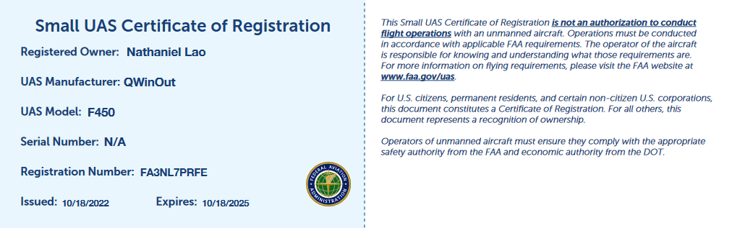

# DEMO

A demonstration of the Drone can be found here:

<https://youtu.be/_2AzHBInPC0>