# Description

This report is not necessarily a software project, but rather a description of the work performed to augment the Quadcopter to a Raspberry Pi (RPi) GPS Drone.

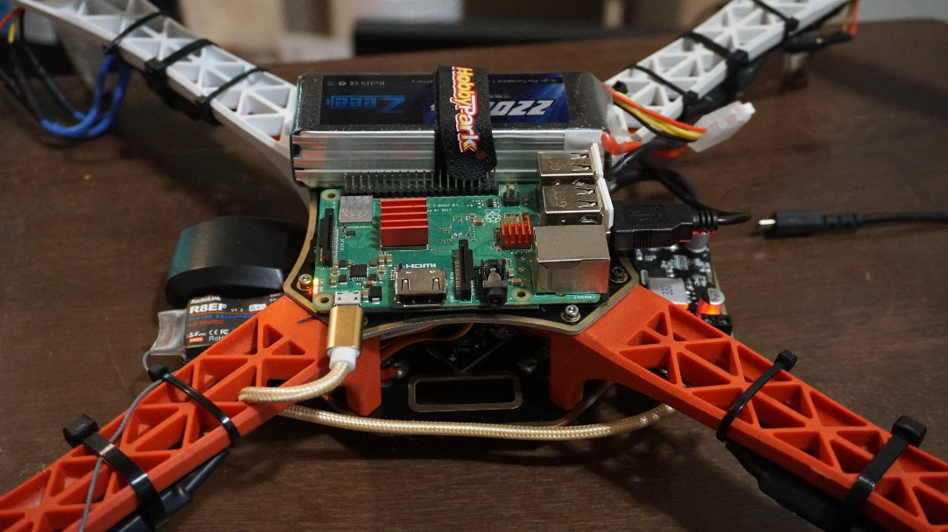

Figure – Drone GPS

# Requirements

The following requirements describe the functionality set forth by the Drone GPS project:

* The Drone shall transport an RPi SoC board.
  + Derived: The Drone shall be able to supply 5 volts.
* The Drone shall transport a GPS module.
* The Drone GPS shall communicate with the onboard RPi.
* The Drone RPi shall transmit GPS Data to a Host
* The Host shall display the GPS Data received from the Drone
* The Drone shall be registered as a UAV under FAA regulations.

# Design

The Drone GPS project consists of two sections: Hardware and Software.

## Hardware

Since the Drone was already equipped with the RPi and 5v buck converter. The only thing to add was the G-Mouse USB GPS module. The camera was removed since this functionality was not required. The GPS module was placed next to the receiver and held down using double sided mounting tape. The extra cable was bundled using zip-ties and hidden inside the chassis.

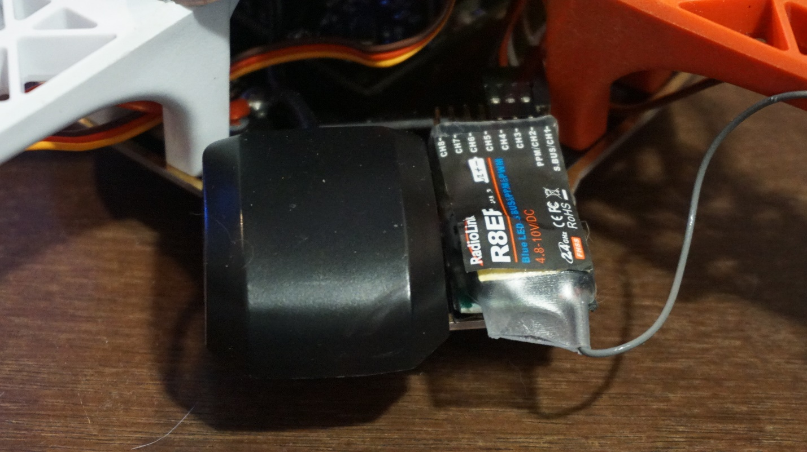

Figure – Drone GPS Closeup

## Software

The RPi was installed with the Raspbian OS. The instructions listed in the “[How can I set up my G-Mouse USB GPS for use with Raspbian.docx](https://jhu.instructure.com/courses/18099/files/3772519/download?wrap=1)” procedures were used for installing the libraries needed. To display the GPS data on the host, MobaXterm was installed on my Windows host computer. The X server was spun up and using X-forwarding, I was able to see the GPS data GUI from a `xgps` invocation.

Figure - XGPS

# Maintainance Squawks

The following list are known squawks encountered during Drone development. It should be noted that some issues have been resolved during development while others are still present and monitored.

* Bad Battery (RESOLVED):
  + ~~The battery delivered was apparently INOP. An attempt was made to charge the battery with the provided charger. The charger did not indicate a charge being performed. After letting charge for approximately 2 hours, the main output terminals indicated only approximately 3 volts DC, rather than the expected ~11 volts.~~
  + Extra batteries were ordered via Amazon. Specs are similar to the original battery (voltage is matches, but the milliampere hours (mAh) and charge constants (C) are allowed to vary).
* Yaw Potentiometer Broken (RESOLVED – WORKAROUND):
  + The Yaw Potentiometer in the KK Controller seems to broken. Rotating the pot does not have a stopping point. Further investigation is needed.
  + No noticeable impact from this issue. This is a non-grounding squawk.
* Inconsistent Motor (RESOLVED)
  + ~~The aft motors seem to be slow to start. If under no load, the aft motors spin at the same time as the front, however, having a propeller load impedes the motor start.~~
  + Extra motors were ordered via Amazon. Investigation over the impact of swapping motors is to be conducted in the future.
  + ~~There is a possibility that calibration is lacking or improperly configured. Future investigation will be conducted.~~
  + Replacing the bad motor allows for an actual takeoff. More practice is needed for proficiency.
* Motion Application Issues
  + Annoyingly, support for motion startup at boot (daemon mode) does not work.
  + The framerate of the Motion RPi library is 1 FPS on browser. Need a more robust method and investigation
* Poor Camera Mounting
  + The camera will shift or break off at hard landings. Need to find a more secure way to lock position.
* No lat/long
  + The xgps GUI did not feature lat/long coordinates. 3D fix was confirmed and zulu time was determined. Possible bug?

# FAA Registration

The Drone was registered under FAA Part 107. The Drone is designed under Tail Number (Nickname) of N42069 (pronounced “November-four-twenty-sixty-nine”) and Registration Number of FA3NL7PRFE.

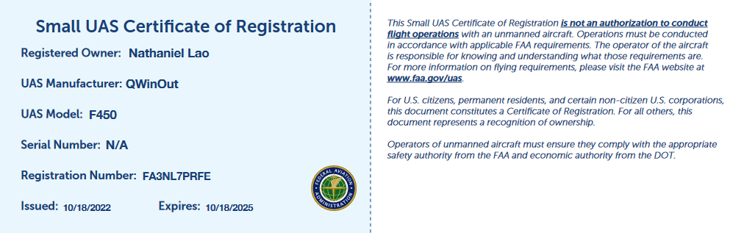

# DEMO

A demonstration of the Drone GPS can be found here:

<https://youtu.be/ZoL0xy2e9Ks>