Lab Activity 4.1: Tailwind, SASS, Basic JavaScript and Website Evaluation
For this lab session you will continue adding advanced CSS elements including Tailwind framework, with CSS preprocessor and with basic JavaScript.

Part 0: We will continue from lab 3.1. Keep the folder named Christmas_Store_lab4_yourLastName.
- Form a group of two people
- Write your partner’s full name
- Submission will be individual. Write your partner's full name in the canvas comment box too.
- You should periodically verify there are no errors as you complete the rest of the lab assignment while working on the following tasks.
  - https://validator.w3.org/#validate_by_input
  - https://jigsaw.w3.org/css-validator/
- Launch VS Code on your machine and open your files.
- When you modify the files, make sure you reload it in your browser to see your changes.
Part 1: Evaluating Website using Web Design Guidelines
In this part of the assignment, you are going to evaluate two websites using the resource for web design guidelines that we discussed today. For each of the websites, you need to fill out a table. The left most column of the table has the criteria for evaluating the websites. You need to fill out the other three columns as per the column headings. Please discuss with your partners and submit the same evaluation.
URL of the first website you are evaluating: https://blinkee.com

Criteria | Explain your observation/s on how the given website meets/does not meets the criterion? | Rate with a scale of 1 through 5 (1- needs major improvement, 2- needs some improvement, 3- fine/can be improved, 4- good/ can be polished, 5- very good) | Specific suggestion/s for improvements or meeting the criterion
Effective home page including, clear purpose and name of the website | Purpose of the Home page is not very clear as it serves as both a shopping page and a contact page at the same time  Looks like the web page has 2 different names, unclear which is the real one.  Purpose is not clear as it appears there are two services offered | 1 | Faster loading time  Only one name  The solgan should not appear on the webpage  image takes up too much of the page  insane loading times  only have one thing to do
Adequate whitespace in each page | The spacing of the elements looks ideal | 5 | No need to improve
Page length and width | Width is fine length is not consistent | 2 | Modify context to have a more consistent length to pages, also the bottom navigation is not on all pages
Images of the webpages | Way to large on average and the sold out is not very clear | 3 | Have the banner image be smaller
Color contrast and color style consistent across the webpages | The color contrast is terrible  its hard to read  the fade on hover makes reading impossible | 2 | Make a better color scheme that is readable  Make the hover not fade the text into the background.
Follow web writing guidelines including consistency of text formatting across pages | Text formatting is the same across pages | 5 | Good enough
Navigation system including functionality of the links and their locations | Two different navigation areas  they go to different places  no way back once you get to the logos | 1 | Make the footer naviagion be on all pages  don’t link to a different website even if it is the same entity.
Relevance of the information, and Organization/layout of each page | Logo image takes up the whole screen  set up like a mobile website even on computer  the logo shop has a changing them of different bright colors | 2 | Smaller logo  make the products actually look like a drop down instead of just another hyperlink  on the logos page don’t need to have such sharp colors
Alignment and proximity of items | Decent | 5 | Could be more consistent between logos and actual shop
User engagement | Its confusion on where to go for what | 3 | Website takes a very long time to do anything  make the home page either b a showcase or a slogan but it cant be both
Usability | Websites loading time is terrible  main functionality seems to work | 3 | While everything works it only works eventually  The loading time is terrible
Works on different browsers like Google Chrome, Mozilla, Safari | yes | 5 | Long waiting times
Anything you want to add __________

URL of the second website you are evaluating: www.apple.com

Criteria | Explain your observation/s on how the given website meets/does not meets the criterion? | Rate with a scale of 1 through 5 (1- needs major improvement, 2- needs some improvement, 3- fine/can be improved, 4- good/ can be polished, 5- very good) | Specific suggestion/s for improvements or meeting the criterion
Effective home page including, clear purpose and name of the website
Adequate whitespace in each page
Page length and width
Images of the webpages
Color contrast and color style consistent across the webpages
Follow web writing guidelines including consistency of text formatting across pages
Navigation system including functionality of the links and their locations
Relevance of the information, and Organization/layout of each page
Alignment and proximity of items
User engagement
Usability
Works on different browsers like Google Chrome, Mozilla, Safari
Anything you want to add __________

Part 2: Modify lab 3.1 with Tailwind. Redo the following tasks using Tailwind framework without errors to receive credit.
      - Use Tailwind CSS for styling
- Use classes of Tailwind CSS for styling
- Just write class for each element and write their class name according to your requirement by following the official website of tailwind CSS
- For example, if you want to change the background color to blue a paragraph then write <p class=’bg-blue-200’>This is paragraph</p>
- Tailwind CSS has classes for every changes you can do with CSS, just follow the Tailwind CSS official website

- Now setup a Common theme across the pages
  - Maintain a box model for all the pages
    - For example, the example shown in the class lecture today
  - Tasks for all the pages- keep the same nav, banner, img and footer elements for every html page to maintain a consistency for every page
  - Nav element design:
    - All the list items mean ‘the links of the navbar will be’ on the same horizon of the page
    - display:flex is applicable to the parent element means the ul of li items
    - margin and padding should be applicable for the list item to have good presentation.
    - Apply inline nav
      - Use hover, visited, active css for the navigations
    - Add margin and padding for each of the nav element
  - Footer design:
    - Center the footer using text-center class from Tailwind
    - Keep the footer element in every html page to keep consistency
  - Banner:
    - Adjust image width, height to improve its presentation
    - Keep the same banner in every html page to maintain consistency

- Tasks for individual pages
  - index.html
    - Create a card for every Christmas product and place all the products like below using display: grid in parent element grid-column-template: 1fr 1fr 1fr to create 3 columns of same sizes as picture below
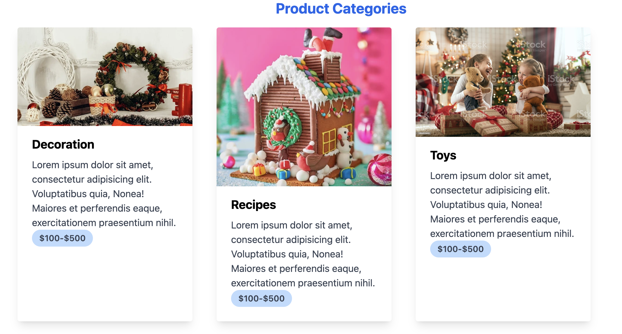
    - navbar, banner will be on the top and footer will be on the bottom
    - fix the position of the banner to top
    - fix the position of the navbar to relative
    - fix the position of the footer to bottom
    - make the main image at center
  - contact.html
    - Add a background image on the form using “z-index”. Use a lighter color image
    - Add a different font families for the contact.html page
    - Use the ::first-letter psedu element for each label of the form
    - Style the form previously created
        - change the color of the input fields while it’s focused
see the example below
input[type=text]:focus {
background-color: lightblue;}
iii. navbar, banner will be on the top and footer will be on the botto

  - deals.html
    - Add a background color to the alternating rows of the table
    - Add a darker background color and a lighter font color to the table header
    - Make the table header’s font bold
    - Add border to each row and column
    - Make card for each deal and create a span element to write the discount like below
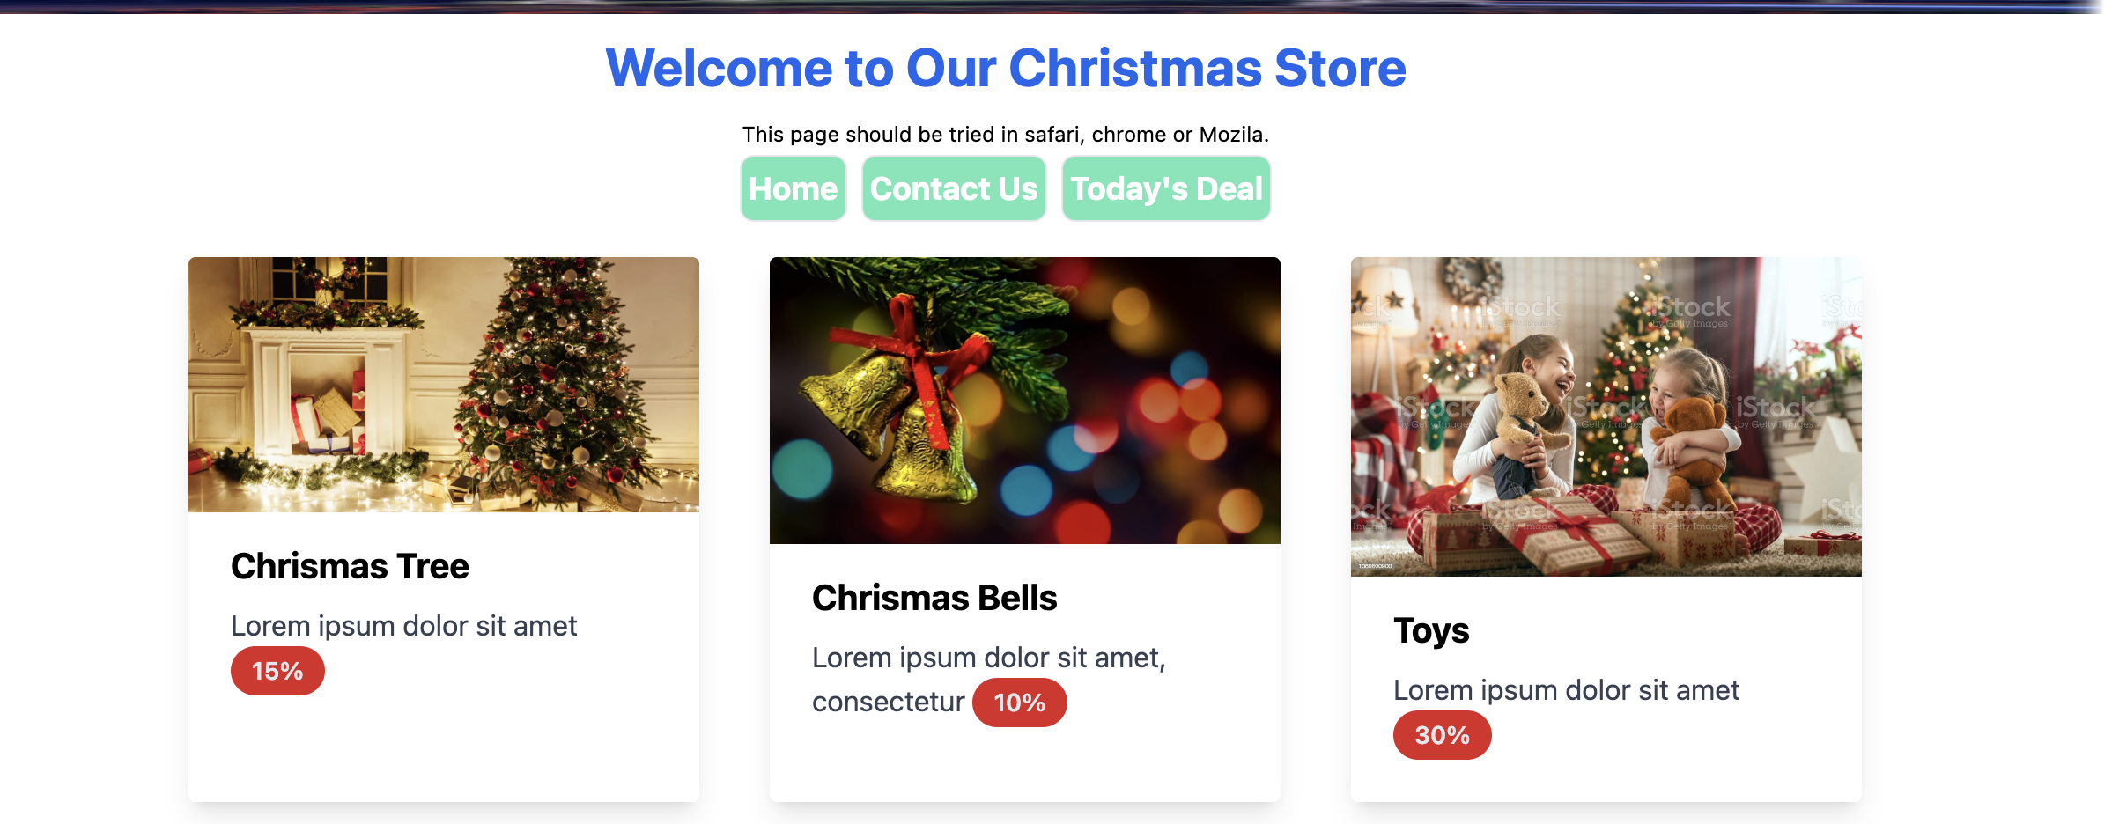
    - Use display:grid and grid-template-columns in the parent element like index.html
    - Each card will be transformed to 1.25x from its original size if user hover on it
    - Add another form of animation

Part 3: Use SASS preprocessor

- Install SASS following the instructions here
  - https://sass-lang.com/install
- Follow the instructions here
  - https://www.geeksforgeeks.org/css-preprocessor-sass/
- Show 3 example usage for the following commands-
  - @mixin and @include
  - SASS nesting
  - @import and @extend rules

Part 4: Basic JavaScript
- Show an alert after successful form submission for the contact.html page
  - Use .getElementById to capture the button from DOM
  - Use Tailwind styling to style the alert box

Part 5: Turn in your activity
There will be two file submissions
  - Each partner needs to submit this word file with your discussion on the website design
  - Generate a zipped file of the solution folder

