**ScreenSavor**

*Concept, Ideation Process, and More*

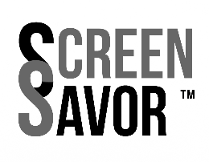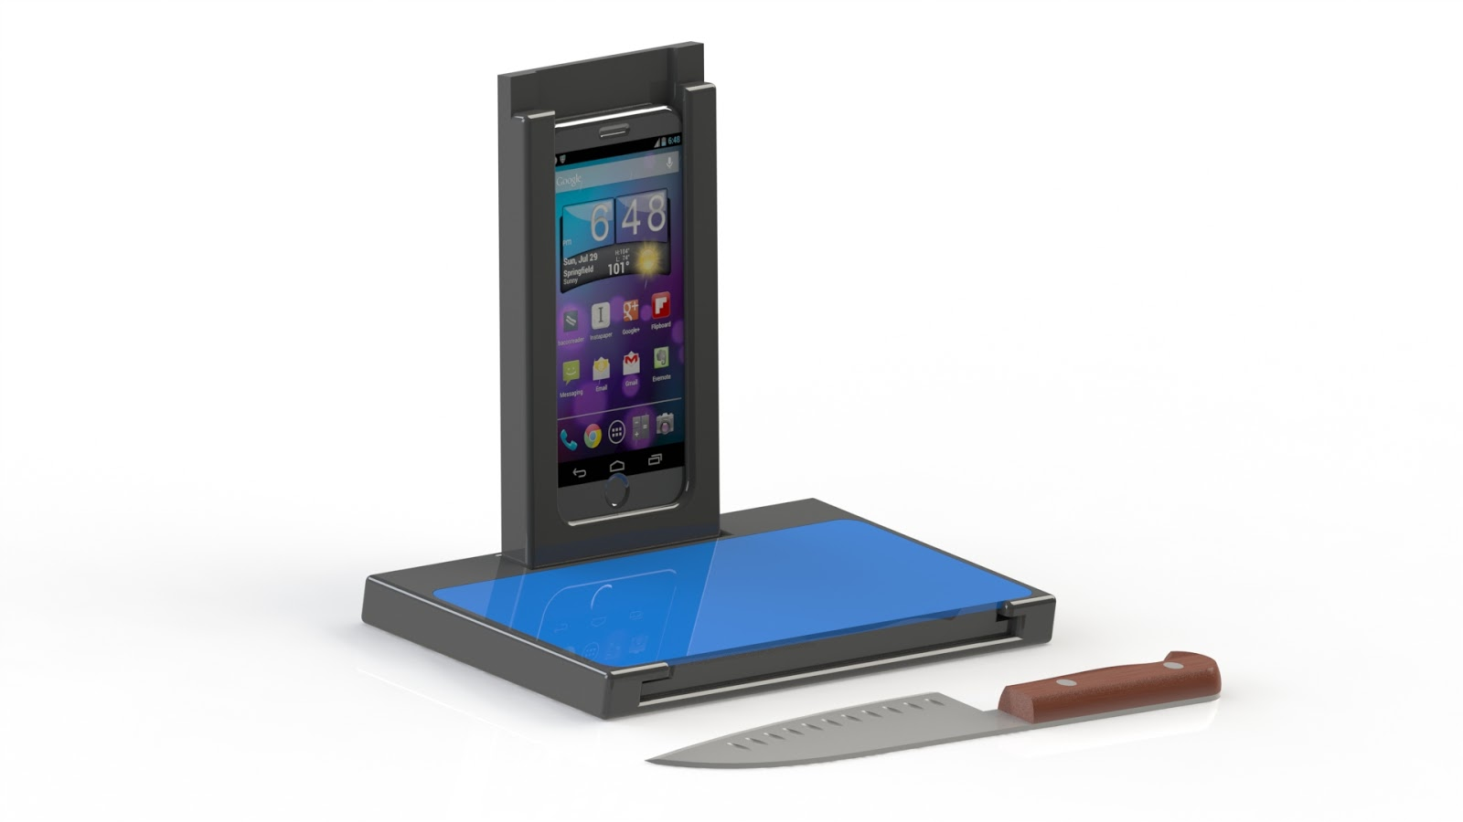

Leila Feldman, Salima Ghadami,

Gregory Howard, Nathaniel Sena,

Mattias Olsson, Marina Palm,

and Benjamin Rosenbaum

**Table of Contents**

1. **Introduction**…………………………………………………………………………………..
2. **Product Concept**…………………………………………………………………………….
3. **Design Thinking Process**……………………………………………………………….....

3.1 Empathizing Process…………………………………………………………………....

*3.1.1 Market Research*……………………………………………………………….

3.2 Definition Process………………………………………………………………………..

3.3 Ideation Process………………………………………………………………………....

*3.3.1 Competitor analysis*…………………………………………………………....

*3.3.2 Product Configuration*………………………………………………………....

*3.3.3 Product Extensions*……………………………………………………………

3.4 Prototyping………………………………………………………….............................

*3.4.1 Material Suggestion*……………………………………………………..........

3.5. Testing……………………………………………………………………………………

**4. Distribution**……………………………………………………………………………………

**5. Marketing & Distribution**……………………………………………………………………

**6. Looking Forward.**…………………………………………………………………………....

**7. Appendix**..……………………………………………………………………………………..

7.1 Survey Results…………………………………………………………………………...

7.2 Competitors………………………………………………………………………………

7.3 Product Extensions……………………………………………………………………...

1. **Introduction**

When tasked with the project to develop a full product concept and pitch it to the VP of Product Development & Design at Lifetime Brands, a leading consumer goods company of global scale, we were thrilled. Before we underwent a rigorous and structured design thinking process, the team’s initial discussions of the ScreenSavor sparked as we discussed our experiences using mobile devices in the kitchen. Our smart phones, computers, and tablets serve essential functions when we cook.

In surveying Lifetime Brands’ current offerings, we deemed that their products failed to capitalize on technology integration in the kitchen. Given the centrality of technology to contemporary food preparation and cooking, we believe this is the perfect space for an innovative, new product development.

1. **Concept**

At its core, the product we conceptualized in the ScreenSavor is a cutting board, designed for tablet integration. The minimum configuration of this product involves two components: a tablet cover and a cutting board base. The tablet cover is itself very similar in design to the cutting board, made out of a base material such as a heat-resistant, tough plastic or treated wood, with a glass or acrylic transparent screen. The cutting board is fashioned similarly, with two variations of the base, either heat resistant, tough plastic or treated wood. The cutting surface is made out of transparent material and is easily removable should the base of the cutting board need special cleaning attention.

We aimed to exceed the functionality and improve upon the design of existing, tablet-integrating cutting boards. The ScreenSavor incorporates two features that are not currently offered on the market in one integrated product. The first is that the tablet remains clean, protected and within control, behind the glass cover. Previous designs either lacked physically protective barriers or relied on a plastic sleeve, which decreases functionality and increases waste, diminishing the user experience on the whole. The ScreenSavor’s second majorly differentiating attribute is the tablet case’s three functional positions. The upright tablet case interlocks with the base in vertical and horizontal positions, allowing users to interact with their tablets in the posture most suitable to their task. From the horizontal position, users might watch videos, while from the vertical position, users might browse recipe ingredients. In total, the upright posture is suited for use during food preparation, as it allows the tablet to have a proper, functional place in the kitchen, without exposure to risk. When the cutting board and tablet case become dirty, the user can easily clean them both by simply placing them in the dishwasher.

The ScreenSavor’s third functional position has the tablet embedded in the base. This setup has two benefits. The first is that the tablet can be viewed behind the clear cutting board within the frame of the base. With the tablet in a locked position, a user can prepare food on the cutting board and simultaneously see content on the tablet underneath. An additional functionality of this design will enable its intended market segment, millennials, to engage in one of their favorite behaviors. When a user wishes to eat in a seated or reclined position, the cutting board and tablet can be placed comfortably on the lap or chest for viewing pleasure while the base is used to support food, reading materials, or even just as a counterweight to keep the tablet propped up.

1. **Ideation Process**

Although fairly unproductive, the first meeting was characterized by burgeoning ideas; the team spirit was high. However, we realized that we were in trouble after the second and third meeting progressed in a similar fashion. Simply throwing ideas out was not going to give us a concept ready to present and elaborate on. It was during the design thinking lecture that we discovered a framework that would allow us to structure our efforts in an organized ideation process, which was exactly what we needed at the time. Wharton Innovation & Design Club’s description, “[Design thinking is an] Intentional process in order to get to new, relevant solutions that create positive impact,” seemed to be perfect for what we were trying to do. With keywords such as “human-centered,” “collaborative,” “optimistic,” and “experimental” we entered the ideation process with new energy.

* 1. Empathizing Process

With a large quantity of ideas and concepts to work on, we interpreted the first part of the design thinking process as an opportunity to narrow down the context of the project. The group decided to focus on millennials. After all, millennials provide a large market for new products, particularly products integrating technology into daily life. Despite the fact that we are all part of the millennial generation, none of us had adequate insight into the interests and desires of millenials as a group when using technology in the kitchen. Consequently, we started collecting both quantitative and qualitative data through primary and secondary research. Our research was predominantly exploratory and descriptive, as explained below. We were aiming to gain a deeper understanding of the typical millenial’s experience using technology in the kitchen.

* + 1. *Research*

We conducted primary research in order to complement our secondary research and further validate our hypotheses on the problems millennials face while cooking. First, we administered an online survey of 52 students through SurveyMonkey, which allowed us to gauge the typical experience of a millennial in the kitchen (see appendix for extended results). Our results indicated that millennials cook at home relatively regularly (47 out of the 52 respondents said they cook at home at least once a month, or 90.4%). In our sample, those who do cook rely on various technological devices to facilitate the cooking process (36 of 47, or 76.6%). For those who reported taking advantage of technology in the kitchen, most surf the web for recipe instructions (36 of 43 who reported, or 83.7%),  recipe ideas and inspiration (26 of 43), or “how-to” videos (16 of 43).

We also investigated the main reasons millennials might be reluctant to integrate their tablets or phones into the cooking process. As we predicted, most participants responded that the risk of damage was their main concern (37 of 52 respondents). A few reported they had difficulty finding a convenient way to position their devices at a suitable viewing angle (4 of 52).

We followed up the survey with two in-depth interviews to further analyze millennial use of technology in the kitchen. The students we spoke to confirmed there is a lot of potential for products integrating technology for use in the kitchen. Isabel, a senior at Penn, said, “I like to watch Paula Dean on my tablet and follow along with her. It makes cooking more fun.” Sarah, a Penn sophomore, uses technology to find inspiration and search for recipes compatible with her vegan diet. Celine, a Penn senior, also reported damaging her iPhone with tomato sauce while cooking only a few days prior to the interview and was annoyed at how difficult it was to clean up after the spill.

Our primary research confirmed that millennials do cook often, and when they do, they utilize technology. Furthermore, the respondents are primarily worried about the clean up process, potential risks of damaging the tablet while cooking, and that they might run into difficulties with positioning of the tablet. However, due to time constraints, the sample type and the limitations with the resources available to us, we cannot ensure the survey results are accurate or representative of the larger millennial population.

* 1. Definition Process

Using the insights we obtained in the empathizing process, we defined three key problems: our peers hate cleaning up, expect immediate availability of information via their technology, and want gadgets to be integrated in our tech-centered lifestyles. We also specifically wanted to focus on the food preparation process. How could we create a product that facilitated food preparation in a way that dealt with the main issues relevant to the target market? Through round-table discussions, framed by the insights from our research, we realized those concepts come together in several different products, some of which had already been brought up in our initial brainstorming meetings.

* 1. Ideation Process

When moving into the ideation stage, we could see the initial ideas we had in a new light. Having already set up a submission system for any ideas, no matter how crazy, we reviewed them again in the context of our defined problems. This time the discussion was completely different, considerably more productive than previously. We refined our brainstormed ideas with the defined problems in the back of our minds, which ruled out all ideas generated that were incompatible with our insights. The ideation process led us to settle on tablet case and stand designed for the kitchen with an integrated cutting board. We set out to see what was out there in related markets in order to refine our solution space and ensure that our product was unique.

* + 1. *Competitor Analysis*

The most obvious existing products intended to protect tablets from scratching and damage are regular screen films, tablet cases and nano-scale coating devices to protect from moisture. However, none presented solutions specifically catered to technology usage in the kitchen.

We found products such as the “Belkin Kitchen Stand and Wand”, the “Lipper Bamboo iPad Stand” and the “CTA Digital Kitchen Tablet Stand Cutting Board with Screen Shield” that serve as tablet stands, but neglect the issues of kitchen spills and dirty fingers (see appendix for photos of these products). The Belkin and Lipper stands mainly serve aesthetic purposes, and provide the user with a method to view their tablet in an upright posture. Yet, they do not protect the tablet from spillage, moisture or potential heat damage. The CTA Digital integrated stand and cutting board attempts to solve this problem by providing a glass shield to protect the screen against splatter and spillage, but does not allow you to interact with the tablet while cooking.

Finally, we determined that the most viable existing competitor on the market is the Orange Chef Cutting Board with iPad Stand.  While this product does protect the tablet from spillage and allows the user to interact with the tablet, we identified a number of issues with the existing product. Since it is disposable and intended for one-time use, the product produces a lot of waste and requires repeated purchase depending on frequency of use. The product is also sold independently from other tools, and therefore requires the purchase of various supplementary products (such as a stand) in order to serve its intended function. In addition, the sleeves are only designed for two tablet types, the iPad and the iPad 2, which limit the product’s application. These problems may deter millenials looking for a one-time, effective, and effortless purchase. We aimed for our product to avoid these problems as well as risks of damage and difficult clean up, while seamlessly integrating technology into the cooking experience.

* + 1. *Product Configuration*

Having identified the Orange Chef Cutting Board with iPad Sleeve as the best possible alternative, we mapped the product configuration and discerned the internal and external components in our potential products’ use.

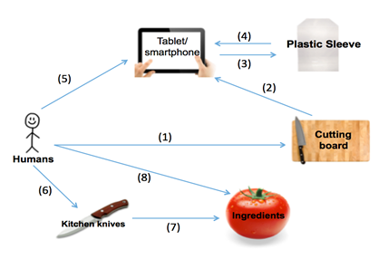In the configuration illustrated below, the user places the cutting board at a convenient place, thereby controlling the location of the cutting board **(1)**. The tablet is held in its upright position by the cutting board at its specific angle. As a result, the cutting board controls both the location of the tablet as well as the angle at which it is held **(2)**. Since the sleeve is placed on the tablet, the tablet controls the sleeve’s location **(3)**. At the same time, the plastic sleeve is designed to ensure that the tablet is protected from any potential spills. Hence, the plastic sleeve controls the surface condition of the tablet **(4)**. The user is then able to control the content displayed on the tablet with the touch of his or her finger, and may also change the location of the iPad **(5)**. The user also positions the kitchen knife in order to cut the ingredients **(6)**. Consequently, the kitchen knife controls the shape of the ingredients **(7)**. Although the ingredients are placed on the cutting board, the cutting board does not control any of the ingredients’ attributes, but rather it is the user who has the ability to change the location and position of the ingredients **(8)**.

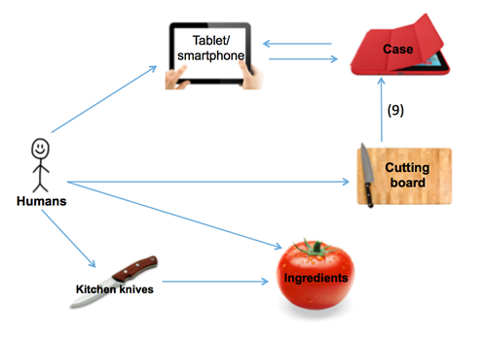After mapping the product’s configuration, we applied the *Replacement* Template, removing the plastic sleeve and replacing it with another component, a case, which retains the function of protecting the tablet from kitchen spills. In addition to the original function, we introduced an additional link between the cutting board and the case. The case fully attaches to the cutting board, meaning the cutting board controls the location and angle of the case. This in turn means the cutting board also no longer controls the location of the tablet directly, but indirectly through the case **(9)**.

We followed the *Functions Follow Forms* Principle and identified various benefits to our new configuration. The resulting configuration displayed above, allows for convenient and easy food preparation, as users no longer have to worry about making repeated sleeve purchases to cover their tablet during the food preparation process.

To further improve the convenience of the product, we decided that the case must be dishwasher-safe for easy clean up. The new product would also significantly reduce the amount of waste produced, as the case is durable. Finally, we realized various benefits of creating one product that serves the same function as multiple existing products. Not only would our product be more convenient for millennials, but would also be cheaper for users over the lifetime of the product if no repeated purchases are necessary (further benefits are outlined above in the *Product Concept* section).

* + 1. *Product Extensions*

We formulated a number of product extensions, many of which are extensions to the ScreenSavor base (see appendix for renderings). Each of the following attachments contains an interlocking mechanism to connect with the base. The first features a strainer and was designed to add a functionality many other cutting boards employ. This feature can improve user experience, for example, when chopping dripping fruits and vegetables that were freshly rinsed. The second attachment is a side tray to offload ingredients from the cutting surface to a secondary highly accessible compartment. The third attachment is similar to the side tray, but is divided into three smaller spaces to keep unique ingredients separate.

We also conceived separate product extensions to add functionality and improve the quality of the ScreenSavor line. One idea is a set of tablet bracket holders which allow the tablet be placed anywhere thanks to command strips. The tablet can be placed on any vertical surface without falling. Tablet bracket holders would enable the tablet to be placed on a refrigerator door, microwave, cabinet, or wall, thus extending the functionality of the tablet in the kitchen. Users could keep the tablet off surfaces which hold food and other messes, and in the process save workspace for meal preparation. While the user’s tablet and ScreenSavor case are mounted with the bracket holders, the cutting board still serves as an additional functional surface.

Another idea involves utensils with capacitative touch stylus tips on the ends of the handles. The utility added here is that users can directly interact with their tablet when their hands are dirty or holding utensils. This design could be implemented in utensils, such as spatulas and whisks, for use during food prep, or even in common cutlery, for tablet interactions in the consumption stage. Additional product extensions include bowls and plates with notches in them, enabling the tablet to stand on the item for use while eating. These extensions would likely be a hit with the younger demographic, for whom screen time often intersects with meal time.

* 1. Prototyping

Our use of CAD software allowed us to visualize our product, putting everyone on the same page with regards to design, strengths, and weaknesses. Using Solidworks, we were able to upload a model of an iPhone 6, whose shape we cut out of a rectangular prism, which would serve as the case (due to size constraints during the 3D printing process, we chose to model an iPhone 6 as opposed to a tablet). We then created an interlocking structure for the case to fit within another rectangular prism, the base. We were careful to leave a few millimeters for heat expansion of the PLA filament in 3D printing, and we designed our prototype within the build dimensions of the 3D printer we had available. We added a lip to the case, so users’ experience a ‘click’ when the iPhone is secure. And created a third, shallower, rectangular prism for the cutting board, shown blue in the rightmost image below, since our filament was blue, and clear in the other two images, to show how the product would look when manufactured in the actual materials.

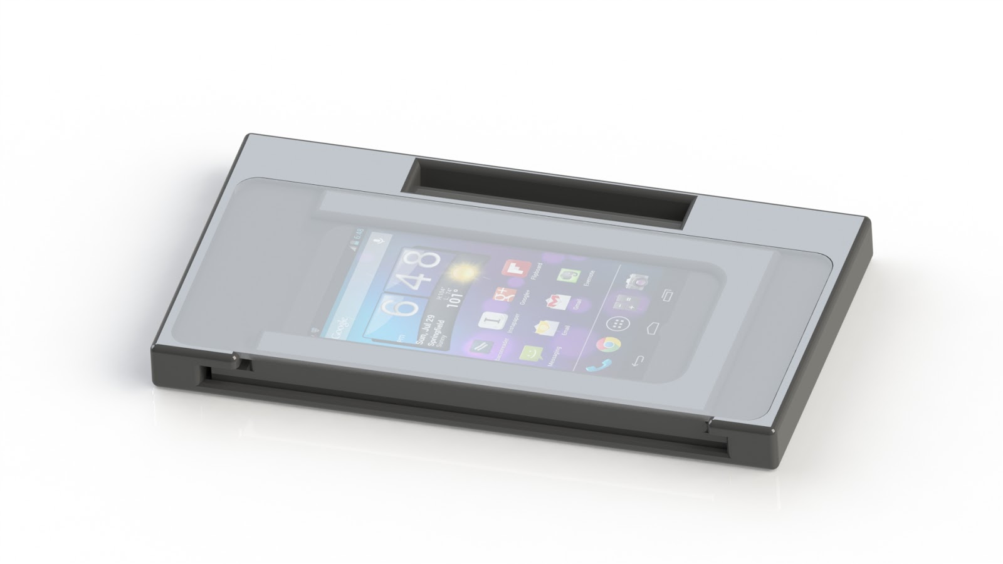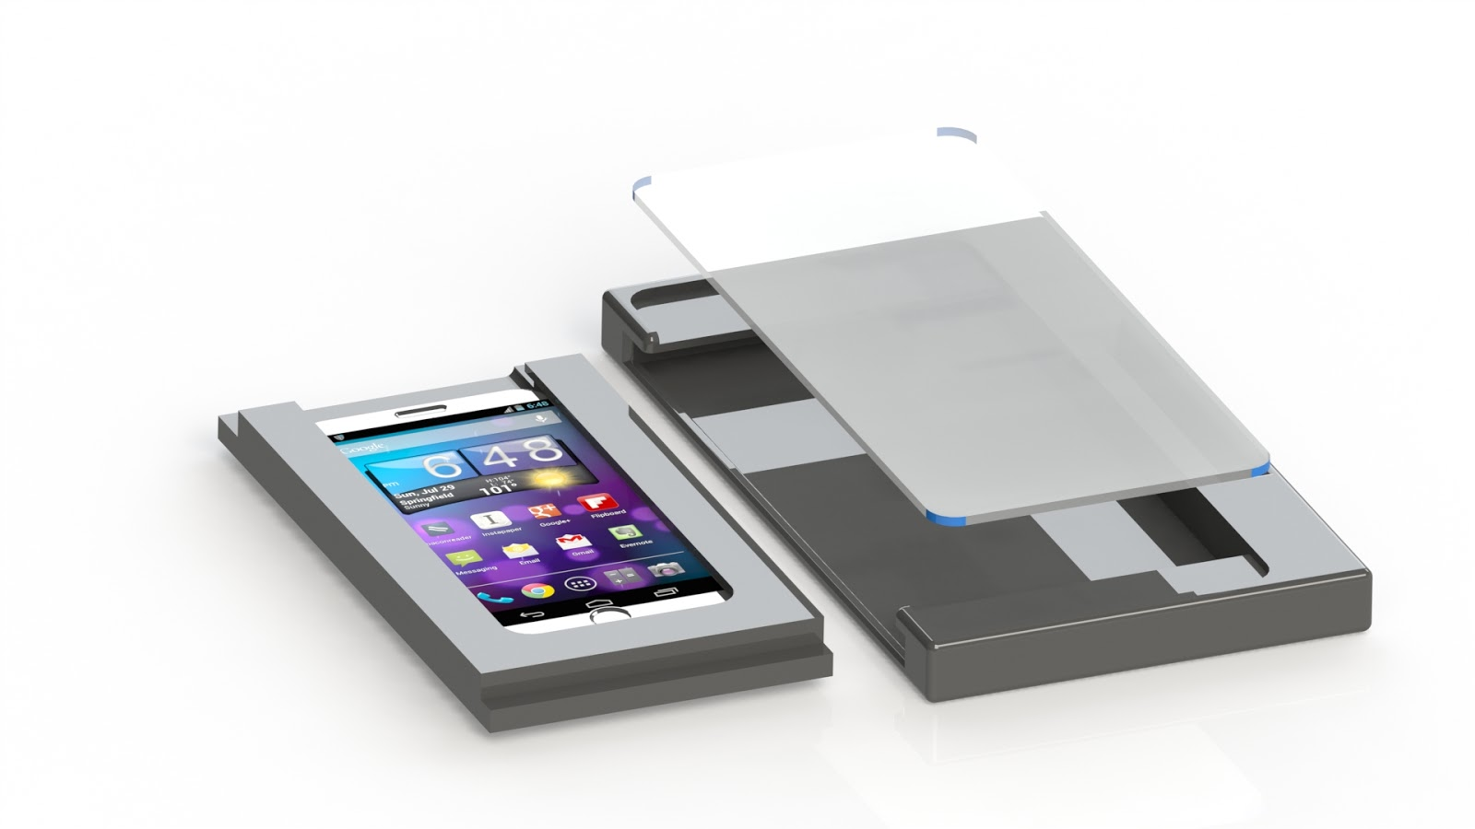

* + 1. *Material Suggestions*

Since we lack experience in material sciences, we conducted secondary research to find indications of what materials might suit the ScreenSavor. We specifically researched materials used in kitchenware and protective technology. We found that tempered or toughened glass is a material used in both of these product categories that satisfies some essential characteristics: thermal resistance (withstands microwave heats), non-porous, dishwasher safe, and reliable for touch screen sensitivity.

3.5. Testing

We consider ourselves to be in this stage of the design thinking process right now. The goal is to try to integrate Bill’s comments, as well as comments from our peers, to improve our product. We were thrilled to hear Bill’s enthusiasm about the product, and we hope that he re-connects with us to give us more comments. After that we to return to the ideation stage to implement changes and refine the prototype. In the meantime, we consider possible marketing and distribution methods.

1. **Distribution**

With the advent of new services like Prime Pantry and AmazonFresh, eCommerce reaches the kitchen more and more. The trend extends to kitchen devices as well, and, undoubtedly, many millennials will search online if considering to purchase the ScreenSavor. Accordingly, we intend to list the product on Amazon.com, one of Lifetime Brands’ existing retail partners with reliable distribution networks.

We also intend for the ScreenSavor to make use of Lifetime Brands’ other existing global retail partnerships, beyond Amazon. For sales in Europe, Carrefour is a fitting existing retail partner. Meanwhile, the ScreenSavor could be sold stateside in Bed Bath & Beyond and Target, both retail partners. A higher-end variant of the ScreenSavor could be sold at Williams-Sonoma, a private label expert that is also one of Lifetime Brands’ retail partners.

Two other Lifetime Brands’ brands, currently offering cutting boards, are Farberware and KitchenAid. However, rather than fit this technology-integrating product into those well-known, established houseware and kitchen brands, Lifetime might alternatively place ScreenSavor within the Reo brand. ScreenSavor would capitalize on Reo’s vibrant and youthful branding, which highly appeals to our team, a sentiment likely echoed by other millennials. Moreover, Reo’s intuitive designs, trend-right colors, and inviting forms overlap nicely with the brand we hope to develop for ScreenSavor.

For these in house brands ScreenSavor could utilize Lifetime Brand’s existing distribution networks, such as the distribution centers in Winchendon, MA, Robbinsville, NJ, York, PA, and Fontana, CA. Lifetime Brand’s existing infrastructure, logistical frameworks, brands, and relationships make the ScreenSavor’s distribution economical, expeditious, and simple. To secure customers as the final link in the distribution chain, we came up with the marketing and advertising campaigns discussed in the following section.

1. **Marketing & Advertising**

In order to market the ScreenSavor to its target audience effectively, we applied the various advertisement templates to develop creative and clever marketing campaigns. We believe that by appealing to millennials’ sense of humor we can relate our message in the most effective way. In our first campaign slogan: “Always Use Protection,” we employed the *Metaphor* template. Though we did not place a symbol of the metaphor directly into the advertisement, we used this popular and widely recognized slogan most commonly associated with condom use in order to convey a similar message about the safety our product provides. With no further explanation, viewers reading this message immediately understand that our product guards whatever is inside from potentially harmful outside elements.

Continuing with this slogan, we used an iteration of the *Inversion* tool to create our first advertisement, which shows the consequences for a viewer who does not use our product. The ad shows an iPad covered in flour and condiments with the “Always Use Protection” slogan written above. We then used the *Absurd Alternative* template to create additional advertisements that show users other absurd ways to get a similar benefit, without actually showing our product. The first one uses the “Always Use Protection” slogan in a slightly different way, showing an iPad wrapped in plastic wrap and covered in flour. Two others advertisements show the user placing the dirty iPad directly into the dishwasher and washing it directly in the sink. In these ads we introduced another tagline, “We’ve Got You Covered”, which plays on the meaning of the phrase, as well as the nature of our product as a physical cover.

We developed our next advertisement using the *Unification Tool*, creating a billboard that exhibits the benefits of the ScreenSavor. We started by using one of the two *unification* techniques, “getting more from an existing medium,” by first choosing the type medium, and then deciding how to convey the product message most effectively through it. We first defined our message that the ScreenSavor protects technology from kitchen spills. We then chose a billboard as our medium, and made a list of the resources (components and traits) of the billboard and its surrounding environment. We determined that the sky, an external component of the billboard, would be a great way to support our message and convey the clarity of the screen when using our product. We then designed a bifurcated billboard with a tablet in the center. The screen of the tablet would be made of a clear material, so that the sky can be seen through it. On the left-hand side of the billboard, the tablet’s screen is covered in food and condiments, blocking one’s view of the sky. On the right-hand side, the tablet is covered by the ScreenSavor, which protects the clear screen so viewers can see an unobstructed view of the sky through the billboard.

Our last campaign, plays off of a popular millennial euphemism, “Netflix and Chill”, which millennials, particularly college students, use to invite someone of the opposite sex over to one’s apartment. The advertisements, which could be part of a cooperative campaign with Netflix, are designed in the same style as the Netflix logo (red background with bold white letters), and read “Netflix and Spill”, “Netflix and Grill”, and “Netflix and Dill”, all relating to some element of the kitchen. On the opposite side of the page, we have a picture of our product with our slogan “We’ve Got You Covered.” Though these advertisements were not developed using the templates directly, they are intended as a playful quip aimed directly at millennials.

For the “Netflix and Chill,” “We’ve Got You Covered,” and “Always Use Protection” campaigns, we intend to employ print and online mediums. They would be appropriate in magazines, such as Clean Eating, Women’s Health, and Men’s Health. We could also get cheap advertising by offering free ScreenSavor products to authors and hosts of food blogs, like How to Cook That, Cooking With Dog, or My Drunk Kitchen. We’d take these advertising campaigns onto social media, particularly Instagram, which has become a hub for marketing of food and cooking products. These campaigns could also be successful in video form, as advertisements on video streaming sites like Hulu and YouTube.

1. **Looking Forward**

As apparent in the advertising strategy outlined above, we place a greater emphasis on online mediums, where viewers are just clicks away from buying their ScreenSavor. The ScreenSavor seamlessly integrates tablet technology in the kitchen, and ensures that all risks associated are controlled for. By solving the main issues of time, clean-up, lifestyle and technology, the ScreenSavor is the ideal product for all millennials in the kitchen, including the members of our team!

1. **Appendix** 
   1. Survey Results

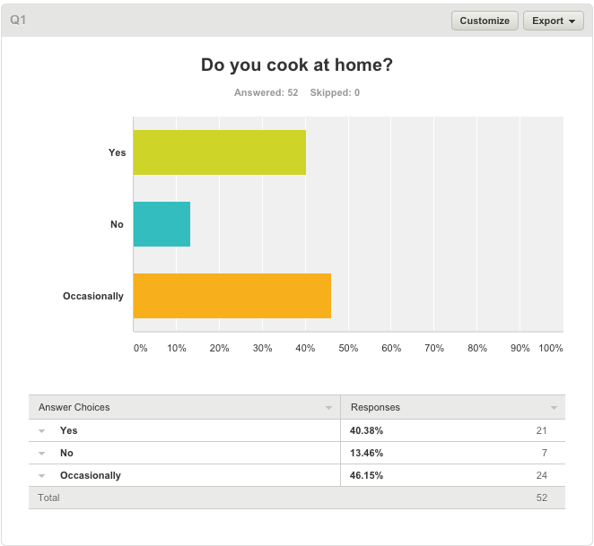

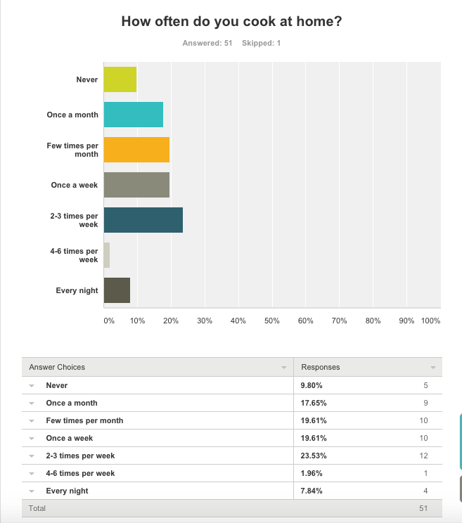



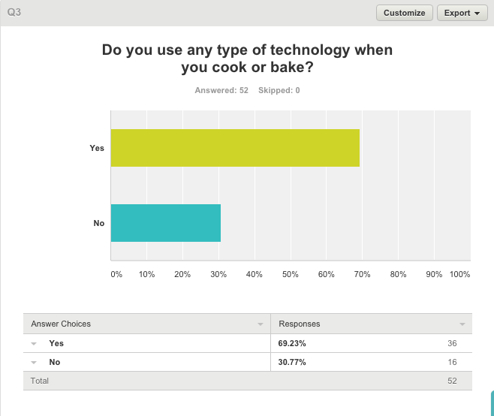

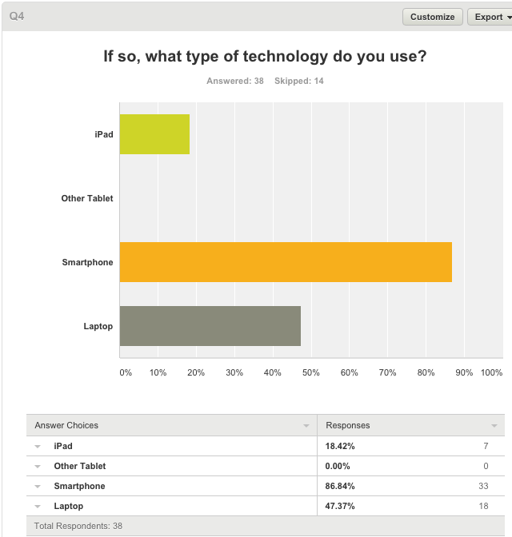

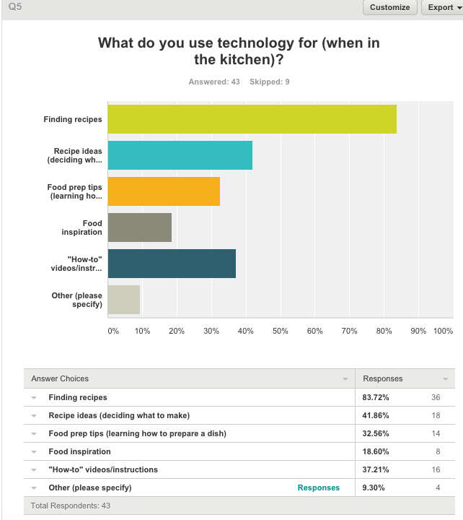

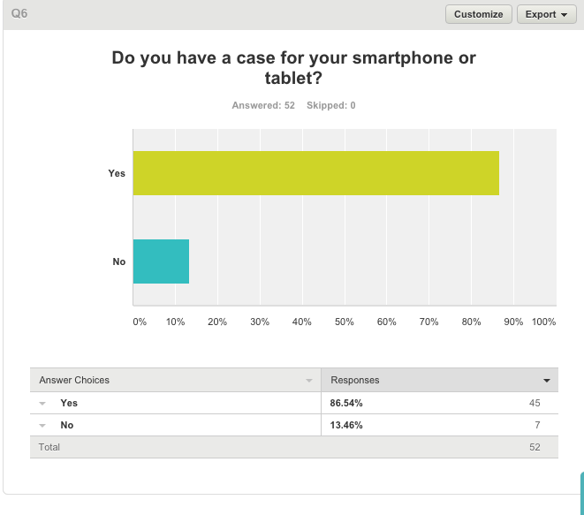

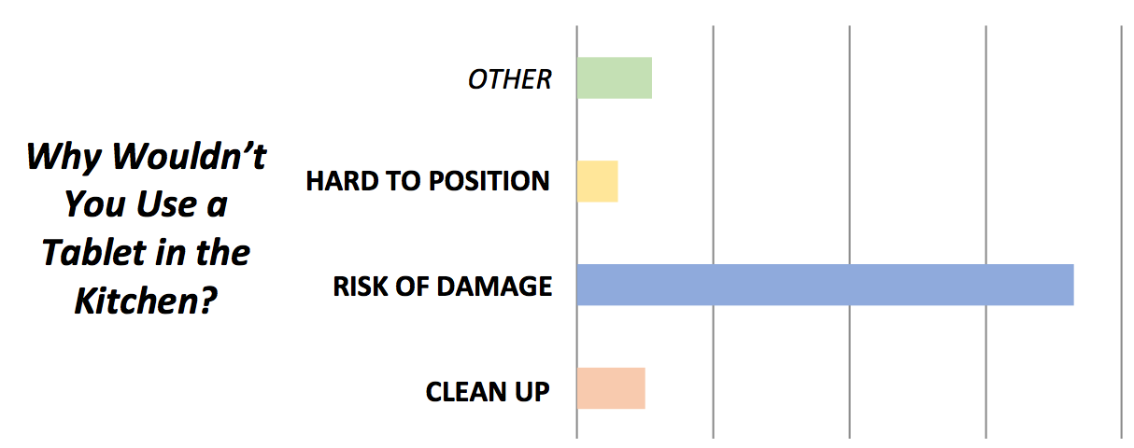

* 1. 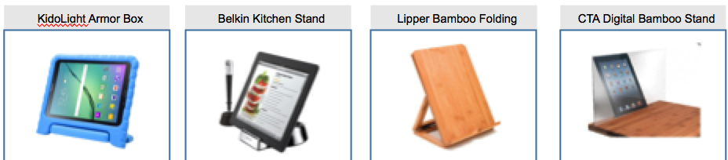Competitors
  2. Product Extensions

