# Databases and Tables

## Step 1: Model an Event as a Single Table

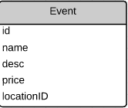

## Step 2: Model an Event as Two Tables

## 

## Step 3: Model an Event as Three Tables

