# Queries

## Step 1: Review Tables

1. A table holds the information and the information type. An event table holds the information about a specific event, such as ID, location, time, date
2. Each row is an information item, or “event:
3. The attributes in which you’re selecting from
4. An event has an ID so if the event is referenced in multiple places, all its information can be easily acquired from its event table. It also identifies events differently from other events.

## Step 1: Practice Querying

Your SQL zoo screen shots

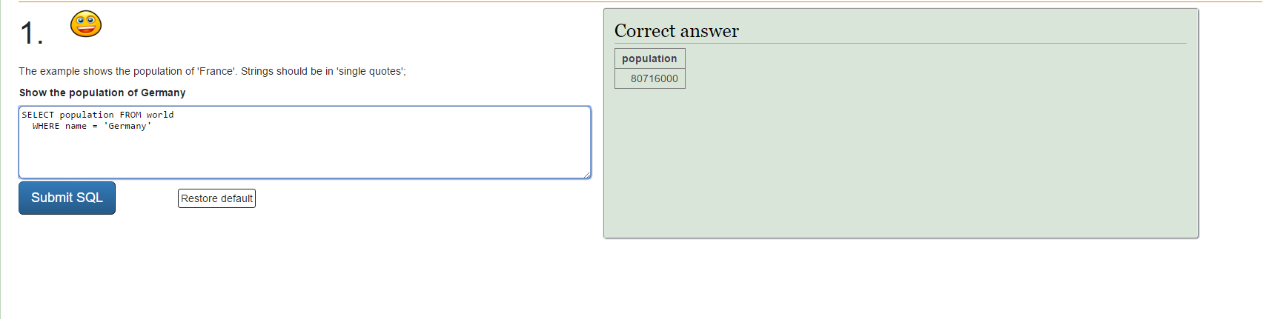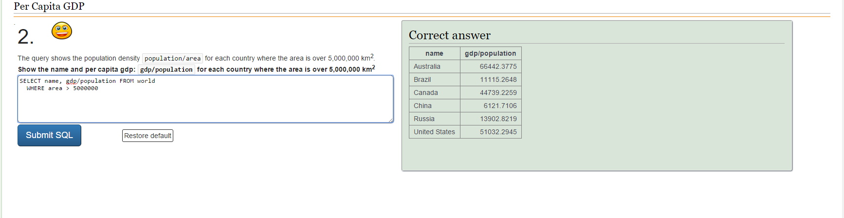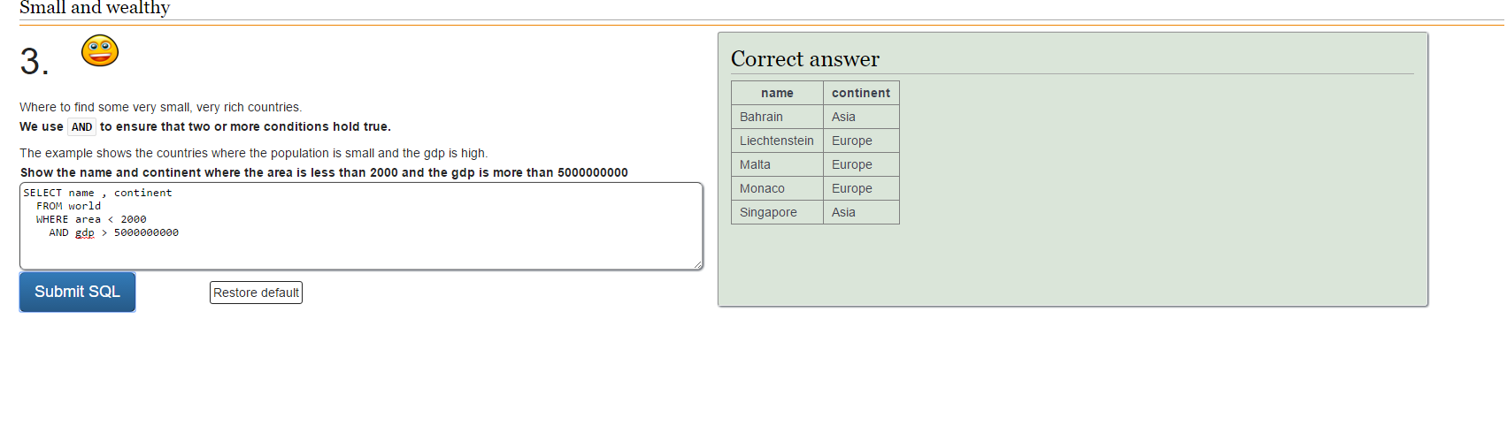Step 3: Write Some Event Queries

1. A query to find all the info needed to create the Event page for the Event with an id of "event1"

SELECT all FROM events WHERE id = ‘event1’

1. A query to find price of the Event with the name "Ender's Game"

SELECT price FROM events WHERE name = ‘Ender’s Game’

1. A query to find the name and id of ALL events so that we can build an ALPHABETICAL list of all the events

SELECT name, id FROM events ORDER BY ascending