# Site Flow and Sketches

## Step 1: Competitive Analysis

|  |  |
| --- | --- |
| Competitor Site 1: <site name here> URL: http://www.seattleweekly.com/calendar/ AnalysisWhat is good about this site?  1. Visually appealing 2. Categorizes events 3. Displays the locations of events via map  What is bad about this site?  1. Site doesn’t use entire page 2. Nav bar is fucking ugly 3. Website is not responsive to screen size | Competitor Site 2s: <site name here> URL: http://www.ticketmaster.com/ AnalysisWhat is good about this site?  1. Events and categories greatly organized 2. Visually appealing 3. Categories are greatly defined in dropdown menus  What is bad about this site?  1. Shows uninteresting events to people not logged in 2. Buttons are not rounded, and look too sharp 3. Doesn’t display ticket prices on start page |

### Competitor 1 Pages

#### Page (or Screen) where you ask “What should I do tonight?”

#### Pages (or Screens) look for the answer

#### Page where you get an answer

### Competitor 2 Pages

#### Page (or Screen) where you ask “What should I do tonight?”

#### Pages (or Screens) look for the answer

#### Page where you get an answer

## Step 2: Sketch One Competitor Flow

### Favorite Competitor: Page Flow Sketch

Pages sketched as boxes for the flow between pages (or screens) where you ask “What should I do tonight?”, look for the answer, and get an answer. Arrows drawn between the boxes show how the pages are connected by clicks. Inside the page boxes details include:

* Where you ask the question
* Where the navigation is that allows you to find things to do
* Where the details of the “things to do” are displayed
* Where you click to move from page to page

## Step 3: Sketch YOUR Flow

### My Site Name

Yt-events

#### Sketch of My Page Flow

Pages sketched as boxes for the flow between pages (or screens) where you ask “What should I do tonight?”, look for the answer, and get an answer. Arrows drawn between the boxes show how the pages are connected by clicks. Inside the page boxes details include:

* Where you ask the question
  + Front page, where it says tonight’s event in the navbar
* Where the navigation is that allows you to find things to do
  + It’s the navbar on top
* Where the details of the “things to do” are displayed
  + They’re descriptions within the event titles
* Where you click to move from page to page
  + Navbar or the event title

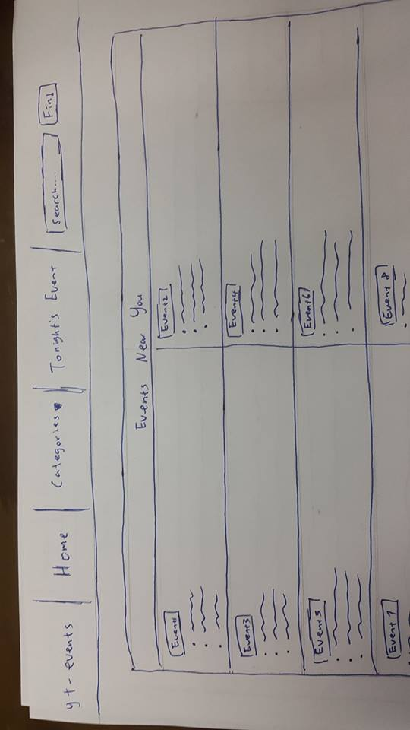

This main page has a list of events near the person and a special one for tonight

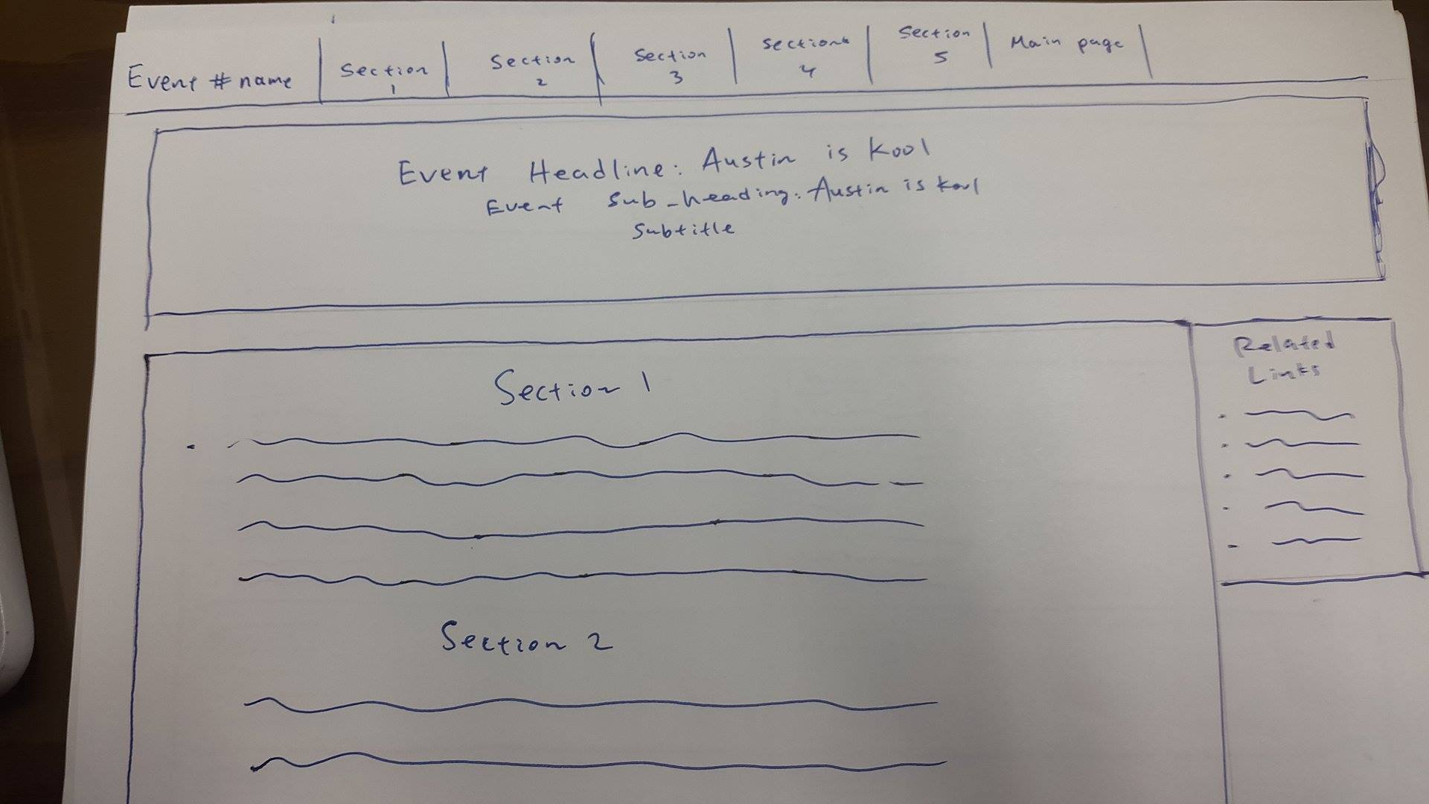

After the user clicks on an event, they’re directed to a page to see what it’s really about, and it gives all sorts of content and info. Users can choose to go to this event or they can go back to the main events page