

User Guide
VIJILIS System Software
Version 1.0 ◆ May, 2017

VIJILIS Emergency Resource Management
A Model for Distributed and Certified Civilian Emergency Response
University of Arizona

Team #16040
Table of Contents:
1. Introduction
1.1. Purpose
1.2. Scope
1.3. System Organization
1.4. Relevant Hashes
2. Describing the System
2.1. Key Features
2.2. Software Requirements
2.3. Environment
3. Installing, Starting and Stopping the System
3.1. First-time Users
3.2. Installing the system
3.3. Starting and Stopping the System
4. General Interface Instructions
4.1. Instructions
4.2. Conventions
4.3. Errors, Malfunctions, and Emergencies
4.4. Messages
4.5. Quick-Reference
5. The Admin Interface
5.1. How to add your logo to the cover page
5.2. How to add your logo to the header
5.3. Updating the Table of Contents
5.4. Adding Notes
5.5. Adding Warnings
5.6. Adding Comments
5.7. Bullet Lists
5.8. Numbered List
5.9. Adding Code Samples
5.10. Samples Tables
6. Appendix A – Reference Documents
7. Appendix B – Glossary of Terms

1 Introduction

1.1 Purpose
The purpose of this document is to define the functionality to be delivered by Team #16040 to VIJILIS for the University of Arizona’s Senior Design Project. This document serves as the sole reference for the scope of the delivered functionality. Any change to the scope of the project or Software will require this document to be updated in accordance with those changes.

1.2 Scope
VIJILIS is an initiative to develop a software model for government use that engages nearby certified civilian contractors to more quickly respond to emergency situations. Our task is to design and test a working model of a system which consists of the registration, movement, verification, allocation and confirmation of emergency resources.

1.3 System Organization
The system is organized into 3 major interconnected components.
- Incident Manager Portal
- Vendor Portal
- Admin Portal

1.4 Relevant Hashes
File Name | File Size (kB) | Hash (MD5 Sum)
vijilis.zip
vijilis_user_guide.pdf

2 Describing the System

2.1 Key Features
The system’s main functionality is to act as a data aggregate. The system’s first major component is the Incident Manager Portal. This portal gives the user access to multiple features:
- To create and search for Jobs
- To search for vendors
- To view a large map detailing all requests and active resources in the system
The second portal, the Vendor Portal, allows the user to:
- View assigned and nearby Jobs
- View and edit their profile
- View, edit and add new resources
- Check-in and log available resource locations
Finally, the third portal, the Admin Portal, gives the user the ability to:
- Create Incident Managers, Vendors, Admins and Polygons
- View Job Codes and Edit resources assigned to them
- Test JavaScript functionality
In the back end, there are a few more key features. These features include the ability to send and receive SMS Text Messages as well as send Emails. The system can also identify the types of resources necessary for a newly created Job and find the closest active resource within the Polygon (Area of Operations).

2.2 Software Requirements
There are three pieces of software required in order to successfully launch and maintain the system:
- Apache 2.0 HTTP Server
- PHP (PHP: Hypertext Preprocessor) Server v7.0.8
- MySQL Server v5.7.16 (MySQL Community Server)

2.2 Environment
The system was developed in equal parts in Windows and OSX environments and was designed to run on any type of server. Being the most common web server platforms however, Linux and Windows are recommended.

3 Installing, Starting and Stopping the System

3.1 First Time Users
This is the username and password for the initial account within the Vijilis System.
Username: admin
Password: 4dminP4ssw0rd!

3.2 Installing The System
This installation guide will be similar for both Windows and Linux environments however where these paths diverge, it will be explicitly stated so to avoid any confusion.
3.2.1 Installing the AMP stack
Linux:
Launch a terminal instance on the server or use SSH (Secure Shell) to access an instance. Once in the instance, run each of the following commands and allow them each to finish before starting the next. First, install the Apache 2.0 HTTP Server:
sudo apt-get install apache2
Install the mySQL Server:
sudo apt-get install mysql-server
Install the PHP Preprocessor and accompanying Apache library
sudo apt-get install php5 libapache2-mod-php5
Finally, restart the apache server and confirm that it works by visiting http://<ip-address>
sudo /etc/init.d/apache2 restart
The LAMP stack is now installed, you may move on to section 3.1.2
Windows:
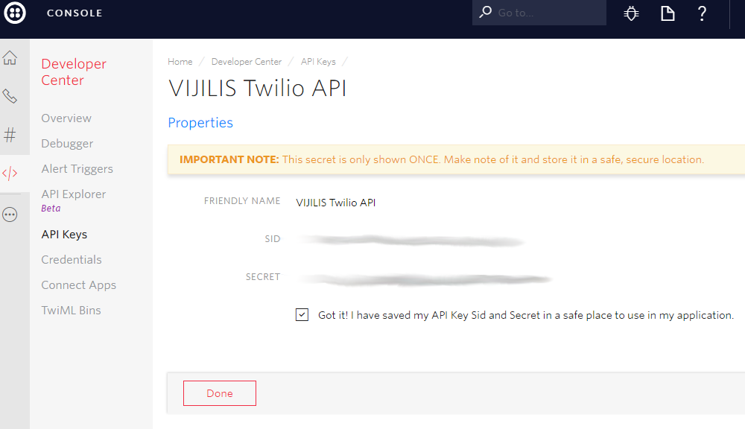
Visit http://www.wampserver.com/en/ or Sourceforge and download the appropriate executable for either x64 or x86. Run the executable and choose your installation directory.

3.2.2 Load the files to the server
First, unzip the archive on your local machine and place the contents of the ‘application’ folder into your Apache directory. In Linux, this will be /var/www/. In Windows, the Apache directory will have been set when installing WAMP.
3.2.3 Create the Database Structure in mySQL
First, log in to the mysql session on the server:
mysql -u root
If this is a fresh install, you may want to reset the root password and create a new user with access to the vijilis database. Otherwise, if you already have a new user set up, you may skip these steps.
- Reset Password: https://dev.mysql.com/doc/refman/5.7/en/resetting-permissions.html
- Add User: https://dev.mysql.com/doc/refman/5.7/en/adding-users.html
Once in the mySQL command line, you will need to create the ‘vijilis’ database. Run:
CREATE DATABASE vijilis
Then exit the command line and unzip the vijilis.zip file again. Move the ‘database’ directory to the root directory and run:
cd /root/database/
mysql -u yourusername -p yourpassword vijilis < vijilis.sql
Now, your mySQL database will be properly configured with the initial admin account in place.
3.2.4 Configure Twilio API for use with System
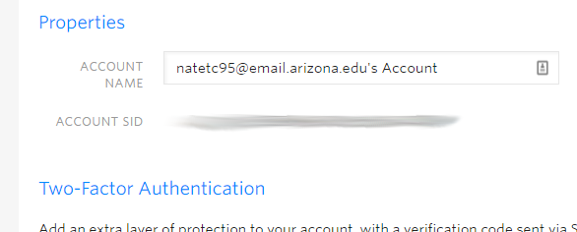
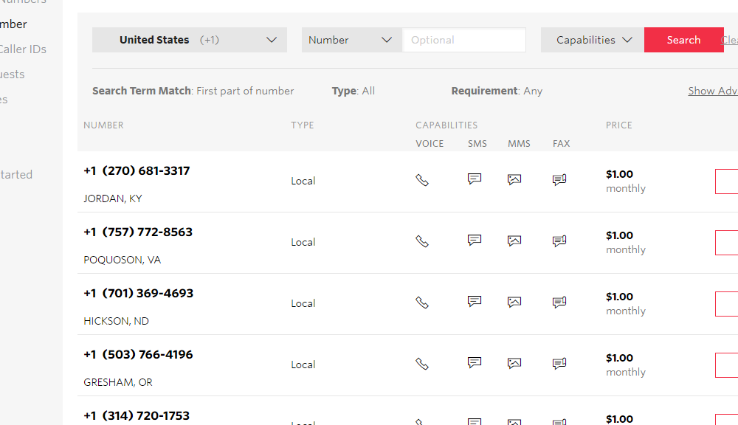
After logging into the Twilio Console, the first piece of information we need to collect is our API Key:
- Launch the Developer Center from the Side Menu (Circle w/ 3 Dots)
- Select API Keys from the secondary menu and launch
- Press the button to add an API Key pair and enter in ‘VIJILIS API’ in the ‘Friendly Name’ field
- Copy down both the SID and SECRET fields. These are the first two entries to configure the system to work with Twilio.
Next up is the Twilio Account Account SID. This token tells Twilio which account we will be accessing via our PHP scripts.
- Access the Account Page by clicking on your account name in the top right corner of the screen.
- Once in the account page, select the Account Settings option and navigate there.
- Finally, collect your Account SID from the page. This is our third entry to configure the system.
Lastly, Twilio needs a phone number to be able to send out messages to the vendors and Incident Managers in the field.
- Launch Phone Numbers from the Side Menu (Circle w/ 3 Dots)
- Select Buy A Number from the secondary menu and launch
- Then search for phone numbers within the area of operations you wish to cover and select the option for the number to have SMS capabilities.
- Choose a phone number from the list and click the Buy button. Copy down the number with the country code and no dashes or parentheses. For example, “+15555555555”. This is the fourth and final entry in our Twilio configuration.
3.2.5 Set up the configurator
The ‘controllers/configurator.php’ file handles all access handles which the system requires to operate. The first (and most important) step is to configure the system to access the new database.
$DB_HOST = 'localhost';
$DB_UNME = 'vijilis_user';
$DB_PWRD = 'vijilis_password';
$DB_NAME = 'vijilis';

Replace the strings ‘vijilis_user’ and ‘vijilis_password’ with the username and password information of the new user we just set up on the mySQL server. You will be able to confirm that the database is functioning as intended by then navigating to the index page and attempting to log in using the supplied admin account details.

Developer’s Note:
The data base can be run on a secondary server for increased security. Simply replace the string ‘localhost’ with the IP address of the configured database server.

Next, we configure the PHPMailer client to handle emailing the users.

$GLOBALS['emailToUse'] = "vijilis@gmail.com";
$GLOBALS['emailPassword'] = "myuniquepassword0";

Replace the strings ‘vijilis@gmail.com’ and ‘myuniquepassword0’ with the Gmail login of the account for use in emailing users.

Developer’s Note:
The use of Gmail is not required to function. The system can be reconfigured to use a custom email server and unique domain name other than gmail.com. This would be done by editing the controllers/verification.php file and replacing the SMTPSecure, Host, and Port variables for each of the three functions.

Next, the application needs to know where to put the files it saves on the server and where to link the users when we send them an email. For the ‘ftr’ (file to root) variable, on Linux, assuming this is the only application installed on the server, should be ‘/’. And for the ‘helpme’ variable, it should be the root apache directory such as /var/www/.
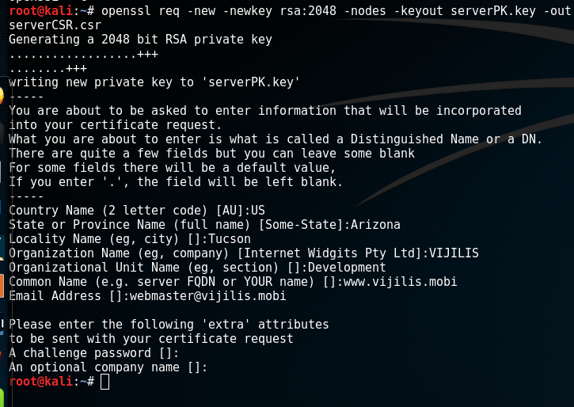
$GLOBALS['ftr'] = '/vijilis/vijilis/';
$GLOBALS['helpme'] = 'C:/xampp/htdocs/vijilis/vijilis/';

Finally, we need to set up the Twilio keys we created in the previous step (3.1.4).

$GLOBALS['twilio_usr'] = 'VIJILIS_API_SID';
$GLOBALS['twilio_pwd'] = 'VIJILIS_API_SECRET';
$GLOBALS['twilio_sid'] = 'VIJILIS_ACCOUNT_SID';
$GLOBALS['twilio_num'] = 'VIJILIS_PHONE_NUMBER';

3.2.6 Configure Apache to use SSL to encrypt data
Depending on your hosting and domain name providers, some may have in house solutions for acquiring an SSL certificate in order to encrypt the data coming out of this application. There are many Certificate Authorities and means of obtaining Certificates. Depending on deployment types and requirements, one CA may be better than another. However, these are the two better options:
- DigiCert
- LetsEncrypt
Generating the CSR via DigiCert’s online wizard:
Visit https://www.digicert.com/easy-csr/openssl.htm and fill out the required information.
Generating the CSR via OpenSSL command line:
On Linux, launch a terminal instance on the server or use SSH (Secure Shell) to access an instance.
openssl req -new -newkey rsa:2048 -nodes -keyout serverPK.key -out serverCSR.csr
Upon running the command, OpenSSL will begin to generate the RSA2048 key and CSR. The user will be asked to enter their Country, State, City, Organization Name, Department, Common Name (FQDN) and email address for contact. One may also enter a challenge password as well as their Company name for the request.
When entering the FQDN, make sure to include the “www.” unless you are planning on using a separate subdomain or issuing a Wildcard Certificate. In either case, the prefix of the FQDN will change.
This command will generate a .key file and a .csr file. Once you have the CSR file, you can import the contents into the Certificate Authority of your choice and they will begin the process of certifying your domain name and granting an SSL Certificate. Once you have successfully received your SSL certificate files, its time to add them to Apache:
Adding your certificate to the Server on Linux:
- Enable the SSL module of Apache by running:
sudo a2enmod ssl
- Create a new folder in the Apache configuration directory called ssl
sudo mkdir /etc/apache2/ssl
- Copy your certificate files here as well as the private key file we generated in the last step.
- Open the Apache configuration file
sudo nano /etc/apache2/sites-available/default-ssl.conf
- Change following items under the <VirtualHost _default_:443> block:
ServerAdmin <your-email>
ServerName <your-domain.com> ← you will need to add this line
ServerAlias <www.your-domain.com> ← you will need to add this line
DocumentRoot /var/www/
SSLCertificateFile /etc/apache2/ssl/yourCert.crt
SSLCertificateKeyFile /etc/apache2/ssl/yourKey.key
- Enable the SSL virtual host:
sudo a2ensite default-ssl.conf
- Restart Apache
sudo service apache2 restart
Adding your certificate to the Server on Windows:
- Place your certificates in the WAMP directory:
<path/to/wamp>/bin/apache/apache2/conf/demoCA/certs
- Place your keys in
<path/to/wamp>/bin/apache/apache2/conf/demoCA/private
- Edit httpd-ssl.conf file and for the following lines:
SSLSessionCache “shmcb:<path/to/wamp>/logs/scache(512000)”
DocumentRoot “<path/to/wamp>/www”
SSLCertificateFile <path/to/wamp>/bin/apache/apache2/conf/demoCA/certs/yourCert.crt
SSLCertificateKeyFile <path/to/wamp>/bin/apache/apache2/conf/demoCA/private/yourKey.key
Developer’s Note:
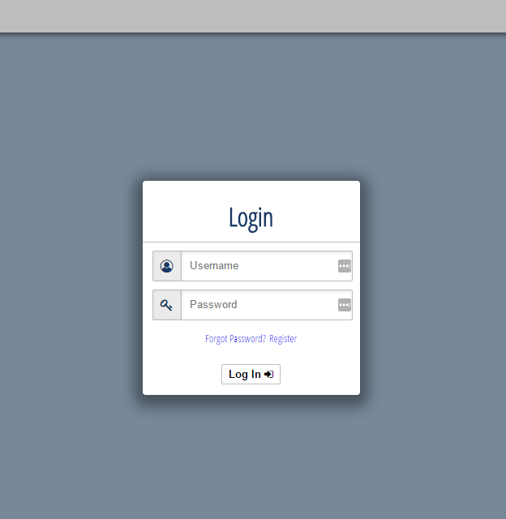
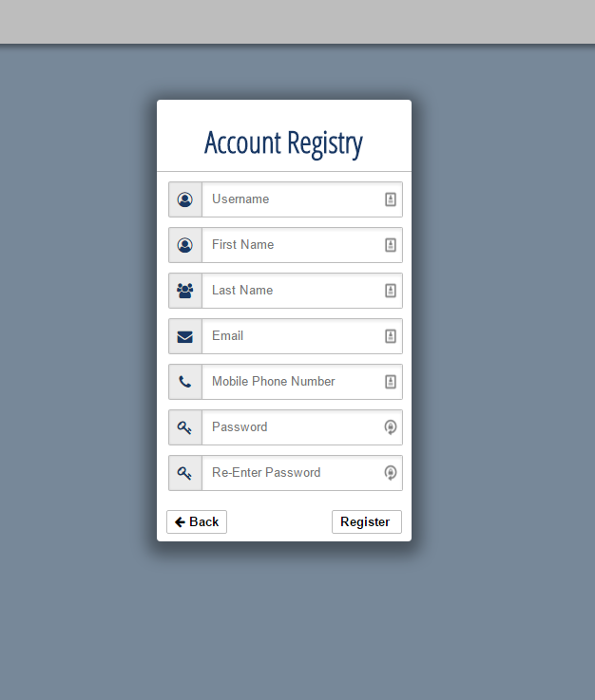
The use of SSL is required to use many of the functions included in the system such as Geolocation, Email, and the Twilio API. This is a requirement of each of the providers.

3.2.7 Finishing up
Notes:
- In order to complete the SSL process, you will have to have already pointed your domain name at the server you are using by editing the records at your Domain Service.

3.3 Starting and Stopping the System
In order to start the system, the user must start Apache.
sudo service apache2 start
In order to stop the system, the user must stop Apache:
sudo service apache2 stop
4 General Interface Instructions
4.1 Logging In
- Forgot Password
Once the user clicks this button, they will be asked to enter their email or username and will then be sent an email with a unique link for them to reset their password.
- Registration
1
2
Once the user clicks this button, the user will be asked to enter the following:
3
- Desired Username
- First Name
- Last Name
- Email
- Phone Number
- Password
  - 1 Capital Letter
  - 2 Numbers
  - 1 Special Character
  - Length 10
- Logging In

