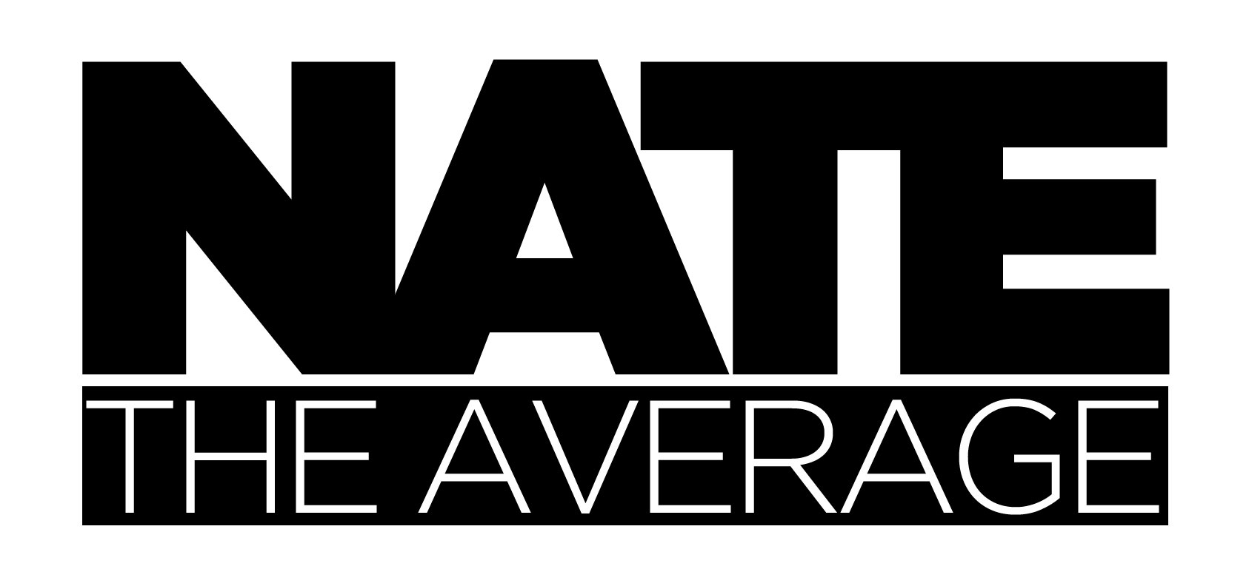
Born: Nathan I.A. Leite / Lie-Tee
Phone: 1-720-560-6882
Location: Denver Colorado
www.NateTheAverage.com
Email: NateTheAverage@gmail.com
PHP Full Stack Design & Development – Laravel Focused - $('nate').favoriteJSLibrary().set('vue.js')

For your consideration...
I am not a writer so summarizing the total package of Nathan Leite is a daunting task, nevertheless. I tend to befriend everyone in my day to day, and many times end up creating lasting bonds. My spare time is often spent educating myself and exploring innovative concepts so that I may share the knowledge. I have as much experience with Photoshop, as I do writing PHP, as I do writing JavaScript as I do developing motion graphics in After effects. I could go on but you get the point. I am exactly the same way with my performance arts, in which I have found much success. An eccentric problem solver, that sees art in code, hence a Laravel / Vue love affair. No need to look any further I am the team asset you are seeking.

Some quick working stats...
11+ Years Professional Experience | 2 Full Time Corporate Employers
3 Part Time Corporate Employers | 20+ Independently Contracted Clients

My personal employment utopia would be...
A career that embraces and encourages my thirst for creating smart memorable experiences using my preferred frameworks. Utilization of my balanced right and left brain by setting forth objectives that require elegant code and/or awesome design solutions. Partial location flexibility in that sitting with a team is highly efficient and remote work can fuel creativity.

Lets get nerdy...
natetheaverage@root
@root: ~/ cd NateTheAverage/Skills
@root: ~/NateTheAverage/Skills (development) $ ls
HTML CSS PHP JS MYSQL LARAVEL VUE FLASH REACT JQUERY HOMESTEAD SASS LESS STYLUS GULP ELIXIR COMPOSER NODE TERMINAL LINUX iOS WINDOWS SUBLIME ATOM STORM WORDPRESS GIT
…
@root: ~/NateTheAverage/Skills (design) $ ls
MOTION GRAPHICS UX WIREFRAME TEMPLATING LOGO ADOBE SUITE MS OFFICE THEATRICAL[DANCE,COSTUME,THEATER,VARIATY,CIRCUS]
…
@root: ~/NateTheAverage/Skills (methods) $ ls
RESTFULL AGILE SOLID | PATIENCS INOVATION DRIVE THIRST FOR LEARNING & TEACHING

foreach( $Qualities as $Quality ) {
if( $Quality > $Amazing ) {

$goodList = array_push( $Quality->name )

} elseif( $Quality < $Amazing ) {

$notSoGoodList = array_push( $Quality->name )

}
}

echo $goodList;
// Unique, Friendly, Constantly Improving, Empathetic, Wise, Forward Thinking, Driven, Patient, Eager

echo $notSoGoodList;
// Difficulty giving up, Tenacious About 'New', English Spelling, Overly Confident, Poor Self Promotion, A Dreamer

Some more detailed working history..

10/2014 FULL-STACK DEVELOPER (Laravel focus) - Independent Contractor, Denver, Co.
Laravel {Homestead), Vue, React, JQuery, ES6, Gulp, sass/stylus, Linux, git. MySQL,
Terminal, API service creation and utilization, WordPress maintenance under disdain
Developing several app's and working with small contract positions.
2011-Present THEATRICAL DIRECTOR / COSTUME DESIGNER / ACTOR –
The ACT Las Vegas, Esque @ DBA Hollywood, The Box NYC & London
Full time performance art. $90k / year (want more? NateTheAverage.com)
05/2010 – 07/2011 UI DEVELOPER - The Villager Today, Denver, Co.
Part time contract position.
07/2009 - Present FULL-STACK DEVELOPER (Wordpress focus) - Contractor, Denver, Co.
Wordpress as a framework, JQuery, JSON.
Some clients include, GoFast, VisitDenver, Comcast
12/2007 – 09/2009 INSTRUCTIONAL DESIGNER/DEVELOPER II – Dish Network, Englewood, Co.
Web based instructional design, built with SCROM compliance.
06/2007 – 12/2007 FLASH DEVELOPER – National CinaMedia, Denver, Co.
Part time contract flash designer.
05/2007 – 08/2007 FLASH UX DEVELOPER - Digital Media Communications, Denver, Co.
Temporary part time position.
10/2006 – 05/2007 FLASH DESINGER / .NET – LION Inc., Denver, Co.
Full time Retail web design.
07/2004 FLASH DEVELOPER - Independent Contractor, Denver, Co.
Time-line animation, .AS 2/3 programming, Full sites, Components, Intros,
XML feeds, banners, .FLV compression, JS, HTML, CSS

To Whom It May Concern:

I have known Nathan Leite for the past two years. He was the Senior Flash and Video developer on my courseware development team from 2007-2009. He has a great sense of creativity and passion for his craft. Nathan was always willing to put in the time and effort to complete his projects under tight and ever-changing deadlines. He is always up-to-date with the latest technologies and trends in design and development. He exhibited great patience when it came to working with the non-technical members of our team. He was able to communicate with them in a manner in which they could relate. In addition, he taught junior developers Flash and Adobe After Effects, sharing his resources and best practices.
I recommend him for employment with no reservations. Please contact me if you need further information.
Sincerely,
Julie Lavorini
Manager, Training & Development
DISH Network – Sales Channel Training

To Whom it may concern,

Please accept this letter on the behalf of Mr. Nathan Leite.
I have had the pleasure of hiring Nathan for a graphic support position at Lion Inc. During his tenure, Nathan has proven himself to be a resourceful and creative team member.
He brings to the table a formidable skill set: he is a talented designer and has worked hard to become very skilled with Flash. He was also extremely forthright in sharing his extensive knowledge with the team. Nathan is calm under fire and was very helpful in relieving the team of many projects when they were heavily burdened.
I have also had the opportunity to have Nathan work on an interactive Flash side project, which my company, Vid2r, LLC has been using to serve our customers since March 2007.
If you have any questions, please do not hesitate to call me at 303.725.6516.
Sincerely,
Marianne Yates
Team Lead + Sr. Web Designer
LION, Inc

To Whom It May Concern:

Nathan Leite worked under me as a Web Developer at LION Inc., a technology solutions company for mortgage brokers. While under my supervision, his responsibilities included doing most of the text, CSS and graphic maintenance and updating of the 4,000 sites that Lion hosted. Nathan also was our primary flash developer, creating inventive and creative custom flash animations/applets for out clients.
Upon his arrival at Lion, Nathan bonded with our team almost immediately and quickly became an asset and key player in the work flow of our group. We soon discovered that Nathan is a dedicated and adept problem solver. Many times someone in our group came to him with a problem that they were stuck on and time and time again he came up with timely, inventive solutions. His Flash skills are top notch; having seen him work on dozens of projects, each with very specific and challenging specifications, I don’t believe that there is anything Nathan can’t accomplish with Flash. Over the time he worked under me, he became my “go-to guy” when I needed a difficult task done.
One example comes to mind: one of our biggest clients came to us with a complicated digital video project with a tight timeline and enormous spec-sheet. I gave the project to Nathan, knowing that it was a nearly impossible situation, but Nathan took it upon himself to rise to the occasion and meet the deadline with an end product that our client was thrilled with. He worked quickly and tirelessly until the project was complete and even helped the client set up the equipment needed to display the project at the trade show.
Nathan is gregarious and easy to work with. He is sharp and competent in general, and is proficient with Photoshop, HTML and CSS. He can handle difficult clients and deliver results. I would highly recommend him for a position within your organization. Please let me know if I can provide you with any further information.
Respectfully,
Brady Fossen
Product Manager eToys Direct

