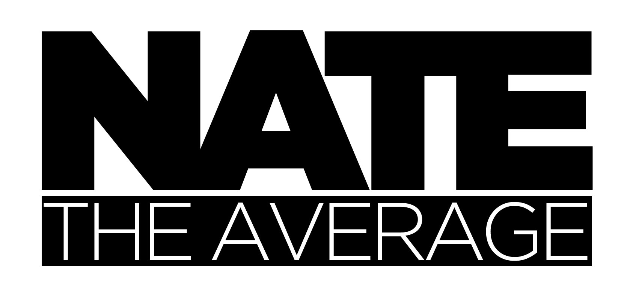
WEB & THEATRICAL PRODUCTION
HTML – CSS - PHP – JS – MYSQL - LARAVEL – VUE – FLASH
COSTUME – SCRIPT - DIRECTION – DANCE – VARIATY ARTS
MOTION – UX – GRAPHIC – WIREFRAME – BACKEND - LOGO
SPECIAL FX MAKEUP – MASKS – INSTALATION ART - PROP
DANCE – STILT – IMPROV – SKIT – CIRCUS - ATMOSPHEARIC
INOVATION – RESTFULL – AGILE – SOLID – UNIQUE SOLUTIONS – PATIENCS – DRIVE – KEEP BOUNCING
Denver Colorado (720) 560-6882

I recall a story written by an old schizophrenic man he wrote about doing impossible things. He was convinced that if you kept at it and didn't waste your time waiting you were 98&¾% guaranteed to accomplish your goal. He wasn't wrong! Hi my name is Nathan Leite and this is one sheet about me!
I love to learn stuff, make things, and create moments. So thats what I do.
12+ years working in web & media development, in and out of corporations.

I started with Flash Action Script which blew my mind and it was my first exposer to object oriented programming. These days I am enjoying Laravel and Vue.js largely due to their elegance and available resources.
Bboy (break-dancing) 18+ years. Performance artist and costume designer 9+ years.
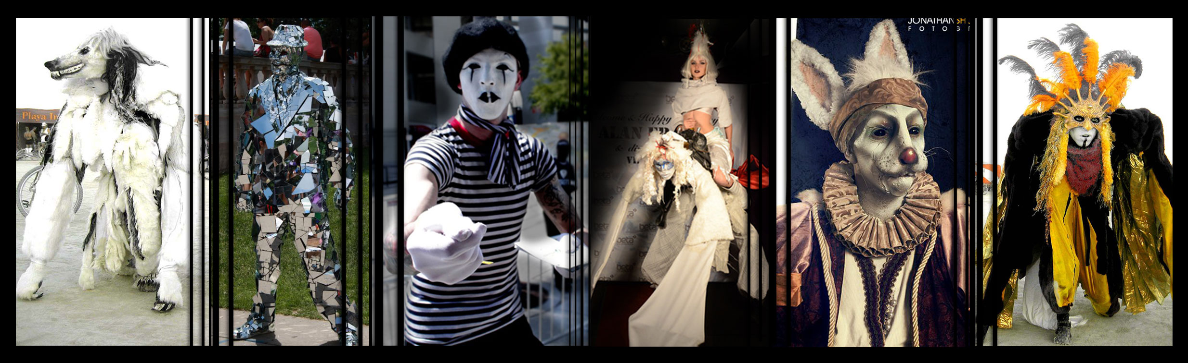

Not just a hobby! I have toured the world since 2008 performing my characters for the largest events and alongside world renounced artists. I have held residency as a Director/Performer in Las Vegas, Hollywood Ca, New York NY, & London England.

I am the Father of two AMAZING boys!
So I find myself back in Colorado growing a family.
Lets Collaborate!

Want all the Nate? www.NateTheAverage.com
Call/Text 1-720-560-6882 (AnySocialNetworkingSite).com/natetheaverage natetheaverage@gmail.com

