|  |
| --- |
| Nuclear Site Suitability Analysis for Wisconsin |
| Nathan Walker |

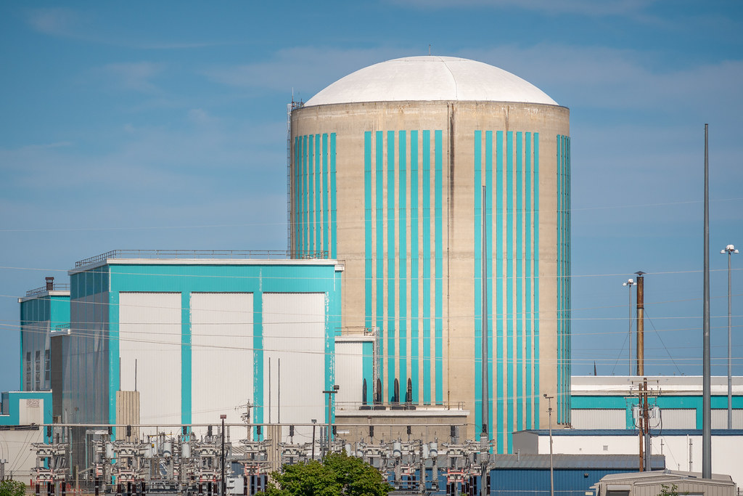

### **Background**

The climate of the world is being transformed, due to the mass burning of fossil fuels and other carbon-contributing sources. One of the major contributors to this crisis is the energy industry. The world is using more and more power, and as a result increasing levels of carbon emissions are being produced (Barnes et al. 2013). While some companies are switching to solar wind, or the only slightly better alternative of natural gas, nuclear power is largely being ignored. (Parson et al. 2019). In Wisconsin there are three nuclear sites, and only one of these is currently in use. This one plant however, produces 14% of the state’s power (Zukas 2013). Nuclear power has potential, along with other sustainable energy sources, to mitigate the carbon emissions while generating energy.

In order to potentially build new nuclear plants however, many different criteria need to be considered. By using GIS and site suitability analysis, this study seeks to identify potential places in Wisconsin that could act as sites for future nuclear plants. Site suitability analysis has enormous potential for identifying locations in energy infrastructure development, as demonstrated by Jain and Subabaiah in their analysis of potential sites for solar panels (2007). This study applies some of the same methods towards identifying potential locations for building nuclear plants.

## Methods

In order to identify areas suitable for constructing a nuclear power plant, a binary site suitability model was constructed, similar to the methods used by Jain and Subabbiah (2007). The following criteria were inferred from the International Atomic Energy Agency, and then data was obtained from various sources (Siting of Nuclear Facilities).

* **Proximity to Heat Sinks**

In the event of overheating, nuclear power plants rely on external cooling systems to relieve excess thermal energy. The most common forms are large lakes or rivers, but these may be supplemented by water towers or other storage facilities. For this study, a large lake was defined as waterbodies and rivers that have a total surface area exceeding 100,000 square miles. Any area within one mile of these large waterbodies was considered to have appropriate access to the heat sink. For this data, the 24k Hydrography dataset was used from the Wisconsin DNR.

* **Slope**

Nuclear plants cover a large amount of area, and to minimize costs of pouring concrete, a relatively flat surface is desired. Generally, areas with less than a 10% slope are considered appropriate for building large structures. To calculate the slope, the 30- meter Digital Elevation Model (DEM) was obtained from the Wisconsin DNR.

* **Access to Major Roads**

Access to a major road or highway is essential for the logistical operations for a nuclear power plant. Workers need access in order to commute, while large trucks and other automobiles hauling inputs or nuclear waste require large roads. To limit new road construction and mitigate costs, only areas that were within five miles to a major road were included. The major roads dataset from the U.S. Census was used for this criterion.

* **Conservation Areas**

As with building any new project, the surrounding ecology needs to be accounted for. This proves even more critical when dealing with nuclear consequences, where a meltdown could potentially cause disastrous impacts on the surrounding wildlife. Areas of concern environmentally were identified through the Wisconsin DNR Conservation Opportunity Areas dataset.

* **Distance from Urban Centers**:

Nuclear power plants are required to be distanced from urban centers, to protect the lives of civilians in the event of a reactor meltdown. Despite examining numerous sources that provided varying degrees of distance based on varying factors beyond the capabilities of this study to define. Instead, the distance was simplified to 20 miles, commonly used for risk assessment.

* **Seismic Activity**

Earthquakes pose one of the greatest potential threats to nuclear power plants and were in part responsible for the meltdown in Fukushima. Nuclear plants need to be built in locations with relatively little seismic activity. Initial geospatial processes were run using the earthquake dataset from USGS but was ultimately excluded from the final analysis. No significantly sized earthquakes capable of impacting a nuclear plant have occurred in Wisconsin.

Once the criteria were specified and data was obtained from the respective sources, a combination of tools were used from ArcToolbox in ArcGIS Pro software. Figure 1 displays the complete model and showcases all geospatial processes performed in the analysis.

*Figure 1*

Initially, vector layers were projected into a common coordinate reference system, 1983 HARN Transverse Mercator. Once this was completed, each criterion dataset had different steps taken before converting the vector layer into a raster. The raster layers were then reclassified into a binary format, being assigned a 1 if the cell had a desirable characteristic, or a 0 if not. These rasters were then overlaid and assigned the summed value of the cells, creating a suitability index with 5 as the most desirable and 0 as the least. Finally, the rasters were then clipped to the extent of Wisconsin, the area of interest for this study.

*Figure 2*

**Results:**

Several areas are capable of potentially having a nuclear plant built. Figure 2 displays the final analysis in map form, along with the pre-existing nuclear power plants. Spaces that are incapable of supporting a nuclear plant are shown in yellow and green, while more optimal locations are shown in shades of blue. One of the immediate notable regions are the northern woods of Wisconsin. While these areas fit all of the specified criteria, building a nuclear plant here would be unwise due to the remote nature of the landscape.

Disregarding these results, three other locations are identified by this analysis. The tip of Door peninsula is distant enough from any major urban centers, while still retaining access to the lake and road infrastructure. However, Door County is a popular tourist destination. The stigma of nuclear power could drive potential tourists away from the area, as well as decrease the natural appeal of the environmental landscape.

Another of the three potential locations identified by our analysis lies in Central Wisconsin, on the Black River. Surrounded by small towns, this area could support a necessary workforce while not being too distant from infrastructure to cause construction or logistics to be difficult. The

Black River is not the largest river, but when supplemented by water tanks or other potential sources, should serve as an ample heat sink source.

The final potential site for a nuclear plant is located on the western border of Wisconsin, on the Mississippi River. The proximity to Minneapolis could prove promising, providing jobs for commuting workers, and acting as a potential power source for the city. It is distant enough to accommodate the risk of a meltdown occurring, but not isolated as a result.

**Conclusions:**

This analysis provides a broad and limited overview over the entire state of Wisconsin but has its limitations. This model proposes four main potential sites for a nuclear plant but, given the constraints of the model, these may not be optimal locations. Context is the ultimate decider for decisions such as nuclear power plants. However, this method of analysis can produce places to begin looking. The model can be improved through additional criteria and refinement for future analyses to obtain more complete results. To exclude places that are too remote, such as the northern woods of Wisconsin, an additional buffer could be run and clipped by the buffer used for urban centers. This would create a ring effect for the optimal distances that are distant enough to avoid potential risks, but not too far that the location becomes remote and inaccessible.

Increasing the number of criteria would further refine the results of the model. Accounting for the risk of floods for example, would help mitigate the risk of damage to the structure. There are numerous possible criteria that could be desired and would be relatively simple to add to the original model. As technology advances, and the criterion for nuclear plants becomes laxer as a result, inputs could also be removed from the model and broaden the potential areas.

As the climate continues to transform the environment, the pressure on energy companies to convert to alternative sources of energy has increased. At the rate that solar and wind energy are being produced however, and to support a higher electricity consumption, nuclear power may be the best answer. In order to change stigma and to implement nuclear power properly and safely, further analysis such as the one performed in this study are needed.

**References**

Barnes, J., M. Dove, M. Lahsen, A. Mathews, P. McElwee, R. McIntosh, F. Moore, J. O'Reilly, B. Orlove, R. Puri, H. Weiss, and K. Yager. 2013. Contribution of anthropology to the study of climate change. *Nature Climate Change* 3 (6):541–544.

Brennecke, P. 2013. Licensing procedures for nuclear installations. *Managing Nuclear Projects* :255–281.

Jain, K., and Y. V. . 2007. Site Suitability Analysis for Urban Development Using GIS. *Journal of Applied Sciences* 7 (18):2576–2583.

Parsons, J., J. Buongiorno, M. Corradini, and D. Petti. 2019. A fresh look at nuclear energy. *Science* 363 (6423):105–105.

Siting of Nuclear Facilities. *International Atomic Energy Agency*. https://www.iaea.org/topics/siting (last accessed 7 May 2021).

Zukas, K. J. 2018. No conflict, no coverage: Media misses repeal of nuclear energy moratorium. *Cogent Social Sciences* 4 (1):1444909.