5 Guys Consulting

Charles Bud

BP Burger

4/9/2026

Table of Contents
Table of Contents ii
1 Project Background 1
1.1 Problem/Opportunity Description 1
1.2 Benefits 1
1.3 Goals 1
1.4 Stakeholders and Clients 1
2 Project Scope 2
2.1 Objectives 2
2.2 Deliverables 2
2.3 Out-of-Scope 3
3 Project Plan 4
3.1 Approach and Methodology 4
3.2 Project Timeline 4
3.3 Critical Path 4
3.4 Context DFD 4
4 Appendix A- Additional Information 5
4.1 Assumptions 5
4.2 ???? 5
4.3 ???? 5
4.4 Etc 5

- Project Background
  - Problem/Opportunity Description
BP Burger is experiencing an increase in demand that its current systems can’t handle. These systems include:
- Inventory Management – Inventory is not being accurately tracked, leading to wasted ingredients and the risk of customers being served spoiled or unavailable items.
- Order Management – Orders are taken by hand on paper and transferred to the kitchen. This process is slow and prone to errors during busy hours.
- Point of Sales – Transactions are handled manually using a cash register and handwritten tickets, which slows service and increases errors. The system also does not collect detailed sales data.
- Forecasting – There is a lack of reliable sales and demand data, making it difficult to predict inventory needs and customer trends. As a result, ordering is reactive rather than data-driven, leading to overstocking, stockouts, and inefficient supplier orders.
  - Benefits
With a better system in place, they can:
- Track Sales to see frequent orders
- Forecast supplies to see what is needed in the future
- Online Inventory management to ensure all supplies are used
- Automatic reordering to get supplies on time
- An online point of sale system to track all orders
- Ensure correct ingredients, as this increases customer satisfaction
- Track customer satisfaction

  - Goals
We want to bring an online system that integrates different business operations to limit mistakes in orders, inventory, and forecasting. The system will limit cost spending and should provide a more efficient and profitable business model.
  - Stakeholders and Clients

- Going through with this project requires the owner and the server to support and be involved with this
- The people outside of this project who would have an interest would be the customers, since their orders would be more accurate
- The people who will be affected by this are the owner, server, supplier, and customers.
- The people that will be affected if this is not undertaken are everyone: the owner, server, customers, and supplier.
- Project Scope
  - Objectives
Objectives are the components or parts of a project – the first level of a work breakdown structure. They describe what will be accomplished – when all objectives are complete, the goal is met. Objective statements will clarify the boundaries of the purpose statement and define the boundaries of the scope of the project. They should be clearly written, specific, and describe a tangible, measurable change.
The most obvious objectives in your project are likely to be great efforts like “developing an application” or “documenting a process.” However, a successful project will define critical components of work that support the change, both at the client level and within a service team. Here are a few useful objectives to consider building into your project:
- Requirements gathering process, with a resulting list of client requirements.
- Implementation plan – if you do not know what product or approach will be taken (especially if you will have a procurement process), consider breaking the work into phases. Phase one gathers requirements, phase two implements the solution. In between, you create a plan for implementing the selected solution – this becomes your project plan for phase 2.
- Service definition
- Handoffs / recommendations to other teams.
- Security – what is your plan for ensuring adherence to business and divisional security policies and practices (and governmental policies if applicable)
- Accessibility incorporation – what is your plan for ensuring accessibility for users with disabilities, including the use of accessibility tools?

Objectives:
      - Gather Requirements – Meet with stakeholders to define and document requirements for inventory, ordering, POS, and reporting.
      - Document Current Processes – Visually map out how current processes work, noting inefficiencies and errors.
      - Design New System – Create a high-level diagram showing how the new system will work together.
      - Build an Inventory System – Make a system that tracks inventory accurately and efficiently.
      - Build Order Management System – Create a digital system for entering and sending orders directly to the kitchen.
      - Implement POS System – Set up the POS system to process transactions and collect data.
      - Add Reporting/Forecasting – Create a reporting system from the data collected.
      - Create Implementation Plan – Make a plan for rolling out the system and making the transition from the old processes.
      - Ensure Data Accuracy – Set up systems to make sure the inventory and sales data are accurate. Test the system to see if it is.
      - Define Security Controls – Implement access controls and data protection.
      - Train Users – Train Bud and Pearl on how to use the new systems.
- Deliver Documentation – Provide standard work for all processes and systems implemented, including troubleshooting or maintenance processes.

  - Deliverables

- Point of Sale (POS) System
Description: A digital POS system that replaces handwritten order tickets and the current cash register
- Functional Specifications:
    - Capture customer orders electronically
    - Automatically calculate totals and process payments
    - Send orders directly to the kitchen for preparation
- Requirements Analysts:
    - Must be simple and easy for Pearl to use as the primary user
    - Must reduce order errors and improve the speed of service
    - Must store transaction data for reporting purposes
- Inventory Management System
Description: An electronic system to track all inventory levels in real time
- Functional Specifications:
    - Track incoming deliveries and daily usage automatically
    - Update inventory levels based on sales data
    - Provide alerts for low stock levels
- Requirements Analysis:
    - Must replace the manual stock logs maintained by Bud
    - Must accurately track both perishable and non-perishable items
    - Must reduce inventory errors and improve ordering accuracy
- Automated Supplier Ordering System
Description: A system to support accurate and timely ordering from suppliers
- Functional Specifications:
    - Generate suggested order quantities based on inventory levels and usage
    - Track order history and delivery schedules
- Requirements Analysis:
    - Must reduce errors caused by manual ordering
    - Must ensure sufficient inventory without overstocking
    - Must align with delivery schedules
- Sales Reporting System
Description: A reporting tool that provides insights into sales performance
- Functional Specifications:
    - Generate daily, weekly, and monthly sales reports
    - Identify best-selling items and trends
- Requirements Analysis:
    - Must provide Bud with accessible and accurate sales data
    - Must support better decision-making and business planning
    - Must replace manual sales logs
- Forecasting Capability
Description: A basic forecasting tool to predict demand based on historical data
- Functional Specifications:
    - Analyze past sales to estimate future demand
    - Support inventory planning and purchasing decisions
- Requirements Analysis:
    - Must help reduce stockouts and excess inventory
    - Must be easy to interpret and use by the owners
- Data Migration and System Setup
Description: Transfer of relevant existing data and configuration of the new system
- Functional Specifications:
    - Input key inventory and sales data into the system
    - Customize system settings to match BP Burger operations
- Requirements Analysis:
    - Must ensure continuity of operations during transition
    - Must accurately reflect current inventory and business processes
- User Training and Documentation
Description: Training and support materials for system users
- Functional Specifications:
    - Provide hands-on training for Bud and Pearl
    - Deliver simple user guides and instructions
- Requirements Analysis:
    - Must be tailored to users with limited technical experience
    - Must ensure smooth adoption of the new system
- System Testing and Implementation
Description: Testing and final development of the system
- Functional Specifications:
    - Test system accuracy for orders, inventory, and reporting
    - Deploy the system for daily use
- Requirements Analysis:
    - Must ensure system reliability before full implementation
    - Must minimize disruption to daily operations
- Post-Implementation Support
Description: Ongoing support after system launch
- Functional Specifications:
    - Provide troubleshooting and system updates
    - Address user feedback and system improvements
- Requirements Analysis:
    - Must ensure long-term usability and effectiveness
    - Must allow for adjustments as business needs evolve

  - Out-of-Scope
Purchasing hardware and renovating to accommodate it
- Computers, tablets, printers
- Installing upgraded electrical or Wi-Fi
- Remodeling to make space for the new equipment
Payroll and employee tracking system
- Time tracking system
- Payroll system or tax reporting tools
- Employee scheduling
Supplier relationships
- Changing delivery schedules
- Adjusting pricing
- Making new contracts
Changing food prep workflows
- Employee training on how to prioritize orders
Inventory
- Reorganizing inventory
- Implementing inventory with the new system
- Managing non-perishable inventory

- Project Plan
  - Approach and Methodology

The project will follow a structured Systems Development Life Cycle (SDLC) approach to ensure an organized and effective transition from BP Burger’s paper-based processes to a fully functional electronic system. The strategy is to move sequentially through planning, analysis, design, development, testing, and implementation while maintaining continuous communication with stakeholders (Bud and Pearl) to ensure the system meets their operational needs.

The project will begin with requirements gathering, where interviews and observations will be conducted to fully understand current workflows, pain points, and desired system capabilities. This will be followed by system design, including the creation of Data Flow Diagrams and Entity Relationship Diagrams to map out how data will move through the system and how it will be structured. Once the design is finished, the team will move into development, where the database and application system will be built based on the approved specifications.

After development, the system will undergo testing and debugging to identify and correct any errors, ensuring accuracy in inventory tracking, order processing, and reporting. A pilot implementation will be conducted to gradually transition from the paper-based system to the electronic system, minimizing disruption to daily operations. Finally, the project will conclude with full implementation and training, ensuring that Bud and Pearl are comfortable using the new system, supported by clear documentation.

The primary tools used for this project will include database management software like MySQL, programming tools for system development, and diagramming tools like Lucidchart for DFDs and ERDs. Excel may also be used for initial data analysis and forecasting.

In terms of resources, the project might require the procurement of basic hardware, like a computer or tablet for order entry and inventory management, as well as a modern point of sale system capable of capturing transaction data. If necessary, limited external support or consulting services may also be utilized for system setup or technical troubleshooting. However, the overall approach emphasizes cost-effective solutions appropriate for small, family-owned businesses while still delivering significant improvements in accuracy, efficiency, and decision-making capabilities.
  - Project Timeline
Using the template provided below or project planning software, indicate the tasks necessary to complete the project. Determine and provide your formula to calculate estimates of duration (add more rows as necessary). The formula should represent your confidence in the time estimate.

ID | Task Name | Start | Finish | Duration
A | Plan/CPM | 0 | 3 | 3
B | Requirement Gathering | 4 | 8 | 4
C | DFD | 9 | 14 | 5
D | ERD | 15 | 17 | 2
E | Create Database | 9 | 13 | 4
F | Programming | 18 | 22 | 4
G | Testing/Fixing | 23 | 25 | 2
H | Implementation | 26 | 28 | 2
I | Final Documentation | 29 | 32 | 3

  - Critical Path

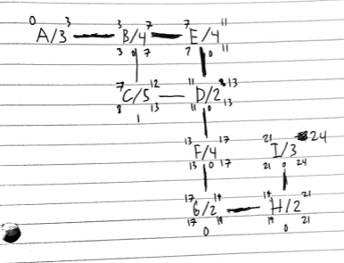
  - Context DFD

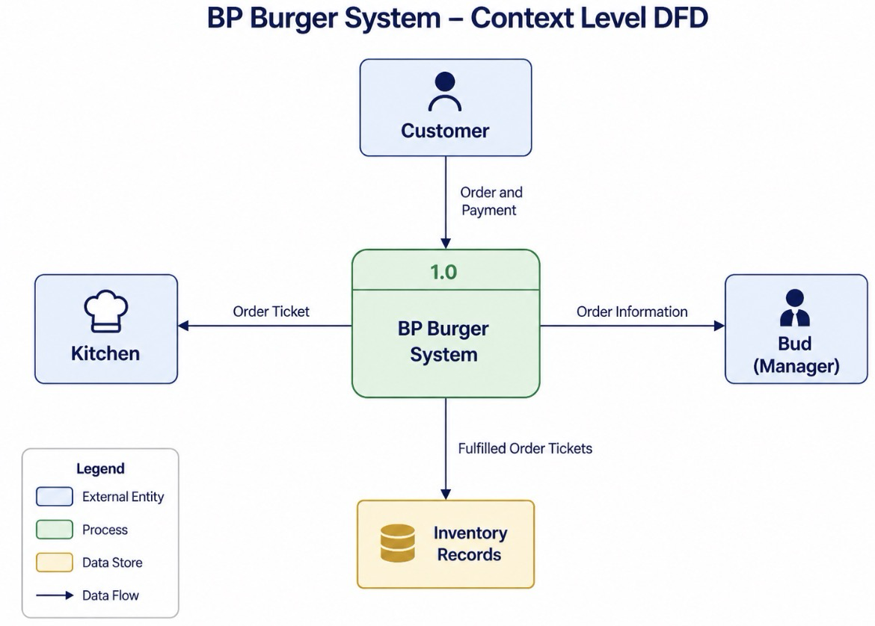
- Appendix A- Additional Information
  - Assumptions
  - Interview Questions
  - Suggestions

- Do not rush the training when it comes to learning the new system.
- Listen to the employees thoughts on the the new system, they will be the ones also using it.
  - Etc

