Namana K.D. Saikiran 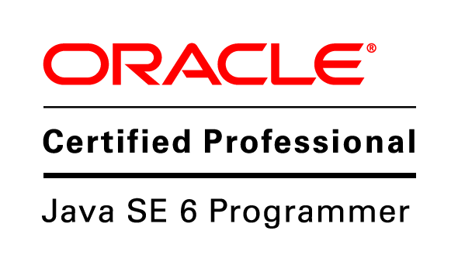

Email: nkdsai92@gmail.com Mobile:+91 8121522935

Profile
- 3.2 years of IT experience on Java/J2EE technologies.
- 3.2 years of experience in Telecom Domain as a Java Developer.
- Experience in Solution Design & Development of Prepaid Telecom OSS/BSS solutions with Intelligent Networks using Java, J2EE, and Oracle Technologies on different operating systems.
- Good Communication Skills.
- Experienced in writing SQL and shell scripting.
- Established and maintained a productive working relationship with management and team members.

Technology Skills
- Java base: Java, J2EE, Servlets, JSP, JDBC, Struts 1.X, Having knowledge on Web Services.
- Servers: OC4J, WebLogic Application server.
- Tools: J-Developer, SQL loader, Rational Clear Case, Eclipse.
- Operating Systems: Windows XP/7, UNIX.
- Database: Oracle 10g/11g
- Languages: PL/SQL, JAVA, Unix Shell scripting

Key Contributions
- Launched several Business critical functionalities & rollouts for TATA Tele Services LTD.
- Designed an end to end solution for service management module in Multi Channel Architecture with implementation of innovative features like Auto re-fire and Load Balancing and ensured Zero SLA slippage with very low maintenance cost.
- Having experience in production support activities like resolving production issues, performance improvements and communicating with users.
- Implementing JNDI and migrating applications from OC4J server to WebLogic Server to overcome VAs with server.
- Having Experience in attending meetings with RM’s and other teams for the discussion of Business requirement changes to the existing Module.
- Key Role in giving knowledge transformation sessions to new trainees to have better understanding about the project and Module.
- Experience in Code reviews and suggesting required changes to trainees.

Appreciations
- Received several Client Appreciations for implementing various process improvements in several functional areas in different technologies of GSM and CDMA like Loyalty rewards processing, SMS BAL, Terminating Triggers updation applications.
- Got Star Performer award for key role in migration of applications from OC4J server to WebLogic Server.

Domain Expertise:
- Interfaces to Intelligent Networks (Telcordia).
- CDMA, GSM, VAS, DND services of Telecom.
- CORBA IN API testing.
Education
Degree | University/Board | Year | Percentage
B.Tech(E.E.E) | University college of Engineering, JNTUK | 2009-2013 | 77.07
Intermediate | INTERMEDIATE BOARD OF EDUCATION, A.P | 2009 | 95.70
SSC | BOARD OF SECONDARY EDUCATION, A.P | 2007 | 89.50
Achievements
- Oracle Certified programmer for java 6.0 (OCJP 6.0).
- Recognized and appreciated by client and higher management with the star performer of the month in TCS for my commitment in different situations.

Career Profile
Dates | Organization | Designation / Role
30th July 2013 to till date | TATA Consultancy Services | System Engineer/Programmer

Projects involved in TCS TTSL Client Assignment
Project # 1 | GSM Service for TTSL (TATA DOCOMO)
Client | TATA Teleservices Limited
Description | TTSL is launching GSM services pan India and this project deals with development of New OSS/BSS Interfaces from MCA towards new Telcordia GSM IN for Activation of prepaid subscribers on IN, Service Management scenarios, EVD, VAS real-time charging for prepaid GSM customers. This project is an extension to existing MCA project which handles CDMA services.
Role | Programmer
Solution Environment | J2EE, CORBA, SQL, UNIX, TIBCO  Oracle 10g App Server on Linux.  Oracle 10g Database in RAC mode,  Telcordia IN
Tools | JDeveloper 10.1.2 SQL Developer, SQL Loader, Rational Clear Case
Responsibilities | - Requirements analysis. Participated in IN Workshops and various discussions with TTSL IT Team and Telcordia vendor team during requirements gathering phase.  - API Testing towards new Telcordia GSM IN.  - Developed online provisioning interface.  - Developed several service management online scenarios, bulk scenarios and BSS support systems  - Preparation of High Level Design document for all the Service Management modules which contain various business use cases which interact with IN.  - Review of code, Unit Test Case document for part of the uses cases of Service Management Module.  - Developed scripts and alerts for complaint handling and operations support.  - Worked on post production fixes.

Project # 2 | VMI Migration
Customer Name | TATA Teleservices Limited
Description | TTSL business has decided to migrate all the Virgin(VMI) subscribers across IN systems to TD GSM or to TD CDMA subscribers. This will enable the TTSL business to provide innovative features to customers which are currently not available with virgin business. This development for both the GSM and CDMA has been done by me. To carry out this migration activity, first we need to delete the customer from VMI base, then we need to map all the balance pools, profiles and prps of VMI customers to normal TD GSM and TD CDMA balance pools, profiles and prps . After this mapping it needs to be checked and the customer has to be re-provisioned as TD GSM or TD CDMA customer. Since this is a tedious activity and even causing so many issues and customer complaints, TCS has developed an automated multi-threaded Java application to support this activity.  This involves migration of subscribers from VMI base to TD GSM and TD CDMA customers at IN and back update same to the other IT systems. Also needs to generate reconciliation reports and statistics for every production run.
Role | Developer.
Solution Environment | J2EE, CORBA, SQL, Oracle 11g AS, Oracle 10g Database,  Telcordia IN
Tools | JDeveloper 11.2.0, Toad, Rational Clear Case
Role Description | - Preparation of Low level design document, Unit test cases, Coding of 2 scenarios.  - Unit testing, SIT & UAT support.  - Production support

Personal Details
Date of Birth | 21-01-1992
Father’s Name | Bhaskara Rao Namana
Permanent Address | H-NO 5-13, Yenugu Vari Street, Kirlampudi, East Godavari District, Andhra Pradesh

Declaration
I, Saikiran, hereby declare that all of the information given above is true to the best of
my knowledge.

