**What is it?**

A theremin is a motion-activated musical instrument, wherein the pitch and volume are determined by the proximity of its player. On this Arduino project, the proximity of the player, and by extension, the pitch and volume output by the piezoelectric buzzer is determined by two – if not three, for data gathering purposes –Light Dependant Resistors, or LDRs. There is also an adjustable metronome on this board, in the form of an LED that switches on or off for every other beat, depending on the meter input by the player into the potentiometer. Both the LED and the Piezo buzzer can be switched off by their respective buttons. The volume varies between 10 and 100; the pitch varies between 0 and 2500 Hz; the meter goes from larghissimo (under 60 bpm) to prestissimo (over 168 bpm).

**Documentation: an Arduino music board**

**(theremin and metronome)**

Nathalie Alexandra Penglin (“Alex”) Tcherdakoff

Comp0002: 1st year CS Project

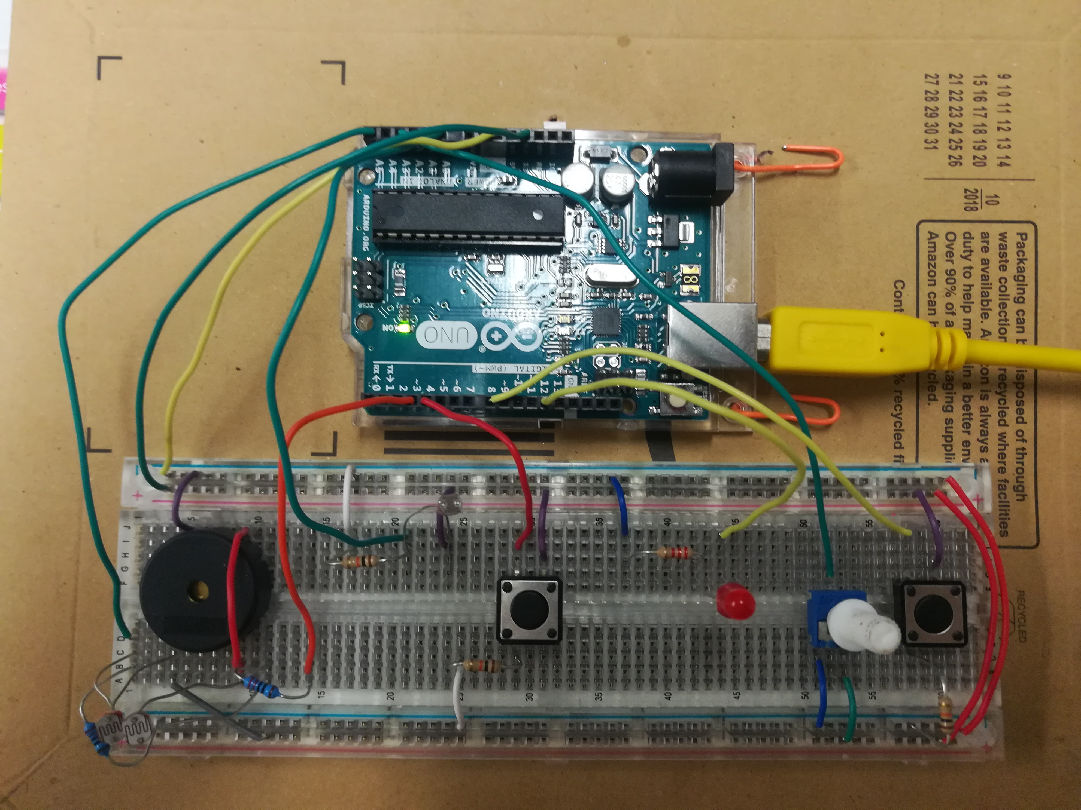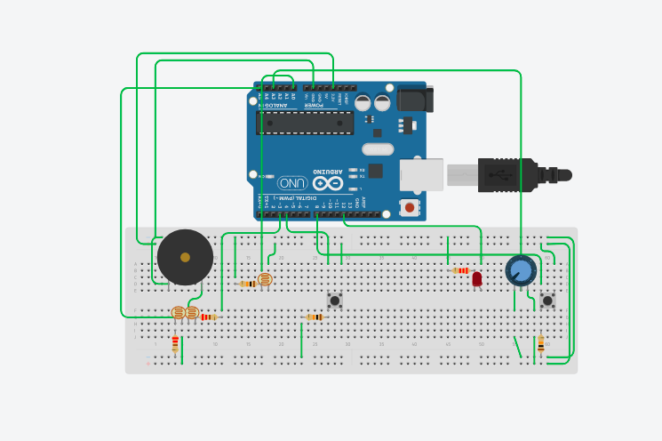

**How does it work?**

Set the board up as follows and run the Arduino source code located in this file. Then, just mess around with it.

You will need:

* 1 Piezoelectric buzzer
* 2 PCB pushbuttons
* 1 10K Ohm potentiometer (PCB terminals)
* 1 5mm red LED
* 1 70..100K Ohm LDR VT90N2
* 2 5mm GL5516 70..100K Ohm LDRs
* 3 10K Ohm resistors
* 2 220 Ohm resistors
* 1 2.2K Ohm resistor
* 1Arduino UNO board
* Assorted wires
* 1 breadboard

**Does it really work?**

Yes! Here’s proof: [**https://youtu.be/tabl3UvNT6c**](https://youtu.be/tabl3UvNT6c)

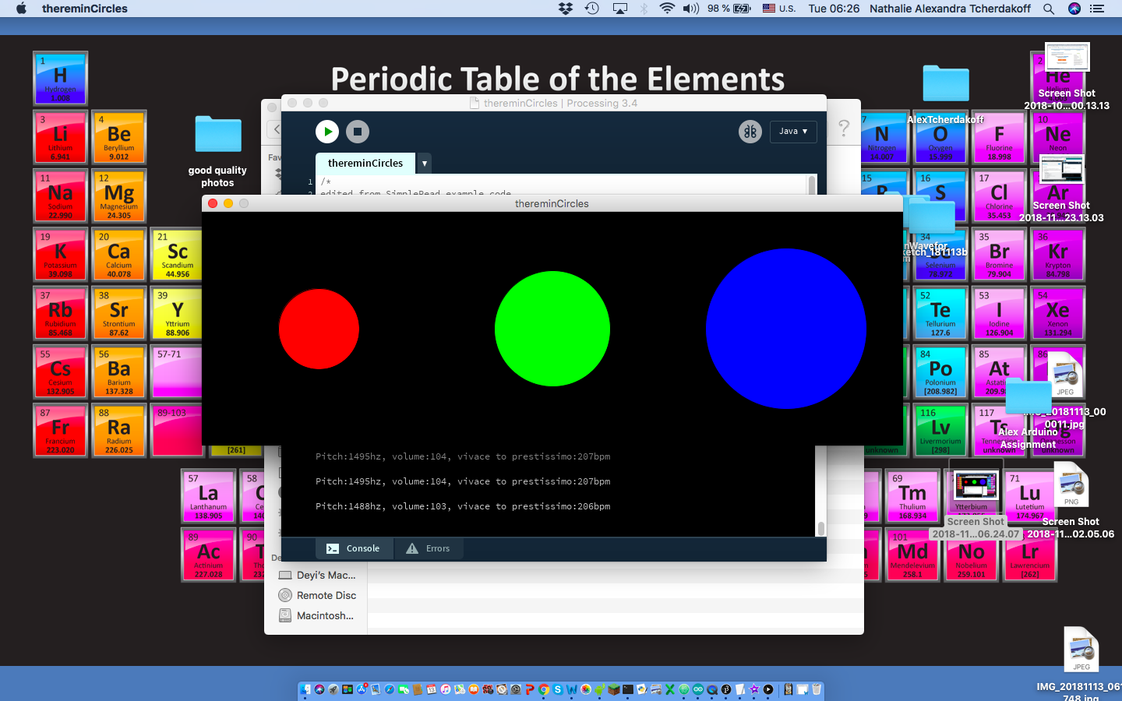

**How do we visualize the data?**

We can look at each value returned as the radius of a circle. The volume returns a red circle, the pitch returns a green circle, and the meter returns a blue circle. The larger the blue circle is, the faster the meter is, the more values get returned for volume and pitch, the more precise our visualization of these values is.

Circuit picture and circuit diagram for the music board