Product Cybersecurity Handbook
Product Cybersecurity Handbook
- IEC EN 62443 series of standards is authoritative and defines the technical requirements for Cybersecurity in the stationary automation industry and formulates necessary organizational requirements for component manufacturers, integrators and operators
  - IEC EN 62443-4-1 defines the requirements for the product life cycle
  - IEC EN 62443-4-2 defines the functional requirements for the components based on the security level to be achieved.
  - ISO SAE 21434 standard in mobile automation
  - UNECE R155 (Cybersecurity-Anforderungen für Fahrzeuge)
- Cybersecurity goals:
  - Confidentiality
  - Integrity
  - Availabilty
  - Authenticity
  - Non-repudiation
Cyber Security Plan, Integration into Development Processes
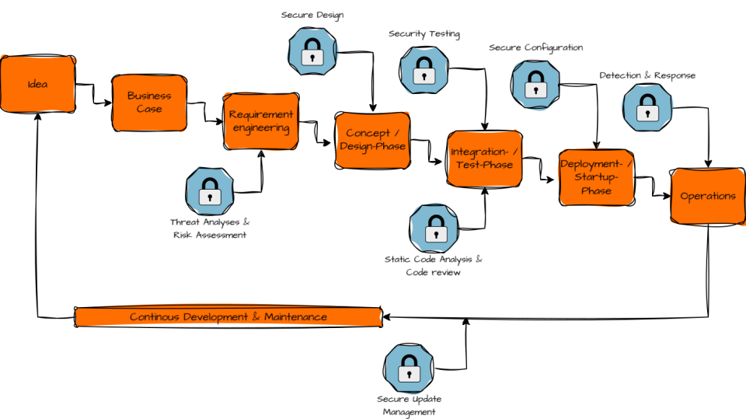

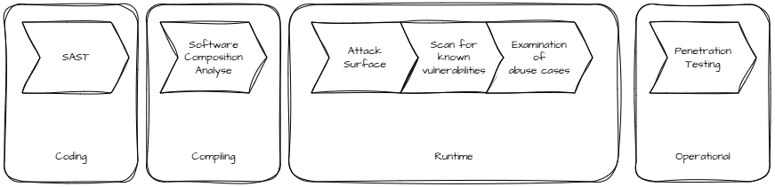
- Cybersecurity Testing Toolchain

1. Cybersecurity Affects the Entire Product Lifecycle
Cybersecurity is not just tested at the very end; it must be considered from the initial idea all the way to decommissioning. This is known as the Secure Development Lifecycle (SDLC).
- Security begins with the requirements: It starts right at the requirements stage.
- Integrated approach: It is integrated into design, development, testing, and maintenance.
- Post-launch care: Even after market launch, products must be monitored and updated.
2. Risk-Based Decision Making
Not every feature requires the same level of protection.
The process is as follows:
- Identify threats (Threat Analysis)
- Evaluate risks (Risk Analysis)
- Define security measures
- Implement and test
The core principle: First avoid risks, then mitigate them, and finally inform the user.
3. Security Objectives
- Confidentiality: Data must only be read by authorized parties.
- Integrity: Data must not be altered without authorization.
- Availability: Systems must remain functional.
- Authenticity: Identities must be genuine.
- Accountability / Traceability: Actions must be logged.
- Non-repudiation: Actions cannot be denied.
4. Secure by Design and Defense in Depth
Secure by Design
- Security is built directly into the architecture, not added as an afterthought.
Defense in Depth
- Multiple layers of security are combined.
Example:
- Network access
- TLS encryption
- Login
- User permissions
If one layer fails, the remaining layers continue to protect the system.
5. Cybersecurity is Teamwork
The involved roles include:
- Product Management
- Development
- Testing
- Cybersecurity Engineering
- Technical Management
- Global Security Services (PSIRT)
Everyone shares the responsibility to openly address and remediate security vulnerabilities.

Result documents
Requirement
Verification
Tool(s)
Responsible
RACI matrix is a project management tool used to clarify roles and responsibilities within a project.
- Responsible: The person(s) who actually do the work to complete the task.
- Accountable: The person who is ultimately accountable for the correct and thorough completion of the task.
- Consulted: The people who provide input and feedback on the task.
- Informed: The people who need to be kept updated on progress or decisions but do not contribute directly to the task.

