Nathan Bricknell

February 7, 2025

Assignment 2

Assignment title in Github: Assignment 2

**Part 1 – Mozilla splash page**

**Link**: <https://nathan-b04.github.io/Web/Assignment2/Part1/MozillaPage.html>

In my Github link, the same issue with images is happening again with my splash page. I tried to fix it multiple times by changing the images sizes and renaming the images but nothing seemed to work.  
Here is a screenshot of my splash page on live server just to show I did import the images:  
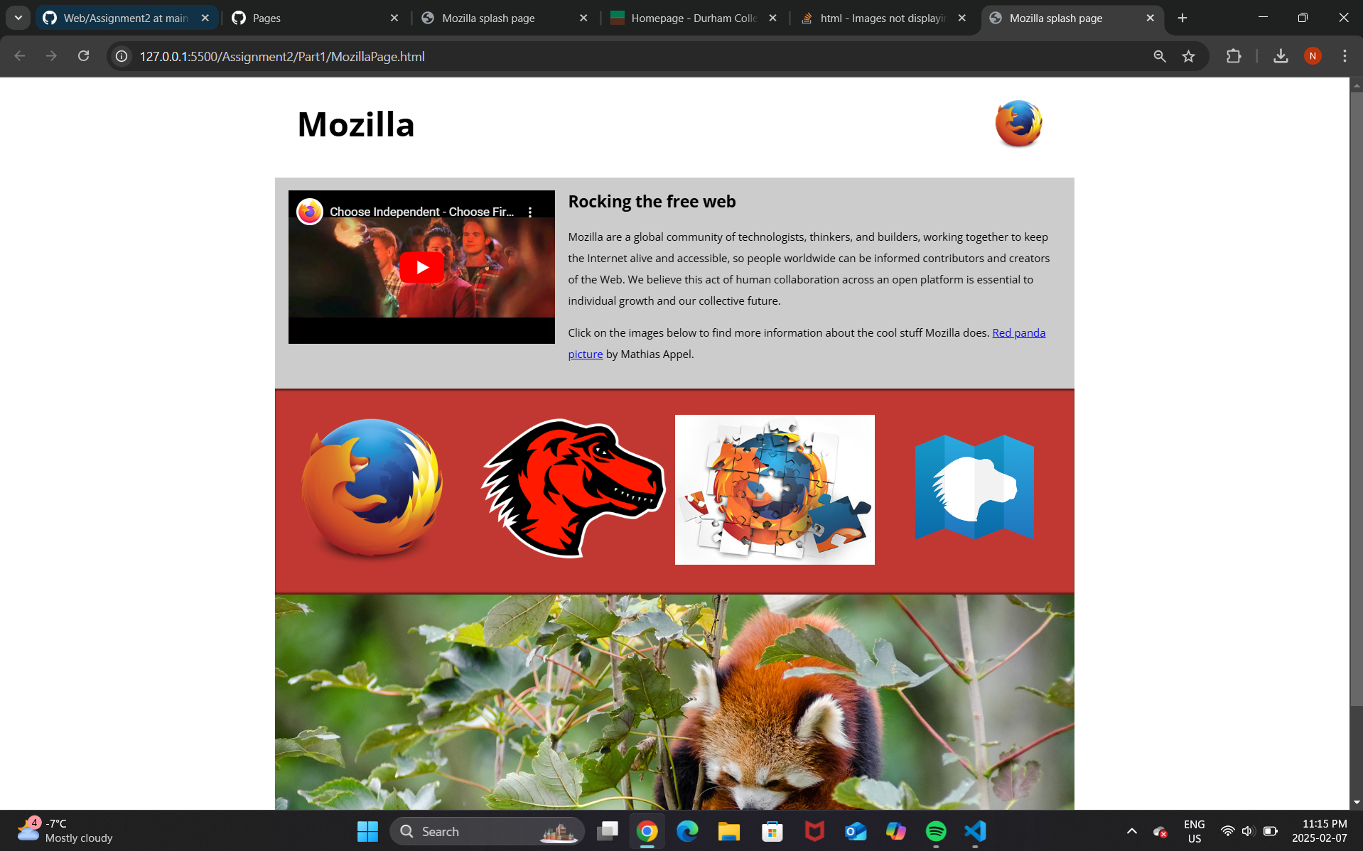

**Part 2 – Planets Data Table**

**Link**: <https://nathan-b04.github.io/Web/Assignment2/Part2/Planet-Table.html>