Question 1

* Ethernet address is 30:3a:64:ad:b6:23

Question 2

* E8:33:81:37:85:60 is not the address of the gaia.cs.umass.edu. It is the address of the router ArrisGro

Question 3

* The hex value for Frame type field is 0x0800. Upper protocol IPv4

Question 4

* ASCII ‘G’ in “GET” appeared after 432 bits or 54 bytes

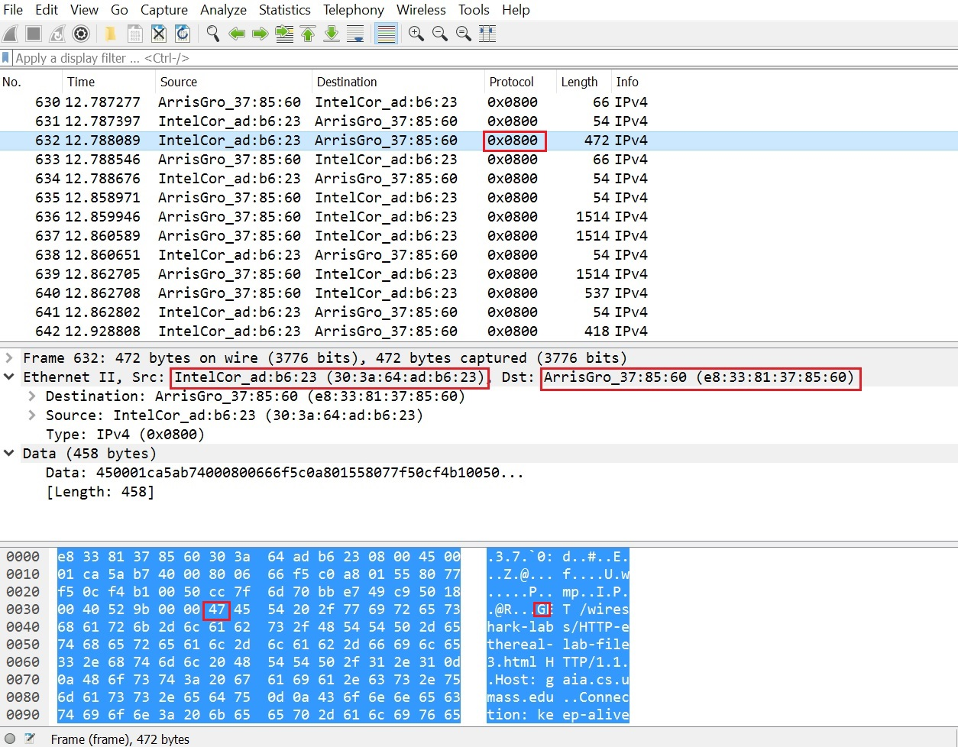

Question 5

* The source address e8:33:81:37:85:60. It is the address of the Ethernet router ArrisGro

Question 6

* The destination address is 30:3a:64:ad:b6:23. It is the address of my computer

Question 7

* The hex value for Frame type field is 0x0800. The bit that value 1 say not fragment

Question 8

* ASCII ‘O’ in “OK” appeared after 104 bits or 13 bytes

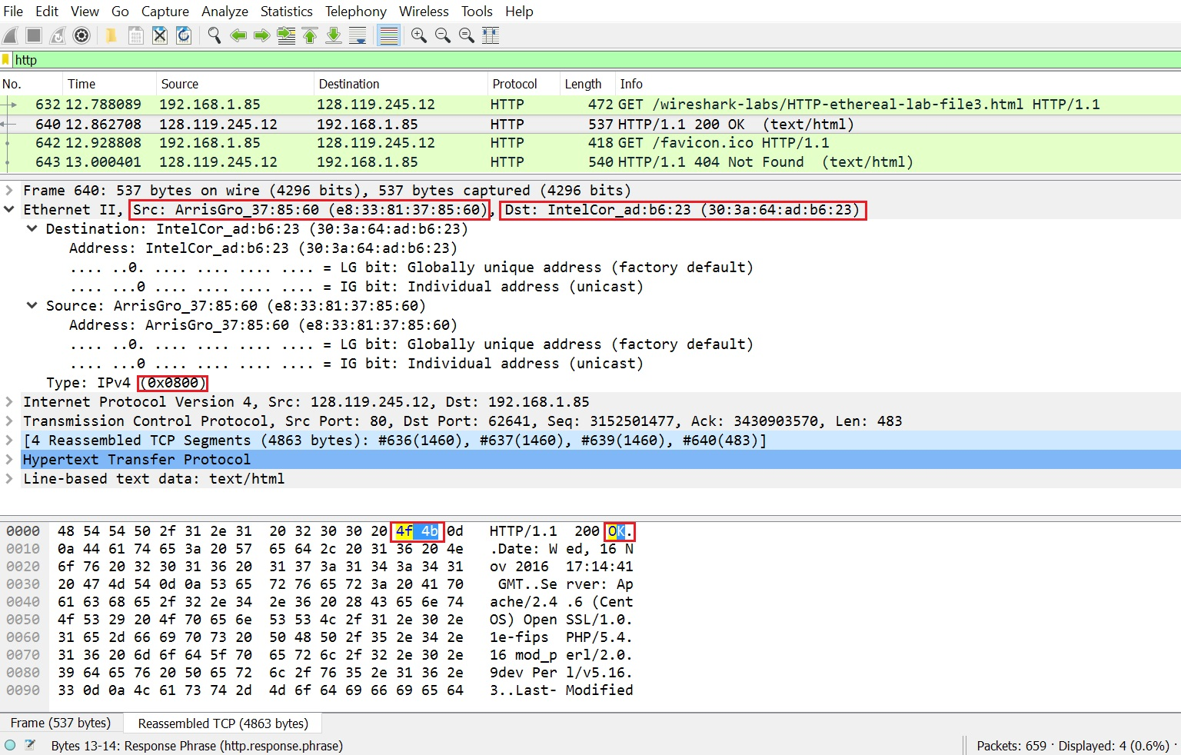

Question 9

cometnet-gw.utdallas.edu (10.21.0.1) at 0:42:5a:eb:5d:e8 on en0 ifscope [ethernet]

? (10.21.255.255) at (incomplete) on en0 ifscope [ethernet]

? (224.0.0.251) at 1:0:5e:0:0:fb on en0 ifscope permanent [ethernet]

* The Internet Address column contains the IP address
* The Physical Address column contains the MAC address
* The type indicates the protocol type (static or dynamic)

Question 10

* The source hexadecimal is 68:c4:4d:e8:e2:c2
* The destination hexadecimal is ff:ff:ff:ff:ff:ff

Question 11

* The hex value for Frame type field is ARP 0x0806

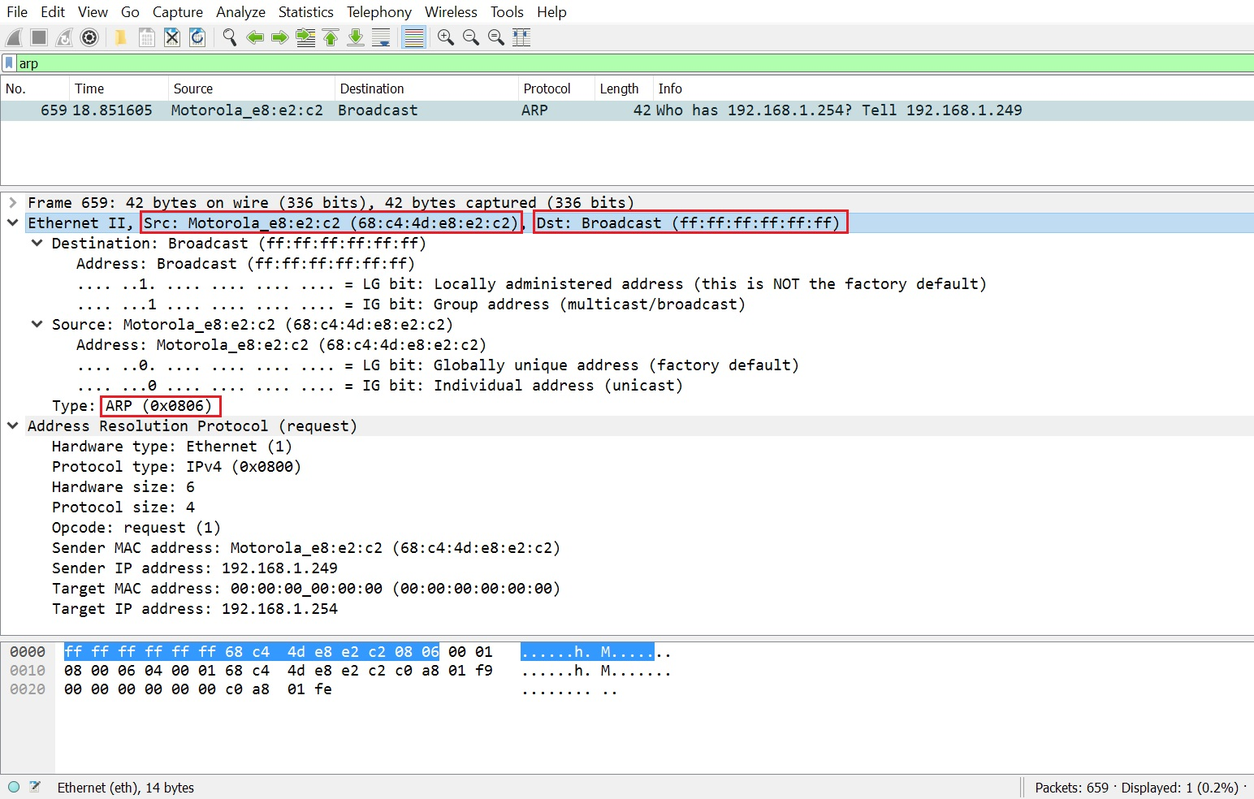

Question 12

* There is no APR reply because the IP address of the computer and APR request does not match. The ARP is broadcast. Therefore, the computer will not receive the request

**Part 2**

1. True
2. True
3. False
4. True
5. False
6. True
7. True
8. False
9. False
10. True

M1. Regarding link level framing methods

* A - with byte count, it is difficult to resynchronize after an error
* B – with byte stuffing, there are reserved bytes that the higher layers is not allowed to send

**Essay and/or calculation (each question is 5 points)**

E1. Consider 4 nodes with MAC addresses A, B, C, and D connected to interfaces 1, 2, 3, and 4 respectively of a switch according to a star topology. Assume prior to event 1, the switch table is empty. Fill in the blanks in the “Switch forwards frame to interface(s)” and “Switch table after the event” below.

Event 1: B sends a frame to D

Switch forwards frame to interface(s): ____1,3,4_______  
Switch table after the event:

|  |  |
| --- | --- |
| MAC address | Interface |
| B | 2 |
|  |  |
|  |  |
|  |  |

Event 2: D replies with a frame to B  
Switch forwards frame to interface(s): ____2_______

Switch table after the event:

|  |  |
| --- | --- |
| MAC address | Interface |
| B | 2 |
| D | 4 |
|  |  |
|  |  |

Event 3: A sends a frame to B  
Switch forwards frame to interface(s): _____2______

Switch table after the event:

|  |  |
| --- | --- |
| MAC address | Interface |
| B | 2 |
| D | 4 |
| A | 1 |
|  |  |

E2. In Voice over IP (VoIP) applications, the user’s speech is encoded in bits by a voice codec (vocoder), and the bits put into packets for transmission over the Internet. Suppose that each VoIP packet consists of L bytes of payload and 5 bytes of header. Suppose the vocoder outputs bits at a constant rate r = 128 kbps. Assume each packet is entirely filled before the source sends the packet into the network. The time required to fill a packet is the packetization delay. A longer packetization delay will affect the quality of the voice conversation.

Express the packetization delay in units of msec, as a function of L and r. What is the numerical value of the packetization delay if L = 1500 bytes (roughly an Ethernet packet) and r = 128 kbps? What is the numerical value of the packetization delay if L = 50 bytes (roughly an ATM packet) and r = 128 kbps?

Packetization delay expressed as a function of L and r:

PD = [((L * 128)/r) + 5] * (1/1000 sec)

Numerical value of packetization delay if L = 1500 bytes and r = 128 kbps: 1.505 msec

Numerical value of packetization delay if L = 50 bytes and r = 128 kbps: .055 msec

E3. List the concerns of token passing MAC protocol.

* Token overhead
* Latency
* Single point of failure (token)

E4. Refer to the 2-dimensional bit parity scheme below. Give an example of a double bit error that the scheme can detect but is not able to correct.

1 0 1 0 1 1

1 0 1 1 1 0

0 1 1 1 0 1

0 0 1 0 1 0

You are able to indicate bit error with column parity, but run into issue with row parity.

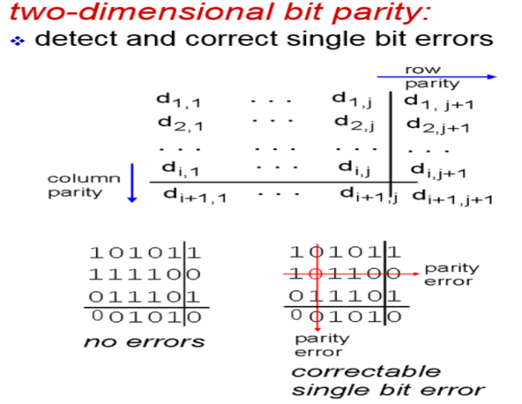

E5. Explain the function of a Start Frame Delimiter in Ethernet

It’s a pattern in the Ethernet packet following the preamble which singles the start of the transmission frame.

E6. Consider a bit stuffing framing method where the start of a frame is indicated by 6 consecutive ones, followed by 2 zeroes. What should be the bit stuffing rules at the transmitter? What should be the bit destuffing rules at the receiver? Fill in the blank to show what is the stream after bit stuffing

Write the rule for stuffing: indicate start of frame with 6 consecutive ones, followed by 00. Added a 0 bit stufing

Example: 111111000 [data] 111111000 [data] ….

Write the rule for destuffing: When read 6 consecutive 1 and three consecutive zeros, remove a zero bit.

Assume the user data stream before bit stuffing is 011111100011111101. What is the stream after bit stuffing? 0 11111000 011111101

E7. List the 3 broad classes of MAC protocols.

1. Channel partitioning
2. Random Access
3. “Taking Turns”

E8. Consider the MPLS network of figure 1. Suppose that routers R5 and R6 are now MPLS enabled, and they are the ingress routers into the MPLS network. Suppose we want to do traffic engineering so that

Flow 1: packets from R6 destined for A are switched to A via R6-R4-R3-R1, Flow 2: packets from R5 destined for A are switched to A via R5-R4-R2-R1.

Show the MPLS tables in R5 and R6 and the modified table in R4, to make that possible. The tables in the other routers are unchanged. Assume the label used for flow 1 on the link from R6 to R4 is X and the outgoing interface from R6 to R4 is interface 0. Assume the label used for flow 2 on the link from R5 to R4 is Y and the outgoing interface from R5 to R4 is interface 1.

Table at R6 (the number of rows is not necessarily indicative of the number of actual table entries. There may be fewer actual entries than the number of rows)

|  |  |  |  |
| --- | --- | --- | --- |
| In label | Out label | Dest | Out interface |
|  | X | A | 0 |
|  |  |  |  |
|  |  |  |  |

Table at R5 (the number of rows is not necessarily indicative of the number of actual table entries. There may be fewer actual entries than the number of rows).

|  |  |  |  |
| --- | --- | --- | --- |
| In label | Out label | Dest | Out interface |
|  | Y | A | 1 |
|  |  |  |  |
|  |  |  |  |

Modified table at R4 (the number of rows is not necessarily indicative of the number of actual table entries. There may be fewer actual entries than the number of rows)

|  |  |  |  |
| --- | --- | --- | --- |
| In label | Out label | Dest | Out interface |
| X | 10 | A | 0 |
| Y | 8 | A | 1 |
|  |  |  |  |