University of Malta
Faculty of Information and Communication Technology
ARI2101 – Fundamentals of Automated Planning

Coursework 2021-2022



Faculty of ICT  Scholastic year: 2021/22 | Andrew Darmanin (95602L)  Nathan Bonavia Zammit (198402L)  Nicole Shaw (66502L)

Part 1: Using Python to develop a solver for the Sliding 8-Tile puzzle
Introduction
The program takes as input the initial state of an 8-tile puzzle, then one of 4 possible search algorithms is chosen. If the algorithm chosen uses a heuristic function, this function can either be Manhattan distance or number of misplaced tiles. After the search is complete, the program outputs:
- The Plan (list of actions in the right sequence).
- The length of the plan.
- The number of unique states generated.
- The time it took to find the solution.
- The board from initial state to goal state, after each action.
- If the plan is a Valid or non-valid plan.
In the following section it will be shown how all of the above was managed to be achieved.

Implementation
Firstly, the empty tile is represented by a ‘0’. A board/state is represented by an array made up of 9 integers. The goal state is constant and is stored in a variable goalState = [1,2,3,4,5,6,7,8,0]. The initial state is obtained from the user by function getInput(). getInput() asks the user to input a string to represent the initial board face. Then the input is put into an array. Example “8 6 7 2 5 4 3 0 1” would be stored as [8,6,7,2,5,4,3,0,1].
From every state there are certain actions which are applicable. The 4 possible actions are: Left, Right, Up, Down. It would be helpful if there is a function which checks which actions are available from a given state. availableActions(puzzle) does exactly this. It checks where the empty tile is and the preconditions of every action. The function returns a 4 boolean array. It is important to note that [0] ->Left, [1] -> Right, [2] -> Up and [3] - > Down. The function swap(actual, action) applies the action by swapping the empty tile with an adjacent one.
In automated planning a search algorithm starts from an initial node (root) and finds its way to a goal node by expanding branches from nodes. Hence the need to implement a “tree” type object is evident. In class StateTree() a node is defined as an object having:
- a state (the 9 integer array)
- A list of children
- A list of actions. These actions, if applied from the initial state, will lead to this state.
- A variable which keeps track of how many children the state has.
The node class has a function called addChild(self, state, action). This function appends an object of type node in the current node’s children list. However in every search function addNodes(node) is used to generate possible children from the current node. This function will get the available actions and apply them one by one to generate new states and add them to the children list of current node.

How the different search strategies were implemented.
Now that there is an understanding of how the nodes are represented, let’s look at how the search algorithms were built.
The 4 search algorithms implemented are:
- Breadth First Search
- Greedy Best First Search
- A* Search
- Enforced Hill Climbing
1. BFS is a simple blind search algorithm which expands every node layer by layer (breadth first) until the goal node is reached. Initially, the initial state is placed in the toVisit queue/list. To avoid ending up in loops or cycles UniqueStates will hold a list of unique visited states. A while loop is created, inside the loop the following procedure is repeated:
- The first value inside the toVisit list is popped and this is the current node to expand.
- Check if the node is a goal node. If is it end else:
- Expand node by adding children using addNodes(node)
- For every child node check if it leads to an undiscovered state if yes add to toVisit list and UniqueStates list.
This way all unique nodes are expanded until goal state is reached. The plan returned from this search will be optimal since it returns the shallowest goal node (hence shortest).
Before describing the other 3 algorithms, first the heuristic needs to be understood. The heuristic can be either:
- Number of Misplaced Tiles
- or, Manhattan Distance
misplacedTiles(puzzle) given a state function returns the number of tiles in the incorrect position. It does this by checking if the elements in the array are in the goalstate indexes.
Manhatten_Distance(puzzle) gives the heuristic value by working the mhd of all tiles to their correct positions and returning the sum. mhd() works out the individual values by getting the (x,y) coordinates of the tile and the tile’s correct location then works out the difference.

2. Greedy Best First Search starts from the initial node and selects the node which has the best heuristic value, this node is expanded and the process is repeated. The nodes are stored in a list called ‘find’ which is made up of dictionaries of type {'node': X, 'priority': h}. This way it is easy to compare different nodes heuristic value. A while loop is created, inside the loop the following procedure is repeated:
- Find the index of the lowest (best) heuristic valued node in find. This will be the node to expand. Also remove it from the list.
- Check if the node is a goal node. If is it end else:
- Expand node by adding children using addNodes(node)
- For every child node check if it leads to an undiscovered state if yes: work out the heuristic and add to find list and UniqueStates list.

3. A* starts from the initial node and similarly to GBFS, selects the node which has the best heuristic function but in A* this is made up from the sum of the heuristic and the cost. That is f(n) = h+c. c is the cost to be at the current node. Which is the steps it takes to reach the current node from root. This can be easily found by finding the length of it’s plan. The rest of the function is the same as before.
4. Enforced Hill Climbing starts from the initial node and expends nodes in a BFS style however when a node of better heuristic is found, the OpenList is discarded and only this node is added. In the implementation three different lists are managed: best, states, visited. best keeps track of the nodes to visit, states keep track of all unique nodes already seen and visited keep track of all the nodes already expanded. Variable H keeps track of the best heuristic seen so far. When expanding a node if none of the child nodes have a better heuristic then all of them are added to the best list. However if one of them has a better heuristic, then the best list is thrown away, H is updated and the child node is added to it.

Results and evaluation
Results for the following two initial states have been tabulated below:
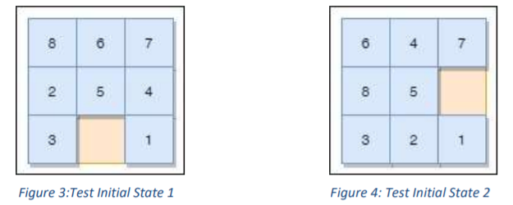
- Results for Test Initial State 1 [8 6 7 2 5 4 3 0 1]
Search Technique | Plan Length | Number of Unique States generated | Time Taken (in ms) | Is Valid?
BFS | N/A | 77939 | BFS didn't manage to find a solution in 15 mins | Not Valid
Greedy Best First Search  (Using mhd as heuristic) | 53 | 151 | 3.0038 | VALID
Greedy Best First Search  (Using misplaced tiles as heuristic) | 61 | 357 | 10.0104 | VALID
A* (Using mhd as heuristic) | 31 | 8582 | 6780.9977 | VALID
A* (Using misplaced tiles as heuristic) | N/A | 68777 | A* didn't manage to find a solution in 15 mins | Not Valid
Enforced Hill Climbing Search (Using mhd as heuristic) | 63 | 119 | 2.0005 ms | VALID
Enforced Hill Climbing Search (Using misplaced tiles as heuristic) | 347 | 1191 | 55.0115 ms | VALID
- Results for Test Initial State 2 [6 4 7 8 5 0 3 2 1]
Search Technique | Plan Length | Number of Unique States generated | Time Taken (in ms) | Is Valid?
BFS | N/A | 81590 | BFS didn't manage to find a solution in 15 mins | Not Valid
Greedy Best First Search  (Using mhd as heuristic) | 53 | 146 | 2.0043 | VALID
Greedy Best First Search  (Using misplaced tiles as heuristic) | 77 | 442 | 11.9984 | VALID
A* (Using mhd as heuristic) | 31 | 9601 | 8018.5444 | VALID
A* (Using misplaced tiles as heuristic) | N/A | 68335 | A* didn't manage to find a solution in 15 mins | Not Valid
Enforced Hill Climbing Search (Using mhd as heuristic) | 47 | 83 | 2.0010 | VALID
Enforced Hill Climbing Search (Using misplaced tiles as heuristic) | 523 | 1703 | 109.0235 | VALID
Important graphs about the performance of each search algorithm. Graphs obtained from results tables.
Time taken by Search
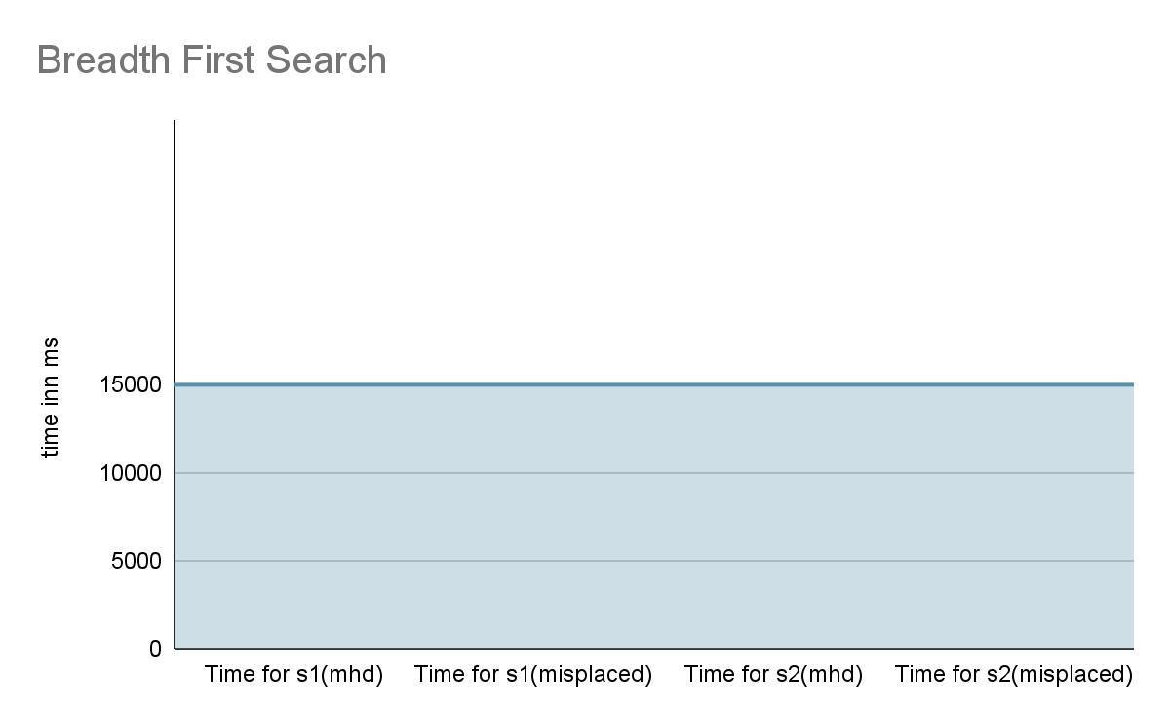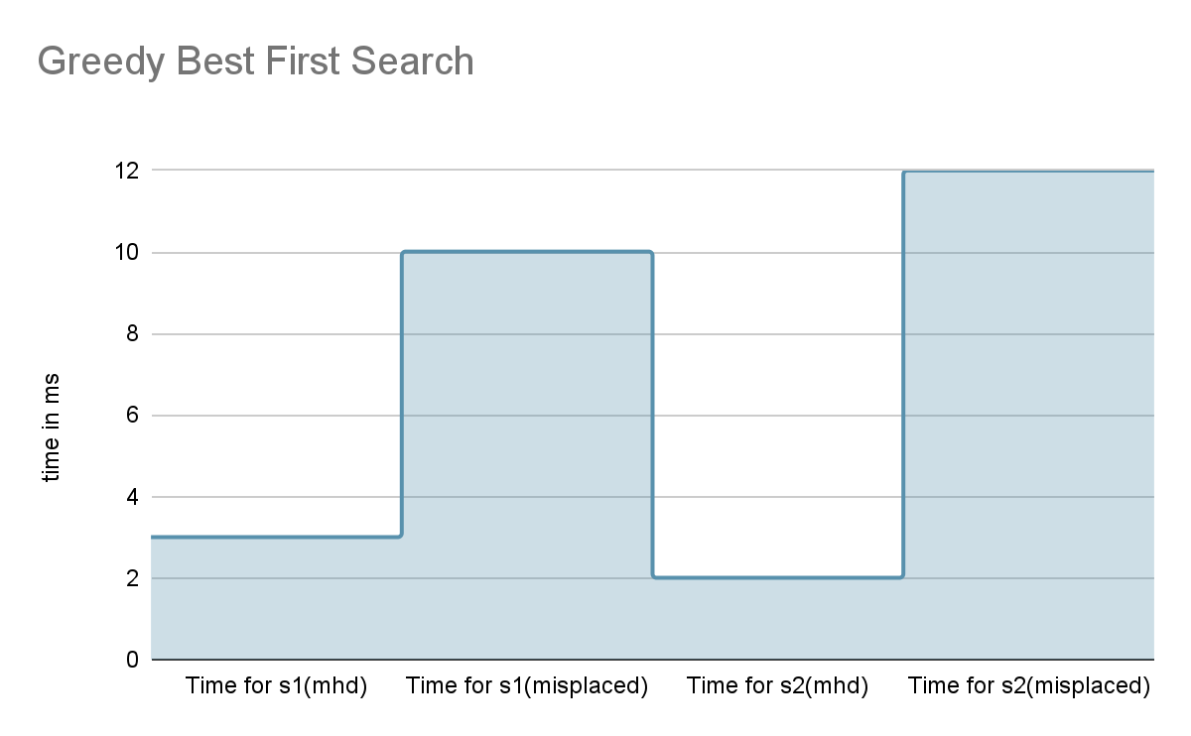

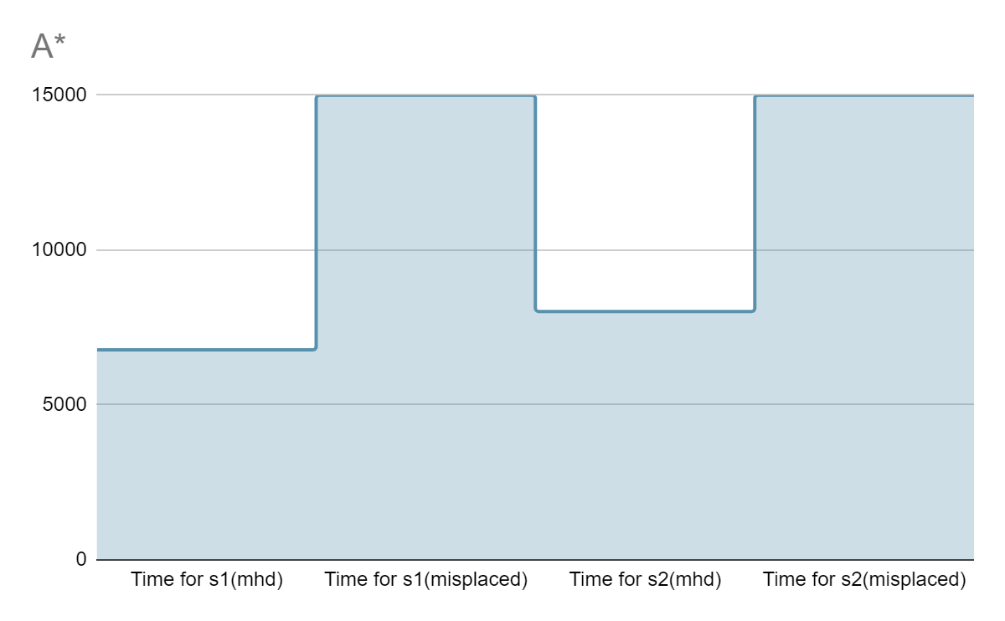
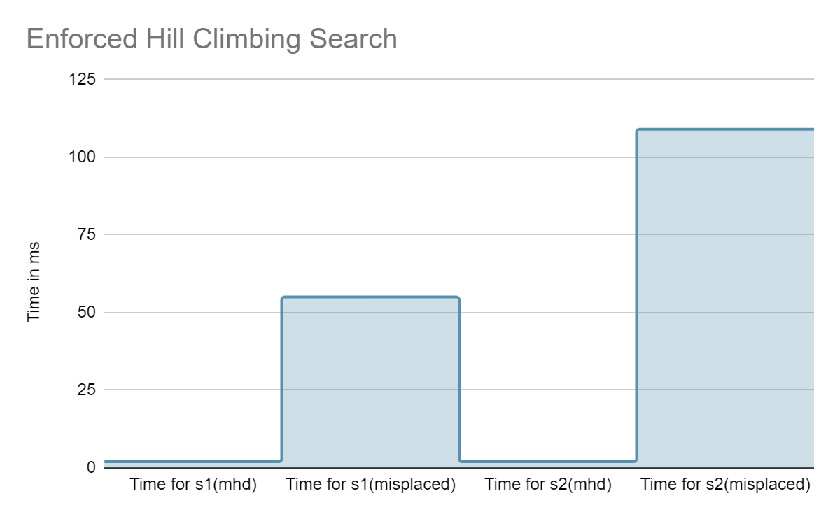
From these graphs one can note that the most efficient (in terms of speed) is Greedy Best First Search and the worst is Breadth First Search. This is what was expected since BFS expands all the possible unique combinations from the initial node irrespective of their heuristic (blind/uninformed search) until the goal state is reached. In contrast, Greedy Best First Search starts from the initial node and always expands the node having the best heuristic value till the goal node is reached. This way a solution is usually found quickly. It’s important to note also that A* took longer than GBFS and Enforced Hill Climb, this was also expected since A* will always converge to the optimal solution, which usually is “harder” to find than any solution.

Unique States explored by Search
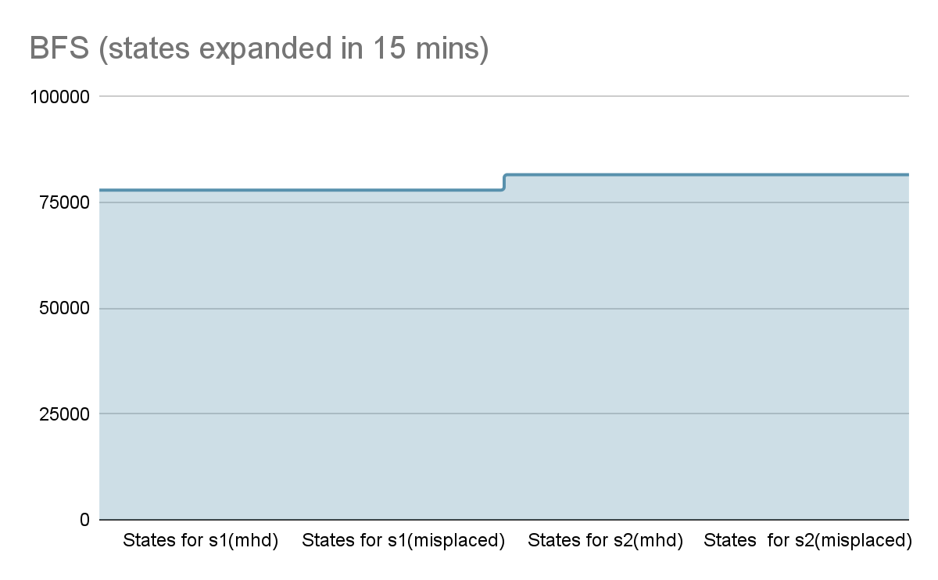
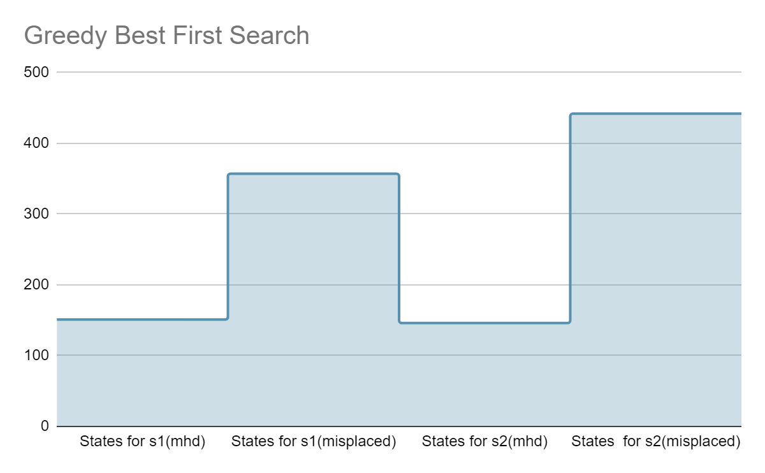
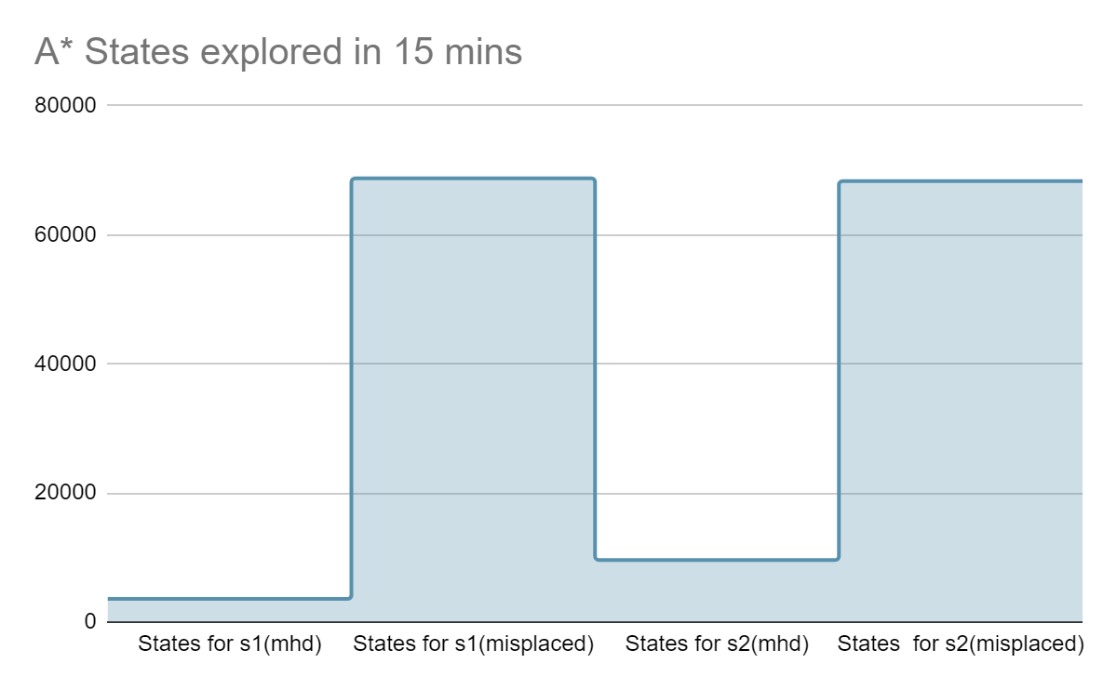
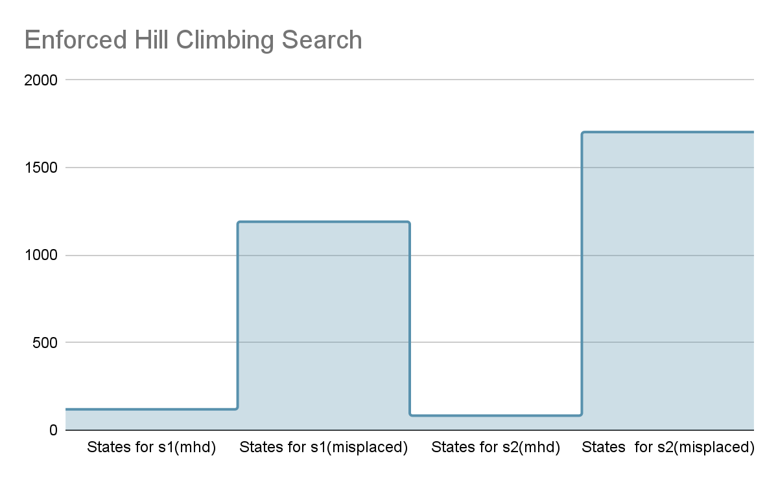
Understanding states generated
Since the algorithms never get stuck in loops or cycles, there is a strong positive correlation between time taken to execute and states generated. Hence there is no need to go into detail about these results. (Same reasoning as when looking at the time taken graphs which was already discussed above)

Length of Plans
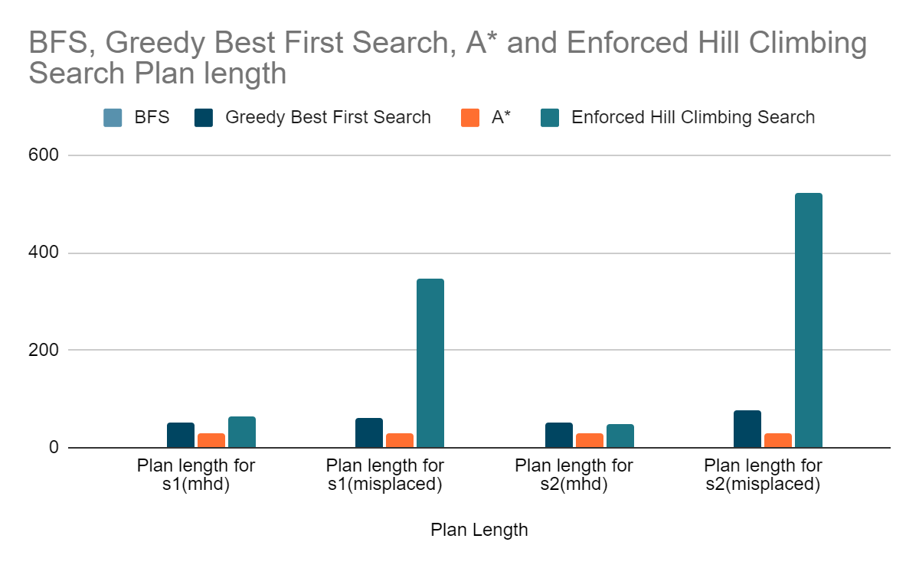
From the above graph, an important observation is that no other search technique has a shorter (better) plan than A*. So will BFS, these two search algorithms will find the optimal solution. (N.B: BFS is not in the graph since it took more than 15 minutes to run). Enforced Hill Climbing search on average returns the longest plan. This is not surprising due to the fact that it will try to expand the best heuristic valued child of a node (hence adding a step (an action to the step)).

Conclusion from the graphs
Important takeaways about the performance of each of the search strategies. The optimal solutions, that is, the algorithm which always returns the shortest path are BFS and A*. From these two strategies, it is clear that A* is the better option in terms of efficiency. Since, as seen from the graphs above, A* manages to find the plan in much less time and by expanding/exploring significantly less states. This is mainly due to the fact that A* is an informed search algorithm while BFS does not use a heuristic/evaluation function (hence a blind). However it can be the case that the problem is satisfiable given any solvable plan. Here Greedy Best First Search and Enforced Hill Climb Search have their advantages over BFS and A*. These two search strategies (GBFS and EHCS) are significantly faster to compute and will take less storage to work out since visiting less states. In situations where time is crucial these strategies may be opt for.
Another key part that makes a fast and efficient search algorithm is the heuristic used. From the results above, there is a clear distinction between using Manhattan distance as a heuristic and using Misplaced tiles as a heuristic. To solve the same problem, despite the search algorithm chosen, using Mhd as a heuristic was proven to be more efficient in terms of both time and states explored. Hence it can be concluded that Manhattan distance is a better representation to how close/(far away) the current state is to the goal state in a 8-tile puzzle. Another reason why Mhd is a better heuristic to misplaced tiles could be that since search algorithms try to find the best h valued node, the range of values offered by mhd is greater than that of misplaced tiles(0-8). Therefore, when using misplaced tiles as heuristic the algorithm faces many more occurrences where it has to choose between the same h values nodes.
References

Team Contributions
Name | Artefact | Documentation | Average | Signature
Andrew Darmanin | 100% | 100% | 100%
Nathan Bonavia Zammit | 100% | 100% | 100%
Nicole Shaw | 100% | 100% | 100%

Andrew Darmanin:
- Team Leader
- Handled the code for the first two searches of Part 1
- Handled the first part of the Part 1 Documentation
Nathan Bonavia Zammit:
- Handled the code for the last 2 searches of Part 1
- Handled the second part of the Part 1 Documentation
Nicole Shaw
- Handled the code and documentation of Part 2

