University of Malta
Faculty of Information and Communication Technology

CPS-2004 Object-Oriented Programming Assignment

Coursework 2021-2022



Faculty of ICT  Scholastic year: 2021/22 | Nathan Bonavia Zammit (198402L)

- DAG (in C++)
  - Implementation of the code
The first task consisted of building a templatized directed acyclic graph data structure (DAG). A DAG consists of nodes which are connected by edges. The edge class creates an edge which returns a source node and a target node. The vertex class consists of multiple functions which are used to create the nodes in the graph, and populate the aforementioned source and target nodes. The dag class is used to build the final DAG. This is done through the use of an edge list. The edge list contains all the edges that will be used in our graph. For example, the first edge is looking for the source node ‘1’. The program will attempt to find said node in the graph that we are building. However, since the graph is currently empty, it will fail and add the node ‘1’ to the graph itself. This is also repeated with the target node ‘2’. After this step if there is any other node in the graph which is using node ‘1’ as a source node, the program will find it in the graph already and use the one in the graph. If any nodes are to be removed this can also be done via the remove_vertex() function. The main method used will print out the DAG and the edge list. In some cases, one or multiple nodes are removed and in this case the DAG and edge list will be outputted again without the nodes that were removed.
  - Test Cases
For the testing the following edge list was used:
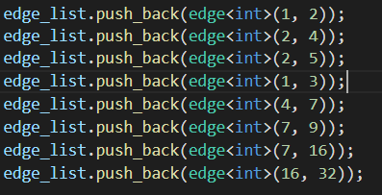
Fig.1: The edge list used, (source, target).

The DAG outputted like so:
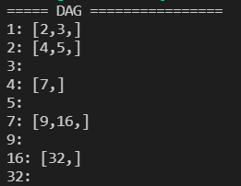 | 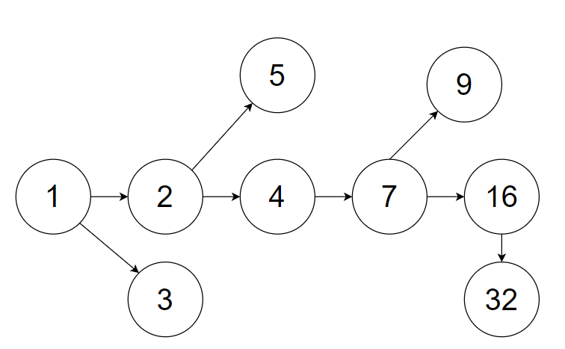

Fig.2: Output of DAG with a diagram of the graph on the right
Along with the edge list as seen below:
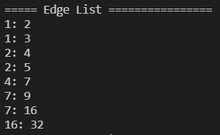
Fig.3: The Edge List
The first two nodes were removed from the DAG and the outputs changed, however the main issue is that disconnected nodes were not completely removed.
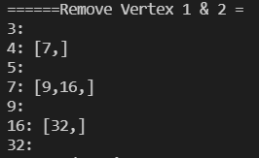 | 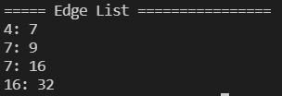
Fig.4: The DAG after removing nodes 1 and 2
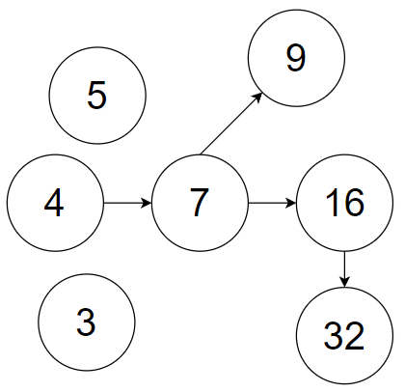
Fig.5: Diagram of the graph for the without nodes 1 & 2
  - UML
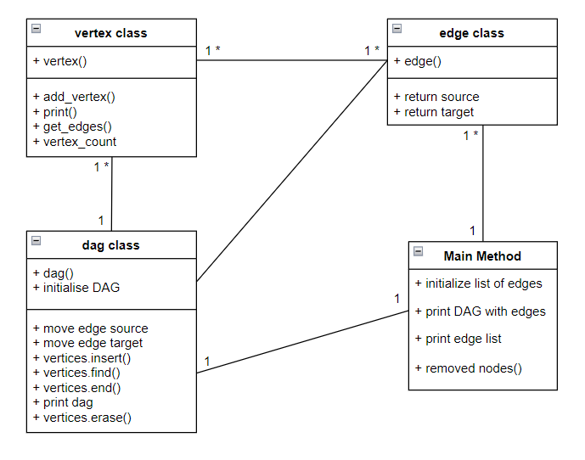
Fig.6: UML Diagram of Task 1
  - Possible Improvements:
Disconnected Nodes removal could make the output look cleaner.
    - This was attempted in the DAG class however it caused bugs and errors and therefore it was left out
A function to check whether a cycle is present in the graph or not could have been added.
- Crypto Exchange (in Java)
  - Implementation of the Code
The second task consisted of building a simple crypto exchange platform. The users that would use said crypto exchange would be Traders or Administrators. The Traders would have to register into the system and be approved by the Administrator. Upon running the program, the user would have 3 options: Register an account, Log in to an existing account, or Exit the system. If the user is an Administrator, then they have the option to approve any accounts waiting for approval, or log out of the system. If the user is an approved Trader, then they have the following options: View their Orderbooks, Buy Crypto, Sell Crypto, View any previous Crypto Transactions, Deposit Money into their account, View their balance, or log out of their account. The Trader and Administrator classes are subclasses to the User superclass since the user’s details such as username, password and ID are required for the Trader and Administrator’s functions to work and they are in the User() object.
  - Test Cases
For the test cases three users were created, 2 Traders and 1 Admin.
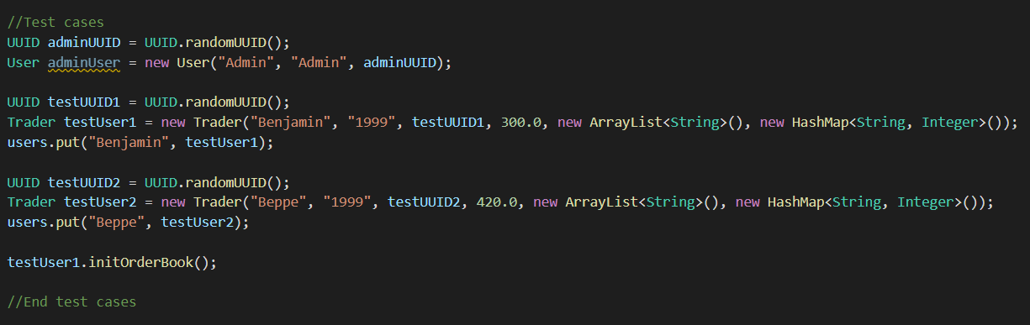
Fig.7: The users which were used for the Test Cases
In order to test out the Admin user, a user was registered so it culd be approved by the Admin.
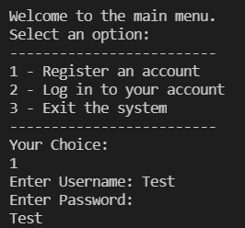 | 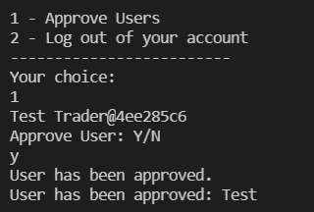
Fig.8: Test user being regiestered and approved
The following menus are shown when logging into an Admin account (Left) or Trader account (right):
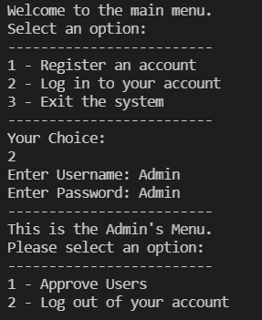 | 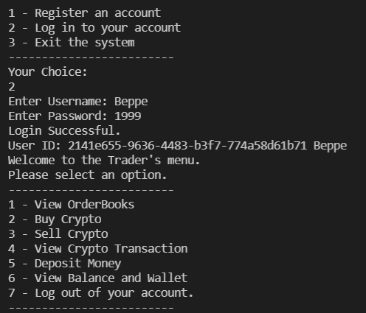
Fig.9: Logging into an Admin account (left) and Trader account (right).
The user ‘Beppe’ bought 10 of Polkadot and the order was successful since he had sufficient funds:
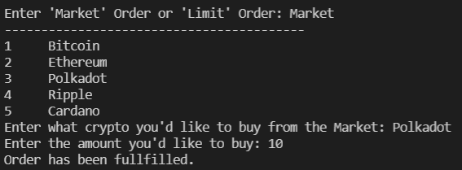
Fig.10: User ‘Beppe’ buying 10 of Polkadot
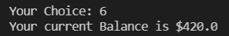
Fig.11: User Beppe’s Balance
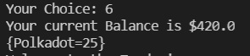
Fig.12: User Beppe’s Balance after buying 10 Polkadot
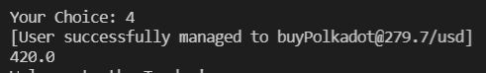
Fig.13: The successful transaction of the purchase

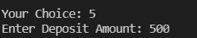 | 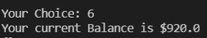
Fig.14: Depositing money into the account (left), and the balance after the addition of the money (right)
If at any point the user wishes to view their Order Book, the following is outputted:
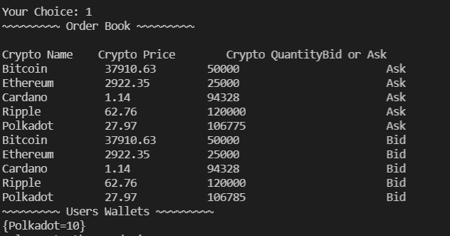
Fig.15: Viewing the Order Book
This can be used to abide by the FATF regulations so that any fraudelemt activity can be investigated by the authorities and scenarios recreated.
  - UML
  - Possible Improvements:
As can be seen in the test cases above, the user’s balance wasn’t being updated whenever a purchase occurred, however whenever money was deposited, the balance was updated.
The sell function wasn’t properly working as whenever the user tried to sell the crypto that they had bought, it perceived it as the user trying to buy it instead of selling it as seen below:
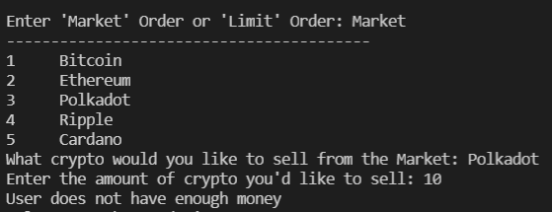
Fig.17: Failure to sell the 10 Polkadot the user Beppe had bought
Due to time constraints and the deadline these errors couldn’t be fixed. If they were to be fixed all requirements for the task would have been met.

- Big Integers (in C++)
  - Implementation of the Code
The third task consisted of writing a templated library that supports integers from 1-bit to 2048-bits. The libraray needed to only support unsigned integers with 2^{n} bits which through the use of the function powerOf2(), this is achieved. All binary integer operators (+, -, <<, >>) needed to be implemented and overloaded in the library. This is done through the use of operator+(), operator-(), operator<<(), and operator>>(). The operators *, /, % were implemented too: operator*(), operator/(), and operator%(). Since vector<bool> is being used, the minimum number of bits possible are being used to store a number which increases the efficiency of the code and since the operations are binary operations this also makes the code more efficient. The functions Integer_to_Binary, reverseBinary, printNum(), and onesComp() are all helper functions to be able to use the operators implemented, print the numbers, or even calculate one’s compliment which is used in the operator-() function. The convertToInteger() function is used to convert the vector<bool> into an integer which is then used to display said integer during testing.
  - Test Cases
For testing the numbers used were 86 stored in x, and 3 stored in y. As can be seen, the numbers are converted to binary and are stored as vector<bool>. When outputting the number the convertToInteger() function is used to convert it back to int.

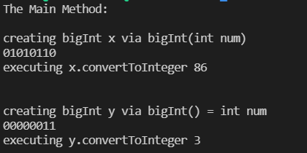
Fig.18: Numbers x(86) and y = 3 being declared

The operators =, -, <<, and >> were tested as seen below. The output was stored in various variables and then converted to integer.
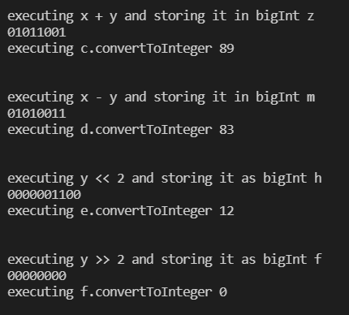
Fig.19: Operators +, -, <<, and >> being used.
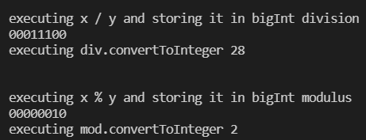
Fig.20: Operators / and % being used.
  - UML
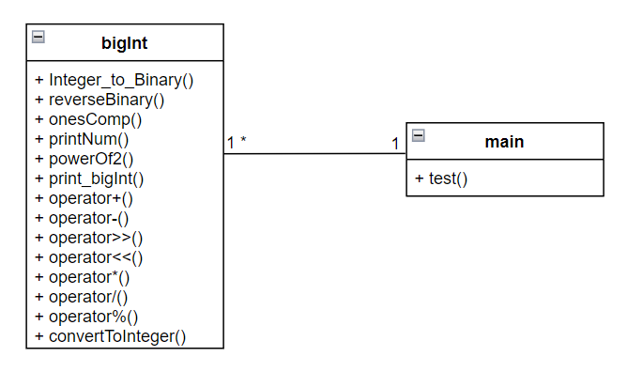
Fig.21: UML Diagram of Task 3

  - Possible Improvements
The operator*() function tends to cause a segmentation fault and as such this could be fixed in the future.
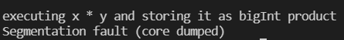
Fig.22: Segmentation fault cause by the operator*() function

