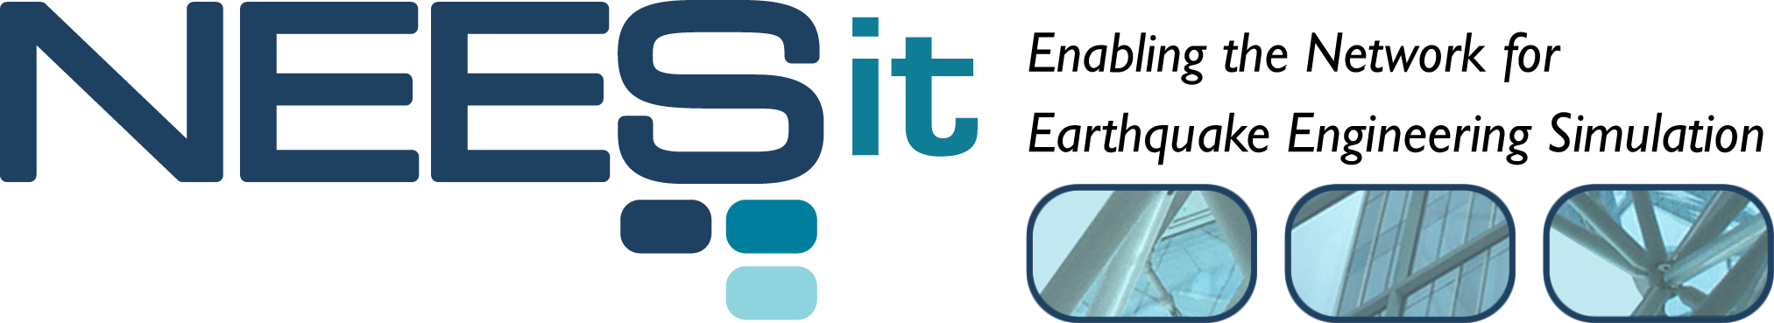
TR-2005-59

Event Markers for Data Turbine
Software Design Specification

Paul Hubbard¹
Lawrence J. Miller¹
Terry Weymouth²

¹NEES Cyberinfrastructure Center, San Diego Supercomputer Center
²University of Michigan

Last Modified: 2026-11-07 Draft: 1.0

Table of Contents

List of Figures

List of Tables

Table of Contents
Revision History 3
About This Document 3
1 Introduction 4
1.1 User Problem Statement 4
1.2 Design Overview 4
1.3 Design Issues 6
1.3.1 Planning for Application Programs That Will Handle Markers 7
1.3.2 Event Marker Submission Utility 7
1.4 System Requirements 9
1.5 Integration Issues 9
1.6 Security Issues 9
1.7 User Impact 9
1.8 Risks 10
1.9 Terms and Definitions 10
2 Architecture 10
2.1 Overview 10
2.2 Feeder modifications required 12
2.2.1 Client code 12
3 Detailed Design 13

Revision History

Date | Version | Description | Author(s)
7/27/05 | Initial | Initial draft for comment | PFH/TEW
9/30/05 | Additions | Addition of the proposed XML schema. | LJM
12/10/05 | Additions | Articulation of design concept and RDV integration detail | LJM

About This Document
This document introduces the idea of event markers, and attempts to explain the problems that they address. It also tries to outline their implementation and usage, with notes as to limitations and consequences.

- Introduction
There are several limitations and problems inherent in the current Data Turbine system for streaming data. Event markers are a proposal to address some of them in a flexible, extensible manner that will add to the usability and usefulness of NEES to the experimenter and public.
  - User Problem Statement
The combination of Data Turbine (DT) and the Realtime Data Viewer (RDV) provides a very good solution to medium-scale sharing of near-real-time data and video to remote participants. However, some data of interest is still not available to the remote observer:
- Has the experiment/trial started?
- Are the various systems (control, DAQ, etc) online?

Together, these provide context that is otherwise only available locally. If you are, say, U Iowa waiting for UMN to start the experiment, it’d be useful to have an interface that alerted you when things got started. Presently, this gap is often filled by external applications such as teleconferencing, IM or similar.

Event markers also address several other needs:
- How do I note interesting events as things happen?
- When I want to save data from DT to disk, and perhaps to NEES central, how do I figure out which portions are of interest?
- How can I automate some lab work? For example, I want to automatically start saving video to disk when the trial starts, and stop when it’s over.
  - Design Overview
The core idea behind event markers as proposed is time-stamped text strings that can be used to
- Start or stop subsystems
- Log system events
- Annotate (user/PI commentary for later analysis and remote users)
- Communicate between system components (proposed, but maybe not useful)

The series of event markers combine to form a text source in the data turbine, which can be monitored using RDV in its current version. The event marker log can also be saved to disk and uploaded as an essential source of experimental data. For example, it would be valuable to have the note that ‘At time X, it looks like the position sensor has failed, and its data should be ignored from now on’. Additionally, this stream of events would provide context for remote users, giving them the ability to understand what’s going on, and perhaps add their own annotations.

If, as noted in the next section, we merge the events, then the proposed event format would look like this: Timestamp, Source type, Source name, Event type, Message String.

Where source type is
- DAQ
- Control system
- User/PI
- Image/video
- Audio
- Other

Source name is simply the DT source name. Event types are proposed to be these, there are probably others that would be useful:
- Start
- Stop
- Keepalive (status not changed, but indicates that the source is still functioning)
- Annotation
- Other
The timestamp is implicit, and added by the turbine. When we display events to the user, we should display the time in human-readable format.

Some examples:

User/PI | Jane Researcher | Start | Experiment 12 begins
DAQ | LV_NW | Start | DAQ started
Control | MTS11 | Start | Quake reply begins
User/PI | Jane Researcher | Annotation | Looks like pier 1 has sheared off at the NW corner
DAQ | LV_SE | Other | Sensor failure of LVDT6
User/PI | Jane Researcher | Stop | End of experiment 12

During the run, tools such as the code that captures data from Data Turbine and puts in it the Central Archive could use these markers to automatically begin and end saving of data to NEES Central. After the experiment, tools that save data from DT to disk could make selection based on events instead of timestamps.

Events can also be used for remote users – for example, it would be easy to write an RDV plugin that illuminated a large onscreen indicator when, say, User/PI event ‘Start’ happened, so that the bored grad student monitoring knew when to start paying attention.

In general, events provide human-useful context that can also be used to make programmatic decisions.
  - Design Issues
Our plan is to implement Event Markers as a channel in Data Turbine, on the "hidden" source ‘_Events’, with one channel for each source that is publishing events. But, this implementation will be wrapped with a java API so that designers of code using the Event Markers will not need to details of the implementation. Our intension is that this API should actually appear in an extension to the RBNB Source implementation (called NeesSource), such that the methods that implement the Event Markers appear to the methods of the RBNB Source that is sending the data.

The current DaqToRbnb is a key element in this. It will be modified to accept events from the DAQ system. The current DAQ communications protocol has start/stop events in it, so only minor changes will have to be made to the reference LabVIEW code. Fake_daq will also need these changes; it will issue a start event when it is started and an end event if it is closed down "gracefully" (with control-C!). We could implement events on a separate TCP port, which would preserve backward compatibility, and allow for low-latency event transmission.

The user interface for events is debatable. An obvious choice is to write an RDV plugin to generate and monitor them:
This is currently manifest as an RDV data panel plugin that reacts to start and stop event markers by changing the display panel color to an obvious green or red for start and stop, respectively.

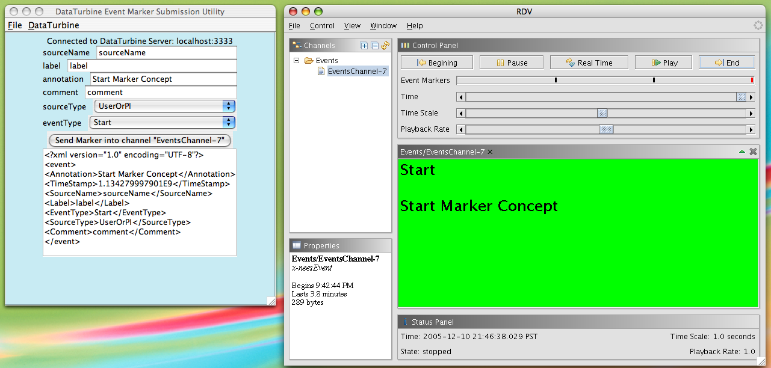
Event Marker Presentation in RDV

Planning for Application Programs That Will Handle Markers
An important consideration in the design of markers is that they contain sufficient information and semantics and are extensible so that future development of applications that compose sets of markers to deliver interval and timeline based are enable with “building blocks” that are adequately expressive. In order to accomplish this, markers will defined in terms of XML schema, which will accomplish all of the afore-mentioned criteria in a fashion that will enable graceful future development of application programs that will use markers to deliver functionality that is of engineering interest. Furthermore, both DataTurbine and RDV currently support text channel handling, which is what XML markers would be, and the use of a custom mime type, “x-neesEvent”, will allow RDV to handle event markers specially and specifically.

Event Marker Submission Utility
The event marker submission utility program, org.nees.rbnb.marker.SendMarkerGUI is currently designed to communicate with DataTurbine via a “wrapper” class, org.nees.rbnb.DataTurbine, which abstracts many of the more frequently used functionality of the DataTurbine SAPI for basic code reuse.
The utility functions by submitting a marker automatically when it first connects and when it disconnects in addition to enabling manual submission of markers encoding the semantics described in section 1.2.
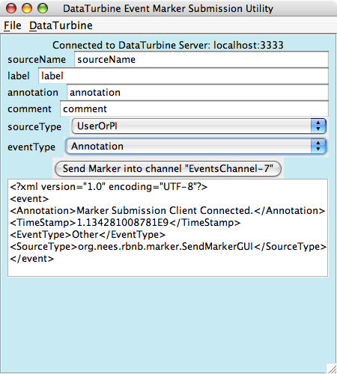
Event Marker Submission Utility

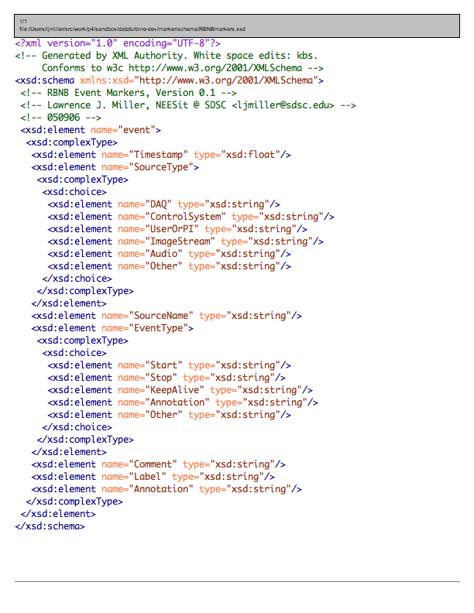
Proposed XML Schema Defining a Marker
  - System Requirements
Sources and the RDV client are pure Java programs that run on any J2SE 1.5 platform. These changes will not affect this.
  - Integration Issues
The main components are either sources or sinks. The turbine itself requires no changes. Sources will need to add event generation and propagation. We have an existing NeesSource base class that should centralize the modifications. As noted, DaqToRbnb will require a bit more work. We will also add event client support via a NeesEvent class that other programmers can use.

RDV, or any other interface, will need a plugin to generate events. It’s current ‘String display panel’ could be used now to display events in string format. It is not clear if RDV’s plugin design is sufficiently flexible to accommodate the prototype interface above. This unprecedented in that RDV will become a hybrid DT source/sink as opposed to its current state of acting as a sink, or consumer of data from the ring buffer.

We will also need new tools to save events to disk, and reload them into the turbine. Tools that make decisions based on events will need to instantiate NeesEvent, determine which event types are of interest, and act accordingly.

We may need a Data Turbine plugin to merge the event channels into a single channel. This would simplify NeesEvent considerably, but would be a new component that has to run on each turbine instance.

  - Security Issues
Since the events can be used to trigger other components, more security is desirable. The Turbine already has host-based security, and we anticipate that this will suffice until GridAuth support is added.

It is assumed that, once we’ve added GridAuth to DT, RDV will also get GridAuth support.
  - User Impact
Event markers will, to a good first approximation, be invisible unless the users want to use them. In the turbine, they will be a low-bandwidth source. The current software release will interoperate by simply ignoring them.

If the user chooses to use events, they will need to run RDV or other program to monitor/generate events. Tools such as the save-to-disk tools will add arguments denoting which events mark the region of interest, or users can still use UTC times.

If events are used as designed, the user experience will become more pleasant, with local and remote personnel having access to greater information and annotation. Components gain a way to signal changes and make decisions based on them, leading to a smarter and more useful system.

On the DAQ side, we can use a separate TCP port for events. This avoids protocol changes, and reduces the latency for event propagation. Current non-LabVIEW DAQ systems will work unmodified with the updated DaqToRbnb.
  - Risks
The primary risk is that sites do not find the idea useful or compelling, and the effort to design and implement it is wasted. This is very unlikely, given the interest expressed to date from different site personnel.

A second risk, always an issue with developers, is that this will take more effort than my estimates here. We can mitigate this by design review and prototype implementations confined to single components.
  - Terms and Definitions
DAQ: Data acquisition system
DT, Data Turbine: Creare Data Turbine, see http://outlet.creare.com/
DaqToRbnb: Feeder program that transfers data from DAQ to DT
Feeder: A program that feeds data into the turbine, see http://users.sdsc.edu/~hubbard/neesit/rbnb-apps.html
RDV: Real-time data viewer, see http://nees.buffalo.edu/software/RDV/
- Architecture
As with other DT applications, this is split into source, sink and turbine. Of the three, only the turbine is unmodified.

On the source side, we modify the feeders to generate or propagate events, which are sent into a shared _Event source. A plugin on the turbine combines these (not sure of this yet!) to form a single stream of merged events, whose format was previously explained.

Clients can subscribe to this event stream. Based on it, they can make decisions, inform the user, or ignore them as they see fit. There’s also an annotate event, where authorized users can make notes and comments as the run progresses.
  - Overview

The big picture looks something like this, where the arrows represent the flow of events:
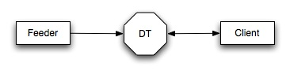
(It’s also possible that feeders could be clients, making decisions based on events.)

Here’s a snapshot of how units are presently implemented in the data turbine. Note the shared _Units source, with one channel per DT source:
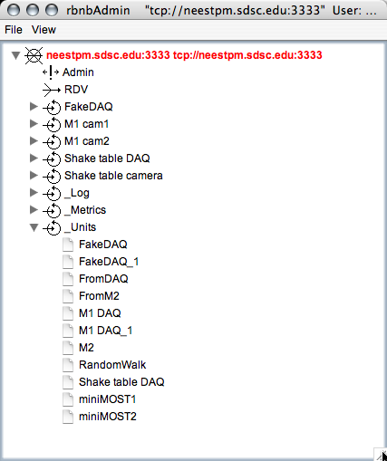
Events would be implemented in the same manner, with a shared _Event source. It’s not yet clear if we should
- Write a plugin to merge events into a single feed or
- Write a Java class for re-use that can monitor 1 to N event sources at once.
  - Feeder modifications required

For each feeder, it needs
- A way to get events from their source (e.g. DAQ hardware)
- A way to push events into the turbine
- (Optional) A way to read events of interest to itself

Number one is system-dependant. For DaqToRbnb, we will use a separate TCP port. This allows backward compatibility and fast propagation. Other systems can use local methods to acquire events, and instantiate NeesEvent to send them to the turbine.

I can see where feeder programs might want to subscribe to some events that interested them, e.g. the DAQ feeder might pause if it saw the control system stop. For this, we will need a NeesEvent method to get events. If we use the event classification above, it should be easy for a client to select events of interest and ignore the rest. This would probably be callback-based or similar. mponents >
    - Client code
There are two client types described so far:
- Read-only consumers of events. For example, we’ll need a program to log events to a disk file for archiving. The string display panel in RDV is another example of what we’ll call a client or ‘pure client’.
- Read-write or hybrid clients. An example of this is a subsystem that monitors events and changes it own state based on external events. It could then generate its own events to broadcast what its doing. An example would be of an automatic repository archiver, that would start and stop based on the state of the experiment as defined by the lab manager or PI, and would announce the start and stop of archive mode.

RDV could be either. After initial discussions with a user, it became clear that one single client program is very appealing. To address that request, we could write a plugin for RDV that was a hybrid client. This would allow monitoring, annotation and the generation of start/stop or other events. As noted in the risks section, the existing plugin API might require extensions to accommodate this; we don’t know yet.
- Detailed Design

I think the best way to proceed is to do a small-scale test first. Modify DaqToRbnb and fake_daq as a source, and then use the string window in RDV to monitor the events generated. We can modify the other feeders to trivially generate events, while looking at RDV as a hybrid client. In parallel, we can figure out the changes required to the LabVIEW distribution that would be needed for true DAQ events.
This has been enable by the creation of org.nees.rbnb.marker.NeesEvent, which is an XML marker and an API with which to interact with it and org.nees.rbnb.DataTurbine, which has a specific method to submit an event marker to DataTurbine and set its mime type to “x-neesEvent”.

