Sample Application

User Guide

Li Yiming

*Artificial Intelligence, Computing Science, the University of Liverpool, Liverpool, UK*

[Y.Li38@student.liv.ac.uk](mailto:Y.Li38@student.liv.ac.uk)

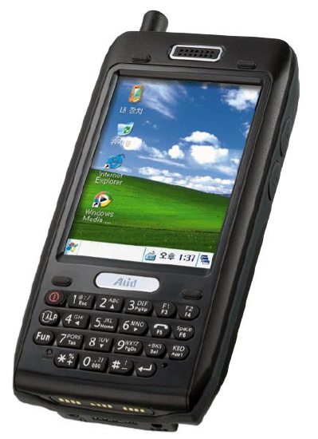

# General

The sample application guide is a demonstration application that can be used as a basis for customer to transfer the RFID from scanners (mobile phone) to a database, which is stored in the server computer. There will be two parts of software, the first one is called “client” installed in the scanners, and the second one is called “server” installed in the computer. For this software, there may be many scanners, which install the “client”. However, only one computer can get all the RFID and store into database (Microsoft Access, Microsoft SQL Server or MySQL). The connection between “client” and “server” is vas telnet, such as wireless or wired.

# Software Requirements

Before using the software, the user should check:

* “Client” (mobile phone): It must install the Java JRE 7.0.
* “Server” (server computer): It also must install the Java JRE 7.0.

***Download Java JRE:*** [http://www.oracle.com/technetwork/java/javase/downloads/index.html](http://www.oracle.com/technetwork/java/javase/downloads/index.html%20)

# Installation

The “Server” is installed in the server computer, which is “server.exe”.

The “Client” is installed in the mobile phone, which is “client.exe”.

# Database

**Create a database before using the program with server:**

1. Mircrosoft Access: product_ID(text), read_Date(datatime), name(text) and temperature(float).
2. Mircrosoft SQL Server: product_ID(ntext), read_Date(datatime) , name(text) and temperature(float).
3. MySQL: product_ID(ntext), read_Date(datatime) , name(text) and temperature(float).

**Each location has a database for storing the temperature:**

1. Mircrosoft Access: time(datatime) and temperature(float).

2. Mircrosoft SQL Server: time(datatime) and temperature(float).

3. MySQL: time(datatime) and temperature(float).

# Describe diagram

## 5.1 UML

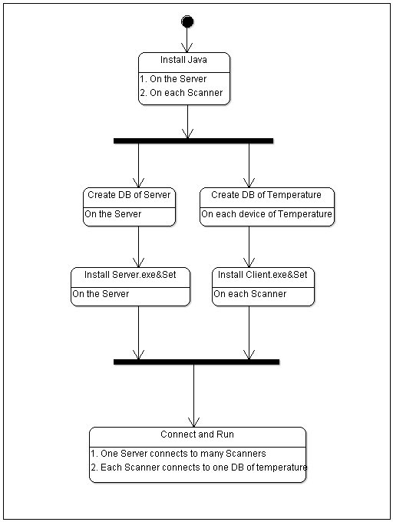

## 5.2 Simulate

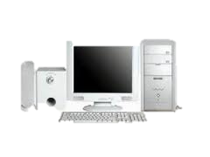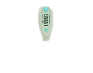

Server

Scanner

Temperature

When the scanner connects to the server, the server can control all the connecting scanners (*solid lines*). If the server adds one scanner S1 to list of working (start to scan), then scanner will scan RFID of product for this location and at the same time get the corresponding temperature from database of temperature (*dotted line*).

# Use

“Server”:

1. There a menu bar with for menus, such as Choose, Set Control and Help:

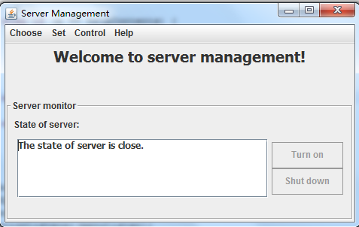

1. Choose:
   1. Choose Database:

There are many database applications to use, however, Microsoft Access and SQL Server are implemented.

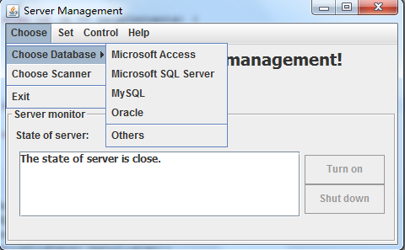

When clicking Microsoft Access, user needs to input the information：

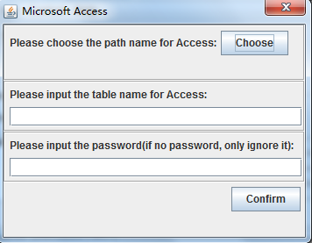

When clicking Microsoft SQL Server, user needs to input the information:

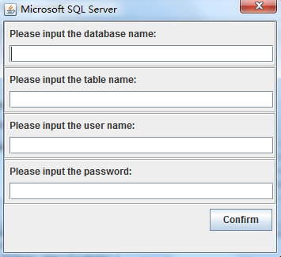

* 1. Choose Scanner

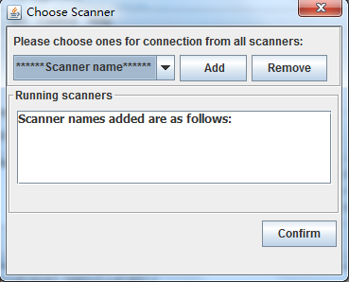

* 1. Exit: The user can exit by this button.

1. Set:
   1. Set Time: Set interval time: 1, 2, 3, 4, 5, 6, 10, 12, 15, 30, 60

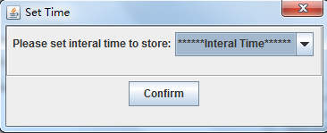

* 1. Set Contents

1. Control:
   1. Turn On: Control the server.
   2. Shut Down: Control the server.
2. Help:
   1. Help Contents
   2. About Program

“Client”:

1. Only one menu contains Set.

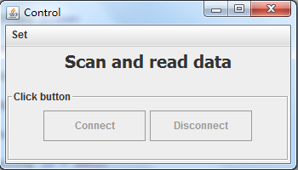

1. Set:
   1. Set Name: For each scanner, it must only have one unique name.

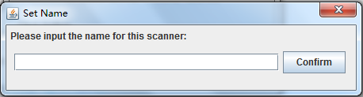

* 1. Set Connection: Connect to the server by telnet using IP.

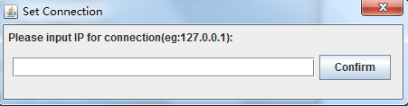

* 1. Temperature database: as the same as the server.
  2. Exit: Exit the program.

# How to set

**Server:**

1. Choose->Choose Database->MySQL(example)
   1. Name of database: product
   2. Name of table: product
   3. User: root
   4. Password: 123456
2. Set->Set Time: 5
3. Turn on

**Client:**

1. Set->Set Name: location1
2. Set->Set Connection: 127.0.0.1
3. Set->Temperature Database->MySQL(example)
   1. Name of database: scanner1
   2. Name of table: scanner1
   3. User: root
   4. Password: 123456
4. Connect

# Range of application

This program is only for testing and showing to transfer from scanner to database. There are many parts to be improved to be a product, for example, in this software; the port is only set to 10000, if possible, it can be changed. At the same time, Java JRE should be embedded into software.