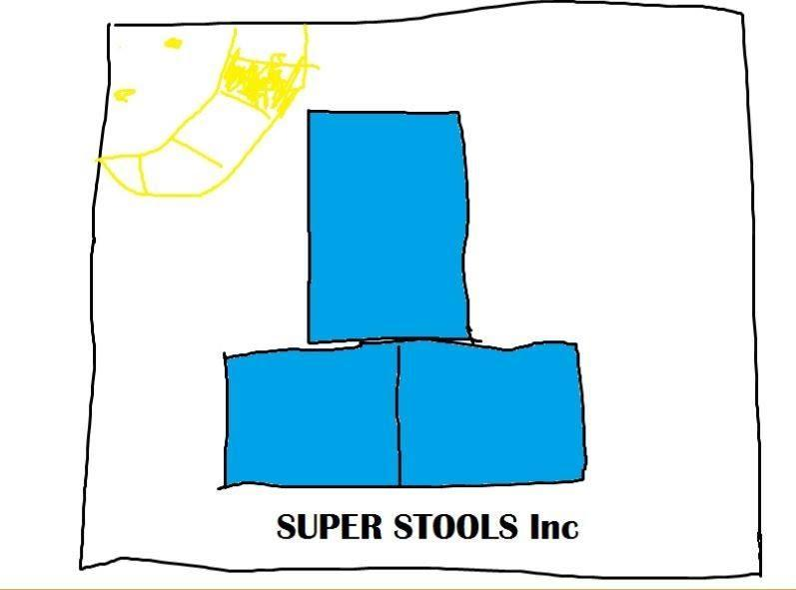

Ryan Kornyk, Christian Simpson, Nathan Siu

Table of Contents

1. Description
2. Wire frame layout
3. Screeshots
4. Future Updates

Description

Our website allows people to work with survey tools view results of a survey. Anyone can answer a survey but only registered users may create a survey. The website will be broken into a few parts.

Login/Register Page – able to login/register on the website

User Profile Page – user is able to edit their profile, and anyone is able to see the users created surveys

Survey Creator/Editor page – a logged in user can create a survey based off of predefined templates

Survey List viewer – a (Possible search function) list of all the created/active surveys at the time

Survey Take site – anyone can answer a survey and that result gets saved to the database

Survey Result Page – a page to view and export the results of the survey/ only the creator can see the results

About page – simple about page with contact info ect

Wireframe Layout

About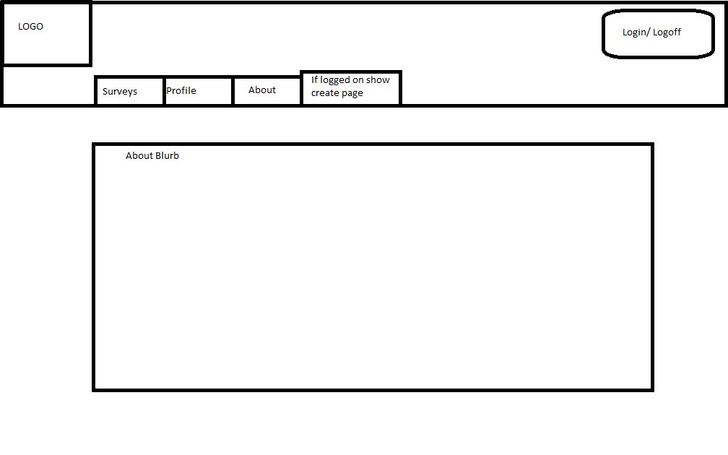

Create Survey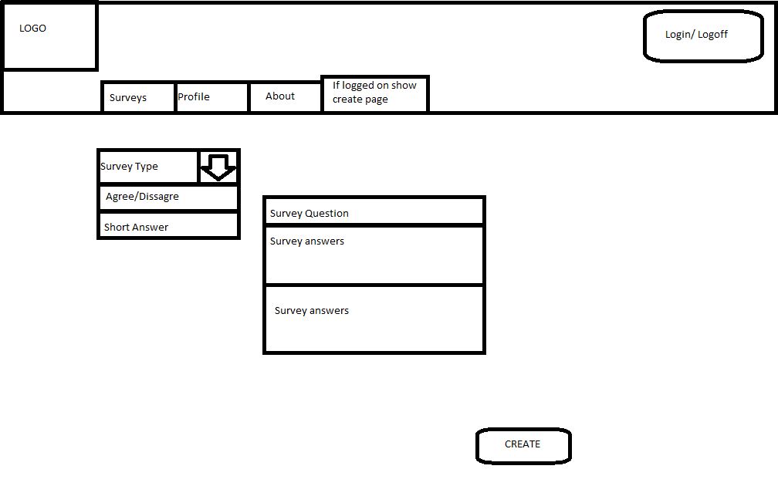

Register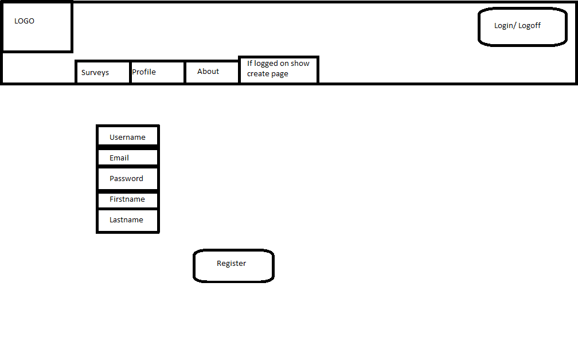

Survey Page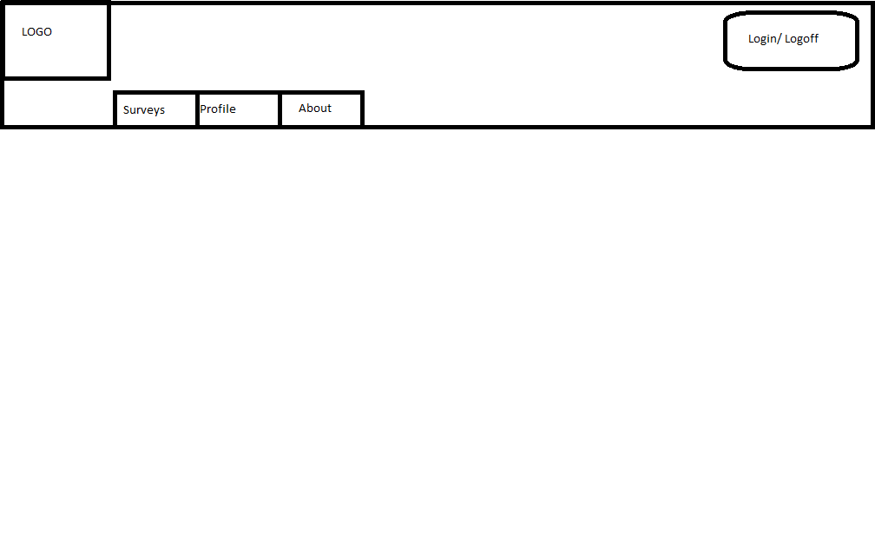

Survey List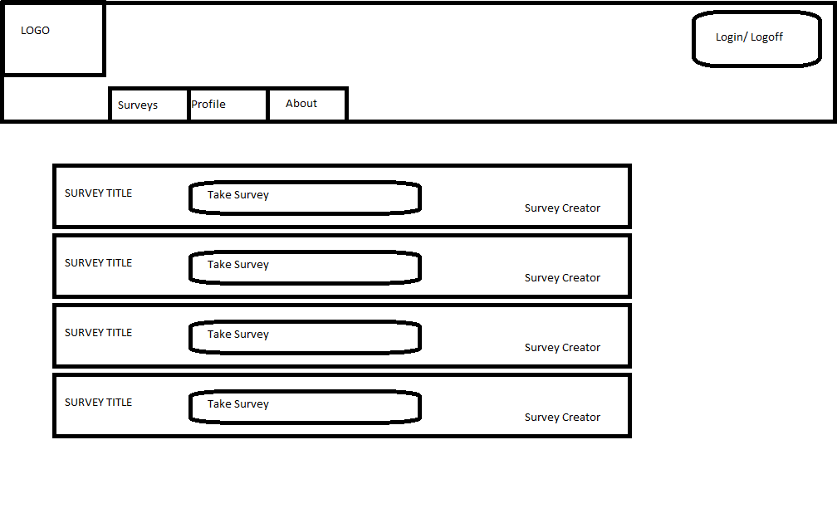

Take Survey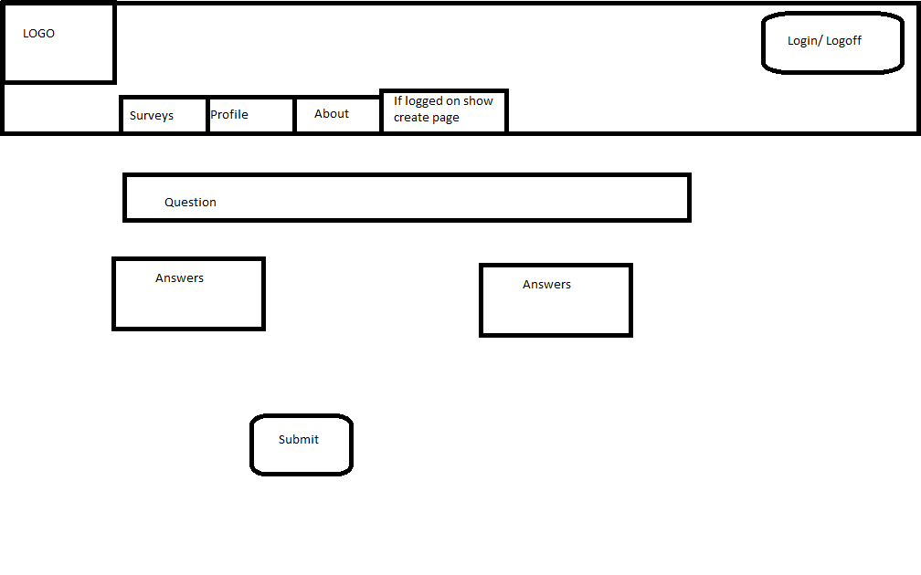

User Profile

Screenshots

Future stuff