1)Int \*p[10]; means an array of int pointers

Int (\*p)[10]; means pointer to an array of size 10

2)Int (\*p)(char (\*a)[]); p is a function pointer that returns int. takes pointer to an array as parameter.

Int \*p(char (\*a)[]); p is a function that returns int. takes pointer to an array as parameter.

4) 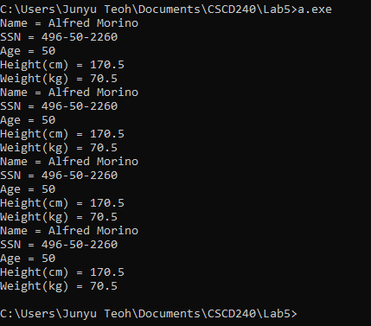

They are all the same. These are just different notations when it comes to accessing the variable within a struct.