Manual test plan, week 1

Run ‘python leaftrader.py’:
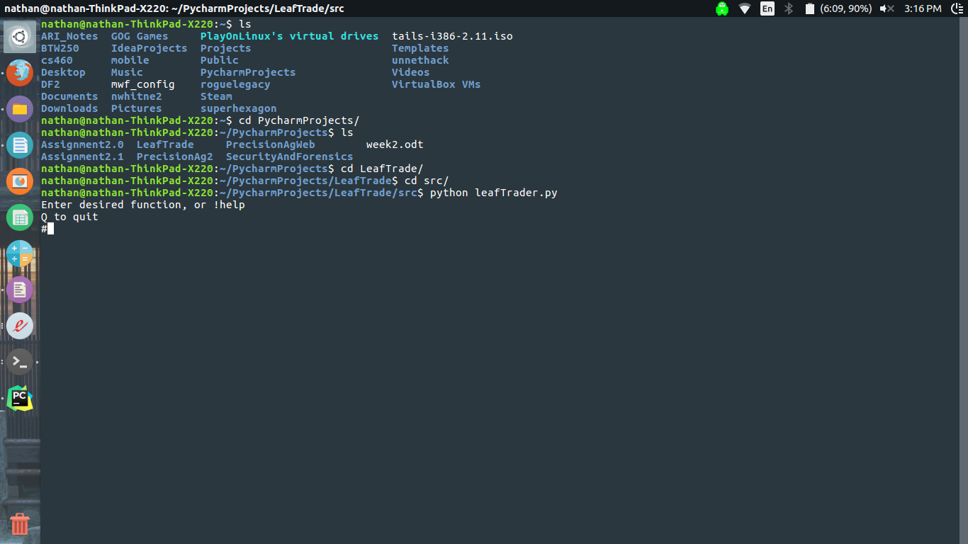
Type ‘!help’:

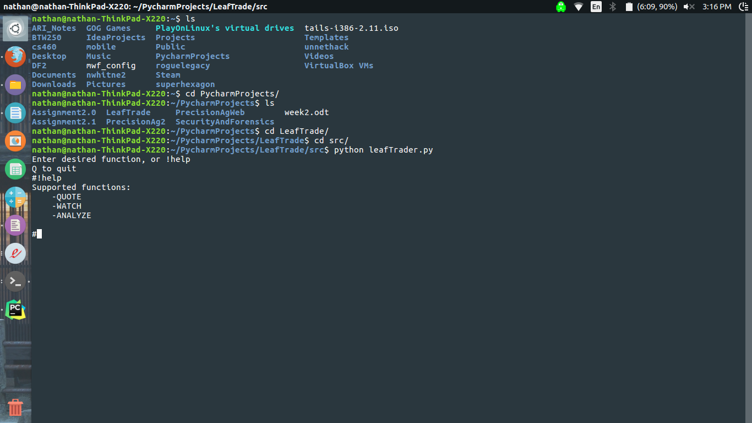

Try the quote function, as shown with inputs:
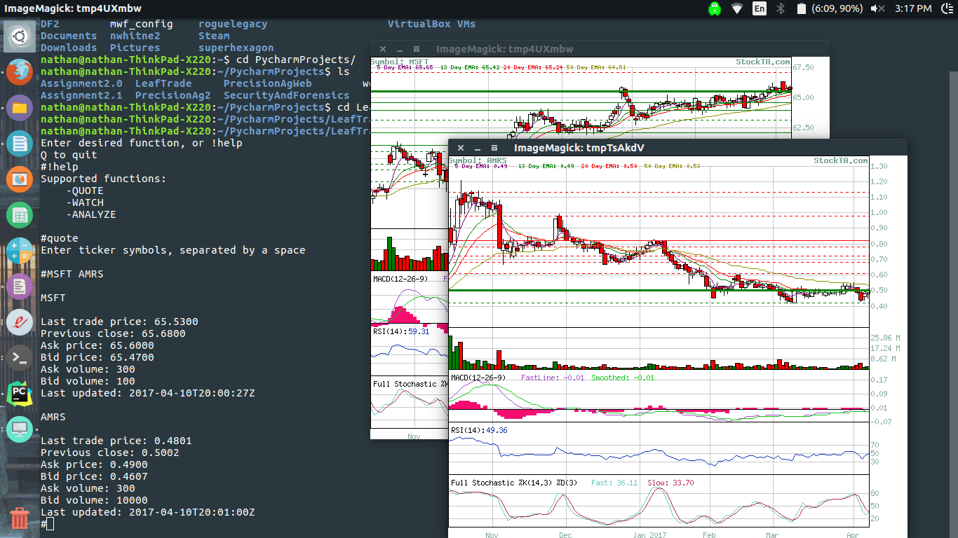
Press Q to escape to the main function. Try the watch function:
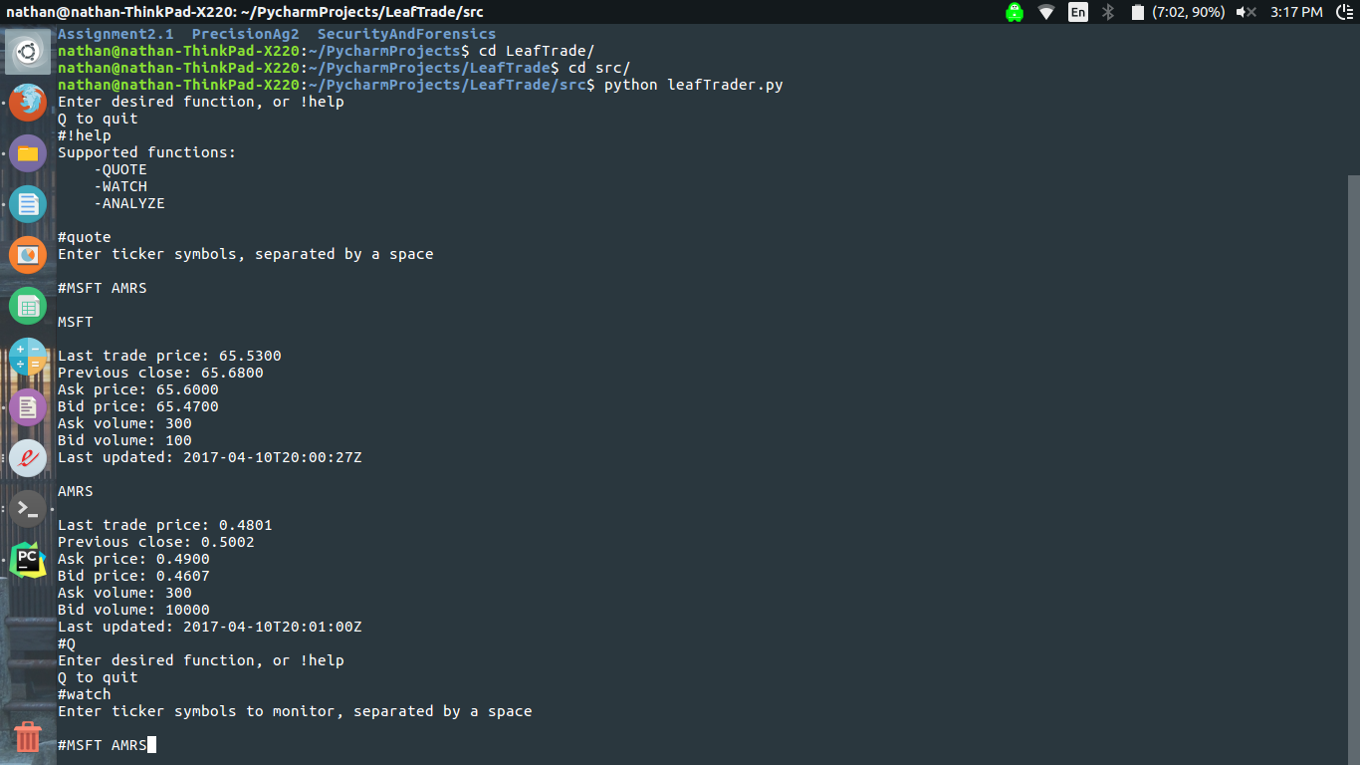

You will see something like this:
