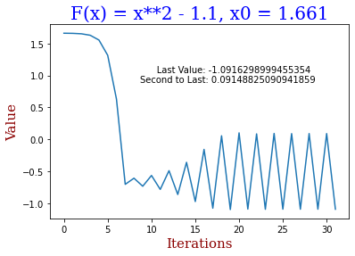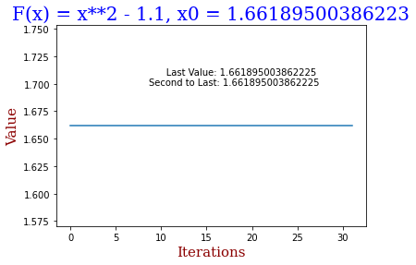

1. A, B

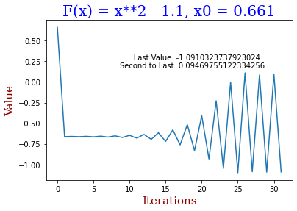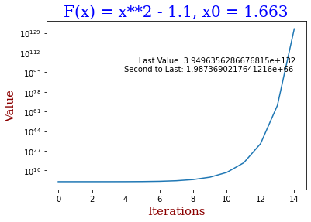

|< x0 <, 2-cycle x0 = , fixed point

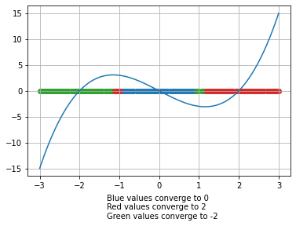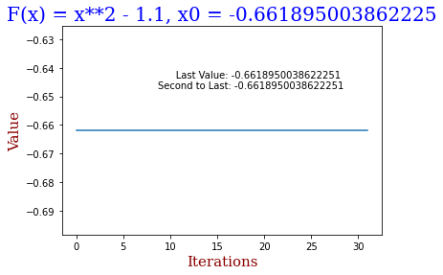X0 > , -> ∞ ≤ x0 <|, 2-cycle

C3: Newton's method will fail if the derivative of F(x), F'(x) is equal to 0. Because:

$$N\left(x\right)= x-\frac{F\left(x\right)}{F’\left(x\right)}$$

And there cannot be a zero in the denominator

x0 = , fixed point

C2: The structure of the basin of attraction implies that newton’s method can be used to find the basin of attraction