VC Scout: Revised Results, Insights Summary, and Implementation Plan
Briefing note and audit-trail companion | Team 17 - Mia Murphy, Finn Kliewer, Kayvon Jafarzadeh, Nathanael Gill, Om Patel
Executive readout. The revised analysis moves VC Scout from a unicorn-only valuation exercise to a defensible benchmark-and-scouting framework. We preserve the original descriptive findings, rerun/audit the expanded data, correct funding-unit risks for unicorn rows, and separate what the data can support from what it cannot. The result is a two-layer framework: (1) a unicorn valuation benchmark and residual outperformance model, and (2) a broader tier diagnostic that improves context but is not treated as a causal startup-success model.
Traceability: revised analysis script vc_scout_final_analysis.py; source-of-truth file vc_scout_source_of_truth_final.json; final slide deliverable team17_vc_scout_revised_results_insights_implementation_final.pptx.

Traceability reference key
Tag | Audit file(s) | Used for
A1 | vc_scout_audit_summary_final.csv; vc_scout_source_of_truth_final.json | dataset audit counts, funding correction counts, Form D quality checks
A2 | vc_scout_audited_startup_master_final.csv; vc_scout_tier_summary_final.csv | expanded tier counts, valuation/funding coverage, corrected funding fields
A3 | vc_scout_era_regime_summary_final.csv; vc_scout_unicorn_year_counts_final.csv; vc_scout_hypothesis_summary_final.csv | 2021/COVID-era regime analysis and hypothesis H1
A4 | vc_scout_model_results_final.csv; vc_scout_permutation_importance_final.csv | valuation benchmark model comparison and feature importance
A5 | vc_scout_unicorn_residuals_final.csv; vc_scout_residuals_by_industry_final.csv; vc_scout_residuals_by_country_final.csv | residual outperformance analysis by company, industry, and geography
A6 | vc_scout_tier_classifier_diagnostic_final.csv; vc_scout_formd_q2_2026_audited_final.csv | expanded tier diagnostic and Form D market-context screen

1. Refined analytics approach
Core change. The project now separates valuation benchmarking from startup scouting. The original model asked how large a unicorn valuation gets once a company is already in the unicorn population. The revised approach treats that as a benchmark problem, then uses residuals and tier comparisons as scouting signals rather than as guaranteed predictions.
- Layer 1 - Unicorn valuation benchmark: predict ln(valuation) among current/former unicorns using audited funding, industry, geography, tier, era, investor count, and years to unicorn. The output is expected valuation, not investment advice. [A4]
- Layer 2 - Scouting signal layer: compare segments by residual outperformance, sample size, sector concentration, and data-confidence flags. Companies or segments above the benchmark become candidates for deeper diligence. [A5]
- Layer 3 - Expanded-tier diagnostic: use the 75,230-row master file to compare unicorns, soonicorn proxies, accelerator controls, funded controls, exited unicorns, and delisted unicorns. This improves context but does not eliminate source bias or survivorship bias. [A2, A6]
Audit references: model comparisons are in vc_scout_model_results_final.csv; residual outputs are in vc_scout_unicorn_residuals_final.csv and segment residual tables; expanded tier diagnostics are in vc_scout_tier_classifier_diagnostic_final.csv.

2. Data shortcomings and how we addressed them
Issue | What we found | Treatment in revised analysis | Audit trail
Survivorship bias | Original Kaggle file only covered companies that reached unicorn status. | Do not claim probability of startup success from unicorn-only data; use conditional valuation and benchmark language. | A2, A4
Expanded data source bias | The master file has 75,230 rows but mixes current unicorns, old funded controls, accelerator portfolios, and proxy tiers. | Use as a diagnostic comparison universe, not a causal success model. | A1, A2
Funding-unit risk | 950 unicorn rows were flagged as unit-suspect when valuation and funding were both present. | Preserve raw values and create audited funding values for analysis. After correction, 0 audited unicorn rows had funding greater than valuation. | A1, A2
Sparse valuation coverage | Only 1,829 of 75,230 expanded rows have valuation. | Limit valuation modeling to rows with defensible valuation data; avoid valuation claims for control tiers without valuations. | A1, A2
Form D noise | Q2 2026 Form D contains 5,728 rows; 238 raises exceed $100M, but 156 are likely non-startup categories. | Use Form D only as market context unless filtered to operating-company raises. | A1, A6
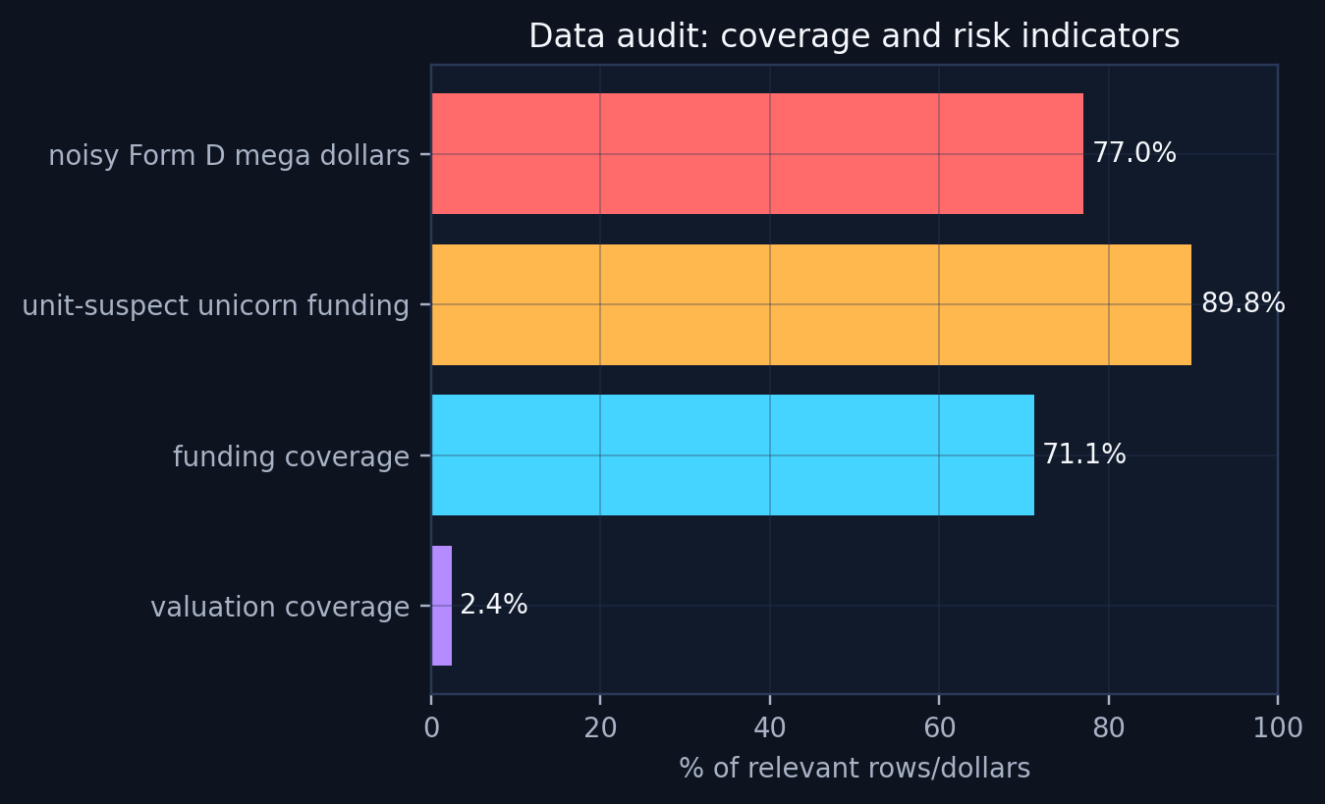
Figure 1. Audit coverage and usable data by field. Source: audit_coverage_final.png; underlying files: vc_scout_audit_summary_final.csv and vc_scout_tier_summary_final.csv. [A1, A2]

3. Detailed insights and hypotheses
Hypothesis | Status | Evidence | Implication
H1 - 2021 is a distinct market regime | Supported descriptively/statistically | 2021 is the largest single dated cohort in the expanded current-unicorn list (441 rows); era differences in valuation and funding are statistically significant; sector mix differs by era. | Bring in external VC funding/interest-rate data only if the final project needs causal COVID interpretation.
H2 - Funding predicts valuation with diminishing returns | Supported | Audited benchmark champion test R2=0.30; no-funding stress test R2=0.05; log-log funding elasticity ~= 0.49. | Use benchmark residuals rather than raw valuations to spot capital-efficient outperformance.
H3 - Sector/geography add signal beyond funding | Partially supported | Industry, country, and continent residual tables show directional variation, but several medians are muted and small categories require confidence flags. | Use sample-size penalties and confidence bands before turning residuals into rankings.
H4 - Expanded controls solve survivorship bias | Disproven / only partially solved | The 75k-row master adds comparison tiers, but sources are mixed across time and valuation coverage is only 1,829 rows. | Use expanded data for diagnostic tier comparisons, not causal startup-success prediction.
H5 - Investor count is enough for investor network effects | Not proven | Investor count is a weak proxy for investor quality, timing, and co-investor networks. | Add top-fund flags and co-investor network features in final implementation.

Insight 1 - 2021 is a distinct market regime, but not automatically a COVID-causality claim
- The expanded current-unicorn list shows 441 dated unicorn rows in 2021, compared with 351 pre-2021 and 607 post-2021. Median valuation declined from $2.30B pre-2021 to $1.67B in 2021 and $1.50B post-2021; median funding also declined from $0.505B to $0.320B and then $0.231B. [A3]
- Kruskal-Wallis tests indicate significant differences by era for valuation and funding, while years-to-unicorn did not differ significantly. The sector mix also differs significantly by era. [A3]
- Interpretation: 2021 should be treated as a financing/valuation regime shock and analyzed separately. The dataset flags the discontinuity, but external VC funding, interest-rate, and digital-adoption data would be required to make a causal COVID claim. [A3]

Insight 2 - Funding matters, but with diminishing returns
- The audited valuation benchmark selected Gradient Boosting as the champion among the tested models, with test R2 = 0.30, MAE = 0.48 log units, and median absolute percentage error of about 40%. [A4]
Reconciliation with the prior model deliverable: the earlier R2 near 0.51 came from the original Kaggle-only unicorn modeling setup. The revised R2 is lower because the benchmark is rebuilt after the expanded-data audit, funding-unit corrections, and inclusion of current/former unicorn-history tiers. We prefer the lower audited estimate because it is more defensible for implementation. [A4]
- A no-funding stress test produced test R2 = 0.05, confirming that most company-level valuation signal comes from funding. [A4]
- The OLS companion model estimates funding elasticity around 0.49, which means valuation rises with funding but less than one-for-one. [A4]
- Business implication: VC Scout should not reward raw capital raised. The useful signal is whether a company, sector, or geography outperforms its expected valuation after controlling for funding. [A5]
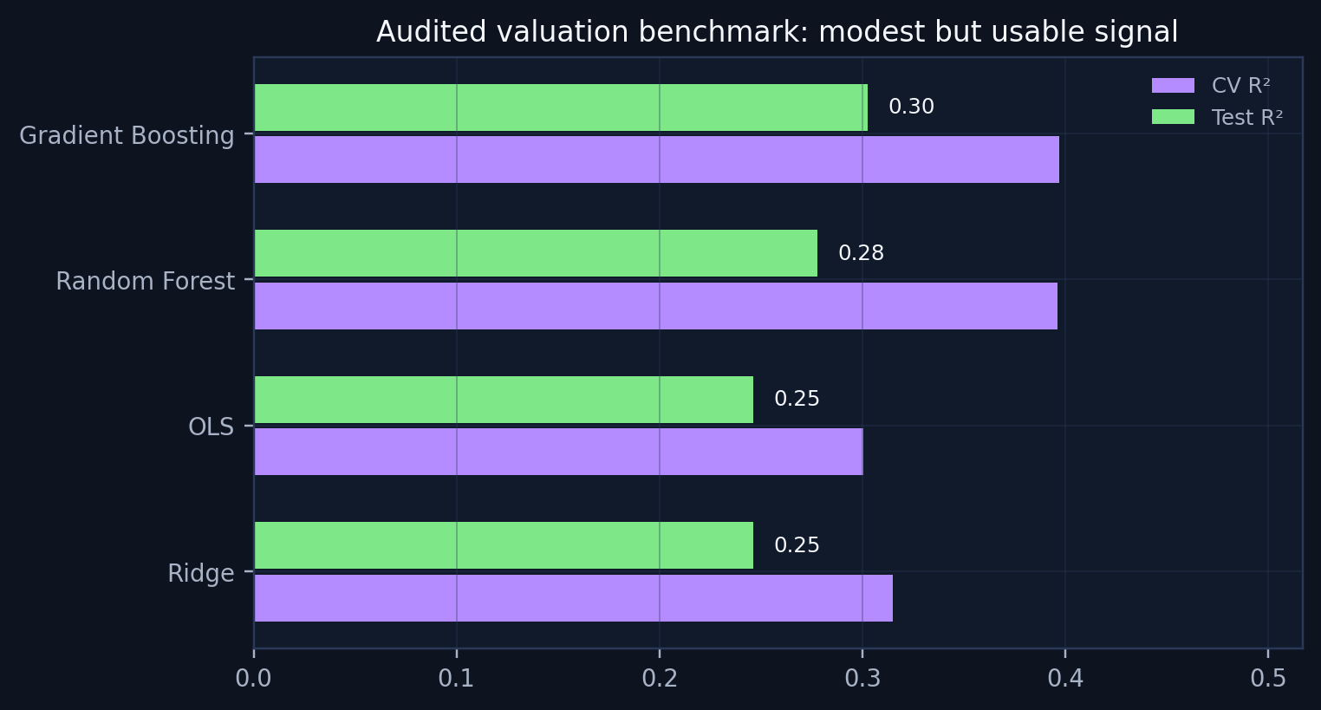
Figure 2. Audited model comparison. Source: model_results_final.png; underlying file: vc_scout_model_results_final.csv. [A4]

Insight 3 - Sector and geography add signal, but residuals are the better scouting lens
- Permutation importance shows ln(funding) is dominant, while industry and continent add smaller but positive signal. Era, tier, investor count, and years-to-unicorn are much weaker once funding is included. [A4]
- Industry residuals are directionally useful: Cybersecurity, Fintech, Enterprise Software, and Health & Bio show positive average residuals in the audited benchmark, while Transport & Logistics and E-commerce & Consumer underperform in this sample. [A5]
- Country residuals show pockets of positive benchmark outperformance, but some segments have small sample sizes. Rankings should therefore include sample-size penalties and confidence bands. [A5]
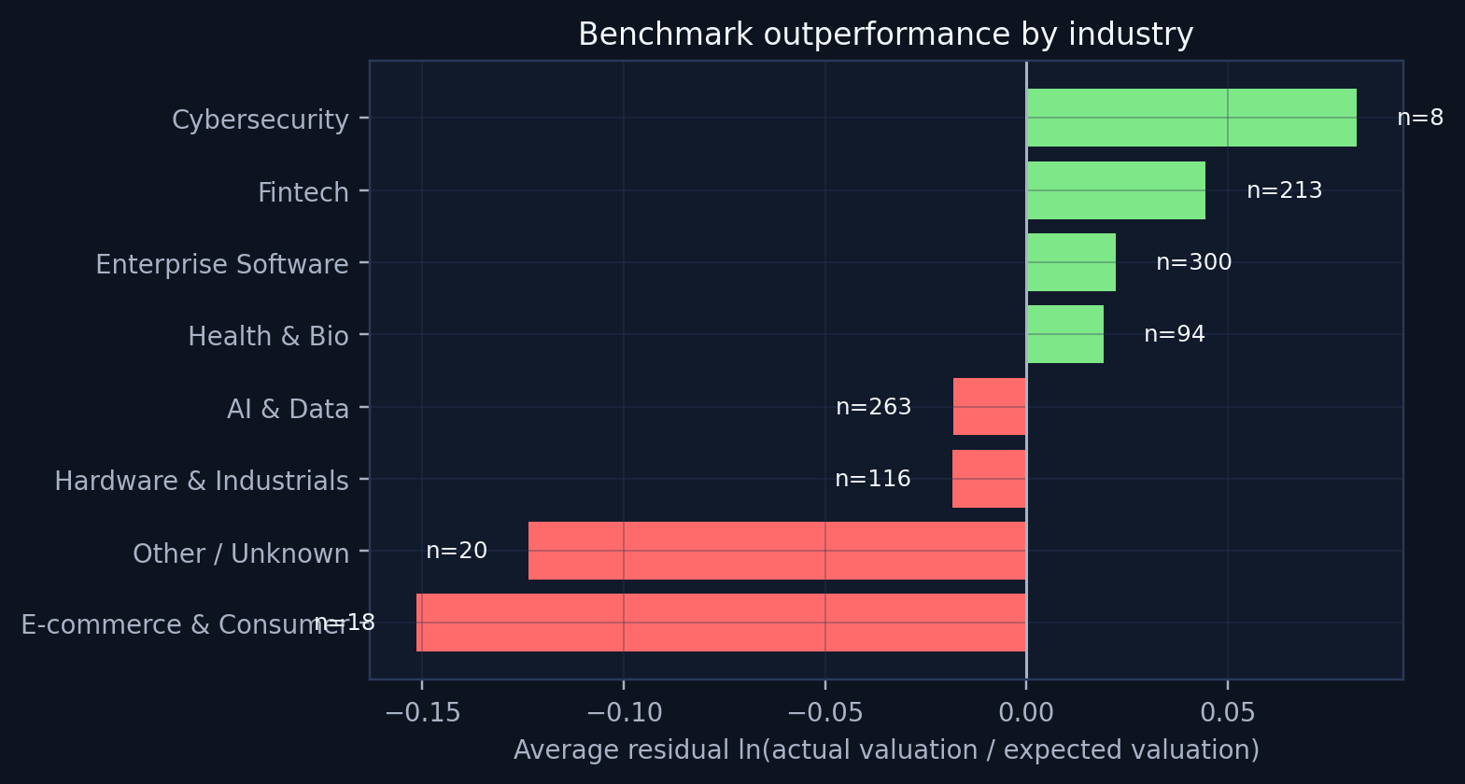
Figure 3. Industry-level valuation residuals. Source: industry_residuals_final.png; underlying file: vc_scout_residuals_by_industry_final.csv. [A5]

Insight 4 - The expanded classifier looks strong, but may be learning data-source artifacts
- The expanded-tier diagnostic model reports very high performance, including Gradient Boosting ROC AUC = 0.993 and balanced accuracy = 0.933 on a sampled tier diagnostic. [A6]
- This is useful as a diagnostic, but not a final success model. The comparison tiers are drawn from different sources and time periods, so the classifier may separate sources rather than true startup quality. [A2, A6]
- Final positioning: the expanded dataset reduces unicorn-only tunnel vision, but it only partially addresses survivorship bias. VC Scout should use it for benchmarking and triage, not causal investment decisions. [A2, A6]
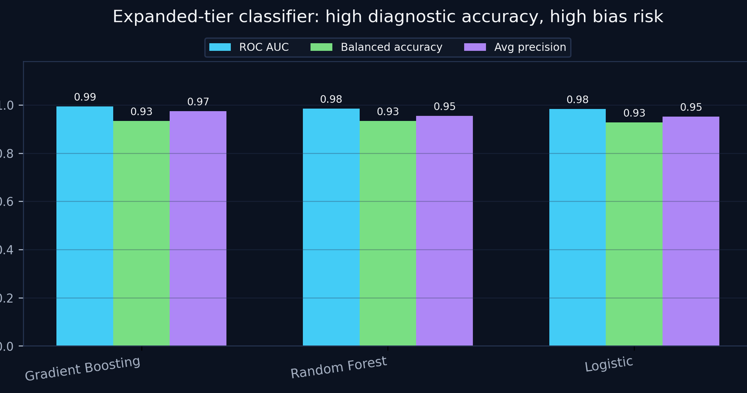
Figure 4. Expanded tier diagnostic results. Source: tier_classifier_final.png; underlying file: vc_scout_tier_classifier_diagnostic_final.csv. [A6]

4. Initial business actions and recommendations
Recommendation | Action | Reason | Traceability
Use benchmark residuals, not raw valuation | Rank sectors, countries, and investor clusters by actual minus expected log valuation. | This controls for funding and market regime instead of rewarding capital intensity. | A4, A5
Treat 2021 as its own regime | Report pre-2021, 2021, and post-2021 insights separately. | 2021 is statistically distinct in valuation, funding, and sector mix. | A3
Use expanded data as context | Use tier comparisons to broaden the story, but label them diagnostic. | Mixed source timing and sparse valuation coverage prevent causal success claims. | A1, A2, A6
Add investor network features | Replace raw investor count with top-fund flags, co-investor clusters, and sector specialization. | Investor count had near-zero importance and does not capture quality or timing. | A4, A5
Publish confidence flags | Attach sample-size and confidence warnings to each sector/geography ranking. | Some high-residual countries or sectors have small n, so rankings should not imply false precision. | A5

5. Implementation plan for final capstone week
Workstream | Next deliverable | Owner logic | Source/audit dependency
Data pipeline | One reproducible cleaned dataset plus documented exclusions. | Data lead maintains raw-to-clean lineage. | vc_scout_final_analysis.py; A1, A2
Benchmark model | Locked valuation benchmark with residual exports. | Model lead owns train/test, diagnostics, and stress tests. | A4, A5
VC Scout scoring layer | Transparent score blending residuals, sector concentration, efficiency, and confidence. | Framework lead translates model outputs into decision-support language. | A3, A4, A5
Dashboard/prototype | Interactive or slide-based view by sector, geography, investor cluster, and era. | Visualization lead builds audience-ready outputs. | All chart PNGs; source-of-truth JSON
Final narrative | Recommendation deck with limitations stated clearly. | Presentation lead ensures the story is not overclaiming. | This memo plus final PPTX/PDF

Appendix - audit-trail inventory for submission
The audit trail ZIP is designed to make the work reproducible. The key files to submit with the deck and this memo are: vc_scout_audited_startup_master_final.csv, vc_scout_model_results_final.csv, vc_scout_unicorn_residuals_final.csv, vc_scout_residuals_by_industry_final.csv, vc_scout_residuals_by_country_final.csv, vc_scout_hypothesis_summary_final.csv, vc_scout_source_of_truth_final.json, and vc_scout_final_analysis.py. These files preserve the raw-to-clean logic, the exact metrics used in the deck, and the exported tables behind the visuals.
Submission package reference: vc_scout_revised_results_audit_trail_final.zip. Companion slide files: team17_vc_scout_revised_results_insights_implementation_final.pptx and .pdf.

