*predicting-avgratings.Rmd*

GameWeight, MfgPlaytime Model

90.48% accuracy

|  |  |  |  |  |  |
| --- | --- | --- | --- | --- | --- |
| term | estimate | std.error | statistic | p.value | level |
| (Intercept) | 5.31E+00 | 1.67E-02 | 3.18E+02 | 0.00E+00 |  |
| GameWeight | 6.07E-01 | 7.85E-03 | 7.72E+01 | 0.00E+00 | *** |
| MfgPlaytime | 1.27E-03 | 1.51E-04 | 8.39E+00 | 5.12E-17 | *** |
| GamePlayInteraction | -2.83E-04 | 3.52E-05 | 8.05E+00 | 9.19E-16 | *** |

Multiple R-squared: 0.294, Adjusted R-squared: 0.2939

* Separately, GameWeight & MfgPlaytime have positive coefficients, but the interaction term is negative.
  + 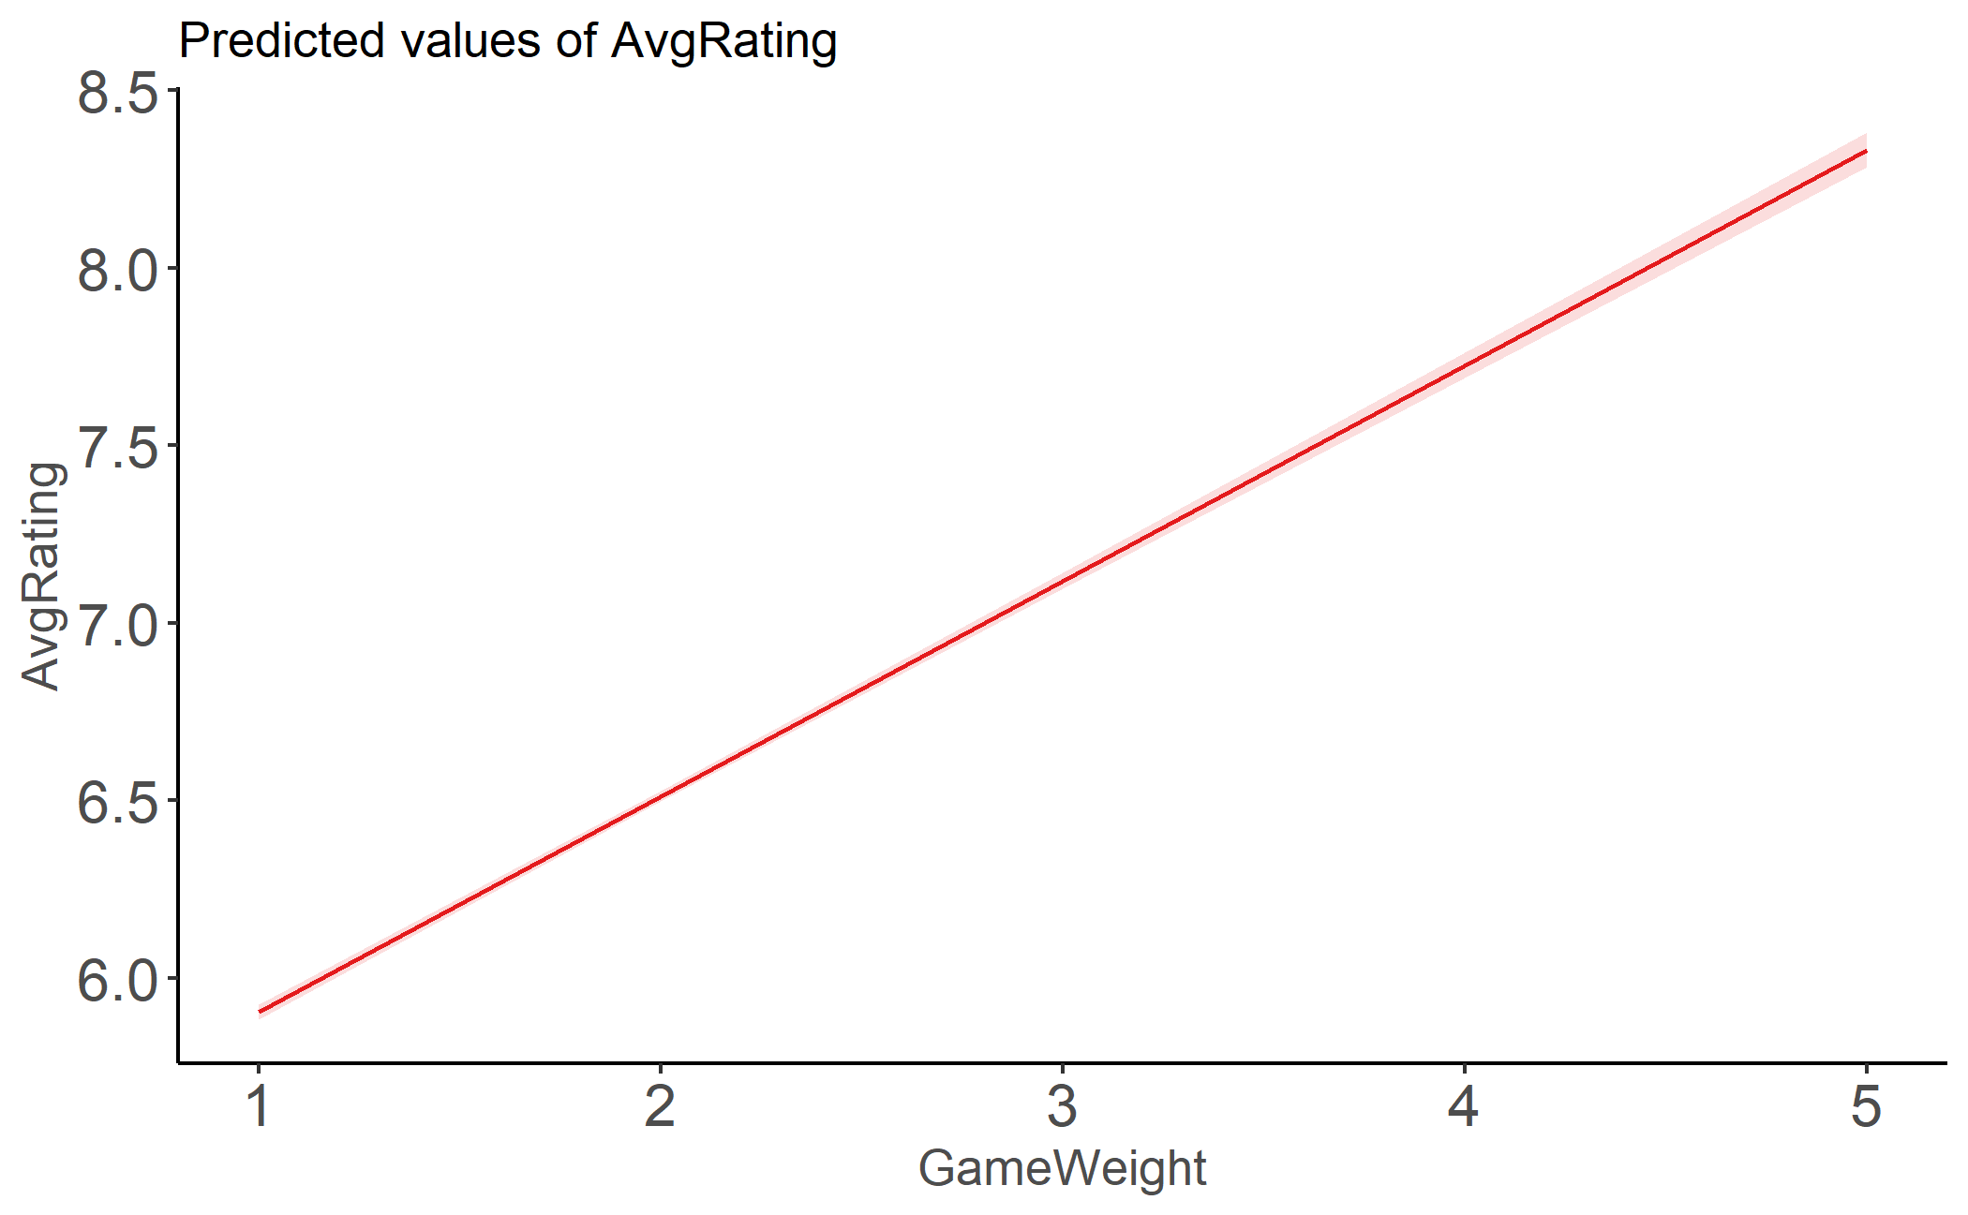Focus on increasing either game complexity or playtime, as increasing both may not have as much of an effect.

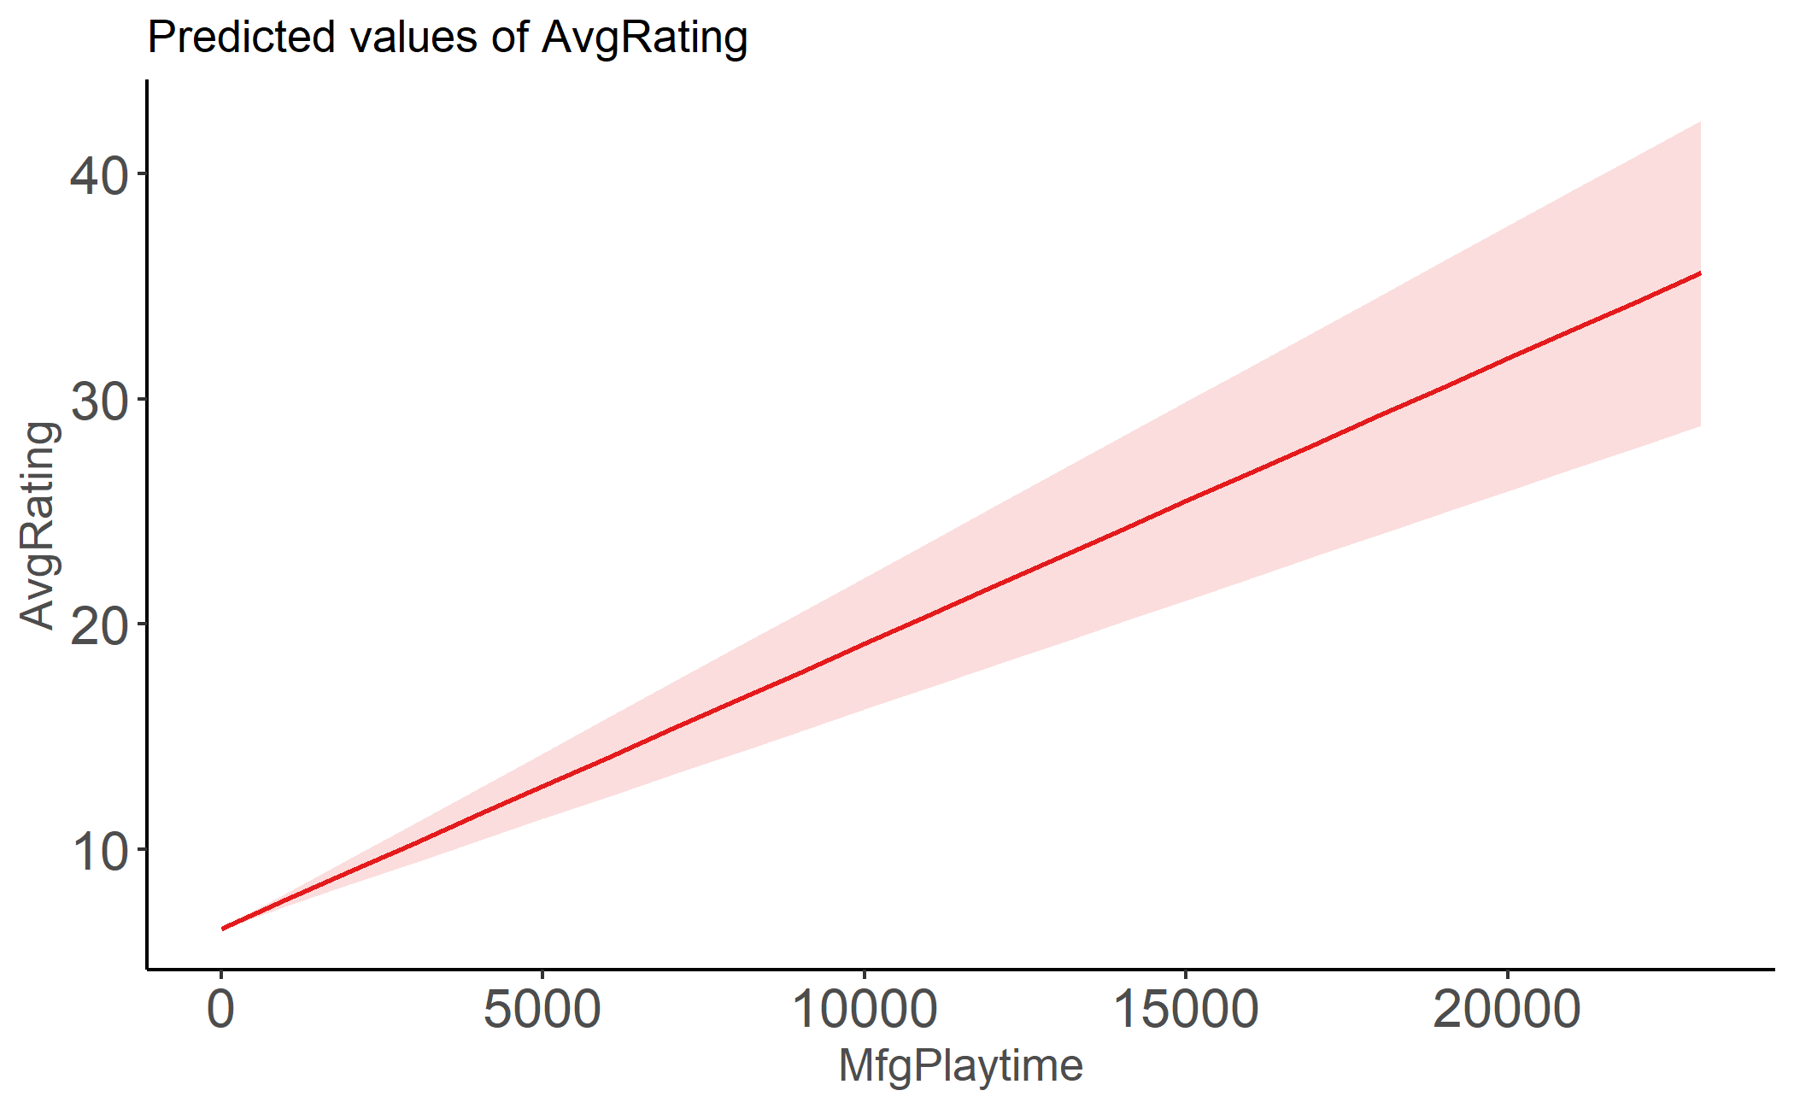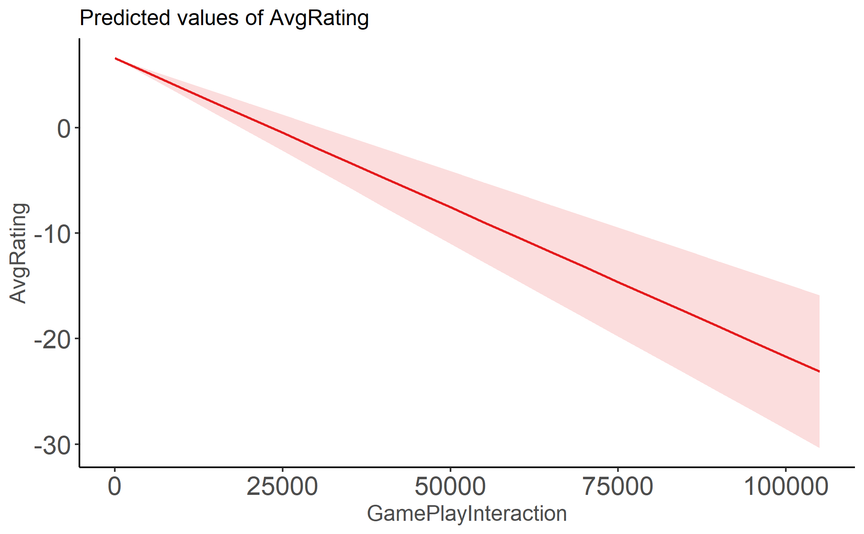

*predicting-avgratings-with-themes.Rmd*

Themes Model Output, filtered to p.values<0.001 and sorted largest to smallest estimate.

89.56% accuracy, only 1 variable of 219 removed from Lasso regression.

|  |  |  |  |  |  |
| --- | --- | --- | --- | --- | --- |
| Theme_Memes | -1.10466 | 0.325819 | -3.39041 | 0.0007 | 0.0007 |
| Theme_Cereal_Games | -1.0796 | 0.283914 | -3.80256 | 0.000144 | 0.000144 |
| Theme_TV_Detectives | -1.05218 | 0.28355 | -3.71074 | 0.000207 | 0.000207 |
| Trivia | -0.40389 | 0.041752 | -9.67356 | 4.53E-22 | 4.53E-22 |
| `Movies_/_TV_/_Radio_theme` | -0.34265 | 0.031846 | -10.7595 | 6.70E-27 | 6.7E-27 |
| Racing | -0.21381 | 0.040223 | -5.31569 | 1.08E-07 | 1.08E-07 |
| Economic | -0.1919 | 0.028363 | -6.76587 | 1.37E-11 | 1.37E-11 |
| GamePlayInteraction | -0.0002 | 3.80E-05 | -5.37712 | 7.68E-08 | 7.68E-08 |
| MfgPlaytime | 0.000969 | 0.000167 | 5.798985 | 6.81E-09 | 6.81E-09 |
| Medieval | 0.106519 | 0.032289 | 3.29888 | 0.000973 | 0.000973 |
| Science_Fiction | 0.122733 | 0.02809 | 4.369244 | 1.26E-05 | 1.26E-05 |
| Fighting | 0.147602 | 0.026665 | 5.535453 | 3.16E-08 | 3.16E-08 |
| City_Building | 0.180116 | 0.042984 | 4.190356 | 2.80E-05 | 2.8E-05 |
| Fantasy | 0.196787 | 0.02255 | 8.726792 | 2.89E-18 | 2.89E-18 |
| Napoleonic | 0.22331 | 0.056227 | 3.971583 | 7.17E-05 | 7.17E-05 |
| `Murder/Mystery` | 0.230852 | 0.053531 | 4.312507 | 1.62E-05 | 1.62E-05 |
| World_War_I | 0.252328 | 0.065758 | 3.837237 | 0.000125 | 0.000125 |
| Sports | 0.254565 | 0.045355 | 5.612718 | 2.03E-08 | 2.03E-08 |
| Trains | 0.270878 | 0.055937 | 4.842578 | 1.29E-06 | 1.29E-06 |
| Theme_Art | 0.427941 | 0.117115 | 3.654032 | 0.000259 | 0.000259 |
| Theme_Anthropomorphic_Animals | 0.571431 | 0.101316 | 5.640066 | 1.73E-08 | 1.73E-08 |
| Theme_Natur | 0.665831 | 0.150392 | 4.42732 | 9.61E-06 | 9.61E-06 |

Multiple R-squared: 0.2832, Adjusted R-squared: 0.2729

* Top 5 (greatest coef to lowest)
  + Recommend making games with these themes – better ratings
    - Theme_Nature
    - Theme_Anthropomorphic_Animals
    - Theme_Art
    - Trains
    - Sports
* Worst 5
  + Don’t recommend making games with this theme – worse ratings
    - Theme_Memes
    - Theme_Cereal_Games
    - Theme_Computer_._Information_Technology_Industry
    - Theme_TV_Detectives
    - Trivia

**Future Directions**

Determine overarching groups of themes and analyze relationship with average ratings.

* Cluster analysis of themes to determine similarities; evaluate which groups are perceived most positively/negatively.
* Focus on broader theme rather than niche themes from the initial analysis, capturing a broader population of gamers.

Get insight into what game characteristics players take into account in ratings.

* Gather raw review data.
* Text analysis of what components of games are most frequently discussed.

Use number of purchases as a response variable and compare results with AvgRating analysis.

* BoardGameGeek features links to purchase games – the number of unique clicks to retailer sites could be used as a proxy for number of purchases.
* Number of purchases may be a more reliable response variable than average ratings, as the BoardGameGeek reviews are skewed towards those most invested in the industry.

**Conclusions**

The game complexity, playtime, and theme positively/negatively impact the average rating of board games. Understanding these components can provide helpful insights in two ways – as part of the research & development for creating new games and for targeting the ideal audience when marketing a new product.