How to Make a Proceedings Paper Submission

Morton Ann Gernsbacher (MAG@Macc.Wisc.Edu)

Department of Psychology, 1202 W. Johnson Street

Madison, WI 53706 USA

Sharon J. Derry (SDJ@Macc.Wisc.Edu)

Department of Educational Psychology, 1025 W. Johnson Street

Madison, WI 53706 USA

Abstract
The abstract should be one paragraph, indented 1/8 inch on both sides, in 9 point font with single spacing. The heading “Abstract” should be 10 point, bold, centered, with one line of space below it. This one-paragraph abstract section is required only for standard six page proceedings papers. Following the abstract should be a blank line, followed by the header “Keywords:” and a list of descriptive keywords separated by semicolons, all in 9 point font, as shown below.
Keywords: cognitive development; exploration; decision-making; attention

General Formatting Instructions
One crucial way in which children’s cognition differs from adults’ is how they allocate their attention. Adults are highly adept at controlling their attention, distributing it or focusing it selectively while ignoring other information. While adults tend to rely heavily on selective attention, young children tend to distribute their attention broadly (Deng & Sloutsky, 2015, 2016; Smith & Kemler, 1977). In situations in which only a small amount of the available information is relevant at the moment, adults will selectively focus on that piece of information, and ignore almost everything else (Rehder & Hoffman, 2005; Blair, Watson & Meier, 2009). Children, on the other hand, will distribute their attention to everything, even information that is not relevant for their current task or goals (Plebanek & Sloutsky, 2017). The question then becomes: why to children seem to use a strategy that is clearly less efficient and potentially less effective? One simple explanation could be that young children simply do not have the ability to control their attention effectively, to focus it selectively and filter out irrelevant environmental stimuli. While it is likely the case that children’s capacity to control attention is still developing, there is also evidence that distributing attention can be adaptive.
While adults’ utilization of selective attention is often highly effective and efficient, distributing attention can sometimes be superior. For example, Plebanek and Sloutsky (2017) found developmental reversals in a change detection task—where children were better than adults at detecting changes in uncued items—and in a visual search task—where, in a surprise subsequent memory test, children outperformed adults on memory for specific features that were irrelevant to the main search task. Whether selective or distributed attention is superior is context dependent. Selective attention is ideal when one is confident that a small portion of the available information is sufficient to achieve their goals and that other available information is superfluous. Distributed attention is a safer option that is ideal when there is more uncertainty about what is and is not important. For young children, who have much less experience and knowledge about how many things in the world work, distributing attention may often be the best strategy. Besides just being a safer bet, by broadly gathering information it facilitates the important long-term goal of building up that rich general knowledge that serves adults so well later in life. In other words, selective attention may subserve exploration. By distributing attention early in life children may be sacrificing immediate benefits in exchange for information.

Subheading about exploration
Research on exploratory behavior makes an important distinction between two types of exploration strategies (Badre, Doll, Long, & Frank, 2012; Daw et al., 2006; Knox et al. 2012; Blanco et al. 2015; Somerville et al. 2017): directed and undirected. Ideally exploratory choices are most valuable when they are directed towards actions with greater uncertainty in their outcomes, as resolving that uncertainty gives the most information. Mounting evidence suggests an important role of prefrontal cortex in this type of exploration (Badre, Doll, Long, & Frank, 2012; Frank, Doll, Oas-Terpstra, & Moreno, 2009; Blanco et al., 2015; Otto, Knox, Markman, & Love, 2014). Conversely, undirected (or random) exploration can be achieved as the simple outcome of a stochastic decision-process, with much less reliance on prefrontal cortical processing. Given that prefrontal cortex shows substantially protracted development (Sowell et al., 2004; Sowell et al., 1999), current theories make a straightforward prediction that young children’s exploration should be largely undirected (Somerville et al., 2017).
In contrast to this straightforward prediction, we recently showed that four-year-old’s choices are highly exploratory, and this exploration is largely systematic (Blanco & Sloutsky, under review). Because of the immaturity of PFC in young children, we hypothesize instead that their exploratory behavior is tied intricately to their immature attention allocation, consistent with recent research suggesting a tight link between attention and decision-making (Gottlieb, 2012; Konovalov & Krajbich, 2016a).
To test this hypothesis more directly, we presented children with a simple reward learning task. Our task was a simplified version of a standard n-armed bandit task commonly used to study reward-based decision-making (e.g., Daw et al. 2006). On each of 100 trials, participants chose one of four options which gave set reward values (10, 3, 2, and 1) that were stable across the experiment and highly separable. Because outcomes are stable and predictable, low levels of exploration would generally be expected in our task, but our previous study found high levels of exploration in young children in this task. Crucially, we also manipulated perceptual saliency/novelty. In two conditions, three options were represented by bland, stable stimuli, while one option was represented by a different salient stimulus on each trial. In the congruent condition the salient option was also the one that gave the highest reward. In the competition condition the salient option was the one that gave the least reward, putting reward-seeking and novelty-seeking in competition with each other.
There are several different possibilities concerning the relationship between attention and choices in young children. One simple prediction is that children’s choices might be driven largely by novelty seeking, rather than reward seeking. In that case we would predict children to choose the salient option most often, whether it is congruent with or in competition with maximum reward. A contrasting prediction is that children’s choices are not driven by attention, but instead their exploration is controlled by other processes—for example, an explicit goal-directed strategy to seek information, or a simple behavioral impetus to switch between options. In this case we expect a small effect of saliency that should be similar across both conditions.
A third class of predictions involves an interaction between saliency and reward, wherein the effect of the salient option is different depending on whether it is congruent or competing with reward. For example, saliency may facilitate memory, leading to better learning of the best option in the congruent condition and more avoidance of the worst option in the competition condition.

Methods

Participants Thirty-two four-year-olds (mean age = 54.8 months) and 34 adults participated in Experiment 1. Experiment 2 included only child participants (N = 39, mean age = 55.3 months). Four-year-old participants were recruited from preschools and childcare centers. Adults were Ohio State University undergraduate students participating for partial course credit.

Procedure The task was framed as a game in which participants asked alien creatures for candy (Figure 1a). The goal of the game was to earn as much candy as possible. On each trial (of a total of 100 trials), participants chose one out of the four creatures. Adults made each choice by clicking on the alien with the mouse, while a touch-screen was used for children. Each creature gave a set number of candies that was the same on every trial. One option gave 10 candies, while the other three options gave 3, 2, and 1 candies respectively. The locations of the creatures and reward values were stable across the entire experiment, but were randomly determined for each individual participant. Following the choice, the reward received for the choice was displayed for 3 s (Figure 1b). Then a meter that tracked total accumulated reward was updated. Children were given stickers for each 180 candies earned, with benchmarks on the meter indicating these goals. When a goal was reached, a congratulatory screen appeared telling the participant that they earned a sticker. Following the main experiment, a short follow-up memory test was given to a subset (N = 22) of child participants. In the memory test, the experimenter pointed to each of the four locations in turn and asked the child how many candies they would get if they chose that option. The locations were displayed blank (with no creatures or rewards visible). Procedures for experiment 2 were identical to Experiment 1, except that the reward available for choosing each option was displayed prior to the choice, instead of pictures of alien creatures (Figure 1).

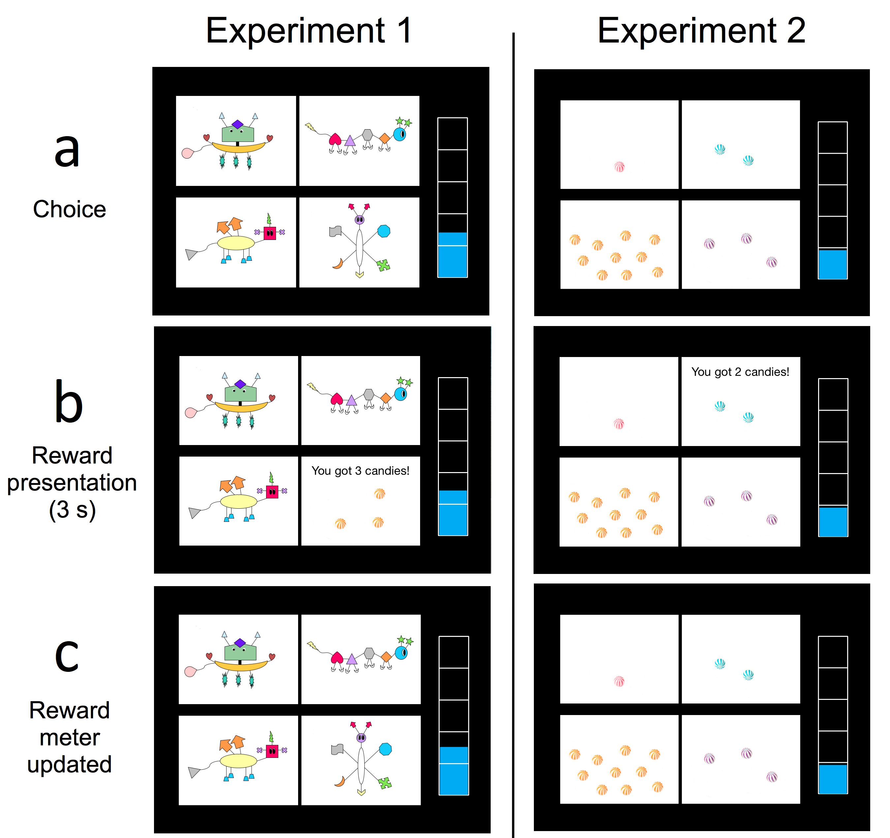

Results

Computational Modeling
Participants’ choices were evaluated in relation to a Reinforcement Learning model (Sutton & Barto, 1998) that included the potential for both systematic (or directed) and random exploration. The model learned the reward values by updating expected values for each option based on the prediction error using the following equation:

where V_{i,t} is the expected value of option i on trial t, R_{i,t} is the reward is the reward on trial t earned for choosing option i, and α is the learning rate (a free parameter). It then made choices according to the following function:



where P(a_{i,t}) is the probability of choosing option i on trial t. L_{i,t} is the lag term—a proxy for uncertainty—that simply encodes the number of trials it has been since option i was last chosen. φ is the weight parameter mediating the relative extent to which the expected values and lags influence choices and is constrained to be between 0 and 1, inclusive. Greater values of φ indicate greater influence of systematic exploration. When φ is 0, the model chooses based only on expected value; when φ is 1 it chooses only based on the lag. β is the inverse temperature parameter that controls random exploration. At β = 0 choice probabilities become completely random, and as β approaches infinity the model chooses the most favorable option (based on the weighted combination of expected value and lag described above) on every trial. Both β and φ were free parameters. This model is similar to the ‘exploration bonus’ models used previously (Daw et al. 2006, 23), but with lag as a proxy for uncertainty and with slightly different parameterization. The model was fit to each individual participant by finding the set of parameters that maximized the likelihood of producing the participant’s data given the model.
This model was compared to a model that did not include systematic exploration, where φ was fixed at 0, in order to validate inclusion of directed exploration in the model. Best-fitting model for each participant was determined using the Akaike Information Criterion (24). The majority of both adults and children in Experiment 1 were better fit by the model that included systematic exploration, though (as discussed above) the relative influence of systematic exploration compared to reward value was much lower for adults. The majority of children in Experiment 2 were better fit by the model without systematic exploration. See Table S1 for the number of participants best fit by each model for each group.

Table 1: Sample table title.

Error type | Example
Take smaller | 63 - 44 = 21
Always borrow | 96 - 42 = 34
0 - N = N | 70 - 47 = 37
0 - N = 0 | 70 - 47 = 30

CoGNiTiVe ScIeNcE

Figure 1: This is a figure.

Acknowledgments
This research was supported by National Institutes of Health Grants R01HD078545 and P01HD080679 to V. M. Sloutsky. We thank Ian Krajbich, Jess Cooper, and Brad Love for helpful feedback. The authors report no conflicts of interest.

References
Badre, D., Doll, B. B., Long, N. M., & Frank, M. J. (2012). Rostrolateral prefrontal cortex and individual differences in uncertainty-driven exploration. Neuron, 73(3), 595-607.
Blair, M. R., Watson, M. R., & Meier, K. M. (2009). Errors, efficiency, and the interplay between attention and category learning. Cognition, 112(2), 330-336.
Blanco, N. J., Love, B. C., Cooper, J. A., McGeary, J. E., Knopik, V. S., & Maddox, W. T. (2015). A frontal dopamine system for reflective exploratory behavior. Neurobiology of learning and memory, 123, 84-91.
Daw, N. D., O'doherty, J. P., Dayan, P., Seymour, B., & Dolan, R. J. (2006). Cortical substrates for exploratory decisions in humans. Nature, 441(7095), 876-879.
Deng, W. S., & Sloutsky, V. M. (2015). The development of categorization: Effects of classification and inference training on category representation. Developmental Psychology, 51(3), 392-405.
Deng, W. S., & Sloutsky, V. M. (2016). Selective attention, diffused attention, and the development of categorization. Cognitive Psychology, 91, 24-62.
Frank, M.J., Doll, B.B., Oas-Terpstra, J., & Moreno, F. (2009). Prefrontal and striatal dopaminergic genes predict individual differences in exploration and exploitation. Nature Neuroscience, 12, 1062–1068.
Gottlieb, J. (2012). Attention, learning, and the value of information. Neuron, 76(2), 281-295.
Kakade, S., & Dayan, P. (2002). Dopamine: Generalization and bonuses. Neural Networks, 15, 549–559. doi:10.1016/S0893-6080(02)00048-5
Konovalov, A., & Krajbich, I. (2016a). Gaze data reveal distinct choice processes underlying model-based and model-free reinforcement learning. Nature communications, 7.
Knox, W. B., Otto, A. R., Stone, P., & Love, B. (2012). The nature of belief-directed exploratory choice in human decision-making. Frontiers in psychology, 2, 398.
Otto, A. R., Knox, W. B., Markman, A. B., & Love, B. C. (2014). Physiological and behavioral signatures of reflective exploratory choice. Cognitive, Affective, & Behavioral Neuroscience, 14, 1167–1183.
Plebanek, D. J., & Sloutsky, V. M. (2017). Costs of selective attention: when children notice what adults miss. Psychological Science, 28(6), 723-732.
Rehder, B., & Hoffman, A. B. (2005). Eyetracking and selective attention in category learning. Cognitive Psychology, 51(1), 1-41.
Smith, L. B., & Kemler, D. G. (1977). Developmental trends in free classification: Evidence for a new conceptualization of perceptual development. Journal of Experimental Child Psychology, 24(2), 279-298.
Somerville, L. H., Sasse, S. F., Garrad, M. C., Drysdale, A. T., Abi Akar, N., Insel, C., & Wilson, R. C. (2017). Charting the expansion of strategic exploratory behavior during adolescence. Journal of experimental psychology: general, 146(2), 155.
Sowell, E. R., Thompson, P. M., Holmes, C. J., Jernigan, T. L., & Toga, A. W. (1999). In vivo evidence for post-adolescent brain maturation in frontal and striatal regions. Nature neuroscience, 2(10), 859-861.
Sowell, E. R., Thompson, P. M., Leonard, C. M., Welcome, S. E., Kan, E., & Toga, A. W. (2004). Longitudinal mapping of cortical thickness and brain growth in normal children. Journal of Neuroscience, 24(38), 8223-8231.
Sutton, R. S., & Barto, A. G. (1998). Reinforcement learning: An introduction. Cambridge: MIT press.

