Crisis Notification and Admin Dashboard Examples
Human + AI Therapy: Better For Everyone (Phase 2: Longitudinal Use) - referencing protocol 2025-519-BYU
Prepared September 7, 2026. This document shows (1) the verbatim on-call crisis notification messages the system sends, and (2) current screenshots of the researcher-facing monitoring dashboards referenced in the Research Procedures and Confidentiality of Data sections. All screenshots were captured September 2, 2026 from the study application's demonstration environment; all names, sessions, and data shown are synthetic demonstration data, not participant data.

1. On-call crisis notification messages (verbatim templates)
When the automated risk pipeline flags a high-severity event, the system pages the on-call researcher's phone by SMS before any database write (a deliberate ordering so a storage failure can never suppress an alert). The two message templates, verbatim from the production code:
High-severity flag during a live session (crisisIntervention.service.ts) - includes a deep link that opens the session directly in the admin dashboard:
URGENT: AI-Therapist HIGH crisis flag
Session <session-id>... - risk <score>/100
<admin-url>/admin#session=<session-id>
High-severity flag in an asynchronous (chat/thread) message (messageSafety.service.ts):
CRISIS MESSAGE ALERT: high-severity risk flagged in a client message (score <score>/100). Review the crisis dashboard.
Every page is followed by an intervention-action audit record. In parallel with the SMS page, the event raises a real-time alert on the Live Monitoring dashboard (WebSocket) and, at high severity, auto-drafts an adverse event report for sign-off.

2. Admin dashboard screenshots
Crisis Management overview - central queue of flagged events with severity, status, and review workflow.
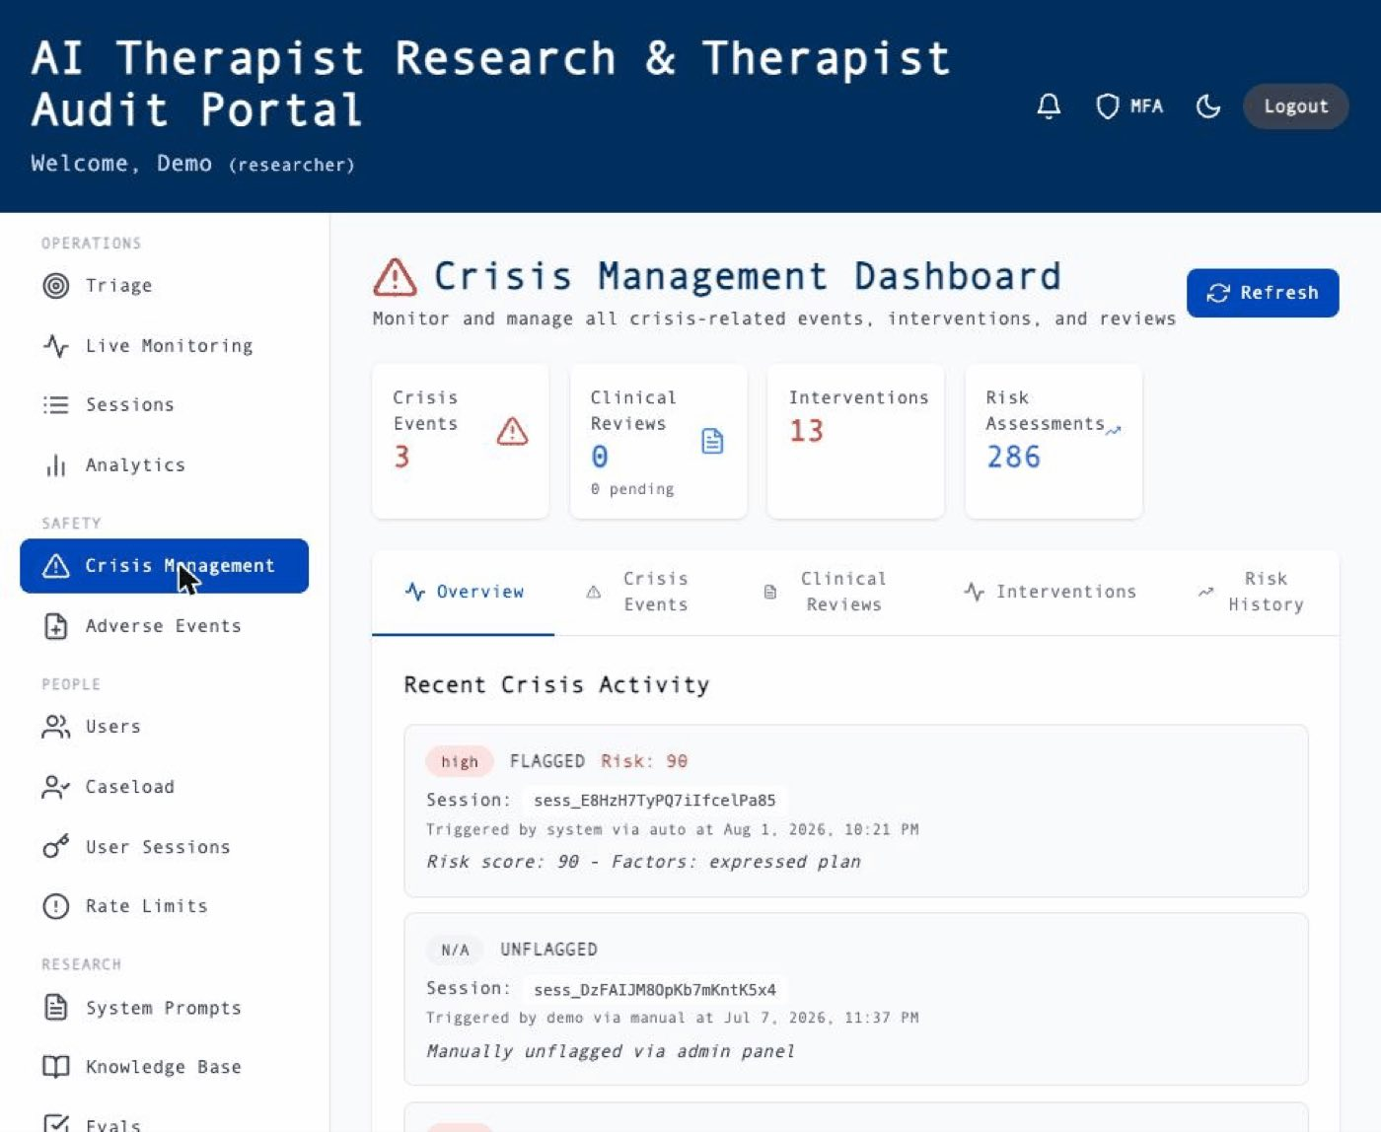
Crisis event detail - per-event timeline: detection, risk score, actions taken, and human review trail.
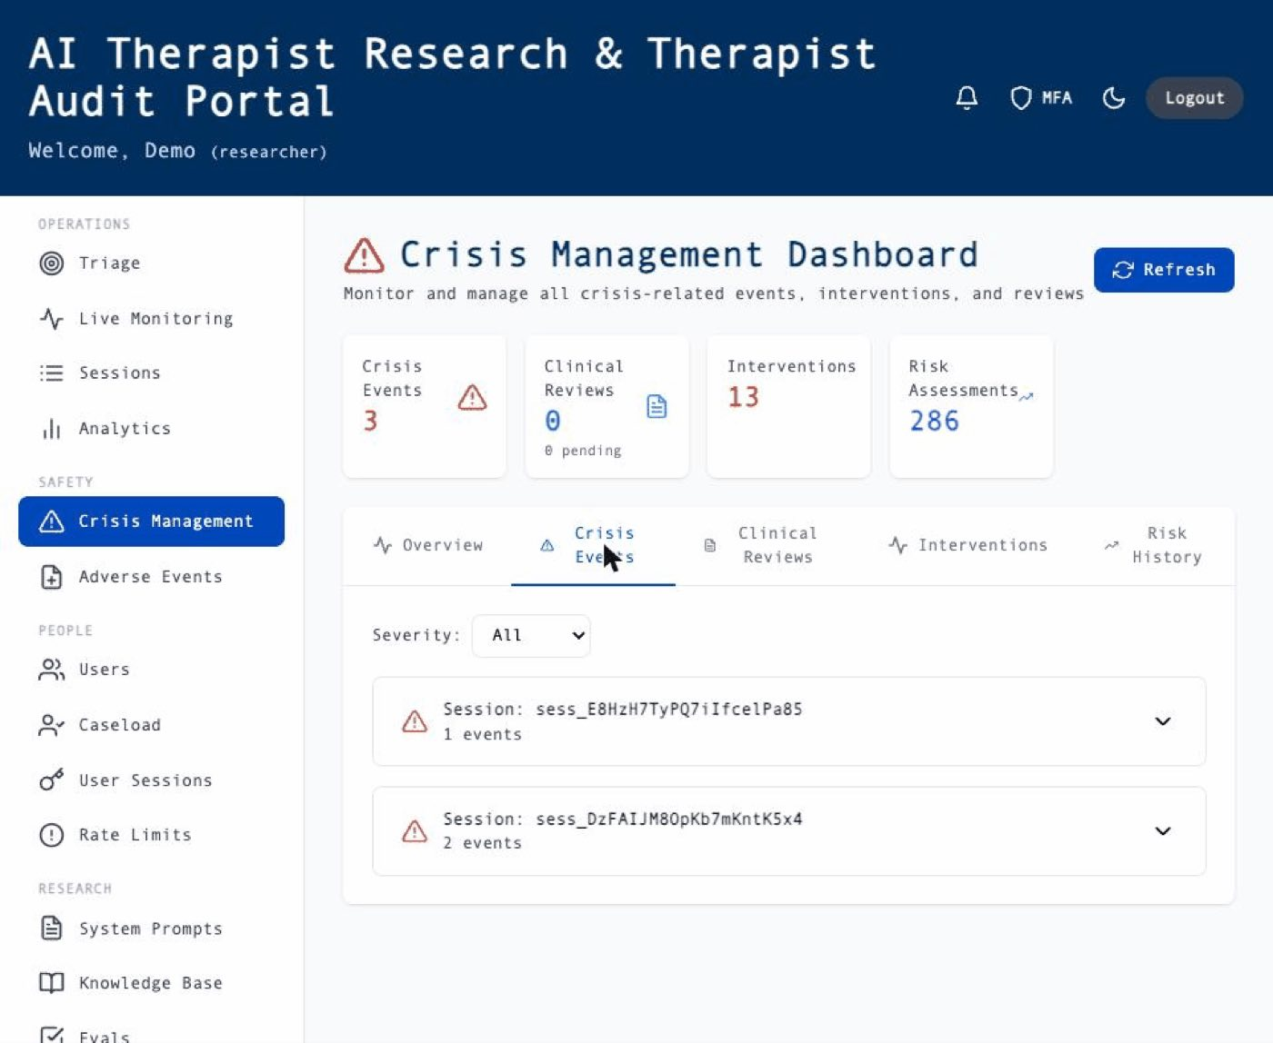
Live Monitoring - real-time view of active sessions with risk indicators; high-severity flags raise an immediate on-screen alert in addition to the SMS page.
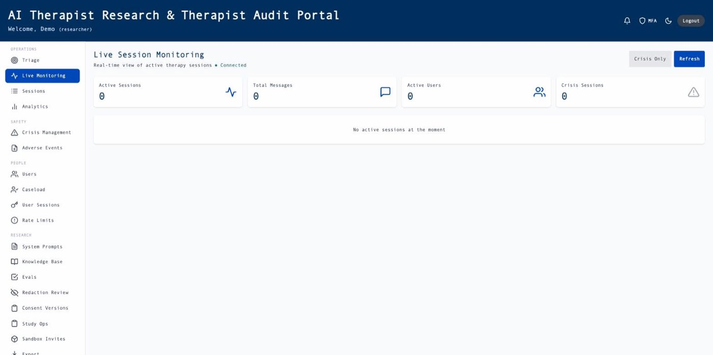
Analytics dashboard - aggregate engagement and safety metrics used for study oversight.
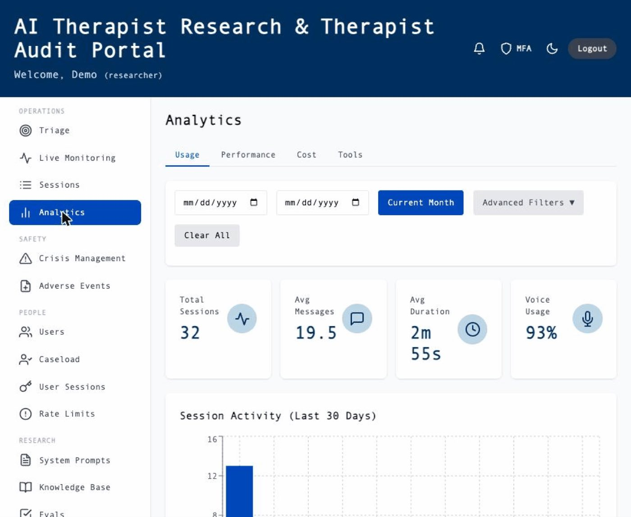
Session history - redacted transcript review view used by authorized researchers; original unredacted content is inaccessible here.
