Optimization of Small Sort Package Systems

Nathan Corpus
BAN 705: Enterprise Processes Analytics
Professor Sohi

Content
Summary 3
Introduction 4
Part 1: Analysis of Existing System 4
Enterprise Analysis 4
Existing System Architecture 4
Existing System Performance Assessment 5
Data Analysis 6
BPM 1 7
Part 2: Proposed System Design 9
Benchmarking 10
Determination of Solution Approaches 10
Requirements Analysis 10
Solution Assessment and Validation 12
Proposed System Architecture 12
Data Analysis 13
BPM 2 16
Part 3: Implementation Plan 17
Project Management Plan 17
Business Case 17
Outstanding Issues and Future Directions 18
Closing Statement 18
References ………………………………………………………………………………………………………………………………20

Optimization of Small Sort Package Systems
Summary
In this paper, I will discuss how the existing architecture of FedEx’s Small Package Sort System can be optimized using automation, technology, and modeling. The first part of the paper will introduce an analysis of the current system in order to assess where the organization stands, the architecture of the existing process, the performance of characteristics at play, how data is used at the time of consideration, and a current business process model. It is important to understand how the current system works to see where optimization can take place and to determine the business objectives. The second section will introduce a proposed system design to improve the system and maximize efficiency. The section will discuss different alternatives to the proposed system, the requirements of completing the project, how data will be used to optimize the system, and complete a full end-to-end analysis to understand the worth of replacing the current architecture. Identifying how the system can better meet the objectives will be key to this project. Lastly, the implementation plan will outline the process that will be used to replace the existing system with the proposed system. This section will highlight how the technology will be created, how the system will be constructed, and the benefits of investment. The project will take time to implement and be costly, so assessing the risk compared to the benefits will be addressed. Outsourcing the technology instead of internally creating the automatic sort systems will better benefit FedEx, because FedEx does not specialize in artificial intelligence technology and implementing such devices. The last part will discuss future research that can be done to analyze how to better improve FedEx’s new Small Package Sort System.
Introduction
FedEx Corporation (NYSE: FDX) supplies superior transportation, e-commerce, and business services to businesses and customers in over 220 countries and territories worldwide. The company began operations on April 17, 1973, with only 389 members delivering 186 packages (FedEx, FedEx History 2023). FedEx now employs over 530,000 employees and delivers 16.5 million packages daily (FedEx, Celebrating 50 years of fedex 2023). Considered one of the leading companies in the industry, FedEx Corporation is an umbrella company that supports and manages each of its operating companies. This project will focus on the Small Packaging Sort System in one of FedEx’s operating companies called FedEx Ground. “FedEx Ground gives customers dependable business-to-business delivery and convenient residential service through FedEx Home Delivery® and FedEx Ground® Economy” (FedEx, Company Structure and Facts, 2023). Created in 2000 by acquiring the company Caliber Inc., FedEx Ground was able to innovate the small package industry by tracing packages in real-time using barcodes.
Part 1: Analysis of Existing System
Enterprise Analysis
FedEx is currently working on joining all of its umbrella companies as one FedEx. The plan is set for June 2024. The plan for joining all operating companies under the name Federal Express will create more efficiency by creating a more powerful enterprise. As the future CEO and President of this united FedEx, Raj Subramaniam, explains, “This organizational evolution reflects how we represent ourselves in the marketplace – focused on flexibility, efficiency, and intelligence. As one FedEx team, we are well positioned to execute on our mission to help customers compete and win with the world’s smartest logistics network” (Subramaniam, 2023). FedEx is also aiming to improve its system support with innovative autonomation business processes and technologies. This support system will help the direction the company is heading by efficiently increasing production and eliminating human error. Not only will this increase efficiency, but also create opportunities for the employees to work on other objectives. Once the system is prioritized and employees understand how the system will come together, the business process will meet its overall objectives of efficiency, intelligence, and production. Though the system will show an increase in production, the limitation of this business process will be the supporting workforce. In order to get past this constraint, employees will need to be held accountable for what is expected in terms of individual production and FedEx will need to hire employees to meet the production of the new automated process.
Existing System Architecture
The existing system architecture of FedEx’s Ground Small Package System works mostly by manual human labor and conveyor belts. The current system begins with the truck containing the packages entering the warehouse and parking in reverse in the line haul section. Then the unloading package handler unloads the packages on the unload conveyer belt. The unload belt then delivers the packages to the small package department, where the packages will end up being retrieved by a feeder. The feeder then feeds the package to the sorter, who sorts the packages into bins for the bagger to retrieve them. The bagger then scans the packages. If the sorter happens to make a mistake by putting the package in the wrong bin, the bagger takes the package and gives it back to the sorter. If the package is in the correct location, the bagger puts the package in a bag. The bagger then ties the bag and writes the truck number on the bag. Then he places the bag on the load belt, which brings the bag to the loaders. The loaders then scan the bag. If the bag is in the wrong location, he puts the bag back on the load belt. If the bag is in the right location, the loader loads the bag inside the trailer. The loader then locks the truck, and the trucks deliver the packages. The current system does not meet the expectations of the stakeholders because it is inefficient due to human error, the speed of the sorter, and the speed of the baggers.
Existing System Performance Assessment
The system’s current performance does not meet its business objectives. This is because the sorters and baggers are unable to meet expectations due to the existing process. The sorter is obligated to sort 800 packages an hour but is limited to the ability of the baggers to keep up and know what bins are full. This causes the sorter to miss their goal by at least 150 packages an hour. There is also the factor of inconsistencies of each sorter. There is a learning process that needs to take place in order to get the sorter up to speed. Some sorters are faster than others and there needs to be a consistent amount of production to satisfy the need for performance goals and the overall flow of the operation.
The baggers are obligated to complete 350 packages an hour but rarely hit that goal due to the inefficient process of not knowing what bins need to be prioritized. If the baggers are not able to keep up or if there is a limited number of baggers, then the sorter has to put the packages on the floor till the baggers can empty the bin. This creates a safety hazard because of the possibility of the sorter tripping over the packages below. There have been occurrences where the sorter tripped over the packages and injured themselves in the process causing the sorter to be out of work.
When the baggers are finally able to complete the bin that is overflowing on the floor, the sorter has to stop sorting and put the remaining packages on the floor into the correct bins. This is the main cause of the sorters not being able to perform at expectation. Another cause of the sorter’s shortfalls is due to human error. If the sorter is unable to correctly sort the packages to the right location, then the bagger will retrieve it by scanning the package. This process will cause the bagger to have to give the package to the feeder to refeed the package to the sorter, which slows the speed of production. If the bagger does not notice the misload on its scanner and puts the package in the bag, then the package will be sent to the wrong location. There is an average of misloads 20 misloads per day with the highest being 35 packages. This causes the package to be late and not satisfy the customer’s expectation of receiving their package on time. All these factors are implications of a need for an improvement of the system and overall business process.
Data Analysis
There are multiple types of data in the small package operation. One of the types of data is key performance indicators. The key performance indicators are the amount the sorter sorts per hour, the number of packages bagged per hour, and the number of misloads a day. The descriptive data in the operation is the previous week’s package volume and the performance of the sorters, baggers, and misloads. This is used to summarize and present the key features found in the data to measure the efficiency of the operation. This also helps to analyze the upcoming work week’s production.
Forecasting and prediction statistics are especially important for FedEx. If the company fails to place employees where they should be or fails to hire enough employees, FedEx will miss their goals and cause customer dissatisfaction. It is in FedEx’s best interest to find trends and patterns in the historical data to predict future needs and performance. This will lead to prescriptive analytics, which will provide the means of decision making. Management will need to produce recommendations to minimize costs and maximize efficiency. Business Intelligence solutions come into play through the use of the scanner and barcode system. By using specialized software to keep track of the package, FedEx can recognize performance, plan for the future, and track the package from when the package first arrives at the facility and when the package is delivered to the customer. This is an important benefit that FedEx gives their customers because it shows the customer the location and estimated arrival of their package.
The overall outlook of operational data can be visualized through the use of data dashboards. The data visualization shows historical data, key performance indicators, and graphs of future trends. This is helpful for the operational manager to see the overall performance and forecasting to make decisions. The data is then disseminated to the dock managers to enforce production goals and help get an idea of which employees need to be where to maximize efficiency and reduce costs.

BPM 1
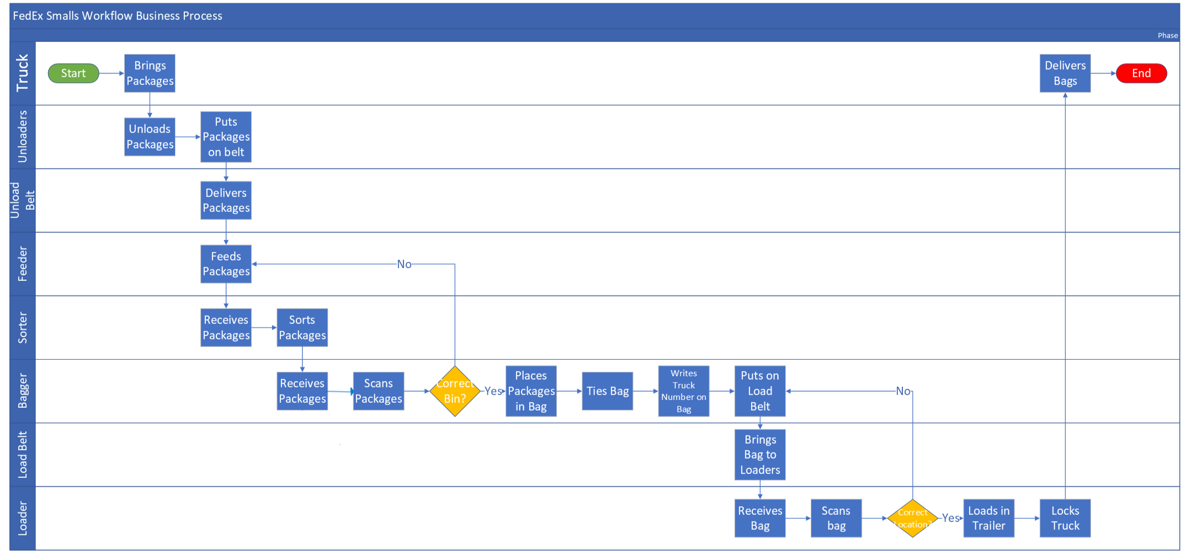

Part 2: Proposed System Design
Benchmarking
Being employed by FedEx for over 7 years, I have firsthand conducted research. Using the business intelligence software system, the sorters were not nearly hitting the goal of 800 packages an hour. The baggers were also not completing the goal of 350 packages an hour. FedEx has already experimented with sorting robots and found “The robotic arm can sort up to 1,000 packages per hour, carry up to 5kg each time, and cover up to 100 destinations simultaneously. Equipped with a barcode reader that scans packages to obtain destination information, it has an accuracy rate of more than 98.5%, and could potentially facilitate the hub moving towards round-the-clock sort operations” (FedEx, FedEx Introduces A-I Powered Robotic Sorting Arm To Drive Operational Efficiency at its Singapore Hub 2022). So, if FedEx has six robotic sorting machines that sort 1,000 packages an hour, 6000 overall, the best practice would be to have 18 baggers available who need to bag a minimum of 350 packages. In order for this system to work, supervisors would need to hold their package handler accountable for hitting their metrics.
Determination of Solution Approaches
An alternative solution to the Automatic Small Sort System would be to hire more baggers to cover the remaining packages. The biggest threat to the existing architecture is the fact that the sorter cannot reach their metrics due to having to waste time putting packages on the floor. When the bins are emptied, the sorter then has to place the packages that are on the floor back in the bins. That wastes quality time when the sorter can be sorting packages. If FedEx hires more employees, they can add more production to make sure the bins are not filling up. Another alternative would be to not invest in the automatic sorting machine and only invest in the smart bins. If the baggers knew what bins to complete, then there would be less chance of the sorting having to stop to access the packages on the floor. This would increase production of the baggers and overall increase production.
Requirements Analysis
One of the requirements that need to be addressed is how is the automatic sorter going to pick up the packages. A gripper would need to be installed on the machine, so the machine does not drop the packages. Another requirement would be a vision system able to capture images of the barcodes or an RFID system to relay the information to the automatic sorter. This is important for misloads and precision. Also, the system will need to be programmed correctly and maintained by a programming technician. The automatic sorter will need to be programmed to use the gripper, precisely read the package, and place it in the right bin. The smart bin would also need to be programmed and maintained in order to sense the fullness of the bin (FedEx, Fedex launches AI-powered sorting robot to drive Smart Logistics 2022). A unload belt would also need to be made to place packages that have their bins full, back onto the unload belt, so the package can circle and feed the package another time. Baggers will also need to meet their expectations of 350 packages in order for the sorting machine to not have to re-sort a package. Supervisors need to hold their employees accountable to maximize production. Finally, operational managers need to overlook the process and make any decisions that need to be made (Doss Visual Solutions, Answers to automatic sorting machine faqs 2022).
Solution Assessment and Validation
FedEx is not a technology manufacturer. So, in order for them to create the automatic sort machines internally would require artificial intelligence experts, mechanical engineers, and software technicians. This could be costly for FedEx. Outsourcing would be preferable because they already have experts, engineers, and technicians that specialize in autonomous mechanical devices. Technology companies know the specifications of these devices and will provide instructions in order to meet business objectives. The risk of an investment like this would be the return on investment. If the development of this architecture has more risks than benefits, FedEx may lose money in the process. Another risk would be if the machine breaks down after the warranty is up. This is why FedEx needs to have a good warranty plan on the system it invests in and prioritize maintenance.
Proposed System Architecture
The proposed system architecture will combine automation technology, smart technology, conveyor belts, and human labor. The proposed system begins with the truck containing the packages entering the warehouse and parking in reverse in the line haul section. Then the unloading package handler unloads the packages onto the unload conveyer belt. The unload belt will then bring the packages straight to the automatic sorter, where the automatic sort will begin to sort the packages. If the smart bin is full, the automatic sorter will then place the package back on the unloading belt, which will circle back and feed the package again to the automatic sorter. If the bin is not full, the automatic sorter will place the package in the smart bin, which will display the count of packages and the fullness of the bin. The bagger will then open the bin and start to scan the packages. If the automatic sorter happens to misload the package, the bagger will put the package on the unloading belt, which will again circle back to the automatic sorter. If the package is in the right bin, the bagger will place the package in a bag, then tie the bag, and write the corresponding truck the bag needs to go to. Then the bagger will place the bag on the loading belt, which will bring the bag to the loaders. The loaders will scan the bag. If the bag is in the wrong location, then the loader will place the bag back on the load belt, which will circle back around. If the bag is in the correct location, the loader will load the bag into the truck. When the truck is full, the loader will lock the truck. The process then finishes with the truck delivering the bags.
Data Analysis
There are many types of data in the improved Small Package Sort System. The automatic sorting machines use memory data for machine learning and digital imaging to accurately recognize what bin the package should go into (Lawton, What is Robotic Process Automation (RPA)? everything you need to know 2021). The way smart bins will work is just like how the new waste management bins work, which is made possible by using wireless ultrasonic fill sensors to collect data and send information directly to the screen. This will precisely show how full the bin is to allocate baggers to where they need to go (Guard Force, How smart bin technology is Revolutionising Waste Management 2023). Another important type of data is the key performance indicators. The key performance indicators are the amount the automatic sorter can sort an hour, the number of packages bagged per hour, and the number of misloads a day. The descriptive data in the operation is the previous week’s package volume and the performance of the automatic sorter and bagger. This is used to outline the important characteristics found in the data to measure the efficiency of the operation. Descriptive analytics helps predict next week’s volume, production, and the needed labor force to keep up with the speed of the automatic sorting.
Predictive analytics are keys to success for the automatic Small Sort Package System. If FedEx fails to predict the production of its current employees or fails to hire new labor, FedEx will miss their goals leading to customers not receiving their packages on time. It is in FedEx’s best interest to find trends and patterns in the historical data to predict future needs and production. This will lead to prescriptive analytics, where management will make needed decisions. Management will need to produce recommendations that are cost-effective and efficient.
Business Intelligence solutions are used to prioritize daily operational data. This can be captured using the barcode and scanner system. By using business intelligence software, FedEx can keep track of the package, analyze performance, forecast, and track the location of the package. This is an important benefit that FedEx gives their customers because it shows the customer the location and estimated arrival of their package.
Data can be visualized through the automatic sorter by showing the number of packages sorted, the busiest bins, and the time it took to sort all the packages. As said in Part 1, FedEx’s operational data can be visualized through the use of data dashboards. The data visualization shows historical data, the accuracy of the automatic sorter, misloads, production factors, and data visualization graphs. The data can first be disseminated to the operational managers to analyze and make decisions. After the operational managers’ analysis, the data should be passed down to the supervisors in order to manage their employees and make any necessary decisions to achieve the goals given by their managers.

BPM 2

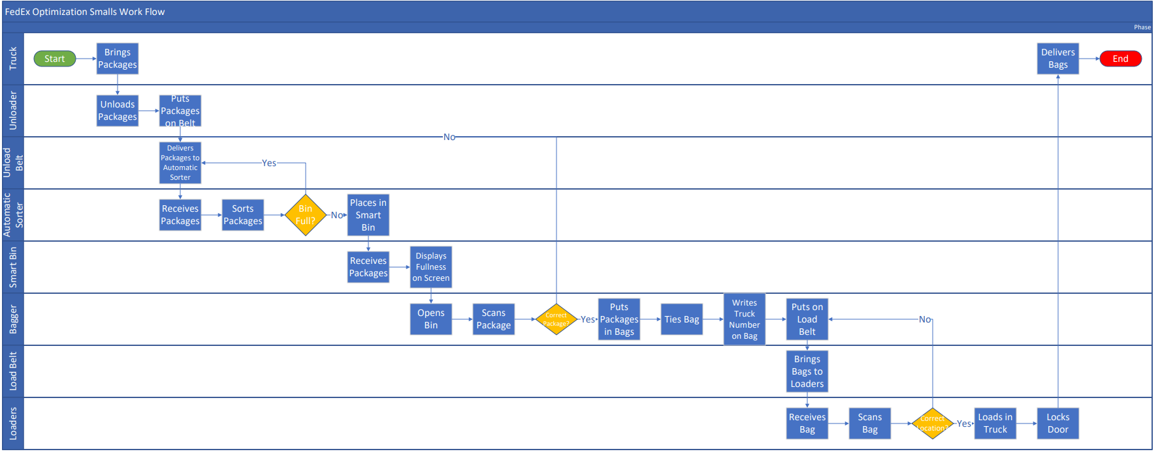
Part 3: Implementation Plan
Project Management Plan
The migration path from the existing system to the proposed system would start by creating a purchase order for the outsourcing tech company to create automatic sorting machines and smart bins. FedEx will then need to create a model addressing what should go where and how many employees would be needed for the project. After the model is created, construction will begin. The existing bins will need to be taken out and FedEx’s mechanical engineers will need to create an unload belt that circles and returns to the automatic sorting machine will need to be created. When the smart bins and the automatic sort machines arrive, they will be installed starting with the automatic sort machines. 18 employees will be needed in order for the automatic sorting machine to work at maximum capacity. The benefits of this new system will be accuracy and production. In the existing system, the sorters were sorting below 800 packages an hour and in the new proposed system, the automatic sorter can sort 1000 packages an hour (FedEx, Fedex launches AI-powered sorting robot to drive Smart Logistics 2022). By implementing the new system, FedEx will see a 20% increase in production. The barrier of the proposed system is the ability of the baggers to reach their metrics. FedEx requires baggers to bag 350 packages an hour and if all 18 employees are meeting that, then there should be no reason for the automatic sorter to have to place a package on the circling unload belt. The estimated project will take an estimation of 6 weeks to complete.
Business Case
The benefit of implementing the proposed system will be an increase of 20% in production. The automatic sorter is also more accurate than a human and can work overtime without a pay increase. Another benefit is the smart bins showing what bins are full, allowing the baggers to maximize their potential, which in the end maximizes labor investments. The cost of implementing the system would be the expensive price of the automatic sorter, smart bins, construction of the circling unload belt, and any maintenance that is needed to keep these devices from breaking.
Outstanding Issues and Future Directions
An outstanding issue with this project that future endeavors can plan upon in the future is how long can the automatic sort machines last without breaking. Like all machines, the machine will need to be well maintained and the software will need to constantly be updated. There was difficulty in finding how much the automatic sorting machines, smart bins, and construction would cost overall, so further examination is needed to conduct an ROI analysis and break-even analysis. An analysis of these subjects will benefit a follow-on project to see the worth of this system. Another issue that needs to be addressed is how the employees will work together with the autonomous system. Employee behavior is important when implementing a system that might make them feel that machines are taking over human jobs. A sociological and behavioral analysis of the employees can be conducted to assess morale and overall competency.
Closing Statement
All and all, automation and smart technology can benefit a company like FedEx. There are so many benefits to developing the proposed design, such as a 20% increase in production. Some barriers will be in place and requirements must be followed, but the end justifies the means. Proper planning can make it easy for the requirements to be met. Designing, analyzing, and mapping are key factors to improve the Small Package Sort System. As long as the employees accept the new system, the improved system will run in harmony.
References
FedEx Newsroom. (2022, June 24). Fedex launches AI-powered sorting robot to drive Smart Logistics. FedEx Newsroom. Retrieved April 28, 2023, from https://newsroom.fedex.com/newsroom/asia-pacific/fedex-launches-ai-powered-sorting-robot-to-drive-smart-logistics
How smart bin technology is Revolutionising Waste Management. Guardforce. (n.d.). Retrieved April 28, 2023, from https://www.guardforce.com.hk/en/news/blog_115/How-Smart-Bin-Technology-is-Revolutionising-Waste-Management---Guardforce_3901
Lawton, G. (2021, April 23). What is Robotic Process Automation (RPA)? everything you need to know. CIO. Retrieved April 28, 2023, from https://www.techtarget.com/searchcio/definition/RPA
Hamzah, A. A., & Abbas, A. F. (2022, August 2). Developed an automated design sorting system according to outer edges of object. TheScientificWorldJournal. Retrieved April 28, 2023, from https://www.ncbi.nlm.nih.gov/pmc/articles/PMC9363178/
BigPxl. (2022, July 14). Answers to automatic sorting machine faqs. Doss. Retrieved April 28, 2023, from https://dossvisualsolutionusa.com/news/highlights/automatic-sorting-machine-faqs/
System down. FedEx. (n.d.). Retrieved April 26, 2023, from https://www.fedex.com/
Company structure and facts. FedEx. (n.d.). Retrieved April 25, 2023, from https://www.fedex.com/en-us/about/company-structure.html
FedEx Newsroom. (2023, April 17). Celebrating 50 years of fedex. FedEx Newsroom. Retrieved April 25, 2023, from https://newsroom.fedex.com/newsroom/global-english/celebrating-50-years-of-fedex
About Us. FedEx. (n.d.). Retrieved April 25, 2023, from https://www.fedex.com/en-us/about.html
FedEx Newsroom. (2023, April 5). Fedex announces planned consolidation of Operating Companies. FedEx Newsroom. Retrieved April 25, 2023, from https://newsroom.fedex.com/newsroom/global-english/fedex-announces-planned-consolidation-of-operating-companies
Innovation & technology policy perspectives. FedEx. (n.d.). Retrieved April 25, 2023, from https://www.fedex.com/en-us/about/policy/technology-innovation.html
FedEx History. FedEx. (n.d.). Retrieved April 25, 2023, from https://www.fedex.com/en-us/about/history.html
Home > company overview > overview of company. FedEx. (n.d.). Retrieved April 25, 2023, from https://investors.fedex.com/company-overview/overview-of-company/default.aspx

