**Run Book**

Module: MIS20080

Name: Nathan Clarke

Student Number: 20387306

In this document I will walk you through my programme. I will make clear what inputs return what outputs, the flow of the programme and give you an overall idea of how my programme is structured. On the last page then you will find a flowchart summarising the flow and structure of my programme

**To Begin:**

Once you set the working directory to my zip file (Project_20387306) containing the bills.csv file, terms_and_conditions.txt text file, and project_code.py program, run project_code.py in your command line.

You will see the welcome message and the Main Menu as follows.

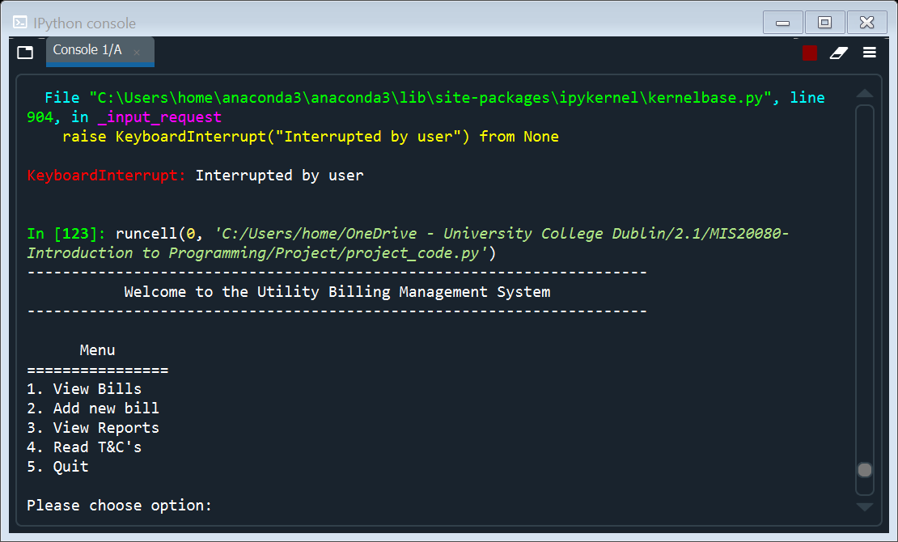

From here you have 5 options.

**Main Menu Option 1:**

This option allows you to view the current bills which have been read from the bills.csv text file. The output should look as follows. You will then be returned to the main menu.

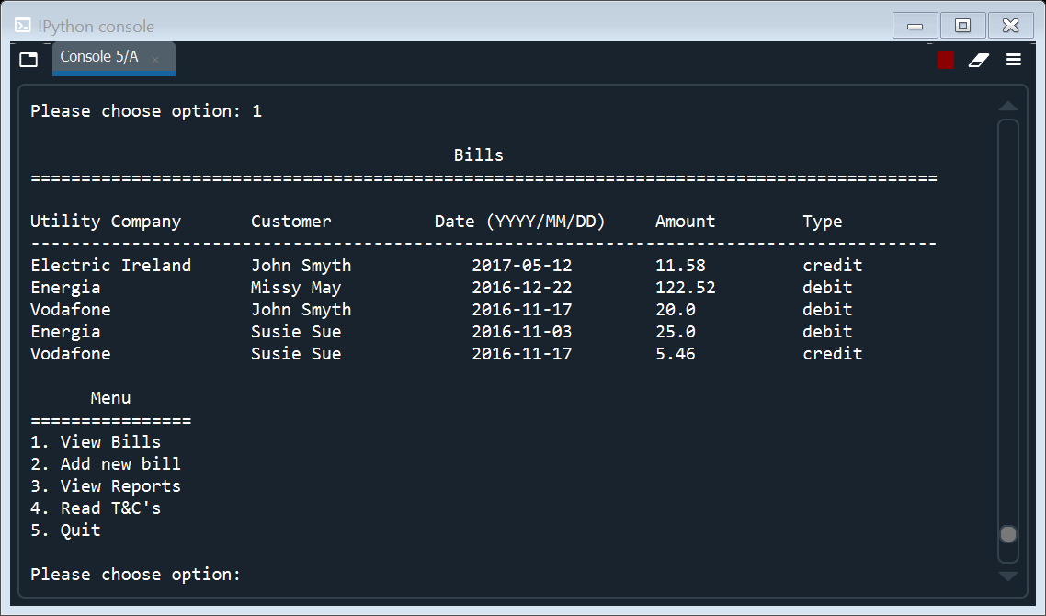

**Main Menu Option 2:**

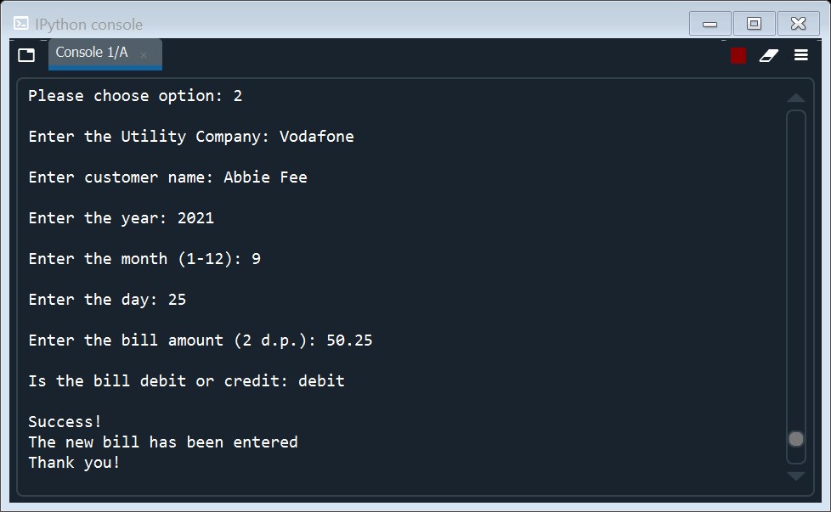This option begins the process of adding a new bill to the csv file. It does this by gather data from the user by asking for inputs. The inputs you will be asked for include utility company, customer name, year, month, day, bill amount and whether the bill is debit or credit. An example of this is shown to the left. You will then be returned to the main menu.

The programme checks each of these entries to ensure that all entries are valid, therefore things such as entering a negative month or a day not in a certain month would not be accepted. Error handling like this is incorporated into all user inputs throughout the program.

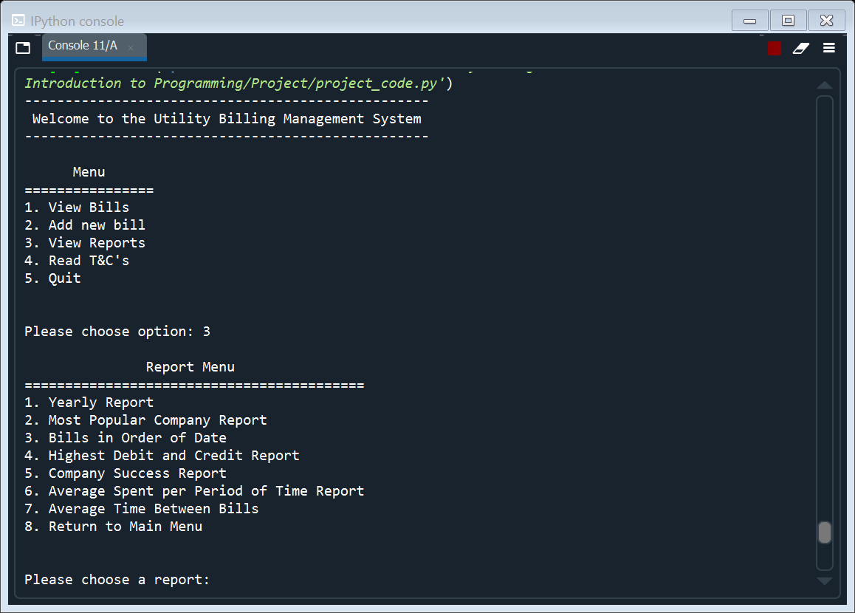**Main Menu Option 3:**

Choosing this option brings you to a new menu screen called “Report Menu” (see right). From here you will be asked to choose from a number of different report options.

*Report Menu Option 1:*

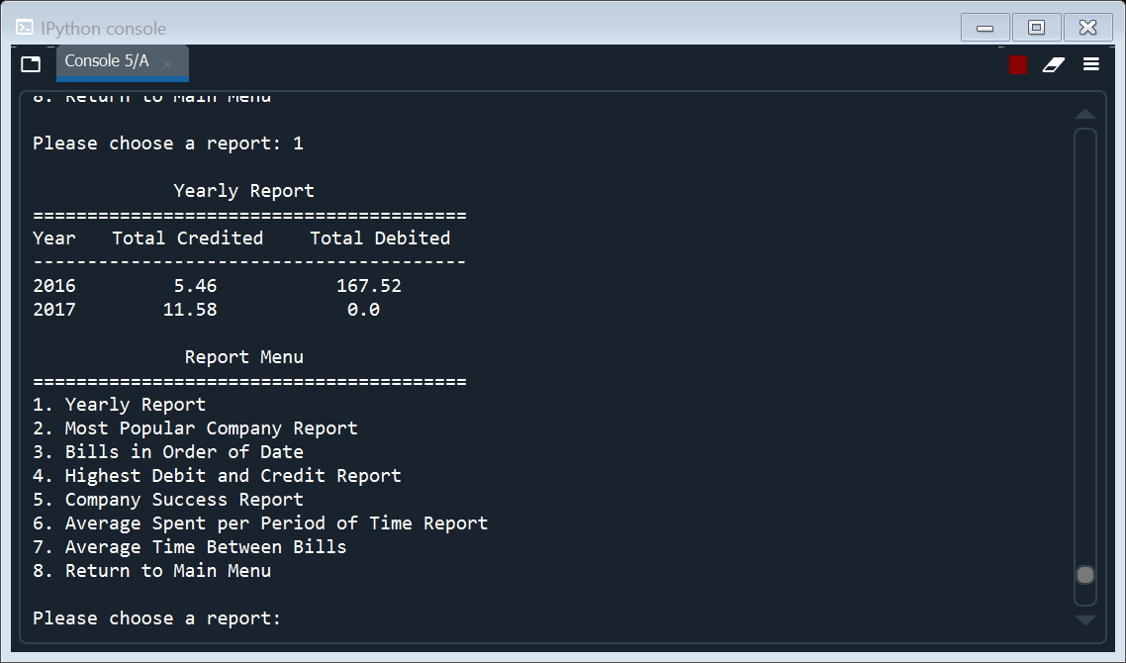Choosing report option 1 (“Yearly Report”) will present the report you see to the left. This report shows you the total credit and total debit amounts entered for each year. The years presented are whichever years are present in bills.csv. You will then be returned to the report menu, if you wish to choose another report you may do so, if you want to return to the main menu, simply choose option 8 (“Return to Main Menu).

*Report Menu Option 2:*

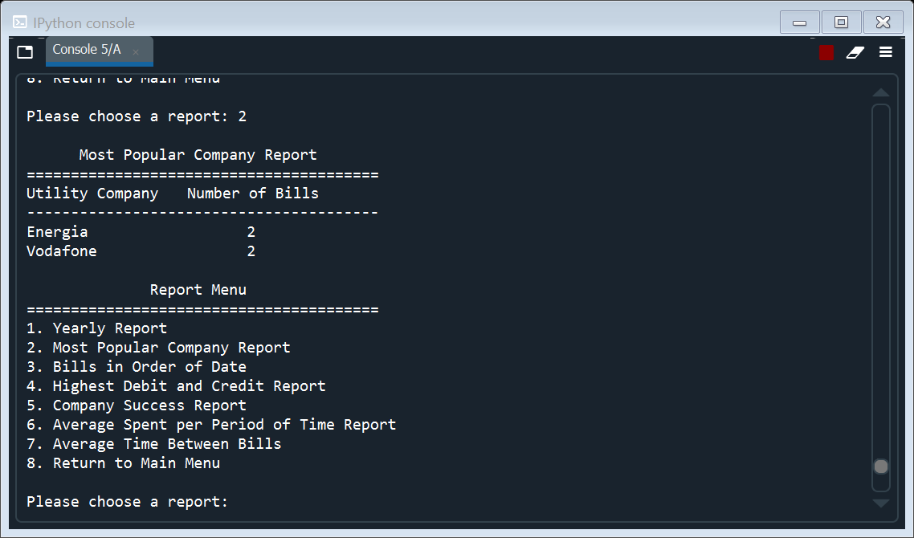Choosing report option 2 (“Most Popular Company Report”) will present the report seen to the right. This report shows the most popular utility company, or in this case companies, and the number of bills associated with them. You will then be returned to the report menu, if you wish to choose another report you may do so, if you want to return to the main menu, simply choose option 8(“Return to Main Menu).

*Report Menu Option 3:*

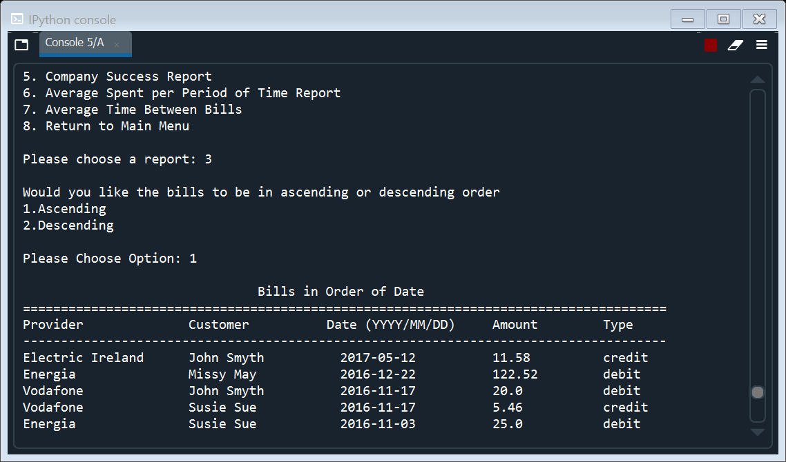Choosing report option 3 (“Bills in Order of Date”) allows you to see all the bills arranged in order of date. However, first you must choose if you want to see the bills arranged in ascending or descending order. Once you have made your choice the report will be printed according to your choice of ascending or descending. To the left I have provided an example of this for ascending order. You will then be returned to the report menu, if you wish to choose another report you may do so, if you want to return to the main menu, simply choose option 8 (“Return to Main Menu).

*Report Menu Option 4:*

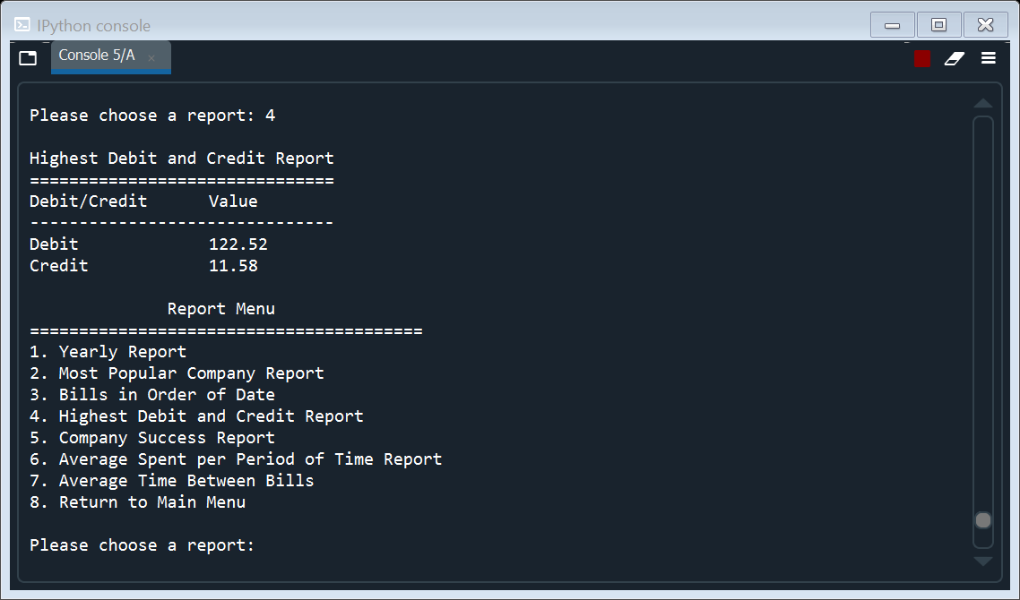Choosing report option 4 (“Highest Debit and Credit Report”) will present the report seen right. This report shows the value of the bill with the highest debit entry and the highest credit entry. You will then be returned to the report menu, if you wish to choose another report you may do so, if you want to return to the main menu, simply choose option 8 (“Return to Main Menu).

*Report Menu Option 5:*

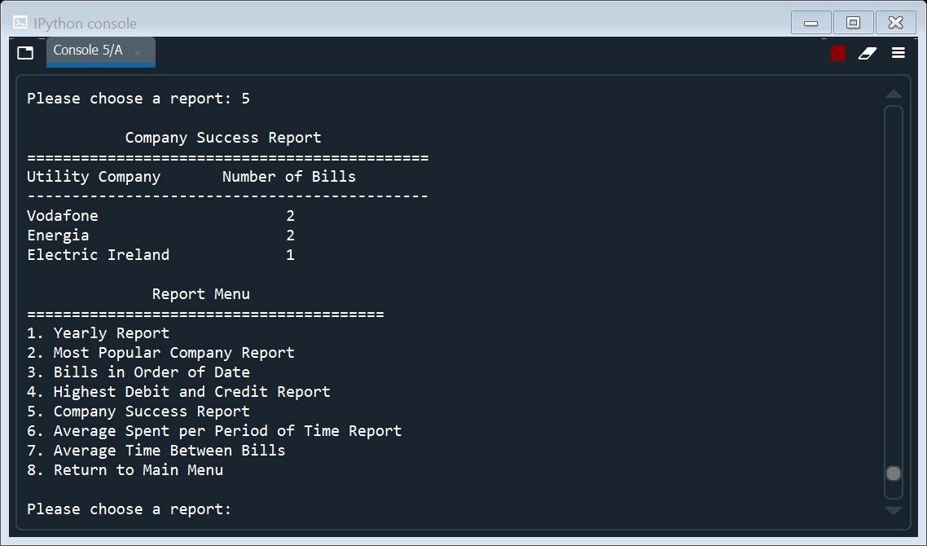Choosing report option 4 (“Company Success Report”) will present report on the left. This report shows the most successful companies and their respective number of bills (which was used to determine their success). You will then be returned to the report menu, if you wish to choose another report you may do so, if you want to return to the main menu, simply choose option 8 (“Return to Main Menu).

*Report Menu Option 6:*

Choosing report option 6 (“Average Spend per Period of Time Report”) allows you to see the average yearly spend or the average monthly spend. So, on choosing this report you will first be asked if you want to see the average yearly or monthly spend or both.

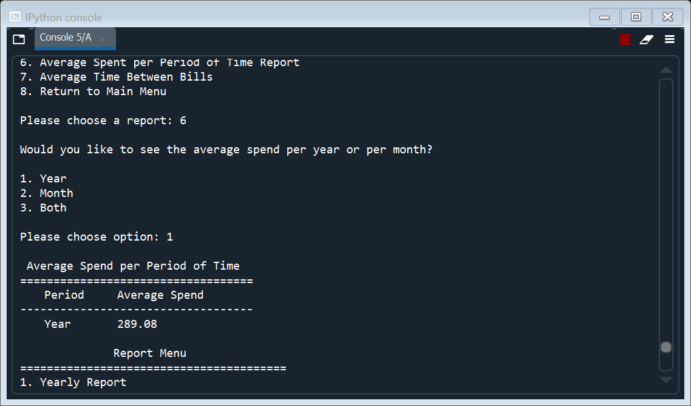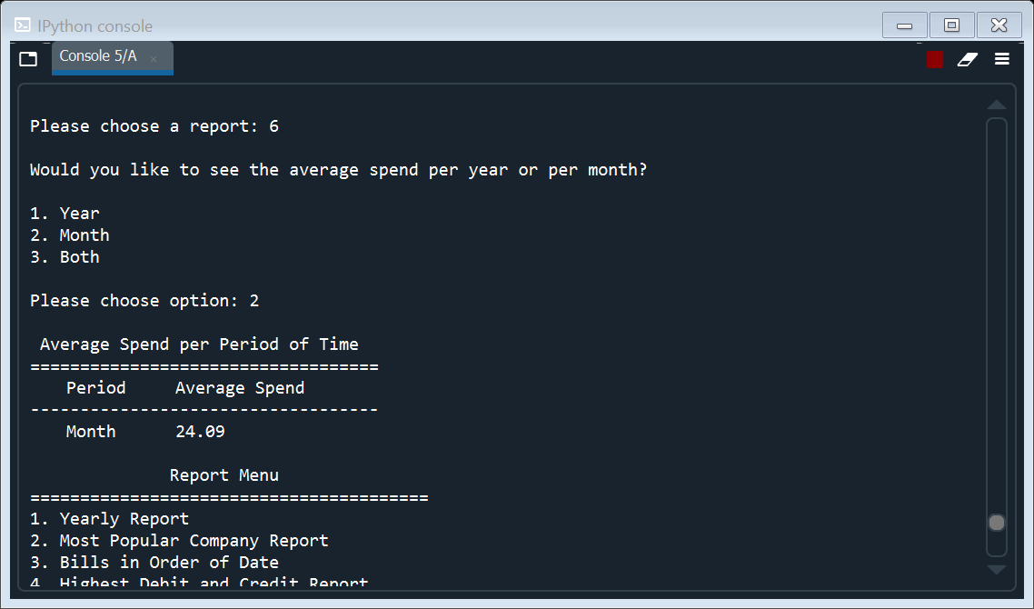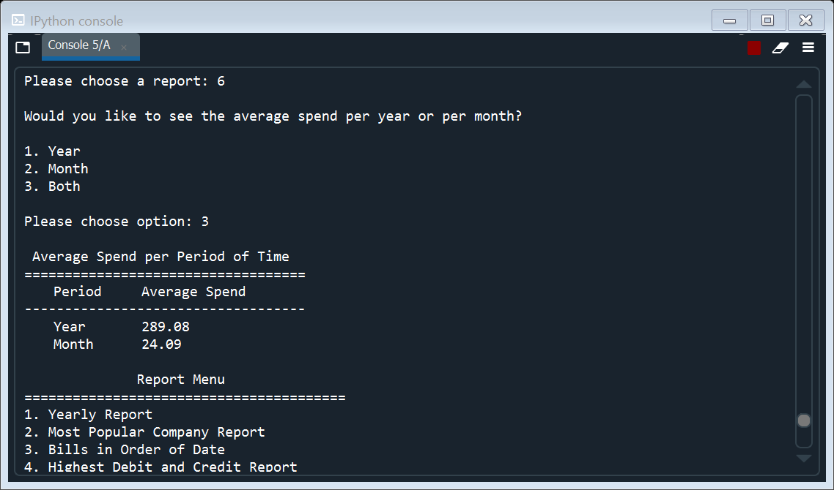Once you have made your choice your chosen report will be printed. I have provided the output for each choice below. You will then be returned to the report menu, if you wish to choose another report you may do so, if you want to return to the main menu, simply choose option 8 (“Return to Main Menu).

*Report Menu Option 7:*

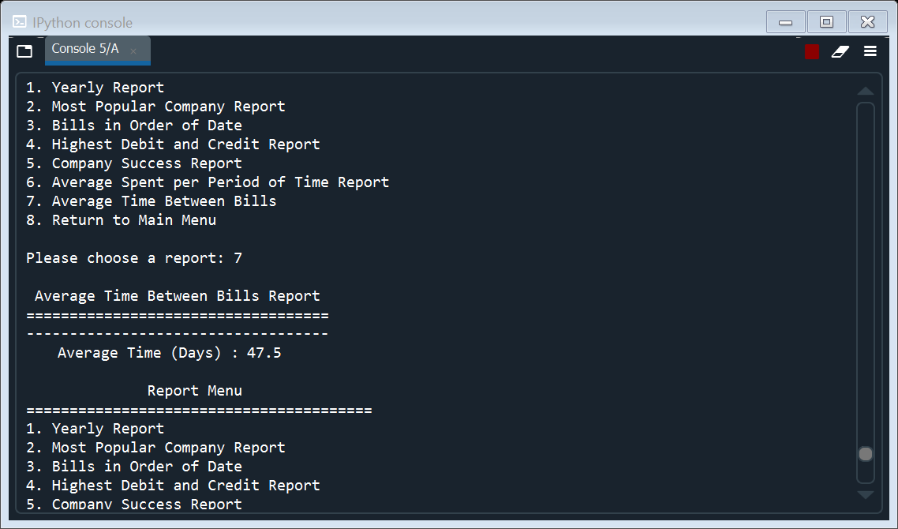Choosing report option 7 (“Average Time Between Bills Report”) will present the report on the right. This report shows the average length of time between bills in days. You will then be returned to the report menu, if you wish to choose another report you may do so, if you want to return to the main menu, simply choose option 8 (“Return to Main Menu).

*Report Menu Option 8:*

Option 8, as I mentioned above, provides the user with the option to leave the report menu and return to the main menu at any stage.

**Main Menu Option 4:**

Once you have returned to the main menu choosing option 4 (“Read T&C”) will present the terms and conditions from terms_and_conditions.txt for you to read (see below). You will then be returned to the Main Menu.

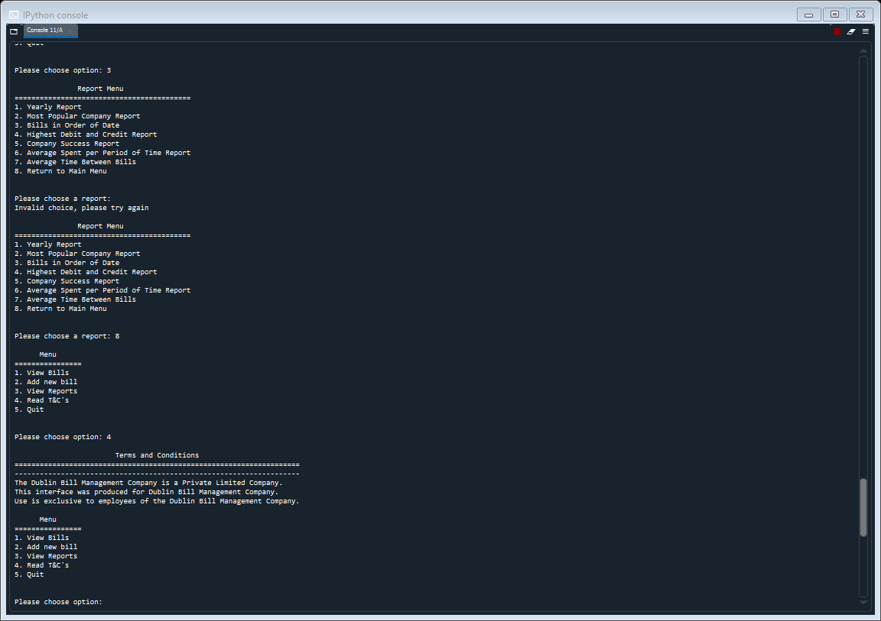

**Main Menu Option 5:**

This is the final option in the Main Menu as and such is the final option in my programme. This option (“Quit”) allows you to finish your use of this “Utility Bill Management System”. Choosing this option updates the bills.csv file to incorporate any new bills which have been added during your session and then prints and thank you message. See the output below.

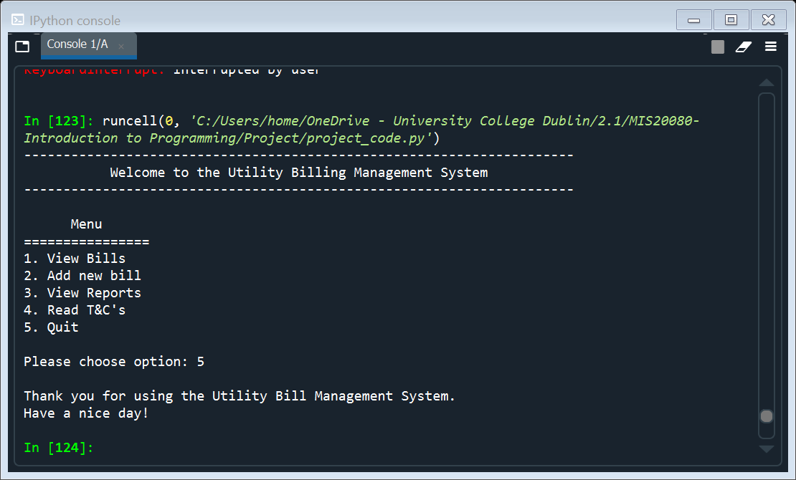

Thank you for using my programme, I hope you enjoyed its features. Please view the flowchart below for a summary of the structure and flow of my programme.

