Software Design Specification
Database Architecture & Data Management Strategy
Casino Blackjack Cheater Detection System
Group: Nathan Cubias, Dane Yaddgo, Maksim Makar, Austin Thomas
Updated continuation of Assignment 2

I. System Description
The system assists casino surveillance staff in identifying possible card counting and other blackjack behavior requiring review. Table sensors and synchronized cameras collect observations; processing reconstructs rounds, tracks publicly visible cards, and analyzes betting and play patterns over time. The system presents alerts with supporting evidence and confidence scores. Card counting alone is not proof of fraud or illegal cheating; authorized staff make decisions under casino policy and applicable law.

II. Updated Software Architecture Diagram
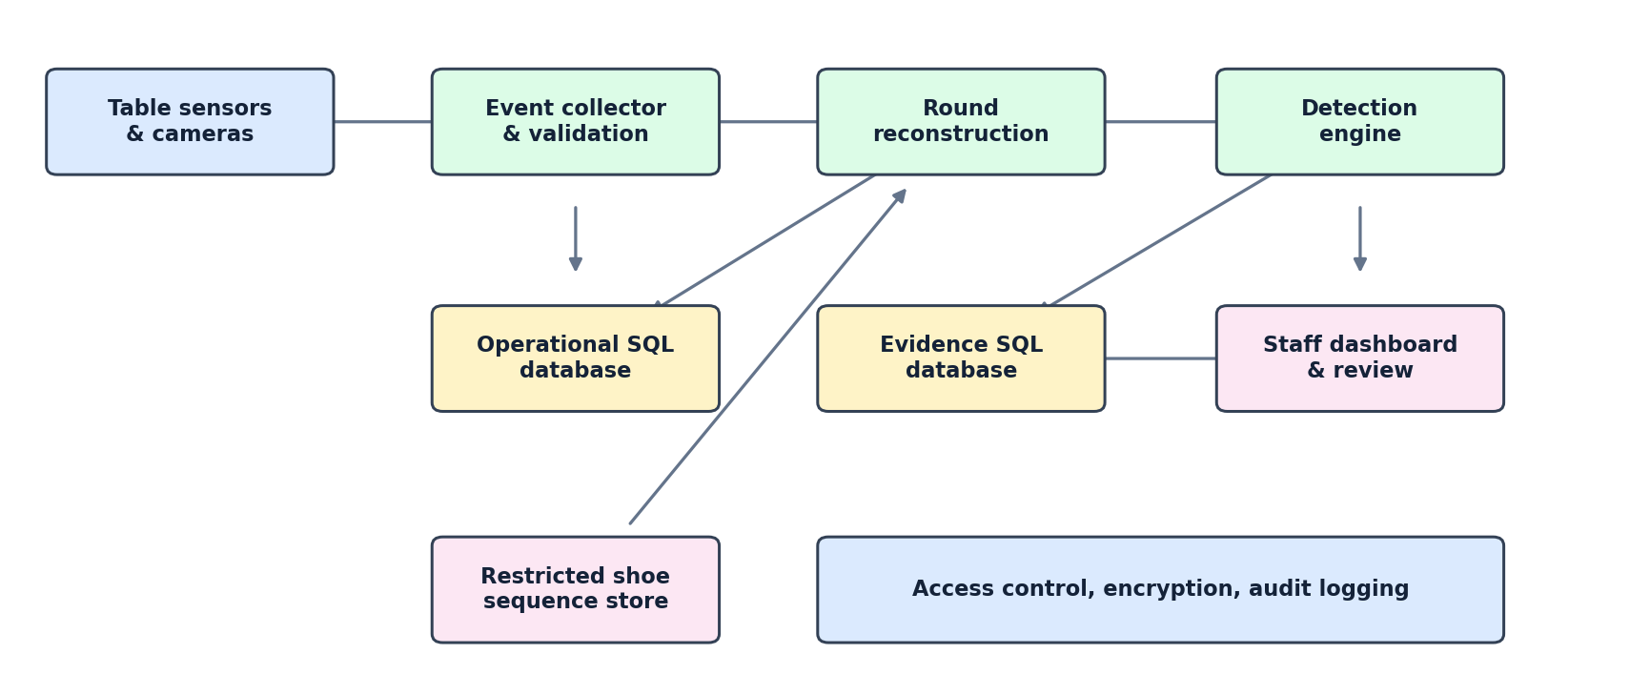
Figure 1. Proposed updated architecture. The three storage areas separate day-to-day operational records, investigative evidence and reviews, and restricted verified shoe order. The restricted store is not available to routine detection scoring.
Capture devices send time-stamped observations to the EventCollector for validation, buffering and deduplication. Round reconstruction associates events with tables, seats, sessions, hands and rounds. DetectionEngine computes the running public count and estimated true count, evaluates behavior across sessions, and creates alerts. The staff dashboard retrieves alerts and supporting evidence and records review decisions. Device-health failures and uncertain observations are surfaced rather than silently treated as facts.

III. Data Management Strategy

A. Technology and number of databases
Proposed implementation: SQL relational storage (for example PostgreSQL) with three logically separated databases or equivalently isolated schemas: (1) Operational Game Data, (2) Evidence and Review, and (3) Restricted Shoe Sequence. SQL is chosen because the system has well-defined relationships, requires referential integrity, and must support reliable queries linking players, sessions, rounds, events and alerts. Three logical data areas follow the separation already shown in Assignment 2 between an evidence database and a restricted verified-card-order database, while adding an explicit operational store for normalized game records. The exact database engine and physical deployment were not specified in Assignment 2 and are proposed here.

B. Database relationship diagram
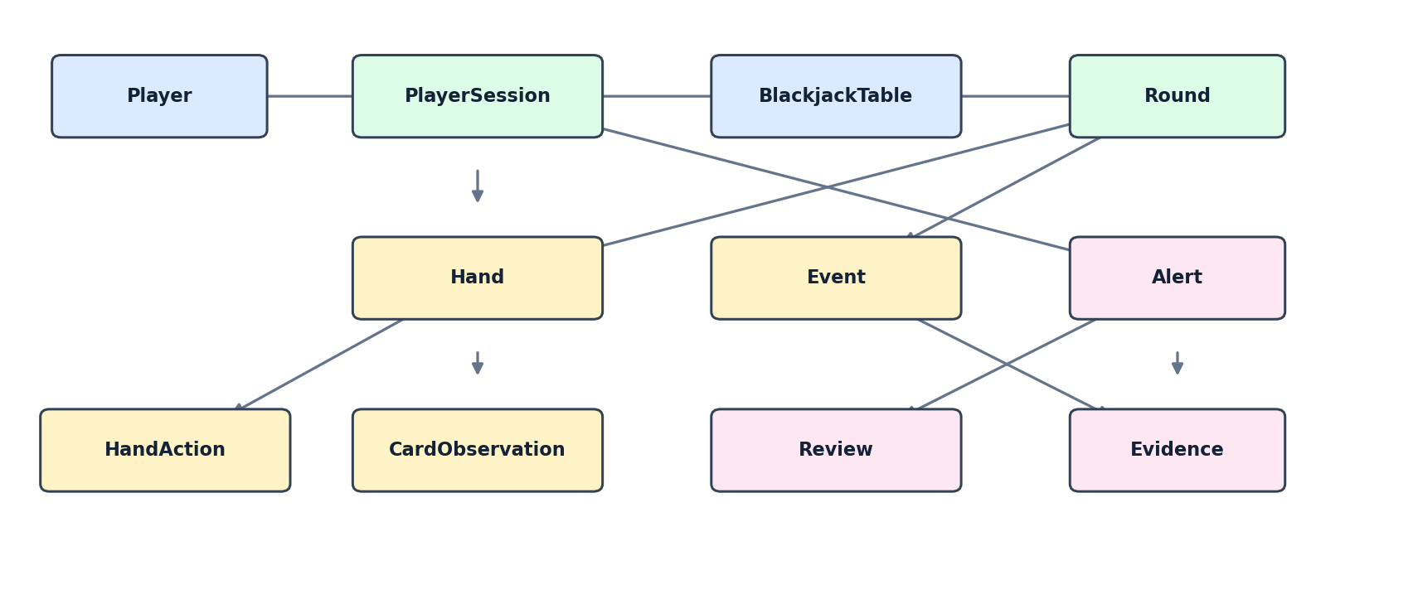
Figure 2. Core logical relationships. Each arrow indicates a related record; detailed foreign keys are listed below. The restricted ShoeSequence data is deliberately omitted from the routine operational relationship graph.

C. Proposed SQL tables and fields
Area / table | Suggested fields | Purpose / notes
Operational  Player | player_id PK; membership_number UNIQUE nullable; first_name; last_name | A player may be unidentified or lack a membership.
Operational  BlackjackTable | table_id PK; deck_count; rules | Table configuration; table_id type consistent throughout.
Operational  PlayerSession | session_id PK; player_id FK nullable; table_id FK; seat_number; start_time; end_time | Tracks a player at a table/seat over time.
Operational  Round | round_id PK; table_id FK; status; start_time; end_time | Round reconstruction and review.
Operational  Hand | hand_id PK; round_id FK; session_id FK; wager | Supports multiple hands, including splits.
Operational  HandAction | action_id PK; hand_id FK; action_type; action_time | Records hit, stand, double, split and other actions.
Operational  CardObservation | observation_id PK; hand_id FK nullable; round_id FK; rank; suit; visible_at; confidence; device_id FK | Records cards, including dealer cards not attached to a player hand.
Operational  Event | event_id PK; table_id FK; round_id FK nullable; device_id FK nullable; event_type; event_time; description | Time-stamped input, shuffle and system events.
Operational  CaptureDevice | device_id PK; device_type; status | Device health and provenance.
Evidence  Alert | alert_id PK; session_id FK; confidence; status; video_reference; created_at | Detection output and investigation queue.
Evidence  Evidence | evidence_id PK; alert_id FK; event_id reference; description; evidence_type; created_at | Links supporting events or clips to an alert.
Evidence  Review | review_id PK; alert_id FK; reviewer_id; decision; notes; reviewed_at | Authorized staff decisions and audit trail.
Restricted  ShoeSequence | sequence_id PK; table_id reference; recorded_at; verified_order; validation_status | Verified card order, accessible only to authorized investigations.
PK = primary key; FK = foreign key. Where tables are in separate databases, references are application-enforced identifiers rather than cross-database SQL foreign keys. If implemented as isolated schemas within one SQL database, database-enforced foreign keys can be used.

D. Data flow, retention, and access

Ingestion and validation
Each capture device supplies a device ID and timestamp. EventCollector validates required fields, buffers transient failures, deduplicates events using a stable source-event identifier, and records uncertain readings with confidence instead of inventing missing cards.

Round reconstruction and analysis
Events are ordered by table and timestamp and associated with rounds, hands, actions, and visible card observations. Shuffle events reset running counts. The public count uses only cards visible at the relevant time; verified private shoe order is kept out of routine scoring.

Evidence and human review
The detection engine creates an Alert linked to the affected session. Evidence records reference the events and clips supporting that alert. Staff record decisions in Review; the system does not automatically classify a player as guilty.

Security and sensitive data
Use role-based access control, encryption in transit and at rest, audit logs for reads and changes to sensitive records, restricted access to verified shoe order, and limited access to video and personally identifiable player information. Avoid storing unnecessary personal details.

Retention, backups and recovery
Use configurable retention periods approved by casino policy and applicable law; preserve records under an authorized investigation hold. Back up databases, test restoration, and maintain documented deletion and archival processes. Specific retention durations are policy decisions, not stated in Assignment 2.

Integrity and performance
Enforce primary keys, unique identifiers, valid confidence ranges (0–1), and referential integrity where available. Index time, table, round, session, and alert status fields; partition high-volume events by date if required. Use transactions for related writes and log failed processing.

E. Alternatives and tradeoffs
Option | Advantages | Disadvantages / decision
Three logical SQL stores (selected) | Clear security boundaries; normalized relations; operational and investigation workloads can be isolated. | More deployment and cross-store coordination; references may need application-level checks.
One SQL database, separate schemas | Simpler joins, transactions, and administration. | Weaker physical isolation unless permissions are carefully configured; shared workload contention.
NoSQL document database | Flexible event payloads and high write throughput. | Complex joins and consistency across hands, sessions and alerts require extra application work.
Event-only append log | Strong auditability and replay of reconstructed rounds. | More difficult day-to-day queries; projections and additional storage required.
An object store for video clips may supplement the selected SQL approach: the SQL Evidence/Alert tables would hold references and metadata rather than large video files. This is a proposed implementation detail, not a requirement explicitly given in Assignment 2.

IV. Alignment With Assignment 2
The updated model retains the original architecture stages (table equipment, processing, review and decision), the EventCollector, Round, Hand, PlayerSession, CardObservation, DetectionEngine, Alert and AlertDashboard responsibilities, and the separately restricted ShoeSequence. It extends the preliminary Player/Event/Evidence database sketch by removing fixed seat1–seat4 fields, modeling hands and actions separately, adding confidence and review fields, and defining clear keys and relationships. These database changes are proposed extensions, not pre-existing implementation claims.

V. Implementation Notes and Open Decisions
Before implementation, the group should confirm: whether the three logical areas will be separate physical databases or SQL schemas; the identifier type (integer versus string/UUID) for table and round IDs; the handling of unidentified players; the video-storage provider; actual retention periods; and how permissions for restricted card-order access are approved and audited. These choices were not fixed by Assignment 2.

Source Documents
Assignment 2: Software Design Specification — Casino Blackjack Cheater Detection System (7 pages), especially the architecture diagram on page 1, UML on page 2, and class descriptions on pages 3–6.
Untitled document.pdf — initial Player, Event, and Evidence database sketch (1 page).

