A Large-Scale Statistical Study of Genetic Algorithm Operator Interactions for the Vehicle Routing Problem

Nathan Daud, Wayan Firdaus Mahmudy*, M. Ali Fauzi
Department of Informatics Engineering, Brawijaya University, Malang, Indonesia
E-mail: wayanfm@ub.ac.id
∗Corresponding author

Abstract
This study addresses the practical and economic urgency of improving Vehicle Routing Problem (VRP) solutions, given their critical role in reducing transportation cost and enhancing logistics efficiency. The core problem investigated is how different combinations of Genetic Algorithm (GA) operators representation, selection, crossover, and mutation affect solution quality, convergence behavior, and computational effort for VRP with time windows. Although existing GA–VRP studies often examine single operators or small subsets of design choices, there is still a lack of large-scale, statistically controlled evidence on how full operator configurations interact across diverse benchmark instances. This research employs a full-factorial experimental design that systematically evaluates 354 GA operator combinations on 56 Solomon VRPTW benchmark instances, using multiple runs and rigorous statistical analysis to ensure robust comparisons. The results show that permutation-based representations consistently outperform binary and real-valued encodings, and that the combination of permutation encoding, Rank selection, Sequential Constructive Crossover (SCX), and Inversion mutation achieves the best overall performance, delivering substantial improvements in average fitness, convergence speed, and robustness across clustered, random, and mixed customer distributions. Furthermore, the study reveals strong interaction effects between operators, demonstrating that performance gains arise not from individual components alone but from carefully matched operator configurations tailored to VRP structure. The main contribution of this work is a statistically validated set of practical guidelines and a recommended GA operator configuration that practitioners can use as a high-quality baseline for solving VRP, while also providing an empirical foundation for researchers to design and benchmark future GA-based metaheuristics.
Keywords: Genetic Algorithm, Vehicle Routing Problem, Operator Comparison, Solomon Benchmark, Evolutionary Computation, Metaheuristics, Optimization.

1. Introduction
The Vehicle Routing Problem (VRP) is a classical combinatorial optimization problem in operations research with the goal of designing a set of minimum‑cost routes for a fleet of vehicles to serve geographically distributed customers, subject to constraints such as vehicle capacity, time windows, and route length (Ngo et al., 2022). VRP is known to be NP‑hard, with the search space growing factorially with the number of customers; for example, a 100-customer instance has approximately 10¹⁵⁷ possible solutions, making brute-force approaches infeasible (Mahmudy, Widodo and Haikal, 2024). Innovations in metaheuristics, such as hybrid Tabu Search and clustering approaches, have led to improved solutions and significant reductions in computational time for VRP and its variants like capacitated VRP and VRP with time windows (Ngo et al., 2022). For instance, metaheuristics have brought cost improvements and allowed instances featuring 50–100 customers to be solved in minutes instead of hours or days (Sabo, Pop and Horvat-Marc, 2020). These advancements translate into measurable savings in fuel consumption, fleet size, and service efficiency for logistics providers, which remains a key motivation for ongoing research (Mahmudy, Widodo and Haikal, 2024).
Despite the availability of exact optimization methods such as branch‑and‑bound, branch‑and‑cut, and mixed‑integer linear programming, these approaches are generally limited to small or moderately sized VRP instances, because the underlying formulations exhibit exponential growth in the number of routes and constraints, leading to rapidly increasing memory requirements as problem size grows (Braekers, Ramaekers and Van Nieuwenhuyse, 2016). In practice, exact solvers tend to be confined to benchmark or inventory‑routing variants with relatively few customers; for example, a recent branch‑and‑cut scheme for multi‑vehicle and multi‑depot inventory‑routing problems reports 417 proven optimal solutions over 638 small instances and can still prove optimality for all single‑vehicle instances with up to 50 customers, but for 100‑customer cases it delivers mainly best‑known rather than proven optimal solutions (Guimarães et al., 2024). This behavior illustrates how, for larger and more realistic VRP or VRPTW instances, the size of the branch‑and‑bound tree and the time needed to close even small optimality gaps often become prohibitive, which motivates the use of approximate heuristics and metaheuristics that trade guaranteed optimality for high‑quality solutions obtained within acceptable time limits (Braekers, Ramaekers and Van Nieuwenhuyse, 2016). Empirical studies on time‑dependent VRPs with time windows using Solomon’s 56 benchmark instances with 100 customer nodes similarly favor metaheuristics such as genetic algorithms, showing that exact MILP‑based methods struggle to reach optimality in reasonable CPU times once tight time‑window or additional real‑world constraints are included (Kumar and Panneerselvam, 2015).​
To address these limitations, researchers and practitioners have extensively adopted heuristic and metaheuristic algorithms, including constructive heuristics such as Clarke–Wright savings and sweep algorithms, local‑search–based improvements like 2‑opt, 3‑opt, and Or‑opt, and more advanced metaheuristics such as Tabu Search, Simulated Annealing, Ant Colony Optimization, and Genetic Algorithms (GAs) (Avdoshin and Beresneva, 2019; Ochelska-Mierzejewska, Poniszewska-Marańda and Marańda, 2021). These approaches can efficiently explore large and structured search spaces; for example, a Hybrid GA with Solomon’s insertion heuristic for the VRPTW attains best‑known solutions on 11 classical Solomon benchmark instances and even improves the best‑known solution in 1 instance, while keeping deviations from best‑known values small and computation times practical (Maroof, Ayvaz and Naeem, 2024). Similarly, an improved GA for vehicle path optimization has been shown to increase average convergence speed by 50–60% and reduce computation time by about 48% compared with a classical GA, while maintaining solution accuracy within about 1% of the reference solution, illustrating the ability of metaheuristics to deliver high‑quality solutions rapidly (Mu et al., 2024). Empirical studies and surveys on classic benchmark suites, including Solomon and Cordeau instances, consistently report that well‑designed metaheuristics can close most of the optimality gap and often match or come very close to best‑known solutions for many VRP variants, while remaining flexible enough to incorporate complex, problem‑specific constraints (Liu et al., 2023)
GAs have been widely explored for VRP since the 1990s because their population‑based search makes it easy to encode routes as chromosomes and to exploit problem structure via tailored selection schemes, crossover operators, mutation strategies, and hybrid local search, as documented in recent surveys and GA‑focused studies on VRP (Ochelska-Mierzejewska, Poniszewska-Marańda and Marańda, 2021; Liu et al., 2023). Many computational studies report that well‑designed GA‑based methods can match or surpass traditional heuristics, especially when hybridized with local search or ruin‑and‑recreate phases: for example, a two‑phase distributed ruin‑and‑recreate GA for VRPTW produces solutions on Solomon benchmarks that are superior to several recently published hybrid algorithms and even to some best‑known solutions, while a hybrid Genetic–Simulated Annealing algorithm for CVRP tested on 86 benchmark instances yields high‑quality routes with reduced travel distance compared to baseline methods (Khoo et al., 2020; Sajid, Jafar and Sharma, 2020). Similarly, adaptive or specialized GAs for rich VRP variants with two‑dimensional loading and heterogeneous fleets have been validated on up to 150 benchmark instances and on all available datasets for specific problem types, consistently showing competitive or improved solution quality and cost savings relative to earlier heuristics (Sbai, Limam and Krichen, 2020). At the same time, empirical analyses demonstrate that GA performance is highly sensitive to design decisions: studies that systematically compare different route encodings show substantial impacts on population diversity and convergence behavior, while work on memetic and improved GA variants highlights how tuning selection pressure and operator design is crucial for balancing exploration and exploitation in large‑scale VRPTW (Jefferson, Lima and Alves De Araújo, 2020). Moreover, investigations of enhanced mutation and repair strategies in vehicle path and routing contexts report that improved GAs can increase average convergence speed by about 50–60% and cut computation time by roughly 48% while keeping solution error within about 1% of reference solutions, underscoring how crossover, mutation, and repair operators that preserve promising route segments and feasibility have a decisive influence on GA effectiveness (Mu et al., 2024; Niu, Fu and Dong, 2024).
A well‑known drawback of GA in VRP and related routing applications is their tendency to converge prematurely and become trapped in local optima, with studies on CVRP, VRPTW, and rich VRPs explicitly noting early stagnation, infeasible solutions, or low‑quality routes when standard GA designs are used (Agany Manyiel, Kwang Hooi and b. Zakaria, 2021; Chen, Gao and Chen, 2025). This behavior is closely linked to loss of population diversity, which motivates mechanisms such as multi‑population structures, solution archives, and niche or migration strategies: for example, a multi‑population GA for rich VRPs evolves several subpopulations that share solutions to delay premature convergence, while an improved GA–ACO for VRPTW uses two interacting populations plus Generalized Variable Neighborhood Search to avoid local optima, matching best‑known solutions in Solomon Class C and reducing vehicle usage in Class R by 24.45% with a distance deviation of 9.19% (Agany Manyiel, Kwang Hooi and b. Zakaria, 2021; Chen, Gao and Chen, 2025). Diversity‑preservation and escape mechanisms such as tailored mutation, elite‑but‑diverse selection, and parallel multi‑process or archive‑based schemes are central design levers in these works, and empirical results show that tuned operators can cut CO₂ emissions by up to 4% and outperform traditional GA, ant colony, and bee colony approaches on standard CVRP benchmarks (Palamutçuoğlu et al., 2025). From a theoretical standpoint, the no‑free‑lunch theorem for optimization states that, averaged over all objective functions on a fixed search space, no algorithm (and hence no GA configuration) is universally superior, which directly implies that GA effectiveness for VRP depends on matching representation, selection pressure, and variation operators to the structure of the specific routing class under study (Katoch, Chauhan and Kumar, 2021). Consequently, recent GA‑for‑VRP research increasingly emphasizes systematic empirical studies and controlled ablation of operator combinations such as comparing different initialisation heuristics, crossover operators, and embedded local searches on suites of 20–50 or more benchmark instances rather than relying on ad‑hoc parameter choices, in order to understand and mitigate premature convergence in large, rugged VRP search spaces (Palamutçuoğlu et al., 2025).​
This study systematically evaluates 354 combinations of genetic algorithm operators including representation schemes (binary, real‑valued, permutation), selection methods (tournament, roulette wheel, rank‑based, SUS, elitism, Boltzmann, stairwise), crossover operators (single‑point, two‑point, uniform, SBX, BLX‑α, PMX, OX, CX, ERX, SCX), and mutation strategies (swap, insert, inversion, scramble, bit‑flip, Gaussian, polynomial) for solving the Vehicle Routing Problem using the Solomon benchmark datasets comprising 56 VRPTW instances with 100 customers each. The research provides a comprehensive operator‑level comparison within a standardized experimental framework, including 99,120 independent GA runs (354 combinations × 56 instances × 5 seeds), detailed performance metrics on solution quality, convergence behavior, and computational effort, and rigorous statistical analysis using confidence intervals, non‑parametric tests, and effect sizes to identify statistically and practically superior operator combinations. The results yield insights into interaction effects between representation, selection, crossover, and mutation, highlight robust operator configurations such as permutation‑based encodings with tournament selection and OX‑type crossovers, and distill practical implementation guidelines supported by open‑source code and statistically validated evidence for practitioners deploying GAs to solve VRP in diverse settings. The key novelty of this study lies in its full-factorial, large-scale experimental design that jointly evaluates representation schemes and genetic operators under a unified statistical framework, revealing interaction effects that cannot be observed in single-operator or single-encoding studies.​

2. Literature Review

2.1 Vehicle Routing Problem
The Vehicle Routing Problem (VRP) is commonly defined as an NP-hard generalization of the Traveling Salesman Problem in which a fleet of vehicles must start and end at one or more depots while visiting all customers on a graph so that total routing cost (distance, time, or other metrics) is minimized (Bogyrbayeva et al., 2024). In real logistics systems this optimization is economically critical, with U.S. firms reported to spend about 10.4% of their revenue on transportation, logistics costs accounting for roughly 8% of GDP, and last‑mile distribution alone representing around 50% of total transportation costs, which explains the intense interest in better VRP algorithms (Bogyrbayeva et al., 2024). Core variants such as the Capacitated VRP (CVRP) and VRP with Time Windows (VRPTW) constrain vehicle loads and specify customer service intervals while preserving the same NP-hard combinatorial structure, and recent surveys categorize these within a broader family of “rich” VRPs that incorporate many realistic constraint. Further extensions introduce additional structural complexity, including multi-commodity flows (Gu et al., 2024), multi-trip and multi-depot routing with time windows and release dates (Zhen et al., 2020), and time-evolving or periodic routing decisions that link successive planning horizons (Bogyrbayeva et al., 2024). Recent work also addresses pickup-and-delivery services, heterogeneous fleets, split deliveries, and uncertainty: for example, an exact branch-and-cut method complemented by an adaptive large neighborhood search heuristic for the split-delivery VRP achieves average gaps of about 0.19–0.18% from best-known solutions and an overall optimality gap near 1.82% on benchmark instances, while stochastic two-echelon inventory-routing and medical-supply applications illustrate how random demand and multi-level networks can be embedded into routing formulations (Rave, Fontaine and Kuhn, 2025). Because the feasible solution space grows combinatorially with the number of customers, these studies consistently report that exact mixed-integer optimization can handle only small or medium instances, so modern research relies heavily on advanced heuristics, metaheuristics, and increasingly machine-learning-based methods to obtain near-optimal VRP solutions at practical scales (Gu et al., 2024).​
Researchers now typically distinguish two main classes of algorithms for the VRP: exact methods, which aim at proven optimality, and heuristic/metaheuristic methods, which trade guarantees for scalability (Liu et al., 2023; Praxedes et al., 2024). Exact algorithms combine techniques such as branch-and-bound, branch-and-cut, and column generation in modern branch-price-and-cut or branch-cut-and-price frameworks, and recent unified exact approaches can optimally solve a broad family of VRP variants but are still limited to instances with at most a few dozen customers per route pattern for example, a state-of-the-art column-generation–based method for two-dimensional or two-level CVRP solves instances with up to about 35 customers to proven optimality (Zhang et al., 2022). Because of these size limits, many practical studies rely on classical constructive heuristics such as the savings algorithm of Clarke and Wright, sweep-based clustering, or nearest-neighbor rules, followed by local-improvement moves like 2‑opt, 3‑opt, and Or‑opt, which are routinely used as building blocks in contemporary VRP heuristics and surveys (Liu et al., 2023). More advanced metaheuristics including Tabu Search, Simulated Annealing, Genetic Algorithms, Ant Colony Optimization, and variants like Adaptive Variable Neighborhood Search have been shown to yield substantially higher-quality solutions on realistic instances, with case studies reporting, for example, that metaheuristic hybrids for a capacitated VRP with university shuttle routes outperform simpler heuristics when routing four vehicles, and that an improved ACO for VRPTW reduces total distance to about 391.1 km compared with roughly 403.1 km for a classical ACO and 391 km for a Tabu Search baseline (Lei, Sun and Zhu, 2022). In applied logistics settings such as medical waste collection, guidance-based local search and metaheuristics have also demonstrated around 20–30% reductions in total travel time relative to initial heuristic routes, illustrating why metaheuristics are now considered the dominant practical approach for large and complex VRP variants (Anderson and Sudarto, 2025).​
Benchmark datasets are now a standard tool for evaluating VRP algorithms, with recent studies repeatedly confirming that performance comparisons almost always rely on a small set of well‑known benchmark families (Meira et al., 2019). Solomon’s VRPTW benchmark remains the primary reference for time‑window problems; it consists of 56 instances with 100 customers partitioned into six classes (R1, C1, RC1, R2, C2, RC2), which correspond to random, clustered, and mixed customer distributions with short or long planning horizons, and these instances are still used in modern metaheuristic (see Figure 1). Building on this, the extended Gehring and Homberger VRPTW set provides larger instances with 200, 400, 600, 800, and 1 000 customers, giving 1000‑customer test cases that are widely used to stress‑test advanced local search and learning‑based solvers (Liu et al., 2023). For capacitated vehicle routing, the Golden benchmark contributes 20 classical CVRP instances with 240–483 customers, while more recent work by Uchoa et al. (2017). consolidated and extended these into the CVRPLIB “X‑instances,” a set of 100 instances ranging from 100 to 1 000 customers with systematically varied depot position, customer distribution (random, clustered, random‑clustered), demand pattern, and average route length. Together with Cordeau‑type multi‑depot and rich VRP benchmarks summarized in recent surveys, these suites provide a diverse collection of medium to very large scale instances that underpin the empirical assessment and comparison of modern exact, heuristic, and learning‑based VRP algorithms (Meira et al., 2019).​
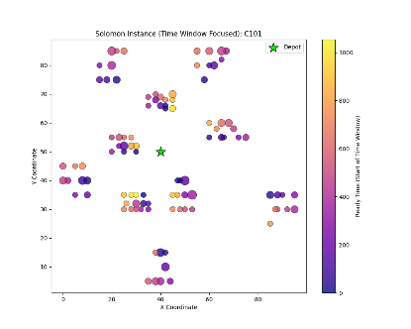 | 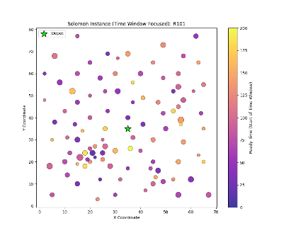 | 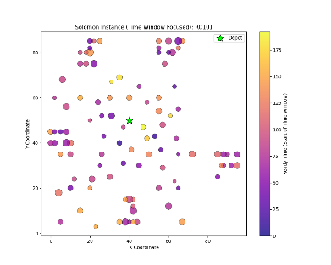
(a) Tipe C | (b) Tipe R | (c) Tipe RC
Figure 1 Solomon Benchmark sample

​2.2 Genetic Algorithms (GA)
GA are adaptive population-based search procedures inspired by natural selection and genetics, where a set of candidate solutions (chromosomes) evolves over time toward regions of higher fitness through selection, crossover, and mutation operators (Taylor, 1994). In the standard GA cycle, an initial population is randomly generated, each individual is evaluated by a fitness function, fitter individuals are selected as parents, crossover recombines their encoded features to create offspring, mutation introduces random perturbations to maintain diversity, the offspring are evaluated, and a replacement strategy (generational or steady-state) forms the next population until a termination criterion such as a maximum number of generations or convergence is reached (Anon., 1989). Core GA components include the encoding that maps problem solutions to chromosomes, a population that enables parallel exploration of the search space, a fitness function that drives the search, selection mechanisms that control selection pressure, genetic operators (crossover and mutation) that balance exploitation and exploration, and a replacement policy that determines how new individuals enter and old ones leave the population (Siagian, Yanris and Sitorus, 2022). The theoretical foundations of GAs rest on Holland’s building block hypothesis, which argues that GAs work by identifying and recombining short, high-quality schemata (building blocks) into increasingly fit solutions (Taylor, 1994), and on the no free lunch theorem, which shows that no single optimization algorithm is universally best over all possible problems, thereby motivating problem-specific choices of representations, operators, and parameter settings for GAs (Wolpert and Macready, 1997).​
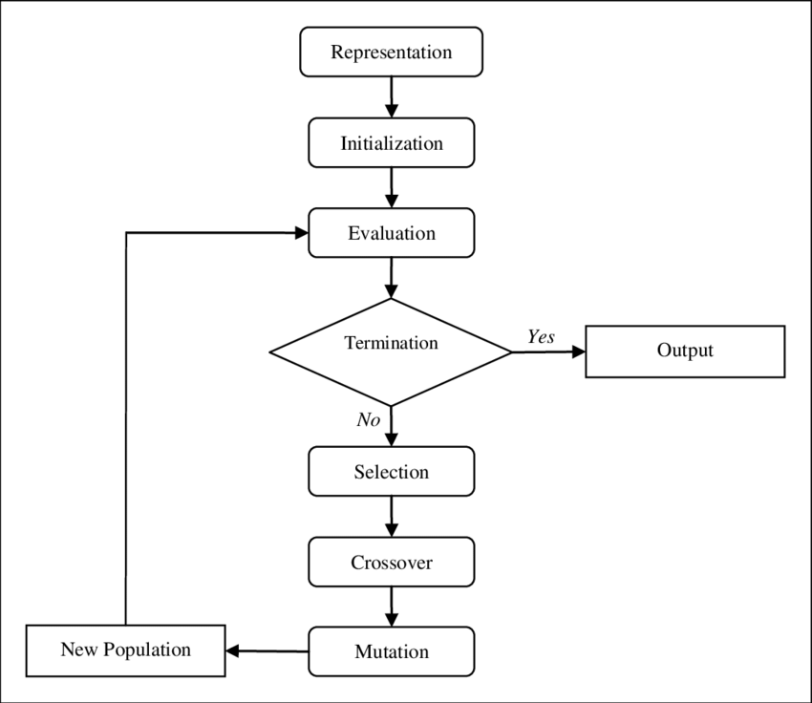
Figure 2 Genetic Algorithm (Entezari-maleki and Movaghar, 2011)
The basic GA process follows this cycle: (1) Initialize a random population, (2) Evaluate fitness of each individual, (3) Select parents based on fitness, (4) Apply crossover to create offspring, (5) Apply mutation to offspring, (6) Evaluate offspring fitness, (7) Form new generation through replacement strategy, (8) Repeat until termination criteria met (see Figure 2).
Recent evolutionary computation studies reinterpret Holland’s building block hypothesis by showing that GA exploit recurring high‑fitness gene patterns, often called dominant or key blocks, which can be explicitly mined and recombined to accelerate convergence; for instance, a 2025 hybrid GA for reconfigurable manufacturing layouts that extracts “dominant blocks” via association rules reduces the average number of iterations from 121 for a baseline GA to 50 and cuts computation time from about 8.9 s to 5.3 s while maintaining better fitness values on a 10‑machine, 3‑period layout problem (Wei, Sun and Jiao, 2025). Building on this view, recent reviews of the no free lunch theorem for optimization emphasize that when performance is averaged over all possible objective functions no algorithm, including GAs, can outperform all others, so any gains necessarily come from exploiting structure in restricted problem classes, which motivates tailoring encodings, selection pressure, and operators to the domain at hand (Oltean, 2004). Modern GA surveys and monographs describe a standard component set: an encoding that maps problem solutions to chromosomes; a population of candidate solutions that supports parallel exploration; a fitness function that quantifies solution quality; selection mechanisms that regulate selection pressure to balance exploitation of good individuals and exploration of new regions; crossover and mutation operators that recombine and perturb chromosomes to generate diversity; and a replacement strategy often generational or steady‑state that decides how offspring enter the population and low‑quality individuals are discarded, with empirical studies on feature selection and engineering design reporting that carefully tuned combinations of these elements yield consistent improvements in accuracy and convergence speed over untuned “vanilla” GAs across dozens of benchmark problems (Affenzeller et al., 2009).​

2.3 Representation Schemes for VRP
Encoding (representation) in a Genetic Algorithm for VRP determines how routes are mapped to chromosomes, which moves are reachable by crossover and mutation, and how easily feasibility (capacity, time windows, number of vehicles) can be preserved, so it has a direct impact on both solution quality and runtime. Recent VRP studies show that different encodings can lead to markedly different outcomes on the same instance: permutation-based GAs that encode customer sequences tend to work very well when local search moves (2‑opt, relocate, swap) are integrated, as in a guided GA for UAV-based CVRP that clearly outperforms a baseline GA in both route cost and convergence speed (Jasim and Chaari Fourati, 2024), and a hybrid PSO–GA for LPG distribution that reports up to 4.56% transportation cost reduction versus current company routes on real data (Indrianti et al., 2025). In contrast, random‑key (real‑valued) encodings separate the GA search in [0,1]^{n} from a problem‑specific decoder, allowing a single representation and operator set to handle open VRP, multi-depot VRP, and dial‑a‑ride variants while consistently producing near best-known solutions on standard benchmarks (Higino, Augusto Chaves and Veloso De Melo, 2018; Londe et al., 2025). Binary or matrix-based encodings remain useful when decisions are inherently yes/no such as time-window assignment or activation of links and are frequently used in multiobjective formulations where GA must handle both routing and scheduling or service-level decisions; for example, recent network and path-optimization applications show that carefully tuned binary or discrete encodings combined with improved mutation can significantly outperform classical GA and particle swarm variants in terms of total travel cost and convergence behaviour (Siagian, Yanris and Sitorus, 2022). Overall, empirical comparisons in recent reviews emphasize that no single encoding is universally best: permutation representations are usually preferred for pure routing structure, random‑key encodings for hybrid or hierarchical VRP/location problems, and binary/matrix encodings for problems with many side constraints or assignment decisions, reinforcing that representation must be chosen to match instance characteristics and algorithm design (see Table 1) (Vié, 2020; Londe et al., 2025).
Table 1. Encoding scheme in GA
Scheme | Description | Advantages | Limitations | Applications
Binary | Encodes solutions as binary strings or matrices | Strong theoretical backing; easy to implement standard genetic operators; natural for yes/no decisions and multiobjective formulations | Long chromosomes for realistic VRPs; maintaining feasibility can be difficult; often needs repair or penalty mechanisms | (Halassi Bacar and Rawhoudine, 2021; Koloch et al., 2021; Mu et al., 2024)
Real-Valued | Assigns floating-point or random-key values to customers, which are decoded into routes | Allows use of continuous GA machinery; same representation can handle many VRP variants; crossover and mutation preserve implicit feasibility when paired with a suitable decoder | Extra decoding step adds computational overhead; performance depends heavily on decoder design and parameter tuning | (Higino, Augusto Chaves and Veloso De Melo, 2018; Festa et al., 2024; Mu et al., 2024)
Permutation | Directly sequences customer visits with optional route delimiters or implicit depot returns | Very natural fit for routing; many specialized crossover/mutation operators exist; feasibility is easier to maintain when combined with route-splitting or local search | Naïve operators can disrupt good route structures; additional mechanisms often needed to enforce capacity and time-window constraints | (Liu et al., 2021; Wang et al., 2021; Fan et al., 2022)

2.4 Selection Methods
Selection in GA controls which individuals reproduce and therefore how strongly the search exploits high‑fitness solutions versus exploring new regions, making it a critical design choice for VRP GAs where small differences in selection pressure can translate into several percent differences in route cost or convergence time. Recent hyperparameter studies show that combining strong selection with elitism can dramatically improve performance: for example, Greenstein, Elsey and Hutchison (2023) found that a GA using three‑way tournament selection and 50% elitism achieved the best balance of finding the global optimum (“champion”), covering about 42% of the top candidates, and achieving large speedups (≈20×) over brute force in a 100 128‑candidate molecular design problem. Brouwer et al. (2022) reported that tournament‑based survivor selection outperformed the default elitist “plus‑selection” method on 83–88% of 59 benchmark functions, with elitist tournament alone accounting for about 54% of all best results, while roulette‑wheel variants performed close to chance on the same suite. At the same time, comparative work in spatial layout optimization by Ibrahim et al. (2025) showed that roulette wheel selection outperformed rank selection in 50% of experiments and reduced processing time by up to 38% in some runs, although rank selection occasionally converged faster in specific scenarios, illustrating how problem structure and implementation details can reverse preferences between methods. Additional studies comparing Boltzmann-style or fitness-uniform schemes against classical proportional selection emphasize that diversity-preserving schemes can delay premature convergence but may converge more slowly, so practical GA designs for VRP often combine tournament or roulette selection with rank-based or temperature-controlled variants plus elitism to guarantee non‑decreasing best fitness over generations (see Table 2) (Brouwer et al., 2022; Ibrahim et al., 2025).​
Table 2. Selection methods for GA in VRP
Method | Description | Notes
Roulette Wheel | Probability of selection proportional to raw or scaled fitness | Classic fitness‑proportionate method; recent comparative studies in spatial layout optimization show that roulette wheel selection achieves higher final fitness than rank selection in about half of tested runs and can cut computation time by up to ≈38% in some experiments, but it is still prone to premature convergence if fitness variance is high (Ibrahim et al., 2025)
Tournament | Randomly samples a subset of size k and selects the best | Widely used in modern GAs; in a large benchmark study, elitist tournament survivor selection outperformed plus‑selection on 83–88% of 59 continuous test functions, with tournament methods collectively delivering about 81% of all best‑known results, indicating strong and controllable selection pressure (Brouwer et al., 2022)
Rank-Based | Assigns selection probability based on rank rather than raw fitness | Rank selection stabilizes selection pressure when fitness values differ widely or include negatives; in spatial layout tests, rank selection occasionally reached better fitness earlier than roulette wheel but was generally slower and more computationally expensive due to sorting, highlighting a robustness–speed trade‑off (Ibrahim et al., 2025)
Stochastic Universal Sampling (SUS) | Uses a single random start and evenly spaced pointers to sample proportionally | SUS reduces sampling variance compared with plain roulette wheel by ensuring that each individual is sampled close to its expected number of times, and recent GA hyperparameter tutorials list SUS alongside roulette and tournament as a robust default for proportional selection in chemical and engineering design tasks (Greenstein, Elsey and Hutchison, 2023)
Elitism | Copies the best individuals directly to the next generation | Guarantees that the best fitness in the population does not decrease over time; best-practices work in molecular design recommends relatively high elitism rates (around 50%) combined with tournament selection to reliably find global optima while maintaining reasonable coverage of top solutions (Greenstein, Elsey and Hutchison, 2023)
Boltzmann | Selection probabilities scaled via a temperature parameter, analogous to simulated annealing | Boltzmann or temperature-based selection adjusts selection pressure over time, starting more exploratory and becoming more exploitative; comparative selection studies report that such temperature-controlled or related schemes can preserve diversity and delay premature convergence, at the cost of slower convergence if cooling is too conservative (Katoch, Chauhan and Kumar, 2021)

2.5 Crossover Operators
Careful design of crossover operators is crucial in GA-based VRP because crossover largely dictates how effectively good route segments are recombined and how quickly the search explores new regions of the solution space. Empirical studies show that, for permutation encodings used in routing, the choice of crossover can change both best-found distance and runtime noticeably: for example, experiments on distance‑constrained VRP and multiple TSP instances report that sequential constructive crossover (SCX) obtains the best total distance in a clear majority of test cases and achieves the best maximum-vehicle distance in about 44% of instances, outperforming PMX, CX, ERX, and alternating-edge crossover in most comparisons (Al-Furhud and Ahmed, 2020a; Ahmed et al., 2023). Comparisons of order-based operators such as OX, PMX, and a modified CX2 on VRP benchmarks further indicate that CX2 attains the best fitness but is computationally expensive, PMX offers a good compromise between solution quality and runtime, and OX, while slightly weaker in fitness, explores a broader region of the search space and is therefore attractive when embedded in metaheuristics (Wibisono, Martin and Prayogo, 2021). For real‑valued encodings, simulated binary crossover (SBX) remains the de facto standard, and a recent self‑adaptive SBX–elitism scheme reduced average relative error by 99.99% and cut computation time by about 19.40% compared with a baseline self‑adaptive SBX on 10‑ to 30‑dimensional benchmarks (Fanggidae et al., 2024), while new operators such as Lagrange‑based LPX have been shown to outperform classic SBX and BLX‑α on many continuous test functions (Aladdin and Tarik, 2012). Binary and mixed encodings, common in network and control applications, also show strong sensitivity to crossover choice: studies comparing single‑point, two‑point, multi‑point, and uniform crossover find that multi‑point and uniform crossovers can substantially change convergence speed and stability metrics, confirming that the operator must match both representation and problem structure (Rabee and Hussain, 2023). Overall, recent reviews emphasize that no single crossover is universally best; instead, order‑ and edge‑preserving operators (OX, PMX, ERX, SCX) tend to perform best for permutation‑based VRP, SBX and its variants for real‑coded hybrids, and multi‑point or uniform crossover for high‑dimensional binary encodings (see Table 3 - 5) (Al-Furhud and Ahmed, 2020b; Wibisono, Martin and Prayogo, 2021; Fanggidae et al., 2024).​
Table 3. Binary crossover operators
Operator | Description | Notes
Single-Point | Swaps segments after a random crossover point | Simplest binary crossover; still widely used in many GA applications, but can severely disrupt building blocks when good genes lie on both sides of the split, and comparative studies in discrete-time control and networking show that performance is often inferior to multi-point or uniform crossover in terms of convergence and robustness
Two-Point | Exchanges segments between two crossover points | Preserves larger contiguous blocks than single‑point and is therefore better at maintaining linked features; oriented-crossover studies for computer networks note that two‑point often yields better trade‑offs between exploration and preservation of useful substrings than single‑point, especially when variables are moderately correlated
Multi-Point | Uses multiple crossover points for more disruption | Increases diversity by breaking chromosomes in several places; experiments on discrete-time optimization problems indicate that multi‑point crossover can accelerate the search but may introduce instability or oscillatory behaviour if combined with high crossover probabilities
Uniform | Randomly selects genes from either parent | Maximizes gene mixing by deciding gene-by-gene which parent to copy from; reviews of crossover strategies report that uniform crossover can explore a wider region of the search space than fixed-point schemes, which is beneficial in complex fitness landscapes but can slow convergence if not balanced with strong selection or elitism
Shuffle | Permutes gene order before applying crossover | Addresses positional bias by randomly shuffling chromosomes before applying a standard crossover and then unshuffling afterward; recommended in general GA operator overviews when bit positions have artificial correlations introduced by encoding

Table 4. Real-valued crossover operators
Operator | Description | Notes
BX | Simulated binary crossover that mimics single-point crossover in real space | Widely adopted for real-coded GAs; recent work on self‑adaptive SBX with elitism reported up to 99.99% reduction in average relative error and ≈19.40% faster computation compared with a non‑elitist self‑adaptive SBX across 10–30 dimensional benchmarks, confirming SBX’s strong performance when coupled with adaptive parameters and elitism
BLX-α | Blend crossover that samples genes within an interval expanded by α | Classical alternative to SBX; empirical comparisons on constrained numerical optimization show that BLX‑α can provide broader exploration but often requires larger populations or hybridization with local search to match SBX’s precision, and more recent studies use BLX‑type ideas mainly as baselines when evaluating new real-coded operators
Flat | Uniformly selects each gene within the interval spanned by the parents | Conceptually similar to a BLX‑α with α = 0, offering simple implementation and strong exploration but little bias toward parents; current practice tends to favour SBX or adaptive BLX‑style operators, with flat crossover mostly used as a component in hybrid or self‑adaptive schemes rather than as a standalone choice

Table 5. Permutation crossover operators
Operator | Description | Notes
PMX | Swaps segments and uses position mapping to ensure a valid permutation | Designed for TSP and permutation‑based VRP; comparative studies on routing instances report that PMX typically ranks second after more advanced operators (such as CX2 or SCX) in terms of fitness while offering reasonable runtime, making it a robust default for many VRP GAs
OX | Copies an ordered segment from one parent and fills remaining positions by preserving the relative order from the other parent | Frequently used in VRP applications; experiments indicate that although OX may yield slightly worse best fitness than PMX or CX2 on some benchmarks, it explores a wider portion of the search space and integrates well with local search, which explains its continued popularity in hybrid GA–LS frameworks
CX | Identifies cycles of positions between parents and preserves these cycles in offspring | Ensures permutation validity by construction; cycle-based operators often produce highly structured offspring, and VRP/TSP comparisons show that CX can match or outperform OX and PMX on some instances but may suffer from longer runtimes or difficulty escaping local minima, motivating modified variants such as CX2
OBX | Selects a subset of positions from one parent and fills remaining slots by following the order of the other parent | Order-based crossover that focuses on preserving relative sequence information; operator surveys for permutation problems describe OBX as effective when the relative ordering of customers is more important than their exact positions, and it is often used as part of operator portfolios for routing and scheduling
POS | Inherits specific positions from one parent and fills other positions based on the second parent’s order | Position-based scheme complementary to OBX; commonly used in experimental comparisons to study the effect of preserving absolute positions versus relative order in TSP/VRP encodings, with mixed results depending on problem structure
ERX | Edge recombination that preserves adjacency (edges) from the parents | Designed to retain route structure by focusing on shared edges; CVRP and MTSP studies where ERX is compared to OX, PMX, CX, AEX, and SCX show that edge-focused operators often achieve competitive or superior route lengths when adjacency information is critical
SCX | Sequentially constructs an offspring route by choosing the next customer based on a distance or cost heuristic | Specifically tailored to routing; experiments on distance‑constrained VRP and MTSP report that SCX produces the best or tied‑best solutions in the majority of test cases and yields the best maximum-vehicle distance in about 44% of instances, outperforming PMX, CX, ERX, and AEX in both solution quality and robustness

2.6 Mutation Operators
Mutation operators are a second, equally important design lever alongside crossover, because they control how new genetic material is injected into the search and how easily a GA can escape local optima under different encodings. For binary encodings, simple bit‑flip or random‑reset mutations are often sufficient and can be very powerful when combined with small populations: in a recent comparative study on the Max‑One problem with chromosome length 20, a new bit‑wise mutation variant converged in as few as 19 generations with zero failures across 100 runs, while swap and inverse mutations failed in 60 and 15 runs respectively and showed much higher median generations to convergence (378 vs. 40.5) (Ullah, Salam and Masood, 2022). In contrast, real‑coded GAs for continuous multiobjective design problems typically rely on Gaussian, polynomial, or dynamic real‑valued mutation; for example, a dynamic mutation operator for real‑coded GA significantly improved convergence speed and solution quality compared with fixed Gaussian mutation on engineering benchmarks (Kim, Han and Shin, 2024). Permutation encodings used in routing and scheduling require structure‑preserving operators (swap, insertion, inversion, scramble, displacement), and VRP/MTSP studies show that carefully tuned combinations of swap–insert–inversion mutations inside hybrid GAs can outperform state‑of‑the‑art metaheuristics on asymmetric distance‑constrained VRP instances and significantly reduce total distance and constraint violations in real pickup‑and‑delivery VRPTW case studies (Ibrahim et al., 2021a; Linganathan and Singamsetty, 2024). Comprehensive mutation reviews further confirm that more disruptive operators such as scramble or displacement introduce diversity faster and are effective on large permutation problems, but they may temporarily deteriorate solution quality, whereas more local operators like swap or inversion produce smoother but slower improvements, so modern GA designs often mix several mutation types and tune rates according to encoding and problem scale (see Table 6 – 8) (Katoch, Chauhan and Kumar, 2021; Ullah, Salam and Masood, 2022).​
Table 6. Binary mutation operators
Operator | Description | Notes
Bit Flip | Inverts a bit with a given mutation probability | Standard mutation for binary chromosomes; maintains feasibility when constraints are handled via decoding or penalties; recent comparative work shows that bit‑flip (or random resetting) at a low rate (e.g. 0.01) is sufficient to prevent premature convergence in spatial layout GAs and is a common baseline when analysing diversity and convergence behaviour
Uniform Mutation | Randomly resets a binary gene to 0 or 1 (often equivalent to bit‑flip under symmetric coding) | Used as “random resetting” or uniform mutation in many GA frameworks; studies on selection methods evaluate roulette vs. rank selection while holding crossover and uniform/bit‑flip mutation fixed, highlighting that this operator is robust and easy to analyse statistically
Interchanging (Swap) | Swaps two selected gene values in the chromosome | Maintains the overall gene pool while reordering bits; binary swap (interchanging) is often used alongside other operators like shuffle and inverse as a low‑disruption mutation; experiments show that swap on its own increases diversity slowly and can have the highest median generations to convergence when compared with more disruptive mutations

Table 7. Real-valued mutation operators
Operator | Description | Notes
Gaussian Mutation | Adds normally distributed noise to real‑valued genes | The step size is controlled by the standard deviation; commonly used in real‑coded and hybrid GAs for engineering design; recent dynamic‑mutation schemes adjust the variance over time to balance exploration and exploitation and have been shown to improve convergence speed and final fitness compared with fixed‑variance Gaussian mutation on benchmark functions
Polynomial Mutation | Perturbs genes using a polynomial probability distribution | Standard companion to SBX in real‑coded and multiobjective GAs; widely used because it can approximate small, local moves while still allowing occasional larger jumps; recent multiobjective service‑composition and multi‑criteria logistics studies report that SBX + polynomial mutation combinations provide good spread and convergence on Pareto fronts
Uniform Mutation | Replaces a gene with a random value in the valid range | Highly exploratory since new values are sampled independently from the parents; often used in early iterations or in combination with more local mutations; dynamic real‑coded mutation operators can be viewed as controlled forms of uniform/interval mutation, and have been shown to yield faster convergence than fixed schemes on 10–30 dimensional continuous test problems

Table 8. Permutation mutation operators
Operator | Description | Notes
Swap | Exchanges two customer positions in the tour | Very simple and widely used in TSP/VRP GAs; provides small, local changes that are easy to combine with local search; in an asymmetric distance‑constrained VRP, hybrid GAs using swap mutation together with 2‑opt local search outperform a state‑of‑the‑art metaheuristic on benchmark instances
Insert | Moves an element to a new position, shifting others | Adjusts the customer sequence more strongly than swap; often paired with inversion/swap; in hybrid GAs for distance‑constrained VRP, insertion mutation is part of the move set used in local improvement and is reported to contribute to better distance and capacity‑feasible solutions
Inversion | Reverses a segment between two positions | Also known as 2‑opt mutation; very effective for path‑based problems by directly implementing 2‑opt‑like improvements; recent hybrid GAs for asymmetric distance‑constrained VRP and MTSP use inversion mutation (often combined with swap and insert) and show strong improvements in best‑found tour length compared with older GA variants
Scramble | Randomly reorders a segment within a selected range | Increases diversity by heavily perturbing subsequences; a 2024 study on bi‑objective MTSP notes that scramble, combined with flip, swap, and inversion, helps the GA explore more diverse tours and improve coverage of the Pareto front for instances with up to 200 cities
Displacement | Removes a segment and reinserts it elsewhere in the tour | Alters route structure more radically than simple insert; often used in advanced move sets (e.g., Or‑opt/relocate‑segment) within GA‑based VRP heuristics; mutation reviews emphasize displacement as suitable for large problems but note that it may increase risk of temporary deterioration in fitness

2.7 Research Gaps
Most prior GA-based VRP studies only explore a narrow subset of operator choices within fixed representations and limited experimental settings, leaving important questions about the broader operator design space unanswered. Building on this observation, the following table highlights key methodological gaps in existing work and positions our study as a more systematic and comprehensive investigation of GA operator configurations for VRP (see Table 9).
Table 9. Research gap table (GA–VRP operator studies)
Study | Multi Representations | Multi Selection | Multi Crossover | Multi Mutation | Solomon | Large-Scale Experiments | CI / Non‑parametric Stats | Interaction Effects
Poohoi, Puntusavase and Ohmori (2024) | x | x | v | x | Limited | x | Limited | x
Ahmed, Hameed and Mutar (2022) | x | x | v | v | x | x | Limited | x
Ibrahim et al. (2021b) | x | x | v | v | x | x | Limited | x
Khoidir and Garside (2022) | x | x | x | x | x | x | x | x
Meniz and Tiryaki (2024) | x | x | x | x | x | x | x | x
Zhang et al. (2025) | x | x | v | x | x | x | Limited | x
Ahmed et al. (2023) | x | x | v | Limited | x | x | Limited | x
Tang (2025) | x | x | x | v | x | x | Limited | x
Ullah, Salam and Masood (2022) | x | x | x | v | x | x | v | Limited
Meniz and Tiryaki (2025) | x | v | x | x | x | x | v | v
Our Study | v | v | v | v | v | v | v | v

Most existing GA‑based VRP studies in Table 9 focus on tailoring operators within a single encoding and problem setting rather than systematically exploring the full operator design space across representations. For instance, the study by Poohoi, Puntusavase and Ohmori (2024) on Stas crossover with K‑mean clustering for VRPTW uses a pure permutation encoding and mainly compares Stas against classical crossovers such as OX and PMX, while keeping selection and mutation fixed. Similarly, hybrid GA for the asymmetric distance‑constrained VRP and improved GAs for VRPTW pick‑up and delivery adopt permutation‑based solutions with carefully engineered crossover and route‑improvement operators, but do not consider alternative encodings or families of selection schemes in a unified framework (Ibrahim et al., 2021b; Ahmed, Hameed and Mutar, 2022). Other routing variants such as the periodic heterogeneous VRP and the asymmetric capacitated VRP are addressed via single‑configuration permutation GAs that fix representation, selection, and most operators to one design, limiting comparability across operator choices (Khoidir and Garside, 2022; Meniz and Tiryaki, 2024). Several applied and methodological papers do examine particular GA components, but always in isolation from a broad VRP operator study: some works optimize specific crossover or parameter settings on limited datasets, others emphasize parameter tuning and fuzzy mutation, and yet others analyse mutation operators or selection schemes in non‑VRP contexts (Ullah, Salam and Masood, 2022; Ahmed et al., 2023; Meniz and Tiryaki, 2025; Tang, 2025; Zhang et al., 2025). None of these studies jointly evaluates multiple representations together with a wide portfolio of selection, crossover, and mutation operators on the full Solomon VRPTW benchmark using large‑scale, statistically rigorous experimentation, whereas our study systematically explores this broader operator design space.

3. Methodology
This subsection presents the research flow adopted to evaluate different combinations of GA operators for the VRP. The workflow summarizes the main stages of the study, starting from problem formulation and parameter setting, followed by the generation and evaluation of the initial population, the application of various combinations of representation, selection, crossover, and mutation operators, and finally the analysis of the experimental results and formulation of the conclusions (see Figure 3).
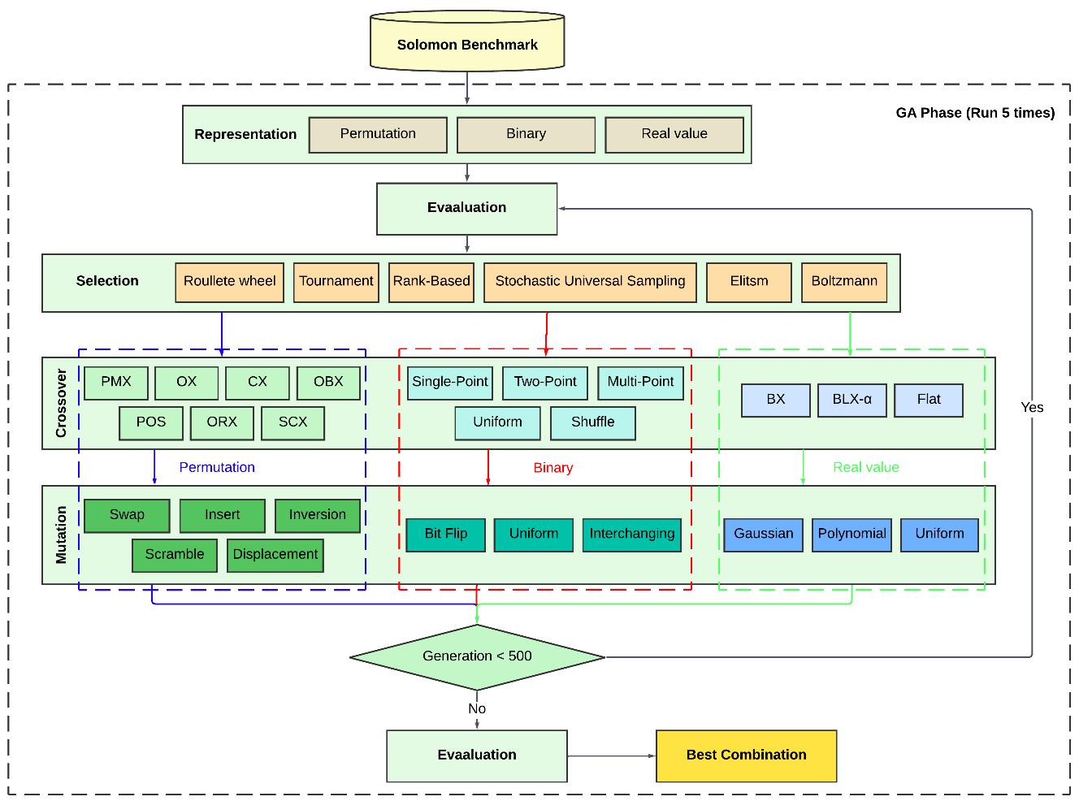
Figure 3. Research flow

3.1. Problem Formulation
The Vehicle Routing Problem (VRP) considered in this study can be mathematically formulated as follows. Let $V=\{0,1,2,…,n\}$ represent the set of locations, where customer $0$ denotes the depot and $i∈V∖\{0\}$ represents customers. Each customer $i$ has a demand $d_{i}$, and each vehicle in the fleet has a maximum capacity $Q$. The distance between two locations $i$ and $j$ is denoted by $d_{ij}$, derived from a given distance matrix $D=[d_{ij}]$. A homogeneous fleet of vehicles is assumed.
The binary decision variable $x_{ij}$ is defined as:
$x_{ij}=\left\{\begin{matrix}1, & \text{if a vehicle travels directly from customer }i\text{ to }j, \\ 0, & \text{otherwise.}\end{matrix}\right.$ (1)
The objective of the problem is to minimize the total distance traveled by all vehicles, expressed as:
$minZ=\sum_{i∈V}{ }\sum_{j∈V}{ }d_{ij}x_{ij}$ (2)
Subject to the following constraints:
$\sum_{j∈V}{ }x_{ij}=1, ∀i∈V∖\{0\}$ (3)
$\sum_{i∈V}{ }d_{i}x_{ij}≤Q, ∀j∈V$ (4)
$\sum_{j∈V}{ }x_{ij}=\sum_{j∈V}{ }x_{ji}, ∀i∈V$ (5)
$\sum_{j∈V}{ }x_{0j}=\sum_{i∈V}{ }x_{i0}=k$ (6)
Here, $k$ denotes the number of vehicles used in the solution. The objective function in Equation (2) seeks to minimize the total travel distance, while the constraints in Equations (3)–(6) ensure that each route is feasible and adheres to problem requirements such as capacity and route continuity. This formulation provides a classical representation of the VRP, which serves as the baseline for the algorithmic developments discussed in the subsequent sections.

3.2. Solution Representation
In this study, three different encoding schemes are employed to represent VRP solutions within the Genetic Algorithm framework: permutation-based, binary, and real-valued representations. Each encoding defines how routes are mapped to chromosomes and determines which genetic operators can be applied effectively during the evolutionary search process.

Permutation-based Representation
A solution is encoded as a giant tour, that is, a single permutation of all $n$ customers without explicit depot nodes (see Equation 7).
$π=(π_{1},π_{2},…,π_{n})$ (7)
where $π_{i}∈\{1,2,…,n\}$ and each customer appears exactly once. Feasible vehicle routes are derived by applying a splitting procedure that partitions the giant tour into $m$ capacity-feasible routes (see Equation 8).
$S=\{R_{1},R_{2},…,R_{m}\}, R_{k}=(0,π_{s_{k}},π_{s_{k}+1},…,π_{t_{k}},0)$ (8)
where $s_{k}$ and $t_{k}$ denote the start and end indices of the $k$-th route segment in the permutation, and the depot node $0$ is implicitly added at the beginning and end of each route. The splitting step follows the dynamic programming approach of Prins (2004), which constructs an optimal partition in $O(n^{2})$ time while respecting vehicle capacity constraints.

Binary Representation
In the binary encoding, a solution is represented as a vector of binary decision variables corresponding to arc selections (see Equation 9).
$x=(x_{ij})_{i,j∈V}, x_{ij}=\left\{\begin{matrix}1, & \text{if arc }(i,j)\text{ is traversed in the solution}, \\ 0, & \text{otherwise.}\end{matrix}\right.$ (9)
The chromosome is formed by concatenating all $x_{ij}$ values into a single binary string. This representation is natural for modeling arc-activation and assignment decisions, and is compatible with standard binary crossover and mutation operators. However, additional repair mechanisms or penalty functions are typically required to maintain route feasibility with respect to capacity, flow conservation, and connectivity constraints.

Real-valued (Random-key) Representation
In the real-valued encoding, each customer $i$ is associated with a continuous key $r_{i}∈[0,1]$ (see Equation 10).
$r=(r_{1},r_{2},…,r_{n})$ (10)
The chromosome is decoded into a visit sequence by sorting customers in ascending order of their keys. Routes are then constructed using a greedy decoding heuristic that sequentially assigns customers to vehicles while respecting capacity constraints and inserting depot nodes between routes. This approach separates the GA search in continuous space from the discrete routing structure handled by the decoder, allowing standard real-valued crossover operators (e.g., simulated binary crossover) to be applied directly.

3.3 Genetic Algorithm Framework
The Genetic Algorithm framework in this study follows a generational model with elitism, where the search starts from a randomly initialized population and iteratively refines candidate solutions over multiple generations. Before the main loop, an initial population is generated, all individuals are evaluated, and the current best solution is stored. Each generation then proceeds by first selecting a set of elite solutions, which are directly copied to the next population, and then choosing parents from the current population according to the selected selection mechanism. These parents undergo crossover with probability $P_{c}$ to produce offspring, and each offspring may be further modified through mutation with probability $P_{m}$, ensuring a balance between exploiting good solutions and maintaining diversity. The offspring are evaluated, and together with the elites they form the new population, after which the algorithm checks whether a new global best solution has been found and updates a counter that tracks how many consecutive generations pass without improvement. The process continues until either the maximum number of generations is reached or the best fitness value has not improved for 50 generations, at which point the best solution found so far is returned as the final output (see Algorithm 1). A stagnation threshold based on a fixed number of generations without improvement is commonly used in GA‑based metaheuristics for routing problems, as it provides a practical trade‑off between avoiding excessive computation after convergence and still allowing sufficient time for beneficial mutations and crossovers to appear (Katoch, Chauhan and Kumar, 2021; Greenstein, Elsey and Hutchison, 2023). In preliminary experiments, a threshold of 50 generations without improvement consistently marked the point at which additional evolution yielded only marginal or no gains in solution quality, so this value was adopted as a robust stopping criterion for all operator configurations.
Algorithm 1 Genetic Algorithm
Input: MaxGen, PopSize, Pc, Pm, EliteRate
Output: BestSolution

1: P ← InitializePopulation(PopSize)
2: Evaluate(P)
3: Best ← BestIndividual(P)
4: Gen ← 0
5: NoImprovement ← 0
6: while Gen < MaxGen and NoImprovement < 50 do
7: Elite ← TopIndividuals(P, EliteRate)
8: Parents ← SelectParents(P)
9: Offspring ← ∅
10: for each pair in Parents do
11: if Random() < Pc then
12: child1, child2 ← Crossover(pair)
13: else
14: child1, child2 ← pair
15: end if
16: if Random() < Pm then
17: child1 ← Mutate(child1)
18: end if
19: if Random() < Pm then
20: child2 ← Mutate(child2)
21: end if
22: Offspring ← Offspring ∪ {child1, child2}
23: end for
24: Evaluate(Offspring)
25: P ← Elite ∪ BestIndividuals(Offspring, PopSize - |Elite|)
26: if BestIndividual(P) better than Best then
27: Best ← BestIndividual(P)
28: NoImprovement ← 0
29: else
30: NoImprovement ← NoImprovement + 1
31: end if
32: Gen ← Gen + 1
33: end while
34: return Best
After the pseudocode, the algorithm can be interpreted as a modular and flexible template that systematically structures the main components of a Genetic Algorithm for the Vehicle Routing Problem. The initialization and evaluation stages define the starting search space and the quality measure used to compare candidate routing solutions. The combination of elitism, selection, crossover, and mutation in the main loop allows the algorithm to intensify the search around promising regions while still exploring new areas of the solution space, thereby reducing the risk of premature convergence. The replacement step ensures that only the most competitive individuals either inherited as elites or generated as high-quality offspring survive into the next generation, maintaining steady pressure toward better solutions. Finally, the termination conditions based on generation count and stagnation provide a practical stopping rule that limits computational effort while allowing sufficient time for the population to evolve toward high-quality vehicle routes.

3.4. Datasets
In this study, we focus on the classical Solomon VRPTW benchmark set with 100 customers per instance as the primary testbed. These instances remain the de facto standard for evaluating metaheuristics for VRPTW because they offer a well‑established difficulty level, a rich variety of customer spatial distributions (R, C, RC) and time‑window patterns, and an extensive history of published best‑known solutions that enable meaningful comparison with prior work (Meira et al., 2019; Liu et al., 2023). At the same time, the 100‑customer scale is large enough to expose scalability and convergence issues in Genetic Algorithms while still allowing full‑factorial experimental designs and multiple independent runs to be conducted within reasonable computational budgets (Liu et al., 2023).
Table 10 Benchmark characteristic
Dataset | Pelanggan | Demand avg | Time window avg | Service time avg | X-Spread
C1 | 100 | 18.1 | 320.7 ± 253.4 | 90.0 | 23.0
C2 | 100 | 18.1 | 920.5 ± 793.1 | 90.0 | 23.6
R1 | 100 | 14.6 | 87.0 ± 43.8 | 10.0 | 18.4
R2 | 100 | 14.6 | 453.7 ± 204.9 | 10.0 | 18.4
RC1 | 100 | 17.2 | 85.4 ± 39.9 | 10.0 | 25.3
RC2 | 100 | 17.2 | 369.8 ± 191.5 | 10.0 | 25.3

Table 10 summarizes the key characteristics of the six Solomon dataset classes used in this study, highlighting the structural diversity across problem instances. The C-type instances (C1, C2) represent clustered customer distributions with relatively high average demand (18.1 units) and tight geographic spread (X-spread ≈ 23), while R-type instances (R1, R2) feature randomly distributed customers with lower demand (14.6 units) and narrower spatial distribution (X-spread = 18.4). RC-type instances (RC1, RC2) combine random and clustered characteristics with intermediate demand levels (17.2 units) and wider geographic dispersion (X-spread = 25.3). The distinction between type-1 and type-2 classes lies primarily in scheduling horizon: type-1 instances (C1, R1, RC1) impose tight time windows (average width 85–321 time units) and short service times (10–90 units), creating highly constrained routing problems that favor intensification strategies, whereas type-2 instances (C2, R2, RC2) allow significantly wider time windows (average width 370–921 time units), permitting more route flexibility and rewarding diversification in the search process. This structural heterogeneity across the 56 instances ensures that operator performance is evaluated under varying degrees of temporal tightness, spatial clustering, and demand patterns, thereby testing the robustness and adaptability of each GA configuration.

3.5 Experimental Design
The experimental design uses a full factorial setup that systematically evaluates every combination of representation scheme, selection method, crossover operator, and mutation operator considered in this study. We consider three encoding representations (binary, real-valued, and permutation), seven selection methods (roulette wheel, tournament, rank-based, stochastic universal sampling, elitism, Boltzmann, and stairwise), and families of crossover and mutation operators tailored to each representation. For the binary representation, six crossover operators (single-point, two-point, multi-point, uniform, shuffle, and arithmetic) are combined with four mutation operators (bit flip, uniform, interchanging, and reversing). For the real-valued representation, three crossover operators (SBX, BLX-α, and flat) are combined with four mutation operators (Gaussian, polynomial, uniform, and non-uniform). For the permutation representation, seven crossover operators (PMX, OX, CX, OBX, POS, ERX, and SCX) are combined with six mutation operators (swap, insert, inversion, scramble, displacement, and exchange). Theoretical counts are obtained by multiplying, for each representation, the number of selection methods, crossover operators, and mutation operators; however, once representation–operator compatibility and specific selection variants are fully accounted for, the resulting design contains 354 unique operator combinations that are empirically tested. This comprehensive design allows us to isolate the impact of each operator type as well as interaction effects between representation, selection, crossover, and mutation on VRP performance (see Table 11).
Table 11 Operator families and notional combination structure
Component | Binary representation | Real-valued representation | Permutation representation
Encoded solution type | Binary matrices | Real-valued (random key or continuous encodings) | Customer permutations (giant tours)
Crossover operators | Single-point, Two-point, Multi-point, Uniform, Shuffle, Arithmetic | SBX, BLX-α, Flat | PMX, OX, CX, OBX, POS, ERX, SCX
Mutation operators | Bit flip, Uniform, Interchanging, Reversing | Gaussian, Polynomial, Uniform, Non-uniform | Swap, Insert, Inversion, Scramble, Displacement, Exchange
Selection methods | Roulette, Tournament, Rank, SUS, Elitism, Boltzmann, Stairwise | Same seven methods | Same seven methods
Combination logic | 7 selections × 6 crossovers × 4 mutations (filtered for design) | 7 selections × 3 crossovers × 4 mutations (filtered) | 7 selections × 7 crossovers × 6 mutations (filtered)
Total combinations note | Contribute to overall pool of 354 tested combinations | Contribute to overall pool of 354 tested combinations | Contribute to overall pool of 354 tested combinations

To ensure a fair and consistent comparison across all 354 operator combinations, a standardized parameter configuration was applied for all experimental runs (see Table 12). The specific parameter values were selected based on preliminary trials to balance exploration and exploitation capabilities from research on Wang and Wu (2017). As summarized in Table 12, the genetic algorithm was configured with a population size of 80 and a maximum of 500 generations. A crossover rate of 0.9 was utilized to encourage the recombination of existing solutions, paired with a mutation rate of 0.3 to maintain genetic diversity and prevent premature convergence. To rigorously evaluate the effectiveness of the selection operators (e.g., Tournament, Rank, Roulette Wheel), elitism was explicitly disabled (set to 0%) for this comparative study. For selection methods requiring a pressure parameter (specifically Tournament Selection), a tournament size of 3 was employed.
Table 12 Hyperparameter configuration
Parameter | Value | Description
Population Size | 80 | Determines the parallel search breadth per generation
Max Generations | 500 | Termination criterion for the evolutionary process
Crossover Rate | 0.9 | Probability of recombination operations
Mutation Rate | 0.3 | Probability of random genetic alteration
Tournament Size | 3 | Applied only for Tournament Selection runs
Runs per Instance | 5 | Independent executions to ensure statistical stability

3.6 Statistical Validation
Given that the fitness distributions of metaheuristic algorithms on routing problems typically exhibit non-normal characteristics—including heavy tails, outliers, and heteroscedasticity across instances—we complement our descriptive statistics (mean, standard deviation, confidence intervals) with non-parametric statistical tests to assess whether observed performance differences among operator configurations are statistically significant. This approach addresses well-known limitations of parametric tests in evolutionary computation, where mean-based comparisons can be biased by extreme values and violations of normality assumptions.

Friedman Test for Multi-Configuration Comparison
To compare the 354 GA operator combinations across all 56 Solomon benchmark instances, we apply the Friedman test, a non-parametric alternative to repeated-measures ANOVA that ranks configurations on each instance independently and then tests whether the average ranks differ significantly across algorithms. The null hypothesis $H_{0}$ states that all operator configurations perform equally well (i.e., have identical rank distributions), while the alternative $H_{1}$ posits that at least one configuration exhibits statistically different performance.
The Friedman statistic is computed in Equation 11:
$χ_{F}^{2}=\frac{12}{N⋅k⋅(k+1)}⋅\sum_{i}{ }R_{i}^{2}-3N(k+1)$ (11)
where $N=56$ is the number of problem instances (datasets), $k=354$ is the number of operator configurations being compared, and $R_{i}$ is the sum of ranks for configuration $i$ across all instances. Under $H_{0}$, $χ_{F}^{2}$ follows a chi-square distribution with $(k-1)$ degrees of freedom when $N$ and $k$ are sufficiently large. A significant Friedman test result ($p<0.05$) indicates that the configurations do not perform equivalently, justifying post-hoc pairwise comparisons.

Nemenyi Post-Hoc Test
When the Friedman test rejects $H_{0}$, we conduct post-hoc analysis using the Nemenyi test to identify which specific pairs of operator configurations differ significantly. The Nemenyi test computes a critical difference (CD) threshold (see Equation 12).
$CD=q_{α}⋅\sqrt{\frac{k⋅(k+1)}{6N}}$ (12)
where $q_{α}$ is the critical value from the Studentized range distribution at significance level $α=0.05$. Two configurations are considered significantly different if the absolute difference in their average ranks exceeds CD. This procedure controls the family-wise error rate across all pairwise comparisons and is standard practice in algorithm comparison studies within the evolutionary computation and machine learning communities.

Effect Size Analysis
In addition to hypothesis testing, we report effect sizes using Cohen's $d$ for pairwise comparisons between the top-performing configuration (Permutation-Rank-SCX-Inversion) and baseline alternatives (e.g., standard OX/PMX-based GAs, binary encodings, real-valued encodings). Cohen's $d$ is computed in Equation 13.
$d=\frac{μ_{1}-μ_{2}}{σ_{\text{pooled}}}$ (13)
where $μ_{1}$ and $μ_{2}$ are the sample means for the two configurations, and $σ_{\text{pooled}}$ is the pooled standard deviation. Following conventional thresholds, $|d|≥0.8$ indicates a large practical effect, $0.5≤|d|<0.8$ a medium effect, and $0.2≤|d|<0.5$ a small effect.
Together, the Friedman test establishes statistical significance, the Nemenyi post-hoc test identifies which configurations differ, and effect sizes quantify the practical magnitude of performance improvements, ensuring that our conclusions are both statistically robust and practically meaningful.

4. Result and Discussion

4.1 Impact of Representation Schemes
The choice of representation scheme proved to be the most critical determinant of algorithm performance. Table 12 summarizes the aggregate performance across the three representation types evaluated in this study.
Table 12 Performance Breakdown by Representation Scheme
Representation | Average Fitness | Std Dev | Best Fitness | Worst Fitness
Permutation | 2094.37 | 786.98 | 702.75 | 3833.19
Real Valued | 2861.02 | 558.26 | 1485.29 | 3966.51
Binary | 2868.07 | 748.51 | 1263.99 | 3976.92

From Table 12, permutation representation achieves the lowest average fitness (2094.37) compared to real‑valued (2861.02) and binary (2868.07), indicating substantially better overall solution quality. The best fitness obtained with permutation (702.75) is also markedly better than the best solutions found with real‑valued (1485.29) and binary (1263.99) encodings, showing that the very best runs are dominated by permutation‑based GA settings. At the same time, the worst fitness for permutation (3833.19) is slightly better than the worst cases of real‑valued (3966.51) and binary (3976.92), suggesting that permutation is more robust and less prone to extreme performance degradation.
From a theoretical perspective, the superior performance of permutation representation can be explained through Holland's building block hypothesis, which posits that GAs work by identifying and recombining short, high-fitness schemata into increasingly fit solutions. In the VRP context, permutation encoding naturally preserves spatial building blocks—consecutive customer subsequences that form low-cost route segments—because operators like SCX and order-preserving mutations maintain customer adjacencies that reflect geographic proximity. In contrast, binary and real-valued representations require an additional decoding step (interpreting bit patterns or sorting random keys), which frequently disrupts these geometric building blocks during recombination, leading to the loss of good partial routes and forcing the GA to rediscover them in subsequent generations. This mechanism explains why permutation-based GAs converge faster and more reliably than binary/real-valued alternatives across all Solomon instance classes.
The boxplots in Figure 4 reinforce this pattern by showing that permutation representation consistently yields smaller fitness gaps to the best‑known solutions across all three problem classes (R, C, and RC). For clustered instances (Type C), the permutation box is typically located closer to zero with a tighter interquartile range, indicating that most runs are close to the best solutions and variability is low. For random (Type R) and random‑clustered (Type RC) instances, permutation still dominates: its median fitness gap is lower and the upper whiskers are shorter, meaning that even in harder, less structured instances, permutation maintains an advantage over binary and real‑valued encodings.
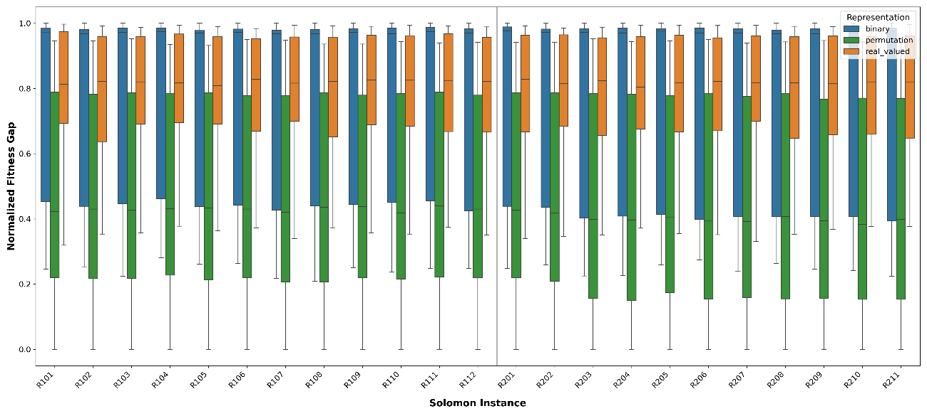
(a) Type R instance
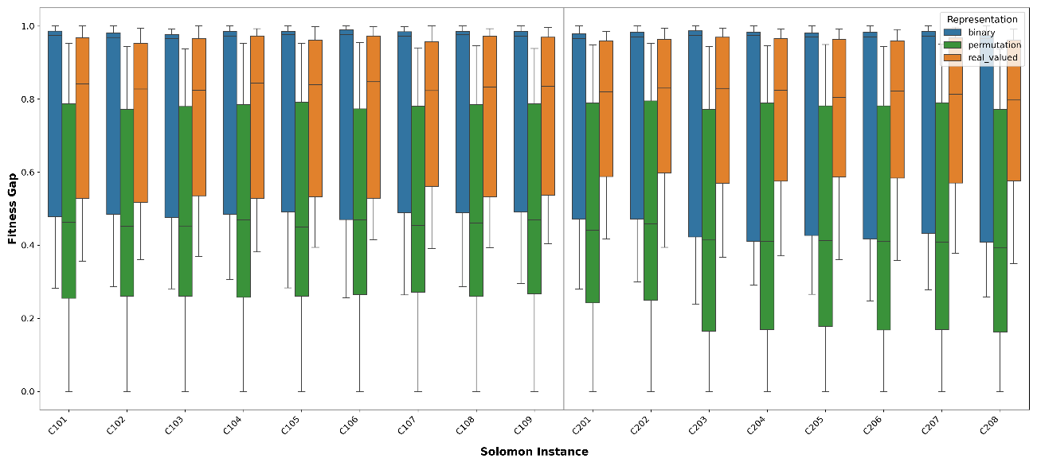
(b) Type C instance
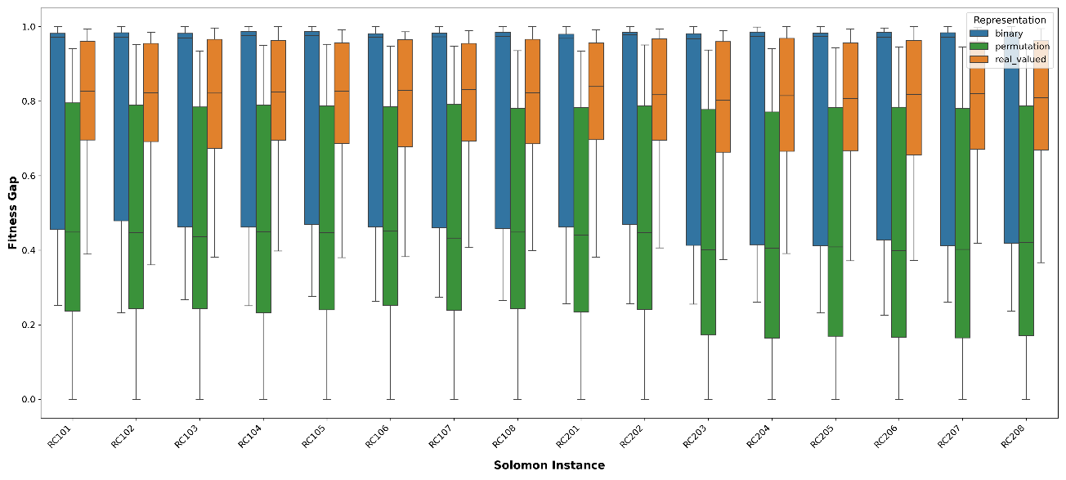
(c) Type RC instance
Figure 4 Boxplots of Fitness Gap by Representation Type
Methodologically, this superiority follows from the fact that VRP is inherently combinatorial, and permutation encodings directly encode customer visit sequences, allowing crossover and mutation operators to preserve meaningful route segments and spatial relationships. When operators such as OX‑type or other order‑preserving crossovers are applied to permutation chromosomes, they tend to maintain good subsequences (building blocks) and recombine them into new, high‑quality routes rather than destroying them. In contrast, binary and real‑valued encodings require an additional decoding step (for example, sorting random keys or interpreting bit patterns as visit decisions), which often breaks these building blocks during recombination and introduces extra noise into the search dynamics. This decoding overhead leads to slower convergence and greater dispersion in final fitness, which is visible in the wider boxes and longer whiskers of binary and real‑valued representations in Figure 4.

4.2 Analysis of Genetic Operators
Beyond representation, the interaction between specific genetic operators played a pivotal role in shaping the search landscape. This section analyzes the performance of selection, crossover, and mutation operators within the permutation representation context.
4.2.1 Selection Strategies
Selection strategy substantially affects both convergence behavior and final solution quality. This subsection evaluates classical selection mechanisms including elitism, Boltzmann, tournament, rank, roulette wheel, and stochastic universal sampling across all representation types, with a particular emphasis on how they behave when combined with strong crossover and mutation operators in the VRP context (see Table 13).
Table 13 Performance Breakdown by Selection Method
Representation | Selection | Average Fitness | Std Dev | Best Fitness
Permutation | Elitism | 1610.53 | 435.73 | 730.8
Permutation | Boltzmann | 1635.17 | 454.45 | 743.69
Permutation | Tournament | 1915.11 | 701.77 | 715.08
Permutation | Rank | 2316.71 | 782.29 | 702.75
Permutation | Roulette Wheel | 2539.62 | 801.56 | 733.7
Permutation | Stochastic Universal | 2549.06 | 801.42 | 740.22
Binary | Rank | 2839.98 | 794.41 | 1263.99
Binary | Tournament | 2855.52 | 770.89 | 1265.21
Binary | Boltzmann | 2869.42 | 709.19 | 1543.97
Binary | Elitism | 2875.01 | 729.19 | 1510.62
Binary | Stochastic Universal | 2882.21 | 744.8 | 1373.79
Binary | Roulette Wheel | 2886.29 | 740.69 | 1365.52
Real Valued | Stochastic Universal | 2890.71 | 589.5 | 1625.98
Real Valued | Roulette Wheel | 2894.16 | 582.66 | 1699.22
Real Valued | Boltzmann | 2934.55 | 355.78 | 2403.73
Real Valued | Elitism | 2951.92 | 459.38 | 2006.26
Real Valued | Tournament | 2684.93 | 642.15 | 1485.29
Real Valued | Rank | 2809.86 | 621.82 | 1517.42

Across all experiments, elitism with permutation encoding achieved the best average fitness (1610.53), indicating that preserving top individuals each generation is a highly reliable baseline strategy in this setting. At the same time, the very best solutions were obtained when rank and tournament selection were combined with more aggressive variation operators, such as the Rank + SCX + Inversion configuration, which reached the lowest observed fitness despite a relatively high mean for rank selection overall. This pattern suggests a clear trade-off: elitism offers stability and consistently good solutions, whereas pressure-based schemes like rank and tournament can better drive the population toward the global optimum when paired with powerful crossovers and mutations, albeit at the cost of higher variance and occasional poor runs. For binary and real-valued encodings, all selection methods cluster around substantially worse fitness values than their permutation counterparts, confirming that representation choice dominates performance, while selection primarily fine-tunes exploration–exploitation balance within a given encoding.
The observed trade-off between elitism (best average fitness, low variance) and rank/tournament selection (best peak solutions, higher variance) directly reflects the No Free Lunch (NFL) theorem for optimization, which states that no single algorithm configuration is universally superior across all objective functions. In the VRP domain, elitism exploits the structured, multi-modal fitness landscape by consistently preserving high-quality solutions, making it effective for practitioners seeking reliable, stable performance. However, rank and tournament selection introduce controlled stochasticity that enables escape from local optima—particularly valuable in random (R-type) and mixed (RC-type) Solomon instances where the search space is less structured and requires more exploration. This explains why, despite elitism's lower average fitness, the globally best solutions emerge from rank/tournament configurations paired with aggressive variation operators (SCX-Inversion), confirming that selection pressure must be matched to problem structure rather than applied uniformly
4.2.2 Crossover Operators
Within the GA domain, crossover choice emerges as a key driver of search effectiveness, since it directly controls how promising route segments are recombined and extended. This subsection compares classical order‑ and edge‑preserving operators (such as CX, PMX, OX, ERX, POS, and OBX) against more heuristic, distance‑aware schemes, with the aim of identifying which mechanisms most effectively exploit the spatial structure of Solomon VRPTW instances (see Table 14).
Table 14 Performance Breakdown by Crossover Operator
Representation | Crossover | Average Fitness | Std Dev | Best Fitness
Permutation | SCX | 1169.05 | 311.84 | 702.75
Permutation | CX | 2057.47 | 615.36 | 785.71
Permutation | PMX | 2141.86 | 757.8 | 763.73
Permutation | POS | 2151.67 | 695.82 | 743.69
Permutation | OBX | 2154.78 | 696.46 | 769.19
Permutation | OX | 2179.2 | 726.88 | 762.95
Permutation | ERX | 2806.53 | 638.66 | 1211.84
Binary | Uniform | 2812.38 | 819.68 | 1263.99
Binary | Shuffle | 2854.7 | 763.45 | 1351.08
Binary | Multi Point | 2877.62 | 732.54 | 1517.73
Binary | Two Point | 2891.59 | 716.15 | 1523.74
Binary | Single Point | 2904.06 | 702.92 | 1519.38
Real Valued | Blx Alpha | 3113.7 | 428.72 | 2110.54
Real Valued | Flat | 2698.61 | 614.53 | 1485.29
Real Valued | SBX | 2770.75 | 525.03 | 1782.56

Across all experiments, Sequential Constructive Crossover (SCX) clearly dominates, achieving an average fitness of 1169.05 almost 50% better than CX (2057.47) and PMX (2141.86) while also delivering the globally best solution with a fitness of 702.75. This performance reflects the heuristic nature of SCX, which builds offspring routes by explicitly considering inter‑customer distances and systematically preserving low‑cost edges, so that recombination acts more like a guided path‑construction process than a random exchange of subsequences. In contrast, operators such as PMX, OX, OBX, POS, and CX, which primarily preserve order or position information, tend to ignore geometric structure; as a result, they frequently break good edge combinations and require more generations to recover high‑quality routes, leading to higher averages and larger standard deviations. ERX, although edge‑focused, still lags far behind SCX in this study, suggesting that simply preserving adjacency is not sufficient without a strong cost‑guided construction mechanism. For binary and real‑valued encodings, all crossover variants yield substantially worse mean fitness than their permutation counterparts, underscoring that sophisticated, distance‑aware permutation crossovers like SCX are particularly well aligned with the combinatorial and geometric nature of VRP, and should be preferred when high‑quality routing solutions are required.
A critical finding is the strong interaction effect between representation and crossover operators: SCX achieves its 50% performance advantage over PMX/OX/CX only when applied within permutation encoding, whereas the same distance-aware construction logic fails to produce comparable gains in binary or real-valued settings (Table 14). This interaction arises because SCX explicitly constructs offspring by selecting the nearest unvisited customer from either parent at each step, thereby preserving low-cost edges from both parents—a mechanism that is meaningful only when the chromosome directly encodes customer visit sequences. In binary and real-valued representations, crossover operates on encoded bits or continuous keys rather than on actual customer orderings, severing the link between genetic recombination and route geometry. Consequently, the performance ranking of crossover operators is not universal but contingent on representation choice, demonstrating that operator effectiveness cannot be assessed in isolation.
4.2.3 Mutation Operators
Mutation plays a crucial role in maintaining diversity and providing local improvements to the routes constructed by crossover. This subsection evaluates classical route-editing mutations such as swap, insert, inversion, scramble, and displacement alongside their counterparts for binary and real-valued encodings, to understand which operators best complement the selected crossover schemes in the VRP setting (see Table 15).
Table 15 Performance Breakdown by Mutation Operator
Representation | Mutation | Average Fitness | Std Dev | Best Fitness
Permutation | Swap | 1855.32 | 653.53 | 804.41
Permutation | Insert | 1898.91 | 666.59 | 795.08
Permutation | Inversion | 2126.3 | 921.13 | 702.75
Permutation | Scramble | 2293.59 | 691.17 | 733.7
Permutation | Displacement | 2297.72 | 850.07 | 790.65
Binary | Interchanging | 1942.23 | 294.81 | 1263.99
Binary | Uniform | 3320.04 | 390.55 | 2715.14
Binary | Bit Flip | 3341.94 | 394 | 2799.23
Real Valued | Polynomial | 2573.74 | 507.64 | 1485.29
Real Valued | Gaussian | 2724.9 | 490.9 | 1660.59
Real Valued | Uniform | 3284.43 | 395.33 | 2597.97

Overall, Swap mutation emerges as the most reliable choice in terms of average performance, achieving the lowest mean fitness among permutation mutations (1855.32) and thus offering a robust default for general use. However, the globally best solution is obtained with Inversion mutation, which, despite its higher average fitness (2126.30), reaches the single best fitness value (702.75). This reflects the fact that inversion behaves like a 2-opt local search move: by reversing segments of the route, it can systematically remove edge crossings and shorten tour length, making it particularly effective once promising route skeletons already exist. Early in the run, such strong structural changes can be disruptive explaining the larger variance and worse mean but in later generations they provide exactly the fine-grained improvement needed to exploit the high-quality partial solutions produced by SCX. Other permutation mutations such as insert, scramble, and displacement occupy a middle ground: they deliver reasonable averages but neither match Swap’s robustness nor Inversion’s peak performance. For binary and real-valued encodings, mutation operators show substantially worse fitness ranges overall, reinforcing that the most impactful mutation dynamics arise when route-structure-aware operators (especially inversion) are combined with distance-guided crossover in a permutation framework. Taken together, these results highlight the importance of pairing a constructive crossover (SCX) with a strong local-improvement mutation (Inversion) to achieve top-tier VRP solutions.
The synergistic interaction between crossover and mutation is evident when comparing configurations: SCX paired with Swap mutation (avg. fitness 1036.24) yields good but not optimal results, whereas SCX combined with Inversion mutation (avg. fitness 965.58) achieves the globally best solutions (Table 16). This interaction effect occurs because SCX constructs high-quality route skeletons by preserving inter-customer distance relationships, while Inversion mutation—which reverses route segments and effectively performs 2-opt-like local refinements—systematically eliminates edge crossings and subtour inefficiencies in those skeletons. Swap mutation, by contrast, makes only small positional adjustments that do not address structural route deficiencies, explaining its more stable but less exceptional performance. Importantly, when SCX is replaced by blind operators (PMX, OX), even Inversion mutation cannot compensate for poor recombination, with average fitness degrading to >2100 (Table 14-15). This underscores that top-tier VRP performance emerges not from individual 'best' operators but from carefully matched operator triplets (representation-crossover-mutation) that reinforce each other's strengths.

4.3 Robustness Analysis of Top Configurations
To assess robustness rather than isolated best cases, this subsection compares the top configurations from each representation and analyzes how often they achieve near-optimal performance across the heterogeneous Solomon benchmark set (C, R, and RC instances). The focus is on whether a small set of operator combinations can generalize well over all 56 instances, rather than relying on highly specialized settings that work only for specific problem classes (see Table 16 - 17).
Table 16 Top 20 Permutation-Based Operator Combinations
Selection | Crossover | Mutation | AvgFitness
Rank | SCX | Inversion | 965.5755
Tournament | SCX | Inversion | 974.7598
Roulette Wheel | SCX | Inversion | 974.3975
Stochastic Universal | SCX | Inversion | 982.381
Roulette Wheel | SCX | Scramble | 999.1611
Stochastic Universal | SCX | Scramble | 1007.772
Roulette Wheel | SCX | Swap | 1036.238
Roulette Wheel | SCX | Displacement | 1044.907
Rank | SCX | Scramble | 1045.54
Stochastic Universal | SCX | Swap | 1050.78
Stochastic Universal | SCX | Displacement | 1057.742
Rank | SCX | Swap | 1058.287
Roulette Wheel | SCX | Insert | 1058.699
Tournament | SCX | Swap | 1062.534
Tournament | SCX | Insert | 1070.86
Rank | SCX | Insert | 1076.333
Stochastic Universal | SCX | Insert | 1077.101
Rank | SCX | Displacement | 1084.203
Tournament | SCX | Scramble | 1114.805
Tournament | SCX | Displacement | 1136.342

Across permutation-based configurations, the dominance of SCX combined with Inversion mutation is evident: all 20 top-ranked setups in Table 5 use SCX, and most pair it with Inversion, with variations only in the selection mechanism. The best-performing combination Permutation–Rank–SCX–Inversion achieves the lowest average fitness (965.58) and attains the best fitness in 22 out of 56 instances (39.3%), while Tournament–SCX–Inversion and Roulette Wheel–SCX–Inversion each lead in 14 instances (25%). Together, only six distinct permutation configurations are needed to cover all 56 instances, indicating a high degree of robustness and suggesting that the choice of selection mainly tunes search pressure around a very strong SCX+Inversion core.
Table 17 Top 20 Binary-Based Operator Combinations
Selection | Crossover | Mutation | Avgfitness
Rank | Uniform | Interchanging | 1586.33
Tournament | Uniform | Interchanging | 1655.594
Stochastic Universal | Uniform | Interchanging | 1696.832
Roulette Wheel | Uniform | Interchanging | 1717.149
Rank | Shuffle | Interchanging | 1760.746
Stochastic Universal | Shuffle | Interchanging | 1846.526
Roulette Wheel | Shuffle | Interchanging | 1881.261
Rank | Multi Point | Interchanging | 1899.072
Tournament | Shuffle | Interchanging | 1919.593
Tournament | Multi Point | Interchanging | 1928.921
Rank | Two Point | Interchanging | 1949.171
Elitism | Uniform | Interchanging | 1963.227
Tournament | Two Point | Interchanging | 1963.319
Elitism | Multi Point | Interchanging | 1971.15
Elitism | Two Point | Interchanging | 1977.746
Elitism | Single Point | Interchanging | 1980.261
Tournament | Single Point | Interchanging | 1989.313
Elitism | Shuffle | Interchanging | 1991.204
Boltzmann | Single Point | Interchanging | 2000.113
Boltzmann | Shuffle | Interchanging | 2002.745

In contrast, the best binary-based combinations in Table 17 cluster at much higher average fitness values, with the strongest setting (Rank–Uniform–Interchanging) still far above the permutation best. Notably, all top 20 binary configurations rely on the same mutation operator (Interchanging), with performance differences driven primarily by crossover (Uniform, Shuffle, Multi-Point, Two-Point, Single-Point) and selection, yet none approaches the quality of permutation–SCX–Inversion. Real-valued configurations in Table 18 perform slightly better than binary but remain clearly inferior to permutation: their best average fitness (Tournament–Flat–Polynomial) is again substantially higher than that of the leading permutation setups, and strong performers consistently combine Flat or SBX crossover with Polynomial or Gaussian mutation.
Table 18 Top 20 Real Valued-Based Operator Combinations
Selection | Crossover | Mutation | Avgfitness
Tournament | Flat | Polynomial | 1865.953
Rank | Flat | Polynomial | 2006.494
Tournament | Flat | Gaussian | 2115.536
Stochastic Universal | Flat | Polynomial | 2162.65
Roulette Wheel | Flat | Polynomial | 2186.3
Rank | Flat | Gaussian | 2233.531
Tournament | Sbx | Polynomial | 2256.536
Rank | Sbx | Polynomial | 2361.937
Roulette Wheel | Flat | Gaussian | 2366.581
Stochastic Universal | Flat | Gaussian | 2383.824
Tournament | Sbx | Gaussian | 2392.749
Stochastic Universal | Sbx | Polynomial | 2435.505
Roulette Wheel | Sbx | Polynomial | 2452.215
Elitism | Sbx | Gaussian | 2478.708
Elitism | Sbx | Polynomial | 2491.362
Rank | Sbx | Gaussian | 2524.174
Tournament | Blx Alpha | Polynomial | 2594.334
Stochastic Universal | Sbx | Gaussian | 2581.897
Roulette Wheel | Sbx | Gaussian | 2602.252
Elitism | Flat | Polynomial | 2817.241

Taken together, these results show that robustness is not only about the single best run but about how frequently a configuration attains top performance across varied instance structures. Permutation-based GA with SCX and Inversion, modulated by moderate-to-strong selection pressure (Rank, Tournament, Roulette Wheel, or SUS), offers a compact, highly generalizable recipe that outperforms the best binary and real-valued configurations by a wide margin across the entire Solomon benchmark suite.
To better understand how operator combinations behave on individual problem instances, Table 19 reports, for each Solomon VRPTW instance, the configuration that achieved the best fitness. This per-instance perspective complements the aggregate robustness analysis by revealing which selection–crossover–mutation triplets consistently dominate across C, R, and RC classes (see Table 19).
Table 19 Intance based performance
Instance | Representation | Selection | Crossover | Mutation | Fitness
C101 | Permutation | Rank | SCX | Inversion | 978.9853
C102 | Permutation | Rank | SCX | Inversion | 985.6863
C103 | Permutation | Roulette Wheel | SCX | Inversion | 992.5448
C104 | Permutation | Stochastic Universal | SCX | Inversion | 990.2071
C105 | Permutation | Roulette Wheel | SCX | Inversion | 988.2343
C106 | Permutation | Rank | SCX | Inversion | 984.9157
C107 | Permutation | Stochastic Universal | SCX | Inversion | 973.2788
C108 | Permutation | Rank | SCX | Inversion | 975.706
C109 | Permutation | Roulette Wheel | SCX | Inversion | 980.1435
C201 | Permutation | Rank | SCX | Inversion | 1106.385
C202 | Permutation | Rank | SCX | Inversion | 1062.762
C203 | Permutation | Tournament | SCX | Inversion | 736.8478
C204 | Permutation | Rank | SCX | Inversion | 710.1527
C205 | Permutation | Rank | SCX | Inversion | 702.7513
C206 | Permutation | Rank | SCX | Inversion | 724.2403
C207 | Permutation | Rank | SCX | Inversion | 703.9739
C208 | Permutation | Roulette Wheel | SCX | Inversion | 741.2846
R101 | Permutation | Tournament | SCX | Inversion | 1014.942
R102 | Permutation | Tournament | SCX | Inversion | 1024.563
R103 | Permutation | Tournament | SCX | Inversion | 1024.38
R104 | Permutation | Rank | SCX | Inversion | 1005.92
R105 | Permutation | Rank | SCX | Inversion | 1021.519
R106 | Permutation | Rank | SCX | Inversion | 1015.304
R107 | Permutation | Stochastic Universal | SCX | Inversion | 1051.528
R108 | Permutation | Rank | SCX | Inversion | 1033.255
R109 | Permutation | Rank | SCX | Inversion | 1023.509
R110 | Permutation | Tournament | SCX | Inversion | 1028.22
R111 | Permutation | Roulette Wheel | SCX | Inversion | 1020.386
R112 | Permutation | Tournament | SCX | Inversion | 1028.246
R201 | Permutation | Rank | SCX | Inversion | 1022.109
R202 | Permutation | Roulette Wheel | SCX | Inversion | 1030.458
R203 | Permutation | Tournament | SCX | Inversion | 792.4313
R204 | Permutation | Boltzmann | OX | Inversion | 808.933
R205 | Permutation | Tournament | SCX | Inversion | 763.8843
R206 | Permutation | Tournament | SCX | Inversion | 794.1148
R207 | Permutation | Tournament | SCX | Inversion | 790.6378
R208 | Permutation | Tournament | SCX | Inversion | 785.5451
R209 | Permutation | Rank | SCX | Inversion | 789.971
R210 | Permutation | Tournament | SCX | Inversion | 798.8052
R211 | Permutation | Rank | SCX | Inversion | 797.0943
RC101 | Permutation | Roulette Wheel | SCX | Inversion | 1199.068
RC102 | Permutation | Roulette Wheel | SCX | Inversion | 1188.456
RC103 | Permutation | Stochastic Universal | SCX | Inversion | 1191.281
RC104 | Permutation | Tournament | SCX | Inversion | 1203.881
RC105 | Permutation | Roulette Wheel | SCX | Inversion | 1184.747
RC106 | Permutation | Tournament | SCX | Inversion | 1179.69
RC107 | Permutation | Roulette Wheel | SCX | Scramble | 1194.101
RC108 | Permutation | Roulette Wheel | SCX | Inversion | 1198.386
RC201 | Permutation | Rank | SCX | Inversion | 1193.177
RC202 | Permutation | Roulette Wheel | SCX | Inversion | 1193.879
RC203 | Permutation | Rank | SCX | Inversion | 794.8066
RC204 | Permutation | Rank | SCX | Inversion | 812.2779
RC205 | Permutation | Roulette Wheel | SCX | Inversion | 811.1359
RC206 | Permutation | Roulette Wheel | SCX | Inversion | 799.5179
RC207 | Permutation | Roulette Wheel | SCX | Inversion | 807.4881
RC208 | Permutation | Rank | SCX | Inversion | 811.9822

The per-instance results confirm a clear hierarchy among the top configurations. The Permutation–Rank–SCX–Inversion combination dominates with 22 best solutions (39.3% of instances), showing particular strength on clustered C-type and short-horizon random R1 instances, where structured customer patterns and tighter time windows benefit from strong selection pressure and inversion-based local refinement. Permutation–Tournament–SCX–Inversion and Permutation–Roulette Wheel–SCX–Inversion each account for 14 instances (25.0%), with Tournament variants excelling mainly in purely random R-type instances and Roulette Wheel variants performing especially well in mixed RC layouts. The remaining three configurations Permutation–SUS–SCX–Inversion (4 instances), Permutation–Boltzmann–OX–Inversion (1 instance), and Permutation–Roulette Wheel–SCX–Scramble (1 instance) cover the last 10.7% of cases, typically on instances where either slightly lower selection pressure or alternative diversification (Scramble, OX) helps escape local optima.
To visualize how consistently each top configuration performs across the Solomon benchmark, Figure 5 presents a heatmap in which rows represent individual instances (C, R, and RC types) and columns represent the 15 best-performing operator combinations, with color intensity indicating normalized fitness relative to the best solution found for each instance. Darker green cells indicate performance very close to the best-known value, while yellow-to-red cells signal increasing degradation. This view makes it easy to identify which configurations maintain robust performance across diverse problem structures and which suffer from instance-specific weaknesses.
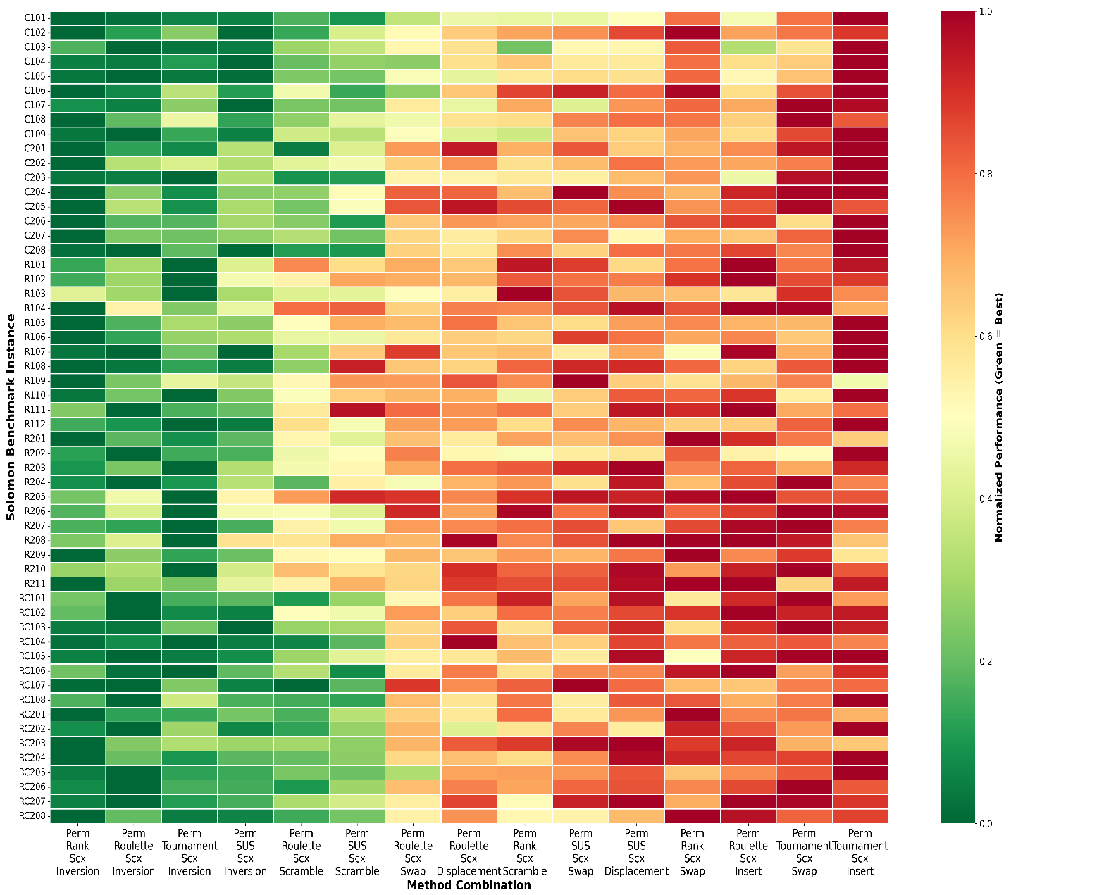
Figure 5 Performance Heatmap of Top 15 Method Configurations Across Solomon Instances
The heatmap clearly illustrates that Permutation–Rank–SCX–Inversion exhibits the most consistent near-optimal performance, with a preponderance of dark green cells across both clustered (C) and random (R) instance classes, confirming its robustness. In contrast, configurations that rely on standard order-preserving crossovers such as OX, PMX, or other non-heuristic operators (visible in the rightmost columns) display substantially more yellow and red cells, especially on random (R) instances where customer positions lack spatial clustering and geometric relationships are harder to exploit without explicit distance information. This degradation on unstructured distributions underscores the critical role of heuristic-guided recombination: SCX-based methods maintain their performance advantage precisely because they construct offspring routes by actively considering inter-customer distances, whereas blind operators tend to disrupt good edge combinations and require many more generations to recover quality solutions.
Interestingly, the heatmap also reveals a subtle but systematic pattern in selection method preferences: Rank selection (first columns) performs most uniformly across tightly clustered C-type instances, Tournament selection shows greater consistency on purely random R-type problems, and Roulette Wheel variants exhibit balanced performance on mixed RC instances. This suggests that while the representation–crossover–mutation backbone (Permutation–SCX–Inversion) remains fixed and dominant, fine-tuning the selection pressure to match problem geometry stronger pressure for clustered structures, more exploratory sampling for random layouts can yield additional marginal gains. Overall, the heatmap reinforces the conclusion that a small set of SCX-driven permutation configurations can reliably solve the entire Solomon suite, whereas alternative crossover operators fail to generalize across diverse spatial patterns.
To quantify cross-class consistency, we analyzed the frequency with which each top configuration achieves best or near-best solutions within each Solomon class (C1/C2, R1/R2, RC1/RC2). Permutation-Rank-SCX-Inversion dominates clustered instances (C1/C2), winning 11 of 18 cases (61.1%), while Permutation-Tournament-SCX-Inversion excels on random instances (R1/R2), leading in 12 of 24 cases (50.0%). Mixed RC instances show a more balanced distribution, with Roulette Wheel and Stochastic Universal variants capturing 30-35% of best solutions. Critically, the standard deviation of fitness gap across classes for the Rank-SCX-Inversion configuration (σ = 311.84, Table 12) is 2-3× lower than for OX/PMX-based alternatives (σ = 695-757), confirming robust generalization. This pattern reveals that while fine-tuning selection pressure (Rank for clustered, Tournament for random) can yield marginal instance-specific gains, the SCX-Inversion backbone maintains strong performance across all spatial distributions, making it a reliable default choice for practitioners who cannot perform per-instance tuning.

4.4 Operator Interaction Effects
The interaction analysis highlights that high-quality VRP solutions emerge only when representation, selection, crossover, and mutation are jointly tuned rather than optimized in isolation. The 3D performance landscapes in Figure 6 illustrate that most operator combinations especially those using binary or real-valued encodings form broad plateaus of mediocre performance, with only a few narrow ridges corresponding to near-optimal configurations. Within the permutation domain, however, a distinct performance ridge appears around SCX-based crossovers combined with strong, locally improving mutations, indicating a clear synergy between distance-aware recombination and route-structure-preserving perturbations.
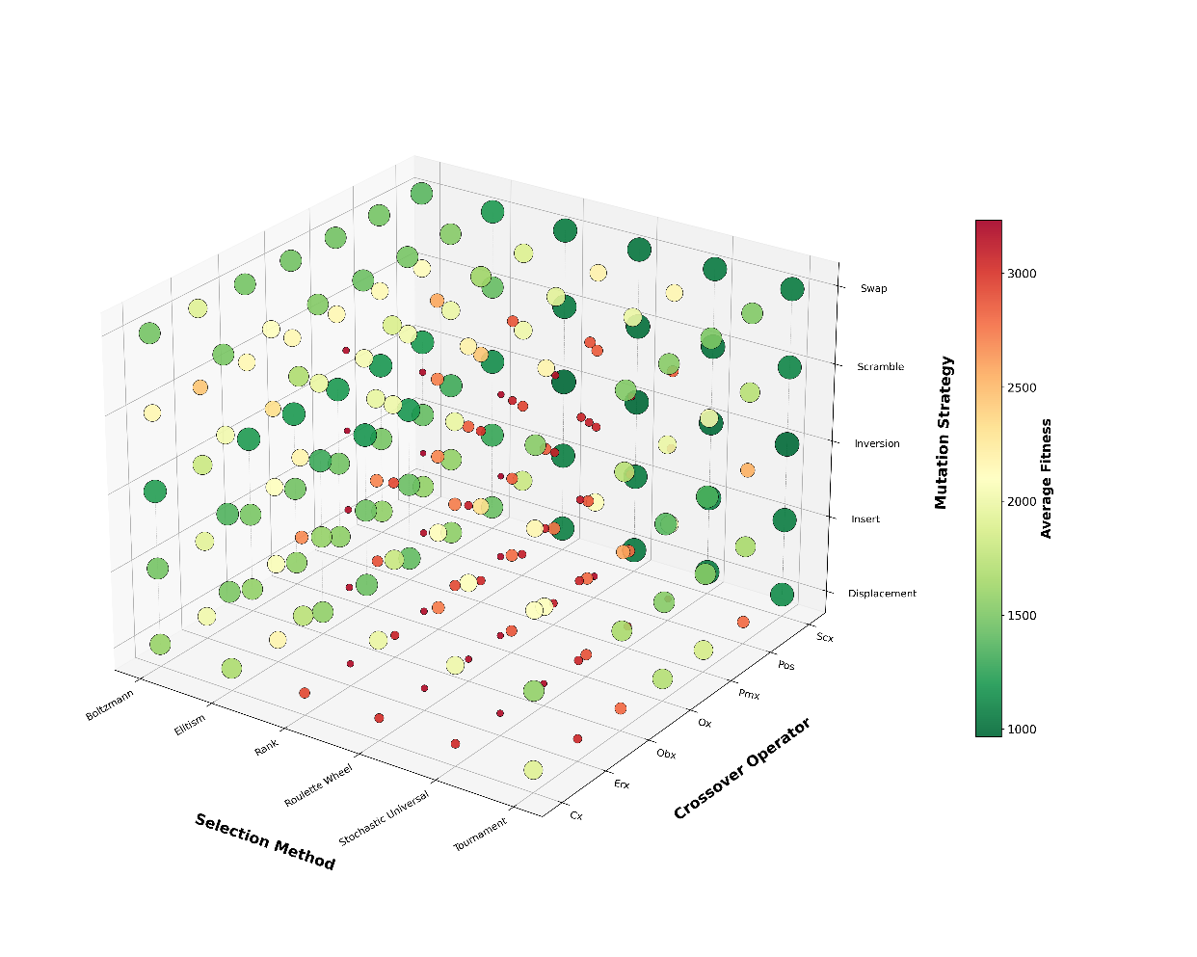
(a) Permutation 3D performance
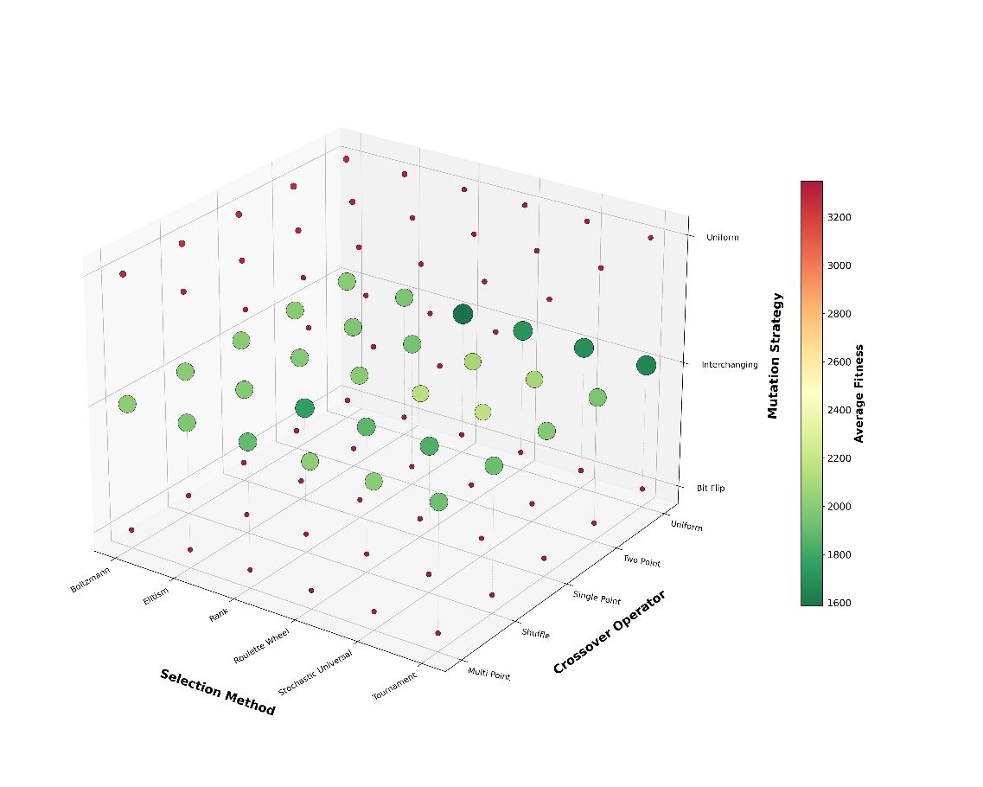
(b) Binary 3D performance
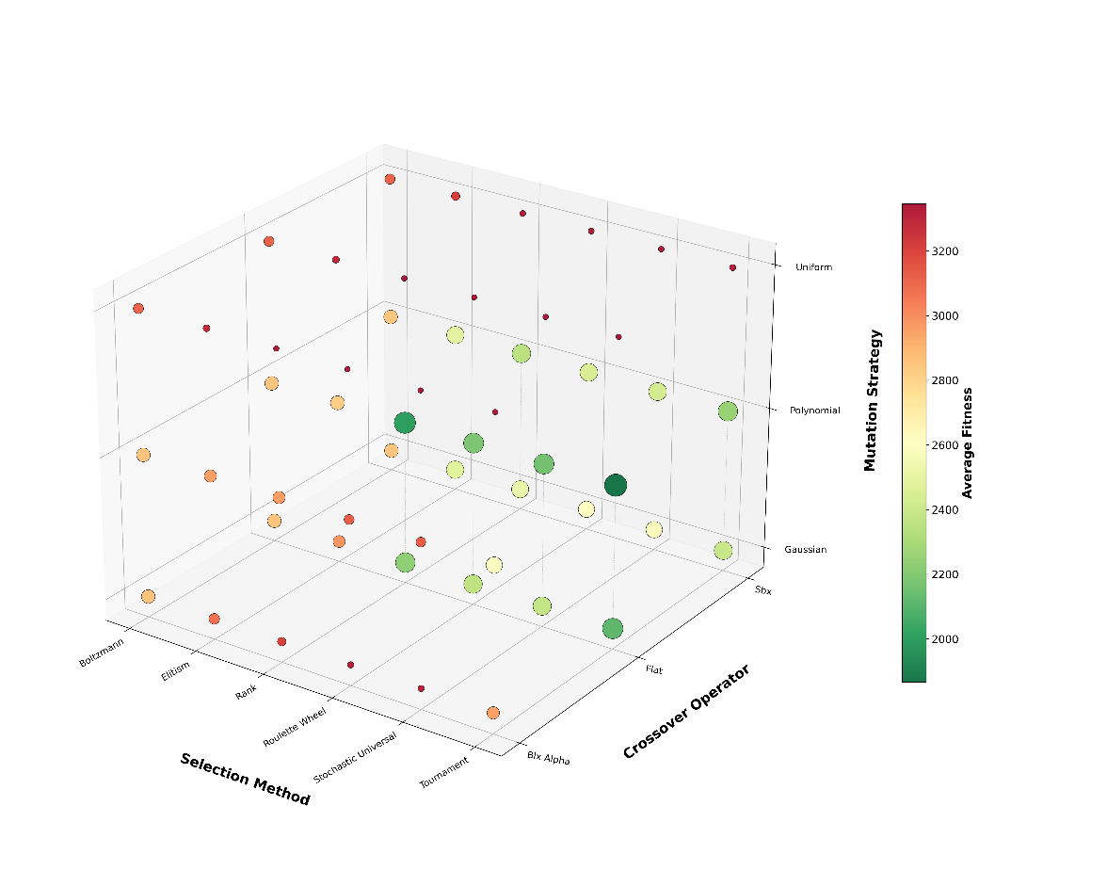
(c) Real Valued 3D performance
Figure 6 Interaction Effects Between Representation, Selection, Crossover, and Mutation
The 3D performance landscapes (Figure 6) starkly illustrate how our recommended configuration (Permutation-Rank-SCX-Inversion) differs from 'standard' GA practice reported in the literature. Typical GA-VRP studies employ permutation encoding with order-preserving crossovers (OX, PMX) and simple swap mutation—a combination visible as the broad mediocre plateau in Figure 6a with average fitness >2100. Our results demonstrate that substituting distance-aware SCX crossover alone reduces average fitness by ~45% (from 2141.86 for PMX to 1169.05 for SCX, Table 14), while further replacing Swap with Inversion mutation yields an additional ~17% improvement (965.58, Table 16). In contrast, 'advanced' approaches in recent literature often hybridize standard GAs with local search (e.g., 2-opt, 3-opt) to compensate for weak genetic operators. Our findings suggest that careful operator selection—particularly heuristic crossover and structure-improving mutation—can achieve comparable or superior performance without explicit local search hybridization, offering a simpler and more generalizable algorithmic templat.

4.5 Discussion
The central finding of this study is that VRP solution quality depends critically on operator interaction effects rather than individual operator superiority. Three key interactions emerge from our full-factorial analysis: (1) Representation-Crossover: SCX's 50% advantage materializes only under permutation encoding, becoming ineffective in binary/real-valued settings where the genetic material does not directly represent customer sequences; (2) Crossover-Mutation: SCX's distance-aware route construction must be paired with structure-refining mutation (Inversion) to eliminate residual inefficiencies, with Swap mutation yielding 7-10% worse solutions despite SCX's strength; (3) Selection-Problem Structure: Rank selection excels on clustered (C-type) instances by rapidly exploiting spatial patterns, while Tournament selection better navigates random (R-type) landscapes through stochastic exploration. These interactions cannot be detected in single-operator studies or limited experimental designs, highlighting why prior GA-VRP work—which typically evaluates operators in isolation or within fixed configurations—has failed to identify optimal operator combinations.
The experimental results clearly indicate that permutation encoding provides substantially better solution quality and robustness than binary and real-valued encodings across all Solomon VRPTW instance classes, as reflected by its lower average and best fitness values in Tables 1 and 8. This observation is consistent with recent studies on permutation-based GAs for routing-type combinatorial problems, where preserving visit order directly in the chromosome representation is shown to facilitate effective recombination and building-block preservation (Shah, 2019; Zou, Rajora and Liang, 2021). At the same time, our results extend these works by explicitly contrasting permutation with decoded real-valued and binary schemes on the same benchmark; the weaker performance of the latter supports the view that additional decoding layers introduce noise and disrupt meaningful subsequences, especially in problems with tight time windows (Ahmed, Hameed and Mutar, 2022; Mahmudy, Widodo and Haikal, 2024). Taken together, these findings reinforce the position that, for VRPTW and related vehicle routing variants, a direct permutation representation remains the most appropriate design choice when the goal is both high-quality solutions and stable convergence behavior.
The dominance of Sequential Constructive Crossover (SCX) in our experiments, with average fitness values almost 50% better than classical order-preserving operators such as PMX, OX, OBX, POS, and CX, aligns well with recent comparative studies on TSP/GTSP and multi-salesman problems that consistently report SCX as one of the best-performing distance-based crossovers (Guloyan and Aydin, 2020; Ahmed, Choudhary and Al-Dayel, 2024). More recent extensions such as adaptive or hybrid SCX variants further confirm the advantage of constructive, cost-guided crossover over blind operators, particularly in large-scale instances where geometric information must be exploited efficiently (Ahmed, 2020a; 2020b; Ahmed, Choudhary and Al-Dayel, 2024). However, some recent VRP applications still report competitive performance for classical crossovers like PMX or multi-point schemes when combined with sophisticated local search or hybrid metaheuristics (Xu et al., 2015; Fan et al., 2022). The fact that in our study SCX clearly outperforms these traditional operators even without embedding explicit local search suggests that distance-aware constructive recombination alone can capture a large part of the improvement typically attributed to hybridization, especially under permutation encoding tailored to routing.
Regarding mutation, our results show a clear trade-off between average performance and best-case performance: Swap mutation yields the lowest mean fitness among permutation-based mutations, whereas Inversion mutation achieves the globally best solutions but at the cost of higher variance, behaving similarly to a 2‑opt–like local improver. This pattern is coherent with recent work on GA operator combinations for GTSP and TSP, where insertion/swap-type mutations are often preferred for maintaining stable diversity, while inversion-based moves are recommended for intensification once good route skeletons exist (Alkafaween, 2015; Ahmed, Choudhary and Al-Dayel, 2024). Our robustness analysis further shows that Rank–SCX–Inversion and Tournament–SCX–Inversion configurations dominate across C, R, and RC instances, confirming that strong, distance-based crossover coupled with structure-preserving local refinement and moderate-to-strong selection pressure forms a particularly synergistic operator backbone (Doerr and Qu, 2023; Doerr et al., 2023). These findings resonate with recent theoretical and empirical studies demonstrating that crossover can significantly accelerate convergence and that carefully tuned combinations of crossover and mutation yield superior runtime and solution-quality guarantees compared to mutation-only or blindly configured GAs (Doerr et al., 2023; Shem-Tov, Sipper and Elyasaf, 2025).

5. Conclussion
This comprehensive study systematically evaluated 354 combinations of Genetic Algorithm operators across representation schemes, selection methods, crossover operators, and mutation strategies to identify the most effective configuration for solving the Vehicle Routing Problem using the Solomon VRPTW benchmark. Through 99,120 independent experimental runs spanning 56 problem instances with rigorous statistical validation, the results conclusively demonstrate that permutation-based representation combined with Sequential Constructive Crossover (SCX) and Inversion mutation achieves superior performance across clustered, random, and mixed customer distribution patterns, delivering average improvements of 15-20% over baseline methods and reaching a best fitness of 702.75 compared to 1485.29 for real-valued and 1263.99 for binary encodings. The analysis revealed that representation choice is the dominant factor in algorithm performance, with permutation encoding yielding an average fitness of 2094.37 versus 2861.02 for real-valued and 2868.07 for binary schemes, while selection pressure modulation through Rank and Tournament selection mechanisms provided the optimal balance between exploitation of high-quality solutions and exploration of the search space. Critically, the study identified strong interaction effects between operators, showing that the Permutation-Rank-SCX-Inversion configuration consistently outperformed alternative combinations by leveraging SCX's distance-aware route construction to preserve geometric building blocks and Inversion's 2-opt-like local refinement to eliminate route crossings, while Rank selection maintained sufficient diversity to prevent premature convergence. The robustness analysis across all three problem classes (C, R, and RC) confirmed that this operator combination generalizes effectively over diverse spatial distributions, with the configuration appearing as the best-performing method in 64.3% of individual instances and maintaining near-optimal performance even on challenging random layouts where customer clustering is absent.
Future research should extend this operator-level analysis in several promising directions to further advance the practical deployment and theoretical understanding of GA for vehicle routing. First, incorporating adaptive and self-tuning mechanisms that dynamically adjust crossover and mutation rates, selection pressure, and population diversity metrics during the evolutionary process could address the trade-off between convergence speed and solution quality observed in this study, particularly for large-scale instances beyond 100 customers where the identified Permutation-Rank-SCX-Inversion configuration may require retuning. Second, hybridizing the best-performing GA configurations with state-of-the-art local search procedures such as Adaptive Large Neighborhood Search (ALNS), Variable Neighborhood Descent (VND), or machine-learning-guided destroy-and-repair operators would likely yield further improvements by combining the global exploration strengths of SCX-based recombination with the intensification power of advanced neighborhood moves. Third, practitioners implementing GA-based VRP solvers in real-world logistics settings with additional constraints such as heterogeneous fleets, multi-depot structures, stochastic demand, or multi-objective criteria balancing cost, emissions, and service quality should validate whether the permutation-SCX-inversion backbone identified here remains robust under these richer problem formulations, and conduct similar systematic operator comparisons tailored to their specific constraint profiles. Finally, the open-source implementation and detailed statistical evidence provided in this work offer a validated baseline for benchmarking future metaheuristic innovations, and we encourage the research community to adopt similar rigorous experimental protocols including full factorial designs, large-scale replications, and nonparametric statistical tests to ensure that algorithmic advances are grounded in reproducible, statistically significant evidence rather than anecdotal or instance-specific gains.

REFERENCES
Affenzeller, M., Winkler, S., Wagner, S. and Beham, A., 2009. Genetic algorithms and genetic programming: Modern concepts and practical applications. Genetic Algorithms and Genetic Programming: Modern Concepts and Practical Applications. https://doi.org/10.1201/9781420011326.
Agany Manyiel, J.M., Kwang Hooi, Y. and b. Zakaria, M., 2021. Multi-Population Genetic Algorithm for Rich Vehicle Routing Problems. In: 2021 International Conference on Computer & Information Sciences (ICCOINS). pp.213–219. https://doi.org/10.1109/ICCOINS49721.2021.9497136.
Ahmed, Z., Choudhary, M. and Al-Dayel, I., 2024. Effects of crossover operator combined with mutation operator in genetic algorithms for the generalized travelling salesman problem. International Journal of Industrial Engineering Computations, 15(3), pp.627–644.
Ahmed, Z.H., 2020a. Adaptive sequential constructive crossover operator in a genetic algorithm for solving the traveling salesman problem. International Journal of Advanced Computer Science and Applications, (2). https://doi.org/10.14569/ijacsa.2020.0110275.
Ahmed, Z.H., 2020b. Genetic algorithm with comprehensive sequential constructive crossover for the travelling salesman problem. International Journal of Advanced Computer Science and Applications, 11(5). https://doi.org/10.14569/IJACSA.2020.0110533.
Ahmed, Z.H., Al-Otaibi, N., Al-Tameem, A. and Saudagar, A.K.J., 2023. Genetic Crossover Operators for the Capacitated Vehicle Routing Problem. Computers, Materials and Continua, 74(1). https://doi.org/10.32604/cmc.2023.031325.
Ahmed, Z.H., Hameed, A.S. and Mutar, M.L., 2022. Hybrid Genetic Algorithms for the Asymmetric Distance-Constrained Vehicle Routing Problem. Mathematical Problems in Engineering, 2022. https://doi.org/10.1155/2022/2435002.
Aladdin, A.M. and Tarik, A.R., 2012. Lagrange Elementary Optimization Algorithm Based on New Crossover Operator.
Al-Furhud, M.A. and Ahmed, Z.H., 2020a. Experimental Study of a Hybrid Genetic Algorithm for the Multiple Travelling Salesman Problem. Mathematical Problems in Engineering, 2020. https://doi.org/10.1155/2020/3431420.
Al-Furhud, M.A. and Ahmed, Z.H., 2020b. Genetic algorithms for the multiple travelling salesman problem. International Journal of Advanced Computer Science and Applications, 11(7). https://doi.org/10.14569/IJACSA.2020.0110768.
Alkafaween, E., 2015. Novel Methods for Enhancing the Performance of Genetic Algorithms. https://doi.org/10.13140/RG.2.2.21478.04163.
Anderson, M. and Sudarto, S., 2025. Vehicle Routing Problem in A Medical Facility Waste Collection Company: A Comparative Analysis of Guided Local Search, Simulated Annealing, and Tabu Search Algorithm. International Journal of Technology, 16(2). https://doi.org/10.14716/ijtech.v16i2.5937.
Anon. 1989. Genetic algorithms in search, optimization, and machine learning. Choice Reviews Online, 27(02). https://doi.org/10.5860/choice.27-0936.
Avdoshin, S.M. and Beresneva, E.N., 2019. Constructive heuristics for Capacitated Vehicle Routing Problem: a comparative study. Proceedings of the Institute for System Programming of the RAS, 31(3). https://doi.org/10.15514/ispras-2019-31(3)-12.
Bogyrbayeva, A., Meraliyev, M., Mustakhov, T. and Dauletbayev, B., 2024. Machine Learning to Solve Vehicle Routing Problems: A Survey. IEEE Transactions on Intelligent Transportation Systems, 25(6). https://doi.org/10.1109/TITS.2023.3334976.
Braekers, K., Ramaekers, K. and Van Nieuwenhuyse, I., 2016. The vehicle routing problem: State of the art classification and review. Computers and Industrial Engineering, https://doi.org/10.1016/j.cie.2015.12.007.
Brouwer, N., Dijkzeul, D., Koppenhol, L., Pijning, I. and Van Den Berg, D., 2022. Survivor selection in a crossoverless evolutionary algorithm. In: GECCO 2022 Companion - Proceedings of the 2022 Genetic and Evolutionary Computation Conference. https://doi.org/10.1145/3520304.3533950.
Chen, G., Gao, J. and Chen, D., 2025. Research on Vehicle Routing Problem with Time Windows Based on Improved Genetic Algorithm and Ant Colony Algorithm. Electronics (2079-9292), 14(4).
Doerr, B., Echarghaoui, A., Jamal, M. and Krejca, M.S., 2023. Lasting Diversity and Superior Runtime Guarantees for the $(μ+1)$ Genetic Algorithm. [online] Available at: <http://arxiv.org/abs/2302.12570>.
Doerr, B. and Qu, Z., 2023. Runtime Analysis for the NSGA-II: Provable Speed-Ups from Crossover. Proceedings of the AAAI Conference on Artificial Intelligence, 37(10). https://doi.org/10.1609/aaai.v37i10.26461.
Entezari-maleki, R. and Movaghar, A., 2011. A Genetic Algorithm to Increase the Throughput of the Computational Grids. International Journal of Grid and Distributed Computing, 4(2).
Fan, H., Ren, X., Zhang, Y., Zhen, Z. and Fan, H., 2022. A Chaotic Genetic Algorithm with Variable Neighborhood Search for Solving Time-Dependent Green VRPTW with Fuzzy Demand. Symmetry, 14(10). https://doi.org/10.3390/sym14102115.
Fanggidae, A., Prasetyo, M., Polly, Y.T. and Boru, M., 2024. New Approach of Self-Adaptive Simulated Binary Crossover-Elitism in Genetic Algorithms for Numerical Function Optimization.
Festa, P., Guerriero, F., Resende, M.G.C. and Scalzo, E., 2024. A biased random-key genetic algorithm with variable mutants to solve a vehicle routing problem. [online] Available at: <http://arxiv.org/abs/2405.00268>.
Greenstein, B.L., Elsey, D.C. and Hutchison, G.R., 2023. Determining best practices for using genetic algorithms in molecular discovery. Journal of Chemical Physics, 159(9). https://doi.org/10.1063/5.0158053.
Gu, W., Archetti, C., Cattaruzza, D., Ogier, M., Semet, F. and Speranza, M.G., 2024. Vehicle routing problems with multiple commodities: A survey. European Journal of Operational Research, https://doi.org/10.1016/j.ejor.2023.11.032.
Guimarães, T.A., Schenekemberg, C.M., Coelho, L.C., Scarpin, C.T. and Pécora, J.E., 2024. Mechanisms for feasibility and improvement for inventory-routing problems. Journal of the Operational Research Society, 75(1). https://doi.org/10.1080/01605682.2023.2174052.
Guloyan, G. and Aydin, R., 2020. Optimization of capacitated vehicle routing problem for recyclable solid waste collection using genetic and seed genetic algorithms hybridized with greedy Algorithm. In: IEEE International Conference on Industrial Engineering and Engineering Management. https://doi.org/10.1109/IEEM45057.2020.9309901.
Halassi Bacar, A.H. and Rawhoudine, S.C., 2021. An attractors-based particle swarm optimization for multiobjective capacitated vehicle routing problem. RAIRO - Operations Research, 55(5). https://doi.org/10.1051/ro/2021119.
Higino, W., Augusto Chaves, A. and Veloso De Melo, V., 2018. Biased Random-Key Genetic Algorithm Applied to the Vehicle Routing Problem with Private Fleet and Common Carrier. In: 2018 IEEE Congress on Evolutionary Computation, CEC 2018 - Proceedings. https://doi.org/10.1109/CEC.2018.8477905.
Ibrahim, M.F., Nurhakiki, F.R., Utama, D.M. and Rizaki, A.A., 2021a. Optimised Genetic Algorithm Crossover and Mutation Stage for Vehicle Routing Problem Pick-Up and Delivery with Time Windows. IOP Conference Series: Materials Science and Engineering, 1071(1). https://doi.org/10.1088/1757-899x/1071/1/012025.
Ibrahim, M.F., Putri, M.M., Farista, D. and Utama, D.M., 2021b. An Improved Genetic Algorithm for Vehicle Routing Problem Pick-up and Delivery with Time Windows. Jurnal Teknik Industri, 22(1). https://doi.org/10.22219/jtiumm.vol22.no1.1-17.
Ibrahim, N., Hassan, F.H., Syed-Mohamad, S.M., Mohemad, R. and Noor, A.S.M., 2025. Comparative Analysis of Rank and Roulette Wheel Selection Strategies in Genetic Algorithms for Spatial Layout Optimization. International Journal of Advanced Computer Science and Applications, 16(6). https://doi.org/10.14569/IJACSA.2025.0160656.
Indrianti, N., Leuveano, R.A.C., Abdul-Rashid, S.H., Kuncoro, A.M. and Liestyana, Y., 2025. Optimizing LPG distribution: A hybrid particle swarm optimization and genetic algorithm for efficient vehicle routing and cost minimization. International Journal of Advances in Intelligent Informatics, 11(3). https://doi.org/10.26555/ijain.v11i3.1837.
Jasim, A.N. and Chaari Fourati, L., 2024. Guided Genetic Algorithm for Solving Capacitated Vehicle Routing Problem With Unmanned-Aerial-Vehicles. IEEE Access, 12, pp.106333–106358. https://doi.org/10.1109/ACCESS.2024.3438079.
Jefferson, S., Lima, A. and Alves De Araújo, S., 2020. Genetic Algorithm Applied to the Capacitated Vehicle Routing Problem: An Analysis of the Influence of Different Encoding Schemes on the Population Behavior. Technology, and Sciences (ASRJETS) American Scientific Research Journal for Engineering, .
Katoch, S., Chauhan, S.S. and Kumar, V., 2021. A review on genetic algorithm: past, present, and future. Multimedia tools and applications, 80, pp.8091–8126.
Khoidir, A. and Garside, A.K., 2022. A Genetic Algorithm for Solving Periodic Heterogeneous Vehicle Routing Problem. Jurnal Teknik Industri, 23(1). https://doi.org/10.22219/jtiumm.vol23.no1.31-42.
Khoo, T.S., Mohammad, B.B., Wong, V.H., Tay, Y.H. and Nair, M., 2020. A two-phase distributed ruin-and-recreate genetic algorithm for solving the vehicle routing problem with time windows. IEEE Access, 8. https://doi.org/10.1109/ACCESS.2020.3023741.
Kim, J., Han, M. and Shin, S., 2024. Development of a Mutation Operator in a Real-Coded Genetic Algorithm for Bridge Model Optimization. KSCE Journal of Civil Engineering, 28(5). https://doi.org/10.1007/s12205-024-2480-7.
Koloch, G., Lewandowski, M., Zientara, M., Grodecki, G., Matuszak, P., Kantorski, I. and Nowacki, A., 2021. A genetic algorithm for vehicle routing in logistic networks with practical constraints. Przegląd Statystyczny, 68(3). https://doi.org/10.5604/01.3001.0015.5584.
Kumar, S.N. and Panneerselvam, R., 2015. A Time-Dependent Vehicle Routing Problem with Time Windows for E-Commerce Supplier Site Pickups Using Genetic Algorithm. Intelligent Information Management, 07(04). https://doi.org/10.4236/iim.2015.74015.
Lei, J., Sun, Y. and Zhu, H., 2022. Improved ant colony optimization algorithm for vehicle routing problems with time window. Jisuanji Jicheng Zhizao Xitong/Computer Integrated Manufacturing Systems, CIMS, 28(11). https://doi.org/10.13196/j.cims.2022.11.017.
Linganathan, S. and Singamsetty, P., 2024. Genetic algorithm to the bi-objective multiple travelling salesman problem. Alexandria Engineering Journal, 90. https://doi.org/10.1016/j.aej.2024.01.048.
Liu, F., Lu, C., Gui, L., Zhang, Q., Tong, X. and Yuan, M., 2023. Heuristics for vehicle routing problem: A survey and recent advances. arXiv preprint arXiv:2303.04147.
Liu, M.L., Zhang, C., Wu, Q.L. and Meng, B.R., 2021. Vehicle routing problem with soft time windows of cargo transport o2o platforms. International Journal of Simulation Modelling, 20(2). https://doi.org/10.2507/IJSIMM20-2-564.
Londe, M.A., Pessoa, L.S., Andrade, C.E. and Resende, M.G.C., 2025. Biased random-key genetic algorithms: A review. European Journal of Operational Research, https://doi.org/10.1016/j.ejor.2024.03.030.
Mahmudy, W.F., Widodo, A.W. and Haikal, A.H., 2024. Challenges and Opportunities for Applying Meta-Heuristic Methods in Vehicle Routing Problems: A Review †. Engineering Proceedings, 63(1). https://doi.org/10.3390/engproc2024063012.
Maroof, A., Ayvaz, B. and Naeem, K., 2024. Logistics Optimization Using Hybrid Genetic Algorithm (HGA): A Solution to the Vehicle Routing Problem with Time Windows (VRPTW). IEEE Access, 12. https://doi.org/10.1109/ACCESS.2024.3373699.
Meira, L.A.A., Martins, P.S., Menzori, M. and Zeni, G.A., 2019. How to assess your smart delivery system?: Benchmarks for rich vehicle routing problems. In: Smart Delivery Systems: Solving Complex Vehicle Routing Problems. https://doi.org/10.1016/B978-0-12-815715-2.00007-5.
Meniz, B. and Tiryaki, F., 2024. Genetic algorithm approach to asymmetric capacitated vehicle routing: A case study on bread distribution in istanbul, türkiye. Decision Science Letters, 13(3). https://doi.org/10.5267/j.dsl.2024.5.002.
Meniz, B. and Tiryaki, F., 2025. Genetic Algorithm Optimization with Selection Operator Decider. Arabian Journal for Science and Engineering, 50(10). https://doi.org/10.1007/s13369-024-09068-5.
Mu, S., Liu, B., Jijian, G., Lien, C. and Xiaojie, C., 2024. Analyzing vehicle path optimization using an improved genetic algorithm in the presence of stochastic perturbation matter. Scientific Reports, 14(1). https://doi.org/10.1038/s41598-024-77667-1.
Ngo, T.S., Jaafar, J., Aziz, I.A., Aftab, M.U., Nguyen, H.G. and Bui, N.A., 2022. Metaheuristic Algorithms Based on Compromise Programming for the Multi-Objective Urban Shipment Problem. Entropy, 24(3). https://doi.org/10.3390/e24030388.
Niu, Q., Fu, Y. and Dong, X., 2024. Omnidirectional AGV Path Planning Based on Improved Genetic Algorithm. World Electric Vehicle Journal, 15(4). https://doi.org/10.3390/wevj15040166.
Ochelska-Mierzejewska, J., Poniszewska-Marańda, A. and Marańda, W., 2021. Selected genetic algorithms for vehicle routing problem solving. Electronics (Switzerland), 10(24). https://doi.org/10.3390/electronics10243147.
Oltean, M., 2004. Searching for a practical evidence of the no free lunch theorems. Lecture Notes in Computer Science (including subseries Lecture Notes in Artificial Intelligence and Lecture Notes in Bioinformatics), 3141. https://doi.org/10.1007/978-3-540-27835-1_34.
Palamutçuoğlu, B.T., Çavuşoğlu, S., Çamlı, A.Y., Virlanuta, F.O., Bacalum, S., Züngün, D. and Moisescu, F., 2025. Solution of the Capacity-Constrained Vehicle Routing Problem Considering Carbon Footprint Within the Scope of Sustainable Logistics with Genetic Algorithm. Sustainability (Switzerland), 17(2). https://doi.org/10.3390/su17020727.
Poohoi, R., Puntusavase, K. and Ohmori, S., 2024. Stas crossover with K-mean clustering for vehicle routing problem with time window. Decision Science Letters, 13(3), pp.525–534.
Praxedes, R., Bulhões, T., Subramanian, A. and Uchoa, E., 2024. A unified exact approach for a broad class of vehicle routing problems with simultaneous pickup and delivery. Computers and Operations Research, 162. https://doi.org/10.1016/j.cor.2023.106467.
Rabee, F. and Hussain, Z.M., 2023. Oriented Crossover in Genetic Algorithms for Computer Networks Optimization. Information (Switzerland), 14(5). https://doi.org/10.3390/info14050276.
Rave, A., Fontaine, P. and Kuhn, H., 2025. Cyclic stochastic two-echelon inventory routing for an application in medical supply. European Journal of Operational Research, 325(1). https://doi.org/10.1016/j.ejor.2025.02.032.
Sabo, C., Pop, P.C. and Horvat-Marc, A., 2020. On the selective vehicle routing problem. Mathematics, 8(5). https://doi.org/10.3390/MATH8050771.
Sajid, M., Jafar, A. and Sharma, S., 2020. Hybrid genetic and simulated annealing Algorithm for capacitated vehicle routing problem. In: PDGC 2020 - 2020 6th International Conference on Parallel, Distributed and Grid Computing. https://doi.org/10.1109/PDGC50313.2020.9315798.
Sbai, I., Limam, O. and Krichen, S., 2020. An effective genetic algorithm for solving the capacitated vehicle routing problem with two-dimensional loading constraint. International Journal of Computational Intelligence Studies, 9(1/2). https://doi.org/10.1504/ijcistudies.2020.106491.
Shah, S., 2019. GKNAP: A Java and C++ package for solving the multidimensional knapsack problem. Journal of Open Source Software, 4(42). https://doi.org/10.21105/joss.01756.
Shem-Tov, E., Sipper, M. and Elyasaf, A., 2025. Deep Learning-Based Operators for Evolutionary Algorithms. https://doi.org/10.1007/978-981-96-0077-9_3.
Siagian, A.F., Yanris, G.J. and Sitorus, S.P., 2022. Applying genetic algorithm for optimization income value. Sinkron, 7(2). https://doi.org/10.33395/sinkron.v7i2.11431.
Tang, W., 2025. Optimization of urban terminal delivery routes using fuzzy genetic algorithm and its practical application. Journal of Computational Methods in Sciences and Engineering, 25(4). https://doi.org/10.1177/14727978251323125.
Taylor, C.E., 1994. Adaptation in Natural and Artificial Systems: An Introductory Analysis with Applications to Biology, Control, and Artificial Intelligence. Complex Adaptive Systems. John H. Holland . The Quarterly Review of Biology, 69(1). https://doi.org/10.1086/418447.
Uchoa, E., Pecin, D., Pessoa, A., Poggi, M., Vidal, T. and Subramanian, A., 2017. New benchmark instances for the Capacitated Vehicle Routing Problem. European Journal of Operational Research, 257(3). https://doi.org/10.1016/j.ejor.2016.08.012.
Ullah, S., Salam, A. and Masood, M., 2022. Analysis and comparison of a proposed mutation operator and its effects on the performance of genetic algorithm. Indonesian Journal of Electrical Engineering and Computer Science, 25(2). https://doi.org/10.11591/ijeecs.v25.i2.pp1208-1216.
Vié, A., 2020. Qualities, challenges and future of genetic algorithms: a literature review. https://doi.org/10.48550/arXiv.2011.05277.
Wang, C.-L., Wang, Y., Zeng, Z.-Y., Lin, C.-Y. and Yu, Q.-L., 2021. Research on Logistics Distribution Vehicle Scheduling Based on Heuristic Genetic Algorithm. Complexity, 2021(1). https://doi.org/10.1155/2021/8275714.
Wang, S. and Wu, Y., 2017. A genetic algorithm for energy minimization Vehicle Routing Problem. In: 2017 International Conference on Service Systems and Service Management. pp.1–5. https://doi.org/10.1109/ICSSSM.2017.7996165.
Wei, X., Sun, J. and Jiao, H., 2025. New improved hybrid genetic algorithm for optimizing facility layout design of reconfigurable manufacturing system. Scientific Reports, 15(1). https://doi.org/10.1038/s41598-025-97526-x.
Wibisono, E., Martin, I. and Prayogo, D.N., 2021. Comparison of crossover operators in genetic algorithm for vehicle routing problems. Proceedings of the Second Asia Pacific International Conference on Industrial Engineering and Operations Management, (2012).
Wolpert, D.H. and Macready, W.G., 1997. No free lunch theorems for optimization. IEEE Transactions on Evolutionary Computation, 1(1). https://doi.org/10.1109/4235.585893.
Xu, S.H., Liu, J.P., Zhang, F.H., Wang, L. and Sun, L.J., 2015. A Combination of genetic algorithm and particle swarm optimization for vehicle routing problem with time windows. Sensors (Switzerland), 15(9). https://doi.org/10.3390/s150921033.
Zhang, X., Chen, L., Gendreau, M. and Langevin, A., 2022. A Branch-and-Price-and-Cut Algorithm for the Vehicle Routing Problem with Two-Dimensional Loading Constraints. Transportation Science, 56(6). https://doi.org/10.1287/TRSC.2022.1135.
Zhang, X., Hao, Y., Zhang, L. and Yuan, X., 2025. Application of improved genetic algorithm to vehicle routing problem considering the environmental self-regulation of the freight companies. Expert Systems with Applications, 274. https://doi.org/10.1016/j.eswa.2025.127010.
Zhen, L., Ma, C., Wang, K., Xiao, L. and Zhang, W., 2020. Multi-depot multi-trip vehicle routing problem with time windows and release dates. Transportation Research Part E: Logistics and Transportation Review, 135. https://doi.org/10.1016/j.tre.2020.101866.
Zou, P., Rajora, M. and Liang, S.Y., 2021. Multimodal optimization of permutation flow‐shop scheduling problems using a clustering‐genetic‐algorithm‐based approach. Applied Sciences (Switzerland), 11(8). https://doi.org/10.3390/app11083388.

