Priyanka Chopra Just Had A Dream Fashion Run, 3 Days In A Row

Every time we see [Priyanka Chopra](https://swirlster.ndtv.com/style/another-day-another-perfect-outfit-on-priyanka-chopra-1913407), we are left wondering if there's anything that the beauty queen can't ace. The power performer and global icon seems to know all the formulas to staying at the top of the game, including making chic style statements to bowl everyone over. Dressing up is clearly no big deal for Priyanka, and event after event she makes it a point to stand out with her experimental style choices and set new trends. If you thought [Priyanka's stylish look at the US Open](https://swirlster.ndtv.com/style/priyanka-chopra-picks-perfect-white-outfit-to-watch-us-open-with-nick-jonas-1911549) was top notch, wait till you see some of her other chic fashion statements that followed it.

Creating a buzz in New York's fashion scene is no easy game, but Priyanka knows her way here too. Among the many chic celeb appearances at the New York Fashion Week 2018, Priyanka is among those to be scoring high on the style charts. She was recently spotted at the Longchamp fashion show on September 8, where she made a chic appearance in a long-sleeved, printed maxi dress from the label. The black dress had contrast stripe patterns with a chest slit, and she teamed it perfectly with neon orange pumps, hoop earrings, orange lips and a top bun to add some spark to her look.

For Ralph Lauren's 50th anniversary show on September 7 at the New York Fashion Week, Priyanka turned up in her glamorous best. She wore a figure hugging, metallic Ralph Lauren gown that ticked all the right boxes. She kept the rest of her look simple with diamond drop earrings and her hair up in a simple bun. Hand-in-hand with her fiance Nick Jonas, the couple instantly stole all attention.

Then for the 6th edition of the Daily Front Row Awards 2018 in New York on September 6, Priyanka looked stunning in a black dress by Dion Lee that featured a cutout waist and oversized tassel detail at the hem. She wore it with black pumps and kept her makeup minimal to let her dress do all the talking.

Well, it seems like Priyanka is only getting started. We definitely can't wait to see more of her.

# India vs England: Defeat On Cards For India After Alastair Cook, Joe Root Pile On Misery

India stared at a disappointing defeat after Alastair Cook's fairytale farewell knock and Joe Root's classy hundred enabled England to pile more misery on the visitors during the penultimate day of the fifth Test. [Cook made dogged 147 off 286 balls in his final knock](https://sports.ndtv.com/england-vs-india-2018/alastair-cook-scores-33rd-test-century-in-farewell-match-for-england-against-india-1914316) while skipper Root roared back to form with a stylish 125, his first hundred in 28 innings, as the duo grinded the Indian bowling into submission with 259-run stand. Courtesy the twin hundreds by the former and current skipper, England declared their second innings on 423/8 with a massive target of 464 for the Indians.

Deflated after fielding for over 112 overs, India's wobbly top-order once again faltered with Shikhar Dhawan (1), Cheteshwar Pujara (0) and Virat Kohli (0) dismissed in quick succession with day end score being 58 for 3    With 406 runs required on the final day and seven wickets in hand, an embarrassing 1-4 series defeat looks imminent for India as of now. The wily Jimmy Anderson (2/23) equalled Glenn McGrath's 563 Test wickets and is expected to break the record on Tuesday while Stuart Broad (1/17) with 433 wickets is just one short of Kapil Dev's (434 wickets).

Dhawan's poor technique was once again exposed as he was adjudged plumb leg before to an incoming delivery from Anderson. Ditto for Pujara, who got a sharp incutter that breached his defence. He wanted a DRS but was late in appealing for one.

Skipper Virat Kohli after a tremendous English summer where he scored 593 runs finally got out for a duck as he nicked one off Broad to Jonny Bairstow, leaving India in tatters. KL Rahul (46 batting) batted in cavalier fashion hitting eight boundaries in the company of Ajinkya Rahane (10 batting).

However, the day certainly belonged to Cook, who scored his 33rd hundred his last appearance to join a select band of players having scored a hundred on debut and final Test. He is fifth in the list after Reginal Duff, Bill Ponsford, Greg Chappell and Mohammed Azharuddin.

His 286-ball knock had 14 boundaries and it certainly overshadowed [Cook's 190 ball effort that had 12 fours and a six](https://sports.ndtv.com/england-vs-india-2018/twitter-lauds-alastair-cook-for-scoring-century-on-final-test-for-england-against-india-1914351). Their partnership literally killed the contest after Ishant Sharma's ankle injury had pegged India further back. In the post-lunch session, the duo looked to build on their partnership and further frustrate the Indian bowlers, bringing up their 200-stand off 303 balls.

Root, on 94, got a second life as Cheteshwar Pujara dropped him at first slip off Mohammed Shami (2-97) in the 77th over. He then went on to score his 14th Test hundred off 151 balls.

Thereafter, Root started attacking as England crossed 300 in the 88th over. India were a bowler short with Ishant leaving the field due to ankle pain.

Hanuma Vihari (3/37) struck twice in the 95th over. First, Root holed out and then Cook was caught behind, with the opener walking off to a standing ovation as well as congratulatory handshakes from the Indian team.

Shami then got the reward as Jonny Bairstow (18) played on and Ravindra Jadeja (2-147) removed Jos Buttler for a duck as England looked to score some quick runs in sight of a declaration.

Earlier, Cook's hundred helped England reach 243-2 at lunch. Starting from overnight 114-2, first up he reached his half-century off 127 balls.

He and Root continued to plunder runs at an easy pace as 55 runs came in the first hour of play, and 129 runs overall in this morning session, the best of this fifth Test.

In doing so, the duo raised their 100-partnership off 171 balls as Cook started breaking records. First, on 76, he went past Kumar Sangakkara as the highest-scoring left-handed batsman in Test cricket history and will finish as the fifth-highest run-scorer overall after Sachin Tendulkar, Ricky Ponting, Jacques Kallis and Rahul Dravid.

Meanwhile, at the other end, Root scored his half-century off 81 balls as England crossed 200 in the 63rd over. He had been dropped at slip by Ajinkya Rahane, on 46, off Jadeja in the 56th over.

The big moment then came in the 70th over of this innings as an overthrow from Jasprit Bumrah (0-61) gave [Cook his 33rd Test century off 210 balls](https://sports.ndtv.com/england-vs-india-2018/alastair-cook-joins-select-first-and-last-test-hundred-club-1914418), surpassing Australia's Steve Waugh (32). Additionally, Cook became only the fifth batsman in Test cricket history to score hundreds in his first and last matches, after Australians Reggie Duff, Bill Ponsford, Greg Chappell and India's Mohammad Azharuddin.

Further, this was his seventh Test hundred against India, more than any other English batsman, ahead of Kevin Pietersen's six hundreds. He is now also the second-highest run-scorer in Test cricket after Ponting (2555 runs). With 15 hundreds in second innings in Test cricket, he also overtook Sangakkara (14 hundreds).

India seemed to have gone off the boil especially with one strike bowler short, as the duo ground them for runs.

**Sonia Gandhi, Son Rahul's Request In Tax Case Rejected By High Court**

Congress leaders Sonia Gandhi and son Rahul Gandhi's requests challenging the reopening of their tax assessment for the year 2011-12 was dismissed by the Delhi High Court on Monday.

"The writ petitions have failed... the I-T department has powers to reopen tax proceedings. Petitioners can approach I-T department with grievances," the judges were quoted as saying.

The Income Tax Department in March this year had served a notice to the Gandhis saying that their tax filings will be reviewed. The Congress leaders had challenged the notice in the court.

The judges also dismissed the petition of Congress leader Oscar Fernandes who too had challenged the reopening of his tax assessment for the same year.

Earlier this year in May, the Delhi High Court [had refused to stop an income tax investigation](https://www.ndtv.com/india-news/national-herald-case-sonia-gandhi-son-rahul-to-face-tax-probe-says-high-court-1692644)into Young Indian, a company which has Sonia and Rahul Gandhi as its main stakeholders, asking it to first approach tax authorities.

At the heart of the case was Associated Journals Limited, publisher of three newspapers, including the National Herald, an English daily founded and edited by Jawaharlal Nehru before he became India's first prime minister.

In 2008, the company shut down with an alleged unpaid debt of about 90 crore rupees.

BJP leader Subramanian Swamy has accused Rahul Gandhi, PM Nehru's great-grandson, and Sonia, of setting up Young Indian Company to buy the debt using Congress party funds even though Associated Journals allegedly had real estate assets worth at least 2,000 crores, which would have cleared the debt.

Mr Swamy alleged that the Young Indian Company then owned all of the equity in Associated Journals and rented out its properties to profit its shareholders, including Rahul and Sonia Gandhi, who together controlled 76 per cent.

# Saudi Princess Says $900,000 Of Jewels Stolen From Ritz In Paris

A Saudi princess has reported the theft of jewels worth 800,000 euros ($930,000) from her suite at the Ritz hotel in Paris, a police source said on Monday.

The woman, who was not named, said the jewels were taken on Friday afternoon. There were no signs that the room had been broken into, the source said. The woman told prosecutors the belongings were not left in the room's safe.

A spokesman for the Ritz declined to comment.

If confirmed, it would be the second heist from the chic hotel on Paris's Place Vendome this year.

In January, axe-bearing thieves burst into the lobby and stole millions of dollars worth of necklaces and other jewellery from display cases.

Police managed to catch three of them inside, and two others who escaped on a scooter ended up dropping a bag of their loot. All the jewels were eventually recovered.

Armed thefts are not uncommon in the area, where dozens of luxury boutiques and jewellery stores align the streets.

In December 2017, a man was able to substitute two diamonds and two rings worth 5.5 million euros in a jewellery store, replacing them with cheap fakes.

In October 2016, reality TV star Kim Kardashian was the victim of a robbery 10 minutes walk from the Ritz, in which millions of dollars' worth of her jewellery were stolen.

# Video: With Tejas Fighter Jet's New Milestone, India Lands In Elite Club

In a big achievement, a made-in-India Tejas fighter jet today refuelled mid-air placing India in an elite group of countries having air-to-air refuelling system for military planes. The aircraft is being manufactured by Hindustan Aeronautics Limited and some dry runs were conducted earlier.

The milestone was achieved at 9.30 am when 1,900 kg of fuel was transferred from the mid-air refuelling tanker of IAF's IL78 to the Tejas LSP8 at an altitude of 20,000 feet, HAL said in a release.

The refueling increases the fighter jets endurance and adds a lethal punch. Apart from this, it also increases its range. The feat was achieved days after the Indian Air Force (IAF) [successfully did a dry run](https://www.ndtv.com/india-news/tejas-fighter-refuels-mid-air-for-the-first-time-1911143) of mid-air refuelling using the Russian-built IL-78 MKI tanker.

The IAF IL78 was piloted by Wing Commander Siddharth Singh with designers from HAL and Aeronautical Development Agency monitoring the system parameteres from the Gwalior ground station.

According to HAL, the speed of Tejas was 270 knots when all the internal tanks and drop tanks were refuelled.

The Indian Air Force currently operates nine Tejas fighters built to an Initial Operating Clearance standard. These jets are being flown by No. 45 Squadron, the Flying Daggers, based at Sulur Air Force Station in Tamil Nadu.

There are still a handful of development strides that the Tejas needs to achieve to be the multi-role jet the Indian Air Force seeks. Though Israeli built Derby air-to-air missiles have been successfully integrated onto the Tejas, the jet still needs to integrate a Russian built GSh-23 gun besides expanding its flight envelope.

# Lalu Prasad Yadav Suffering From Depression: Medical Report

RJD chief Lalu Prasad Yadav is suffering from depression, director of the Rajendra Institute of Medical Sciences (RIMS) R K Shrivastava said Monday.

Doctors attending the former Bihar CM at RIMS have mentioned this in their report, Mr Shrivastava told PTI, adding that depression was also mentioned in the medical discharge slip from AIIMS.

Asked about reports that a psychiatrist may look into Lalu Yadav's condition, Mr Shrivastava said there is no update as of now.

Some media reports have attributed Lalu Yadav's deteriorating health to corruption cases affecting his family and also reports of political one-upmanship between his two sons.

Lalu Yadav has already publicly shown his preference for younger son Tejashwi Yadav as his heir apparent. But elder son Tej Pratap Yadav, a senior minister in the previous grand alliance, has high public standing.

Tej Pratap's padyatra (foot march) from Patna to Sitab Diara, the birthplace of socialist leader Jai Prakash Narayan, is seen as counter to Tejashwi's July bicycle yatra from Bodh Gaya to Patna.

On Wednesday last, Lalu Yadav was shifted to the paying ward of the hospital after RIMS accepted his prayer that cited poor hygiene, mosquito menace and bark of dogs as perilous to his health.

Lalu Yadav, convicted in the fodder scam, was shifted to the 100-bed paying ward, Mr Shrivastava had said. The RJD supremo will have to pay Rs. 1,000 per day at the present ward. Mr Shrivastava said the change was done after permission was obtained from the jail superintendent.

After spending a few months out of jail, the RJD supremo surrendered before a CBI court in Ranchi on August 30, upon the expiry of the provisional bail granted to him by the Jharkhand High Court for medical treatment.

# 1.5 Lakh Job Cuts May Give Army Rs. 7,000 Crore To Buy Weapons

Worried about antique weapons in its arsenal, the army is seriously thinking about a proposal to shed up to 1.5 lakh jobs. By doing so, the army would save between Rs. 5,000 and Rs. 7,000 crore which could be used to bump up its capital expenditure account used to maintain and replenish the stock of weaponry that it currently holds.

At the moment, 83 per cent or Rs. 1.28 lakh crore of the army's total budget goes towards its revenue expenses - day-to-day running costs and salaries. This does not include the army's annual pension pay out which is independently accounted for. Just 17 per cent of the budget, Rs. 26,826 crore, goes towards capital expenditure - a figure the army finds wholly unsatisfactory. By shedding flab over the next few years and adding up to Rs. 7,000 crore, the army may be able to raise its capital budget to between Rs.31,826 and Rs. 33,826 crore.

In March, the then Vice Chief of the Army, Lt General Sarath Chand told a parliamentary panel, "The state today is [that] 68 per cent of our equipment is in the vintage category with just about 24 per cent in the current and 8 per cent in the state-of-the-art category."

What's more, the modernisation budget of the army, used to procure new systems essential in increasing firepower is woefully inadequate. "Allocation of Rs. 21,338 crore for modernisation is insufficient even to cater for committed payment of Rs. 29,033 crore for 125 on-going schemes and emergency procurements," said Lt General Chand in his deposition to the parliamentary panel.

Sources in the army have clarified that the proposal being looked at to reduce manpower is still to be accepted and that there is no question of laying off serving officers and soldiers. 60,000 personnel retire from the army every year. If the army were to reduce it manpower, it would do so by cutting down on its annual recruitment spread over a few years.

[14 COMMENTS](javascript:void(0);)

At the moment, four senior Lieutenant Generals of the Army are preparing reports looking into how the Indian Army, the fourth largest in the world, can be made into a more efficient force. The reports look at army headquarters restructuring, restructuring of the Indian Army, an officer cadre review and a report looking into the terms and conditions of service of Junior Commissioned Officers (JCOs), soldiers who have a lower status that officers who are fully commissioned.

**No Role In Fuel Prices, Says BJP Amid Nationwide Bandh Protests: 10 Facts**

1. Rahul Gandhi was joined by his mother Sonia Gandhi and former prime minister Manmohan Singh at Delhi's Ramlila grounds. Taking a dig at PM Modi, Mr Gandhi said the prime minister's claim that what happened in the last four years of his rule has not happened in 70 years is actually true. "Hatred is being spread, one Indian is fighting the other, the country is being divided," he said.
2. "Diesel, petrol price rise is out of our hands because oil producing countries have limited production... We're not saying we can't do anything. The BJP strongly believes that despite some momentary difficulties, the people of India do not support this protest," union minister Ravi Shankar Prasad said.
3. Twenty-two opposition parties are participating in the Bharat Bandh -- the exception being Arvind Kejriwal's Aam Aadmi Party and Mamata Banerjee's Trinamool Congress. Top opposition leaders like Sharad Pawar, MK Stalin and Left leaders have supported the strike, the effect of which was especially evident in Karnataka, Maharashtra, Kerala and Bihar.
4. Andhra Pradesh Chief Minister Chandrababu Naidu announced a cut in state tax for fuel today, which will bring the prices down by Rs. 2. A similar cut was announced yesterday by the BJP government in Rajasthan, where elections will be held later this year.
5. Violence was reported from some states. In parts of Gujarat's Bharuch, protesters burnt tyres and forced shops to close. In Bihar capital Patna, Jan Adhikar Party workers vandalised vehicles. In Maharashtra's Pune, the police arrested six workers of Maharashtra Navnirman Sena who were trying to close shops forcibly. The Congress said it has urged party workers not to indulge in any violent protest.
6. Hitting out at the opposition parties, Mr Prasad said they should stop this "dance of violence and game of death". Citing the death of a three-year old girl in Bihar who died before getting medical attention because of the ambulance being delayed, the minister asked if Congress president Rahul Gandhi will take responsibility for it.
7. Schools and colleges remained closed in Bengaluru as Karnataka's ruling Janata Dal Secular, which is in alliance with the Congress, said it would support the day-long protest. Schools in Odisha too are closed, though Chief Minister Naveen Patnaik's party  refused to back the shutdown.
8. Train and road traffic were affected in many parts of Bihar. Over a dozen long distance trains had to be stopped at Patna, Gaya, Bhojpur, Jehanabad, Bhagalpur and Muzaffarpur railway stations.
9. The ruling Trinamool Congress in West Bengal expressed support on the issues on which the shutdown has been called, but said it was against any kind of strike in the state according to the stated policy of Chief Minister Mamata Banerjee.
10. The price of petrol has been spiralling with the rising price of crude oil following US sanctions on Iran and the slide of rupee against the dollar. Petrol has touched an all-time high of Rs. 88 in Maharashtra. In one pocket of the state, Pharbani, it has touched Rs. 89.97.

# Virat Kohli Is The "Worst Reviewer In The World", Says Michael Vaughan

Former England captain Michael Vaughan called Virat Kohli the worst reviewer in the world on Sunday. Indian skipper Virat Kohli had taken two reviews during [England's second innings during the fifth and final Test](https://sports.ndtv.com/cricket/scoreboard?matchid=enin09072018184495) being played at The Oval, London. Both the DRS calls didn't go India's way and the visitors ultimately lost both of them. Michael Vaughan later took to Twitter to make his feelings heard. "Virat is the best Batsman in the World .. #Fact .. Virat is the worst reviewer in the World .. #Fact #ENGvsIND", he captioned.

[https://pbs.twimg.com/profile_images/1025503485234692099/G3PplVfe_normal.jpg](https://twitter.com/MichaelVaughan)

**[Michael Vaughan](https://twitter.com/MichaelVaughan)**

[✔@MichaelVaughan](https://twitter.com/MichaelVaughan)

Virat is the best Batsman in the World .. [#Fact](https://twitter.com/hashtag/Fact?src=hash) .. Virat is the worst reviewer in the World .. [#Fact](https://twitter.com/hashtag/Fact?src=hash) [#ENGvsIND](https://twitter.com/hashtag/ENGvsIND?src=hash)

[8:46 PM - Sep 9, 2018](https://twitter.com/MichaelVaughan/status/1038808402326155264)

[4,354](https://twitter.com/intent/like?tweet_id=1038808402326155264" \o "Like)

[862 people are talking about this](https://twitter.com/MichaelVaughan/status/1038808402326155264" \o "View the conversation on Twitter)

[Twitter Ads info and privacy](https://support.twitter.com/articles/20175256)

The first incident took place in the 10th over (9.2 overs) when England opener Keaton Jennings was hit on the pads off [Ravindra Jadeja](https://sports.ndtv.com/england-vs-india-2018/twitter-lauds-ravindra-jadeja-for-unbeaten-half-century-against-england-1913832)'s delivery. A review was taken and replays suggested the impact was outside off. The Hawk Eye later showed the same as the ball was tossed up outside off.

The second incident came to light in the 12th over (11.6 overs). [Alastair Cook](https://sports.ndtv.com/england-vs-india-2018/india-vs-england-alastair-cook-receives-guard-of-honour-from-team-india-in-farewell-test-1913038)was hit on the pads off Jadeja's delivery. Kohli yet again decided to go for a review. The impact was again outside the off stump as Cook was caught on his back-foot as he looked to cut but missed it completely. The ball struck on the back-thigh which was well outside off.

India currently trail England 1-3 in the three-match series. India lost the first Test at Edgbaston by 31 runs and the second Lord's Test by an innings and 159 runs. The visitors pulled one back after a 203-run victory over England at Trent Bridge. However, India lost the fourth Test at Southampton 60 runs giving the hosts an unassailable 3-1 lead.

**Salman Khan's Paint Date With Nephew Ahil Is Winning The Internet**

A video of [Salman Khan and his nephew Ahil](https://www.ndtv.com/entertainment/inside-salman-khans-nephew-ahils-birthday-celebrations-in-abu-dhabi-1831025)making a painting on canvas together will brighten up your day for sure. Ahil's mother Arpita Khan Sharma shared the aforementioned adorable video with her Instfam and it has over 1.5 lakh views and several comments. "Ahil's first painting on canvas escapade with mamu," she captioned the post. In the video, Salman Khan can be seen instructing Ahil (covered in paint) to move on the canvas. At one point in the video, Salman Khan rolls on the floor asking Ahil to mimic him, which is easily the cutest moment in the clip. Ahil obeys his*mamu* resulting in his hilarious expressions and a fine art work.

**iPhone 6.1-Inch LCD Model's Pricing Leaked Ahead of September 12 Launch**

Apple  is all set to unveil the [iPhone 2018](https://gadgets.ndtv.com/tags/iphone-2018) lineup on September 12 at its [special event](https://gadgets.ndtv.com/mobiles/news/apple-september-12-event-invite-2018-iphone-x-model-launch-expected-1908847) at the Steve Jobs Theater in Cupertino, California. Rumours largely suggest that three [iPhone](https://gadgets.ndtv.com/tags/iphone) models are coming this year - an [iPhone X](https://gadgets.ndtv.com/apple-iphone-x-4258) successor with a 5.8-inch OLED model, possibly named the [iPhone Xs](https://gadgets.ndtv.com/tags/iphone-xs); a larger 6.5-inch OLED model, the [iPhone Xs Plus](https://gadgets.ndtv.com/tags/iphone-xs-plus); and a cheaper 6.1-inch LCD model that could be named the [iPhone Xc](https://gadgets.ndtv.com/tags/iphone-xc). A new leak has now surfaced online that reveals the expected pricing of the three iPhone variants.

At a China Mobile meeting in the telecom operator's home country, [first spotted](https://www.weibo.com/1638739665/Gydhxkhv1) on Weibo, the pricing of the purported iPhone 2018 models has been leaked. According to a slide, the cheapest iPhone Xc will get a starting price tag of CNY 5,888 (roughly Rs. 62,100), the iPhone Xs will be priced starting at CNY 7,388 (approximately Rs. 77,900), and the iPhone Xs Plus might start at CNY 8,388 (about Rs. 88,400). This seems slightly inflated when we consider previous reports that suggested lower pricing for all three variants.

Apart from that, a CNBC report also [claims](https://www.cnbc.com/2018/09/07/goldman-sachs-raises-apple-outlook-eat-our-hat-on-iphone-demand.html) an analyst from Goldman Sachs says that the cheapest iPhone, called the iPhone 9 in this report, will actually come at a base price of $849 (roughly Rs. 61,500) instead of the previously rumoured $699 (around Rs. 50,600). As per this forecast. Goldman Sachs raised its price target for Apple's stock to $240 (approximately Rs. 17,400) from $200 (about Rs. 14,500) and remained positive for the short term.

Dual-SIM slots are expected on the iPhone Xc, though even the dual-SIM model is said to be limited to China only. It is also unclear whether the iPhone Xs and iPhone Xs Plus will also get the dual-SIM treatment or not. Also, whatever pricing Apple decides to set for the upcoming iPhone models will be announced in the next couple of days at the event slated for 10am PT (10:30pm IST) on September 12. Stay tuned for latest updates.

# LIVE IND vs ENG: राहुल का पांचवां टेस्ट शतक, भारत 150 रन के पार

1936-2014 के दौरान भारत ने 12 टेस्ट खेले हैं, जिनमें से उसे सिर्फ 1 में जीत मिली, 4 गंवाए और 7 ड्रॉ रहे. भारत ने अपने टेस्ट इतिहास में अब तक सीरीज के पांचवें टेस्ट के रूप में कुल 34 टेस्ट खेले हैं, जिसमें से उसे 11 में हार मिली, जबकि 5 टेस्ट ही जीत पाए और 18 ड्रॉ रहे.

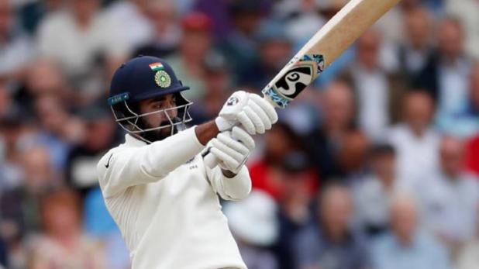India vs England

https://smedia2.intoday.in/aajtak/at_2.07.09.18/resources/theme_v2/common/images/anchor-Defaulticon.gif

aajtak.in [Edited By: तरुण वर्मा]

लंदन (इंग्लैंड), 11 सितंबर 2018, अपडेटेड 17:18 IST

टीम इंडिया और इंग्लैंड के बीच पांच मैचों की टेस्ट सीरीज का पांचवां और आखिरी मुकाबला लंदन के 'द ओवल' मैदान पर खेला जा रहा है. टॉस जीतकर पहले बल्लेबाजी करते हुए इंग्लैंड की टीम ने अपनी पहली पारी में 332 रन बनाए. इसके बाद अपनी पहली पारी खेलने उतरी टीम इंडिया 292 रन पर ऑल आउट हो गई. इंग्लैंड को पहली पारी के आधार पर 40 रनों की बढ़त मिली.

दूसरी पारी में इंग्लैंड ने 8 विकेट पर 423 रन बनाकर पारी घोषित कर दी और भारत को जीत के लिए 464 रनों का लक्ष्य दिया. जवाब में भारत ने 5 विकेट गंवा कर 154 रन बनाए हैं. केएल राहुल (101) और ऋषभ पंत (6) क्रीज पर हैं.

[**LIVE स्कोरबोर्ड**](https://aajtak.intoday.in/scorecard/live-cricket-score/?matchid=enin09072018184495)

**दूसरी पारी में लड़खड़ाई टीम इंडिया**

भारतीय टीम शुरू में ही लड़खड़ा गई और केवल 20 गेंद के खेल में उसने शिखर धवन (1), चेतेश्वर पुजारा (0) और कप्तान विराट कोहली (0) के विकेट गंवा दिए.

जेम्स एंडरसन (23 रन देकर दो) ने धवन और पुजारा को तीसरे ओवर में एलबीडब्ल्यू आउट किया. एंडरसन ने इसके साथ ही ग्लेन मैकग्रा के 563 विकेटों की बराबरी भी कर ली है.

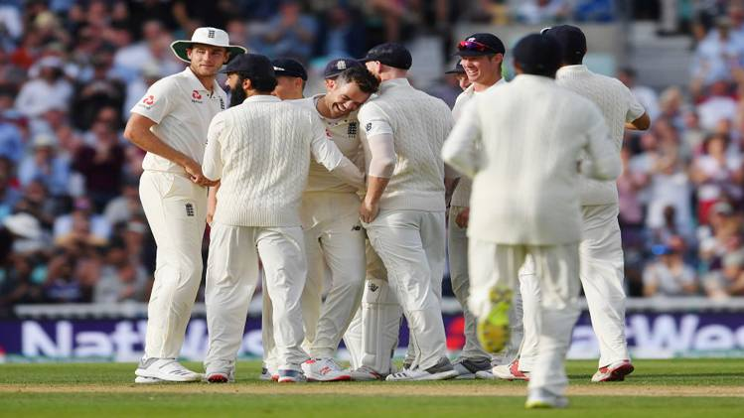

स्टुअर्ट ब्रॉड (17 रन देकर एक) ने कोहली को विकेट के पीछे कैच कराया जो अपने करियर में तीसरी बार गोल्डन डक (पारी की पहली गेंद पर आउट) बने.

**कुक और रूट के शतक से इंग्लैंड ने भारत को दिया 464 रनों का लक्ष्य**

दूसरी पारी में इंग्लैंड ने 8 विकेट पर 423 रन बनाकर पारी घोषित कर दी और भारत को जीत के लिए 464 रनों का लक्ष्य दिया. इंग्लैंड की तरफ से सबसे ज्यादा रन अपना आखिरी अंतरराष्ट्रीय मैच खेल रहे एलिस्टेयर कुक ने बनाए. कुक ने अपने टेस्ट करियर का 33वां टेस्ट शतक जड़ते हुए 147 रनों की पारी खेली. उनके अलावा कप्तान जो रूट ने 125 रन बनाए जबकि बेन स्टोक्स ने 37 रन की पारी खेली.

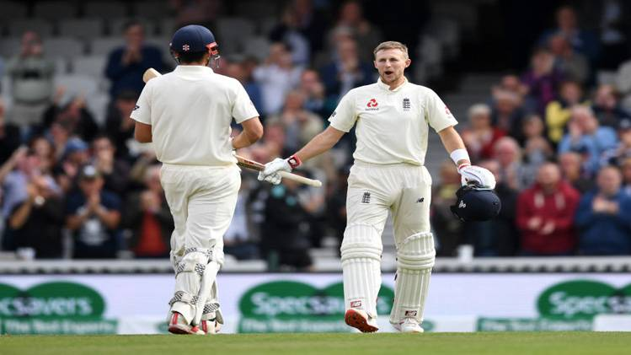

भारत के लिए अपना डेब्यू मैच खेल रहे हनुमा विहारी और लंबे समय बाद टेस्ट में वापसी करने वाले रवींद्र जडेजा ने 3-3 विकेट लिए जबकि मोहम्मद शमी को 2 विकेट मिले.

**कुक ने शतक जमाकर विदाई टेस्ट को यादगार बनाया**

एलिस्टेयर कुक अपने पहले और अंतिम टेस्ट मैच में शतक जड़ने वाले केवल पांचवें बल्लेबाज बने. कुक 147 रन बनाकर आउट हुए जो उनका 33वां टेस्ट शतक है.

कुक से पहले ऑस्ट्रेलिया के रेगी डफ, बिल पोन्सफोर्ड और ग्रेग चैपल तथा भारत के मोहम्मद अजहरूद्दीन ही अपने पहले और आखिरी टेस्ट मैच में शतक जड़ने की विशिष्ट उपलब्धि हासिल कर पाए थे. कुक ने जब 76 रन बनाए तो उन्होंने कुमार संगकारा को पीछे छोड़ा.

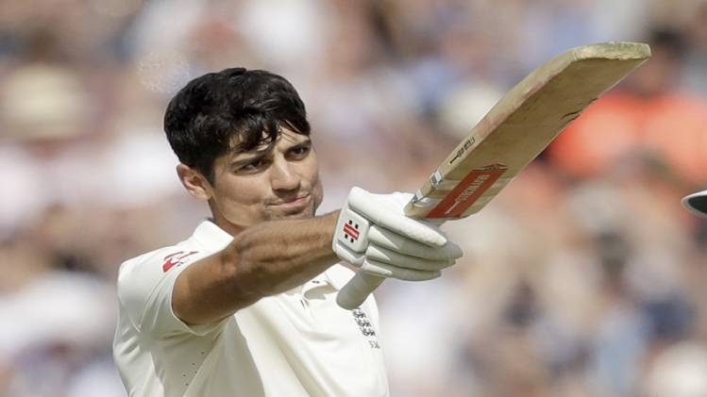

अब वह सर्वाधिक टेस्ट रन बनाने वाले बल्लेबाज बन गए हैं. ओवरआल उनसे अधिक रन अब सचिन तेंदुलकर, रिकी पोंटिंग, जैक कैलिस और राहुल द्रविड़ के नाम पर दर्ज हैं.  पारी के 70वें ओवर में कुक ने जसप्रीत बुमराह के ओवरथ्रो से अपना 33वां शतक पूरा किया.

कुक ने स्टीव वॉ (32 शतक) को पीछे छोड़ा. कुक के शतक का दर्शकों ने खड़े होकर जश्न मनाया और इस बल्लेबाज ने भी उनका अभिवादन स्वीकार किया. कुक ने 161 टेस्ट मैचों में 12472 रन बनाकर अपने टेस्ट करियर का अंत किया जिसकी शुरुआत उन्होंने 2006 में नागपुर में भारत के खिलाफ की थी.

**दूसरी पारी में इंग्लैंड**

दूसरी पारी में बल्लेबाजी करने उतरी इंग्लैंड को पहला झटका केटन जेनिंग्स (10) के रूप में 27 के स्कोर पर लगा. उन्हें मोहम्मद शमी ने बोल्ड किया. इसके बाद कुक ने मोईन अली (20) के साथ दूसरे विकेट के लिए 35 रन जोड़े. अली टीम के 62 के स्कोर पर रवींद्र जडेजा की अंदर आती गेंद पर बोल्ड हो गए. उन्होंने 52 गेंदों की पारी में तीन चौके लगाए.

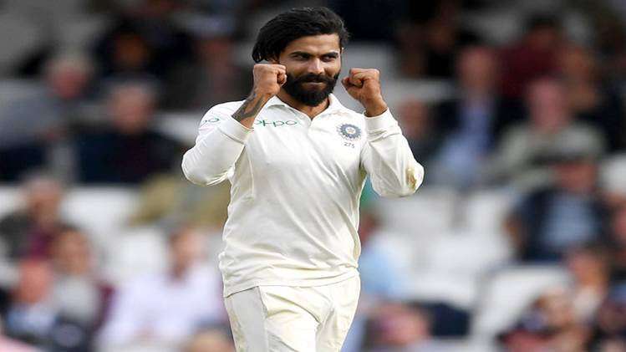

रूट को विहारी ने 125 के निजी स्कोर पर आउट कर दिया. विहारी ने अपनी आखिरी पारी खेल रहे सलामी बल्लेबाज कुक (147) को भी पवेलियन भेजा. इसके बाद, भारत के गेंदबाजों ने धारदार गेंदबाजी की और जॉनी बेयरस्टॉ (18) एवं जोस बटलर (0) को आउट किया. बेयरस्टॉ को शमी जबकि बटलर को जाडेजा ने पवेलियन की राह दिखाई.

इसके बाद, इंग्लैंड के बल्लेबाजों ने तेजी से रन बनाए. बेन स्टोक्स ने 37 और सैम कुरेन ने 21 रनों का योगदान दिया. आदिल राशिद 20 रन बनाकर नाबाद पवेलियन लौटे. भारत के लिए हनुमा विहारी और रवींद्र जडेजा ने 3-3 विकेट लिए जबकि मोहम्मद शमी को 2 विकेट मिले.

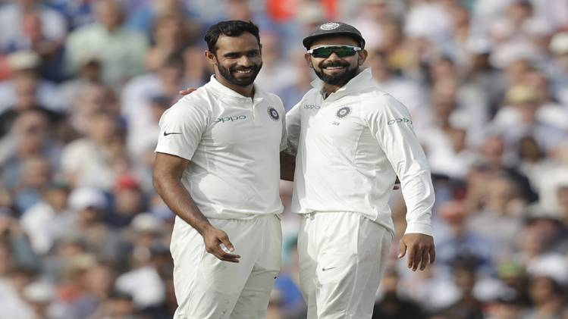

**जडेजा की बदौलत 292 रन तक पहुंचा भारत**

रवींद्र जडेजा की शानदार पारी की बदौलत टीम इंडिया ने अपनी पहली पारी में 292 रन बनाए. पहली पारी में बनाए गए 332 का स्कोर बनाने वाली इंग्लैंड के पास 40 रन की बढ़त है.

भारत की तरफ से रवींद्र जडेजा ने सर्वाधिक नाबाद 86 रन बनाए, जबकि अपना पहला टेस्ट मैच खेल रहे हनुमा विहारी ने 56 रन का योगदान दिया.

जडेजा ने 156 गेंदों की पारी में 11 चौके और एक छक्के की मदद से सर्वाधिक नाबाद 86 रन बनाए. जडेजा ने अपने टेस्ट करियर का नौंवा अर्धशतक पूरा किया. उन्होंने जसप्रीत बुमराह (0) के साथ आखिरी विकेट के लिए 32 रन की साझेदारी की.

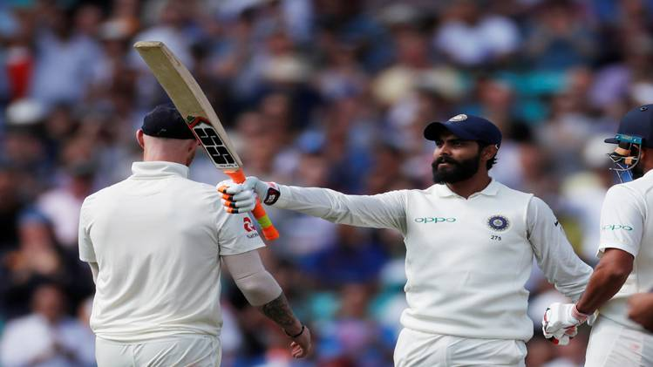

जडेजा के अलावा अपना डेब्यू टेस्ट खेल रहे हनुमा विहारी ने 124 गेंदों की पारी में सात चौकों और एक छक्के की मदद से 56, लोकेश राहुल ने 37, शिखर धवन ने तीन, चेतेश्वर पुजारा ने 37, कप्तान विराट कोहली ने 49, अजिंक्य रहाणे ने शून्य और ऋषभ पंत ने पांच रन बनाए.

इंग्लैंड के लिए जेम्स एंडरसन ने 54 रन पर दो विकेट, बेन स्टोक्स ने 56 रन पर दो विकेट, मोईन अली ने 50 रन पर दो विकेट, स्टुअर्ट ब्रॉड ने 50 रन पर एक विकेट, सैम कुरेन ने 49 रन पर एक विकेट और आदिल राशिद ने 19 रन पर एक विकेट हासिल किया.

**ऐसी रही भारत की बल्लेबाजी**

अपनी पहली पारी में बल्लेबाजी करने उतरी भारतीय टीम की शुरुआत सही नहीं रही. मेहमान टीम को छह रन के स्कोर पर ही शिखर धवन (3) के रूप में पहला झटका लगा. धवन को स्टुअर्ट ब्रॉड ने एलबीडब्ल्यू आउट किया. भारत को दूसरा झटका लोकेश राहुल (37) के रूप में लगा. जब उन्हें सैम कुरेन ने बोल्ड कर दिया.

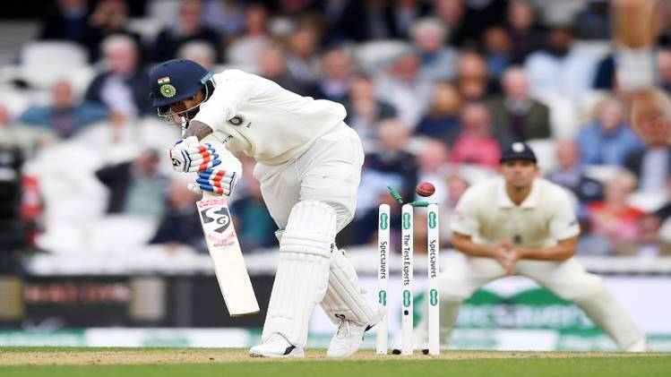

जेम्स एंडरसन ने चेतेश्वर पुजारा (37) को आउट कर भारत का तीसरा विकेट गिराया. पुजारा उनकी गेंद पर विकेट के पीछे जॉनी बेयरस्टॉ के हाथों लपके गए. उप-कप्तान अजिंक्य रहाणे विकेट पर पैर जमाते उससे पहले ही जेम्स एंडरसन ने उन्हें कुक के हाथों कैच आउट करा कर पवेलियन लौटा दिया. रहाणे शून्य पर आउट हुए.

रहाणे के सस्ते में निपटने के बाद कप्तान कोहली (49) ने विहारी के साथ पांचवें विकेट के लिए 51 रन की साझेदारी की. कोहली अपने अर्धशतक बनाने से चूक गए. उन्होंने 70 गेंदों की पारी में छह चौके लगाए. उन्हें बेन स्टोक्स ने कप्तान जो रूट के हाथों लपकवाया. कोहली टीम के 154 के स्कोर पर आउट हुए. कोहली के आउट होने के कुछ देर बाद ही ऋषभ पंत (5) भी स्टोक्स का दूसरा शिकार बन बैठे.

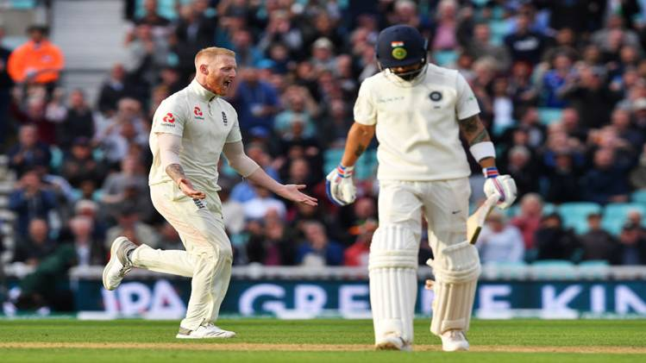

भारत को 7वां झटका हनुमा विहारी (56) के रूप में लगा. उन्हें मोईन अली ने बेयरस्टॉ के हाथों कैच कराया. भारत को आठवां झटका 249 के स्कोर पर ईशांत शर्मा (4) के रूप में लगा. उन्हें मोईन अली ने बेयरस्टॉ के हाथों कैच कराया. इसके कुछ देर बाद ही मोहम्मद शमी (1) भी आदिल राशिद की गेंद पर आउट हो गए. स्टुअर्ट ब्रॉड ने बुमराह को रन आउट कर भारतीय पारी को 95 ओवर में 292 रन पर समेट दिया.

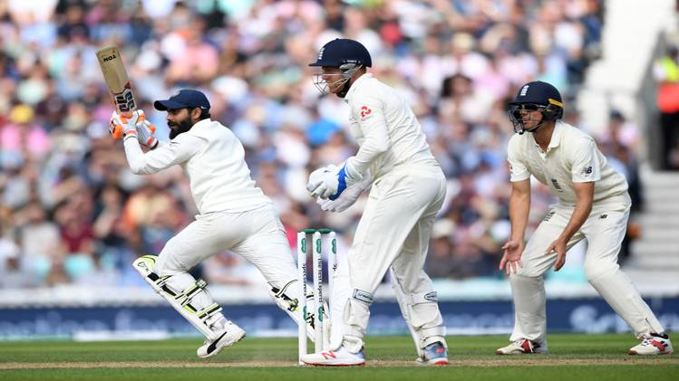

**बटलर के 89 रन के दम पर 332 तक पहुंचा इंग्लैंड**

जोस बटलर के शानदार 89 रनों की मदद से इंग्लैंड ने अपनी पहली पारी में 332 रन का अपेक्षाकृत मजबूत स्कोर बना लिया. बटलर ने 133 की गेंदों की पारी में छह चौके और दो छक्के लगाए. बटलर का यह 10वां अर्धशतक है. बटलर के अलावा एलिस्टेयर कुक ने 71 रन बनाए जबकि मोईन अली ने 50 रन की पारी खेली.

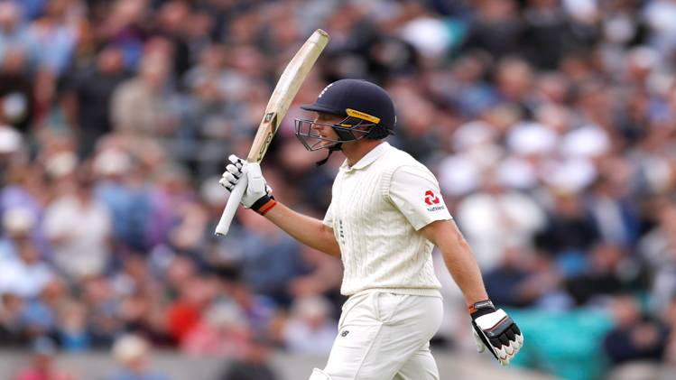

एक समय इंग्लैंड ने 181 रन के स्कोर पर अपने 7 विकेट गंवा दिए थे, लेकिन आखिरी 3 विकेट के लिए 151 रनों की पार्टनरशिप हुई. ब्रॉड ने 38 रनों का योगदान दिया. ब्रॉड और बटलर के बीच नौंवे विकेट के लिए 98 रन की साझेदारी हुई.  भारत की ओर से रवींद्र जडेजा ने 79 रन पर चार विकेट, जसप्रीत बुमराह ने 83 रन पर तीन विकेट और ईशांत शर्मा ने 62 रन पर तीन विकेट चटकाए.

**अच्छी शुरुआत के बाद बिखरी इंग्लैंड की टीम**

60 के स्कोर पर इंग्लैंड को पहला झटका लगा. केटन जेनिंग्स अपनी पारी को बड़े स्कोर में नहीं बदल पाए और रवींद्र जडेजा की बॉल पर शॉर्ट लेग पर खड़े केएल राहुल को आसान सा कैच देकर पवेलियन लौट गए. कुक और जेनिंग्स ने पहले विकेट के लिए 60 रन की साझेदारी की.

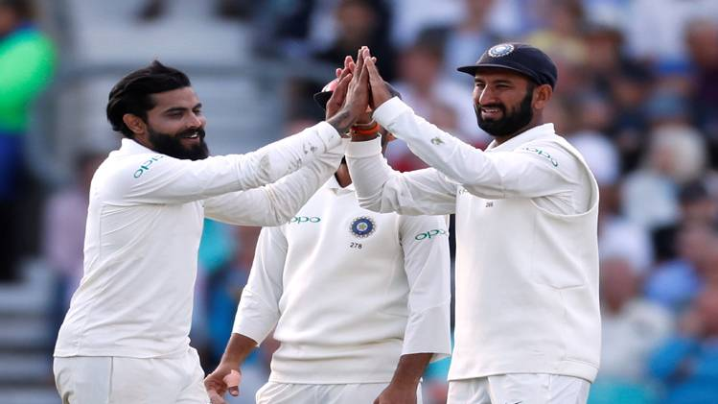

अपना आखिरी टेस्ट मैच खेल रहे कुक ने बेहद धीमी बल्लेबाजी की लेकिन वह पिछली नौ पारियों के बाद पहली बार 50 रन की संख्या पार करने में सफल रहे. कुक ने अपने सलामी जोड़ीदार कीटोन जेनिंग्स (23) के साथ पहले विकेट के लिए 60 रन जोड़े जबकि मोईन अली के साथ उन्होंने 73 रन की साझेदारी की. अपने टेस्ट करियर का आखिरी मैच खेल रहे कुक का यह 57वां अर्धशतक है.

कुक और मोइन को 31वें और 32वें ओवर में जीवनदान भी मिला. अली को कप्तान विराट कोहली ने जबकि मोइन को अजिंक्य रहाणे ने जीवनदान दिया. इसके बाद 64वें ओवर में बुमराह ने 133 रन के कुल स्कोर पर कुक को बोल्ड कर अपने आखिरी अंतरराष्ट्रीय मैच में शतक बनाने की उनकी उम्मीदों को तोड़ दिया. कुक ने अपने टेस्ट करियर का 57वां अर्धशतक पूरा किया. उन्होंने 190 गेंदों पर आठ चौके लगाए.

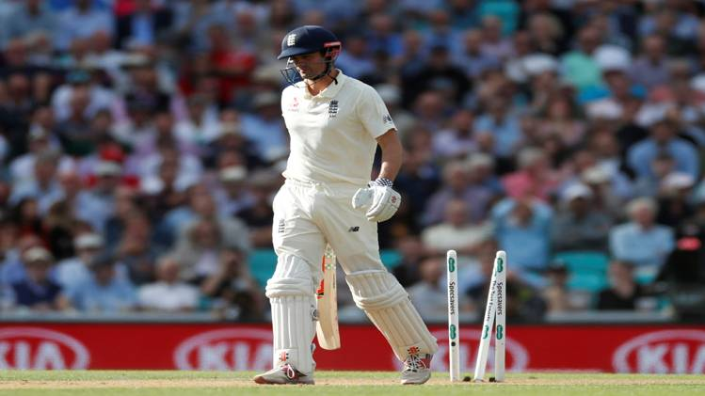

कुक के आउट होने के बाद इंग्लैंड ने एक रन के अंदर ही कप्तान जो रूट (0) और जॉनी बेयरस्टॉ (0) का भी विकेट गंवा दिया. रूट को बुमराह ने तो बेयरस्टॉ को ईशांत ने अपना शिकार बनाया. हालांकि अली ने इस दौरान बेन स्टोक्स (11) के साथ पांचवें विकेट के लिए 37 रन की साझेदारी की, लेकिन स्टोक्स भी टीम के 171 के स्कोर पर पांचवें बल्लेबाज के रूप में आउट हो गए. उन्हें जडेजा ने एलबीडब्ल्यू आउट किया.

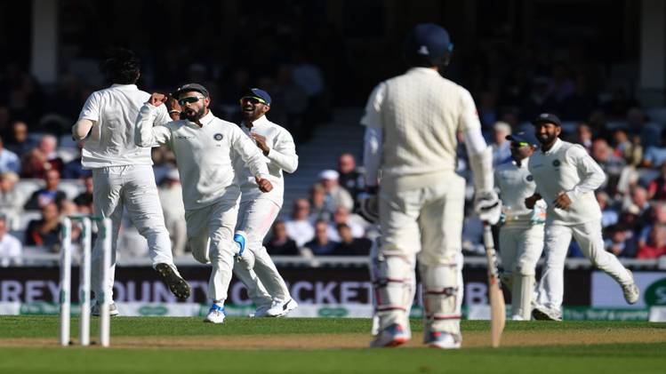

स्टोक्स के आउट होने के बाद मोईन अली भी अपने टेस्ट करियर का 13वां अर्धशतक पूरा कर चलते बने. उन्होंने 170 गेंदों पर चार चौके लगाए. अली टीम के 177 के स्कोर पर छठे बल्लेबाज के रूप में आउट हुए. पिछले कुछ मैचों में शानदार पारियां खेलने वाले सैम कुरेन खाता भी नहीं खोल पाए. उन्हें ईशांत ने इंग्लैंड के 181 के स्कोर पर आउट किया.

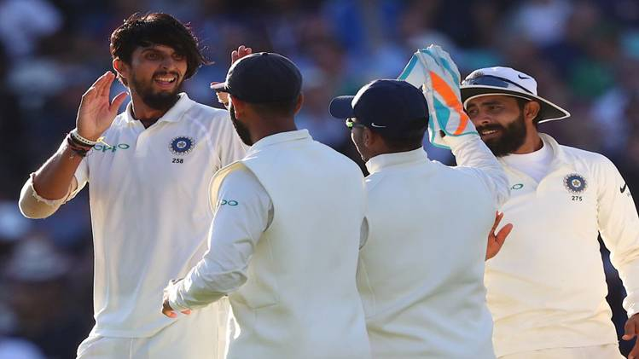

इंग्लैंड को आठवां झटका आदिल राशिद (15) के रूप में 214 के स्कोर पर लगा. उन्होंने 51 गेंदों की पारी में तीन चौके लगाए. राशिद, बुमराह की गेंद पर एलबीडब्ल्यू आउट हुए.

इंग्लैंड को नौवां झटका स्टुअर्ट ब्रॉड के रूप में लगा. उन्होंने 59 गेंदों की पारी में 38 रन बनाए जिसमें तीन चौके शामिल थे. ब्रॉड का विकेट 312 के स्कोर पर गिरा. उन्हें जडेजा की गेंद पर लोकेश राहुल ने लपका. ब्रॉड के आउट होने के 20 रन बाद बटलर आउट हुए. उन्हें रवींद्र जडेजा ने अजिंक्य रहाणे के हाथों कैच कराया और इंग्लैंड की पारी को 332 रन पर रोक दिया.

[[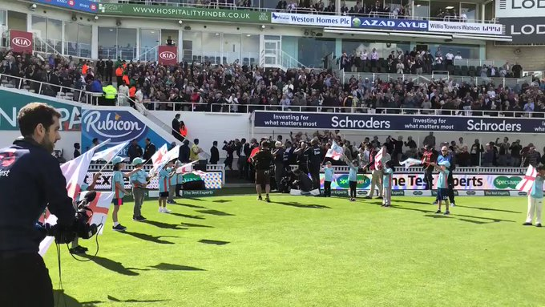](https://twitter.com/englandcricket/status/1038004572093120512)](https://twitter.com/englandcricket/status/1038004572093120512)

[https://pbs.twimg.com/profile_images/1023864928162263040/7MJufmef_normal.jpg](https://twitter.com/englandcricket)

**[England Cricket](https://twitter.com/englandcricket)**

[✔@englandcricket](https://twitter.com/englandcricket)

What a reception! [https://www.ecb.co.uk/matches/6813#overview …](https://t.co/IroJonUcBW)[#ThankYouChef](https://twitter.com/hashtag/ThankYouChef?src=hash) [#EngvInd](https://twitter.com/hashtag/EngvInd?src=hash)

[3:32 PM - Sep 7, 2018](https://twitter.com/englandcricket/status/1038004572093120512)

[7,268](https://twitter.com/intent/like?tweet_id=1038004572093120512" \o "Like)

[2,313 people are talking about this](https://twitter.com/englandcricket/status/1038004572093120512" \o "View the conversation on Twitter)

[Twitter Ads info and privacy](https://support.twitter.com/articles/20175256)

**इंग्लैंड ने टॉस जीतकर पहले ली बल्लेबाजी**

इंग्लैंड ने टॉस जीतकर पहले बल्लेबाजी का फैसला किया और भारत को गेंदबाजी सौंपी. टीम इंडिया की प्लेइंग इलेवन में दो बदलाव हुए. ऑलराउंडर हार्दिक पंड्या की जगह हनुमा विहारी और ऑफ स्पिनर रविचंद्रन अश्विन की जगह रवींद्र जडेजा को मौका मिला.

हनुमा विहारी इस मैच से अंतरराष्ट्रीय क्रिकेट में अपना डेब्यू कर रहे हैं. अब भारत के लिए टेस्ट मैच खेलने वाले 292वें खिलाड़ी बन गए. इंग्लैंड के पूर्व कप्तान एलिस्टेयर कुक के करियर का यह अंतिम मैच है. इसके बाद वह क्रिकेट से संन्यास ले लेंगे. रूट ने इस मैच के लिए अपने अंतिम एकादश में कोई बदलाव नहीं किया है.

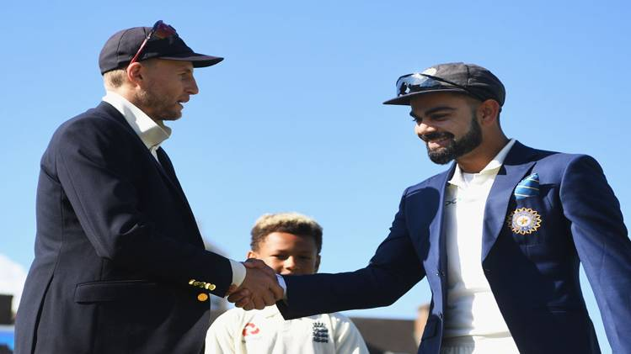

[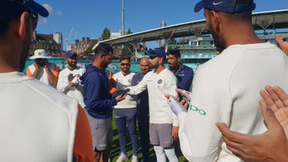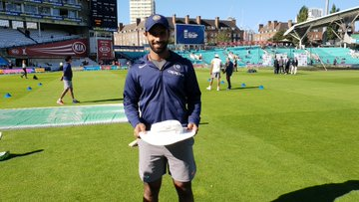](https://twitter.com/BCCI/status/1037991423986081799/photo/1)

[https://pbs.twimg.com/profile_images/808958294131781632/b5z_etzB_normal.jpg](https://twitter.com/BCCI)

**[BCCI](https://twitter.com/BCCI)**

[✔@BCCI](https://twitter.com/BCCI)

Proud moment for Hanuma Vihari as he becomes the 292nd player to represent [#TeamIndia](https://twitter.com/hashtag/TeamIndia?src=hash) in Tests.[#ENGvIND](https://twitter.com/hashtag/ENGvIND?src=hash)

[2:40 PM - Sep 7, 2018](https://twitter.com/BCCI/status/1037991423986081799)

[9,704](https://twitter.com/intent/like?tweet_id=1037991423986081799" \o "Like)

[1,097 people are talking about this](https://twitter.com/BCCI/status/1037991423986081799" \o "View the conversation on Twitter)

[Twitter Ads info and privacy](https://support.twitter.com/articles/20175256)

**ओवल में भारत का रिकॉर्ड**

1936-2014 के दौरान भारत ने 12 टेस्ट खेले हैं, जिनमें से उसे सिर्फ 1 में जीत मिली, 4 गंवाए और 7 ड्रॉ रहे. भारत ने अपने टेस्ट इतिहास में अब तक सीरीज के पांचवें टेस्ट के रूप में कुल 34 टेस्ट खेले हैं, जिसमें से उसे 11 में हार मिली, जबकि 5 टेस्ट ही जीत पाए और 18 ड्रॉ रहे.

**प्लेइंग इलेवन:**

**भारत:** विराट कोहली (कप्तान), शिखर धवन, लोकेश राहुल, चेतेश्वर पुजारा, अजिंक्य रहाणे, ऋषभ पंत, रवींद्र जडेजा, हनुमा विहारी, ईशांत शर्मा, मोहम्मद शमी, जसप्रीत बुमराह.

**इंग्लैंड:** जो रूट (कप्तान), एलिस्टेयर कुक, केटन जेनिंग्स, जॉनी बेयरस्टाॅ, जोस बटलर, मोईन अली, आदिल राशिद, सैम कुरेन, जेम्स एंडरसन, स्टुअर्ट ब्रॉड, बेन स्टोक्स.

# Weight Loss: 5 Morning Habits That Are Making You Gain Weight And Belly Fat

What you do in the morning plays a huge impact on your[weight loss](https://doctor.ndtv.com/topic/weight-loss-336) regime. When you are trying to lose weight, your morning rituals are extremely important. And you have to be even more careful in case you want to shed[belly fat](https://doctor.ndtv.com/living-healthy/5-seemingly-innocent-habits-that-increase-belly-fat-1797869) - it is a tad bit difficult to shed weight from this part of the body! At times, you might be going right in every aspect. You might be eating healthy, exercising regularly and sleeping well. But there are some basic habits which can ruin all of your hard work. However, you are not alone in this. Many people remain in a state of confusion as to why they are unable lose weight despite all efforts.

When you are not able to achieve your desired outcomes, there are definitely some places where you are going wrong. Most blunders are made when people begin their day with the wrong practices.

## Read below to know some morning habits and rituals which are making you gain weight and belly fat:

**1. Not exercising**

Studies say that [exercising](https://doctor.ndtv.com/heart/these-are-the-best-exercises-for-your-heart-health-1846670) in the morning helps you burn more calories and prevents gain in weight. Morning exercise on an empty stomach can help in burning more body fat and contributes to weight loss in a more efficient way. Waking up early in the morning and taking out time for exercising gives you a very different and refreshing feeling altogether. Plus, this doesn't mean that you have to specifically go to the gym and workout rigorously. You can include a variety of exercises to your workout regime like brisk walking, jogging, cycling, running, skipping, etc. At times, even half an hour of workout is enough to make you feel refreshed and energised and help you in weight loss more efficiently.



Exercising in the morning will help in weight loss and losing belly fat  
Photo Credit: iStock

Also read: [How Many Eggs Can I Eat In A Day For Weight Loss](https://doctor.ndtv.com/living-healthy/how-many-eggs-can-i-eat-in-a-day-for-weight-loss-1845347)

**2. Not drinking water**

Dietitians, nutritionists and fitness experts all over the world have recommended drinking lots of [water](https://doctor.ndtv.com/news/heres-why-older-adults-must-drink-more-water-1841336) for both staying healthy as well as losing weight. Sufficient water intake helps in flushing out toxins from the body and gives a boost to the metabolism. And drinking a glass or two of warm water in the morning can help you in losing weight and belly fat. It will help in cleansing your system. Drinking water reduces appetite and calorie intake and helps in maintaining hydration levels in the body.



Drinking water on any empty stomach in the morning can help in weight loss  
Photo Credit: iStock

**3. Not getting enough morning sunlight**

Yes, being exposed to some sunlight can help you in your weight loss regime. Studies say that [ultraviolet rays of the sun](https://doctor.ndtv.com/living-healthy/the-heat-wave-is-here-tips-to-deal-with-it-1698085) in the morning are healthy for your body. They can make you feel more energetic and increase your metabolic activity. Some exposure to sunlight in the morning can bring down your BMI and improve health.



Being exposed to some sunlight in the morning is important for the body  
Photo Credit: iStock

Also read: [Weight Loss Without Dieting: 6 Science-Backed Ways​](https://doctor.ndtv.com/living-healthy/6-science-backed-ways-of-losing-weight-without-going-on-a-diet-1845968)

**4. Eating processed foods for breakfast**

Being in rushed state every morning can make you inclined towards having quick and easy to make options for breakfast. Today, markets are flooded with [processed and packaged foods](https://doctor.ndtv.com/living-healthy/top-6-processed-foods-you-should-definitely-avoid-1755938). And no matter how healthy a choice you make from these processed foods, the preservatives and added flavours in them will have an adverse impact on your health. Moreover, having these junk and fast foods for breakfast can be one of the worst things you can do for your health. Preservatives and sugar content in processed foods can increase your cravings and ultimately lead to overeating. Breakfast should be wholesome and healthy and must include natural foods such as fruits, nuts, oat meals, fruit juices, etc. And this is irrespective of the fitness and diet regime that you are following.



Avoid eating processed food in the morning  
Photo Credit: iStock

Also read: [Weight Loss: 3 Tablespoons Of This Drink In A Day Will Help You Lose Belly Fat And Lower Cholesterol Levels](https://doctor.ndtv.com/living-healthy/3-tablespoons-of-this-drink-in-a-day-will-help-you-lose-belly-fat-and-lower-cholesterol-levels-1849145)

**5. Skipping breakfast**

On most days, you are in a hurry and do all your morning chores rushing here and there. The most convenient option seems to be grabbing a quick or sandwich along with a cup of coffee, or even worse, skipping breakfast. There is a reason why breakfast is hailed as the most important meal of the day. It is the first meal of the day which gives a kickstart to your energy levels. On days when you skip breakfast, your metabolism messes up. Skipping up breakfast slows down body's fat burning process. Also, on days when you skip breakfast, you are more likely to make poor food habits throughout the day. Eating a healthy breakfast during the day helps in reducing cravings and prevents excessive hunger in later part of the day. 

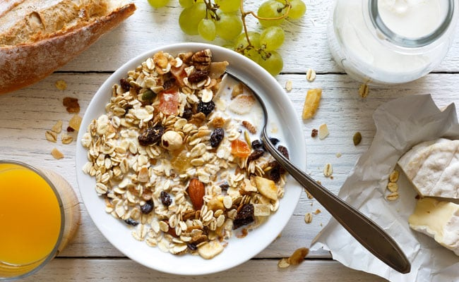

# Sent High-Profile Fraud List To PM's Office: Raghuram Rajan's Bombshell