**To change in seapipe**

* **SLEEPSTAT**

project_name.macro_dataset(xml_dir = None,

out_dir = None,

rater = None,

subs = 'all',

sessions = 'all',

outfile = True)

* Remove rater as not needed in ﻿sleepstats_from_csvs function either
* Add cycle to extract sleepstat per cycle (default = False)
* **SO**
* Warning message saying no input .xml but work anyway
* **SPINDLE**

Export_detect_spindle

ERROR: when adap_bands = Auto (or Manual), it creates the event_adap but also create en event (without adap)

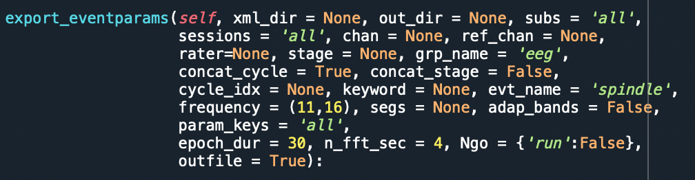

* make sure reject poor and artefact is not in the second function and just in the detection
* rater not needed
* ERROR: do not see event named XX_adap so can’t extract it
* Why default = (11,16)? Eg for SO (what is detection range of SO detect?)

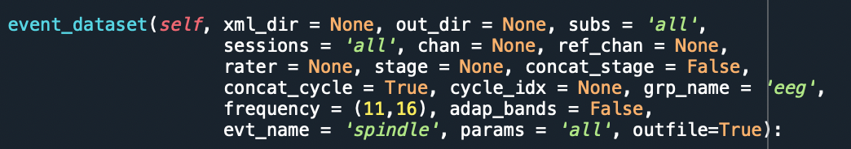

* rater not needed
* frequency not needed
* **FOOF**
* Create a function that can extract and combine in a dataset all the peaks selected for spindle detection (for now using R script)