FreelanceHub Project Specification
WDD 430 team project proposal | Nathan Escujuri | September 2026
FreelanceHub gives freelancers and their clients a shared view of project work. This specification defines the intended user experience, data, permissions, and proposed API for a team project.

Project purpose
Freelancers often spread client conversations, deadlines, and progress updates across email, spreadsheets, and task tools. FreelanceHub brings essential project information into one workspace. Freelancers organize clients and work; clients sign in to follow their own projects and discuss them in context.

Audience and scope
Primary users are independent service professionals and small service businesses, including developers, designers, writers, and consultants. Their clients are secondary users who need a simple, trustworthy view of progress. The MVP supports one freelancer workspace with its own client records and projects; a freelancer cannot see another freelancer’s workspace.

Core MVP features
- Accounts: freelancer registration and sign in; client account access through an invitation or association to an existing client record; profile editing and sign out.
- Client management: create, list, view, update, and archive client records, including clients who have not yet accepted an invitation.
- Project management: create, list, view, update, and archive projects for a client; record status, dates, description, and progress.
- Task and milestone management: create, view, edit, complete, and remove project work items; mark each item client visible or internal.
- Dashboards: freelancer summaries of projects, clients, and deadlines; client summaries restricted to assigned projects.
- Project communication: authenticated participants read and post project messages. Message editing or deletion is limited to the author or workspace owner.
- Access rules: freelancers manage only their workspaces; clients read only their linked projects, visible tasks, and related messages.
- Responsive layouts: all primary journeys work on desktop and mobile.
The advanced feature for the MVP is role based access control, enforced on every protected resource as well as in the interface.

Additional features
After the MVP, prioritize project file sharing, client review and approval of deliverables, live notifications, calendar views, invoicing and payments, time tracking and analytics, then proposals and contracts. These are possible extensions, not dependencies of the initial workflow. File sharing and approvals would introduce a Deliverable record and related endpoints.

Main views and user journeys
A freelancer signs in, adds a client, opens a project, adds milestones and tasks, updates progress, and posts an update. A linked client signs in, sees only assigned projects, reviews visible work and deadlines, and replies within the project. The main views are sign in and registration, freelancer dashboard, client list and details, project list and details, client dashboard, and profile settings.

Initial data models
Model | Key information | Relationship and rules
User | ID, name, email, authentication credentials, role, profile details, timestamps | One freelancer owns a workspace; a client account may link to a client record.
Client | ID, owner ID, business or display name, contact details, status, optional user ID, timestamps | Belongs to one freelancer; can exist before an account is linked.
Project | ID, owner ID, client ID, name, description, status, start date, deadline, progress, timestamps | Belongs to one client and one freelancer.
Task or milestone | ID, project ID, title, description, type, status, priority, due and completion dates, client visibility | Belongs to one project; internal items stay hidden from clients.
Message | ID, project ID, sender ID, content, created and edited times | Belongs to a project; sender must be an authorized participant.

A project’s progress may be entered by the freelancer for the MVP; the displayed value should agree across freelancer and client views. Archiving a client or project preserves historical context while removing it from active lists. Deleting a task is permanent only after confirmation.

Access and acceptance criteria
- A new freelancer can create a client without a linked login and later associate exactly one client account with that record.
- Every project belongs to a client in the same freelancer workspace. The client account sees only projects attached to its linked record.
- A client cannot create or change clients, projects, or tasks, and cannot retrieve internal tasks by direct URL or API request.
- Participants can post and read messages only within authorized projects.
- Freelancer and client workflows remain usable at mobile widths; navigation, lists, forms, and project details adapt without horizontal overflow.

Proposed API surface
The paths below describe expected application behavior and may be refined during development. Every protected operation checks identity, role, and ownership.

Area | Endpoints | Access
Account | POST /auth/register; POST /auth/login; POST /auth/logout; GET /users/me; PUT /users/me | Authenticated profile actions; registration and login public.
Clients | GET /clients; POST /clients; GET /clients/:id; PUT /clients/:id; DELETE /clients/:id | Freelancer in owning workspace; delete archives.
Projects | GET /projects; POST /projects; GET /projects/:id; PUT /projects/:id; DELETE /projects/:id | Freelancer manages; linked client reads authorized records; delete archives.
Tasks | GET /projects/:id/tasks; POST /projects/:id/tasks; GET /tasks/:id; PUT /tasks/:id; DELETE /tasks/:id | Freelancer manages; linked client reads visible tasks only.
Messages | GET /projects/:id/messages; POST /projects/:id/messages; PUT /messages/:id; DELETE /messages/:id | Project participants read and post; author or owner edits or removes.
Dashboard | GET /dashboard | Role appropriate summaries only.

Optional file sharing would add GET and POST /projects/:id/files, GET and DELETE /files/:id, and PUT /files/:id/approval. Client invitation or account linking requires a secure association flow; the exact endpoint and delivery method can be defined during implementation.

Delivery and team workflow
The team will use Git and GitHub for meaningful individual contributions, track work in a project board, set weekly sprint goals, and keep brief planning and retrospective notes. The finished repository README will include the project description, team members, setup and installation instructions, API documentation, known issues, and future improvements.
The MVP is complete when the two end to end journeys above work with enforced access rules and responsive views. The technology stack, database choice, and hosting approach remain open for discussion.

Wireframes
These low fidelity screens show hierarchy and expected controls. Sample names and counts illustrate the interface; they are not required seed data. On phones, navigation becomes a menu, summary cards and columns stack, and record rows become cards.

1 Login and registration
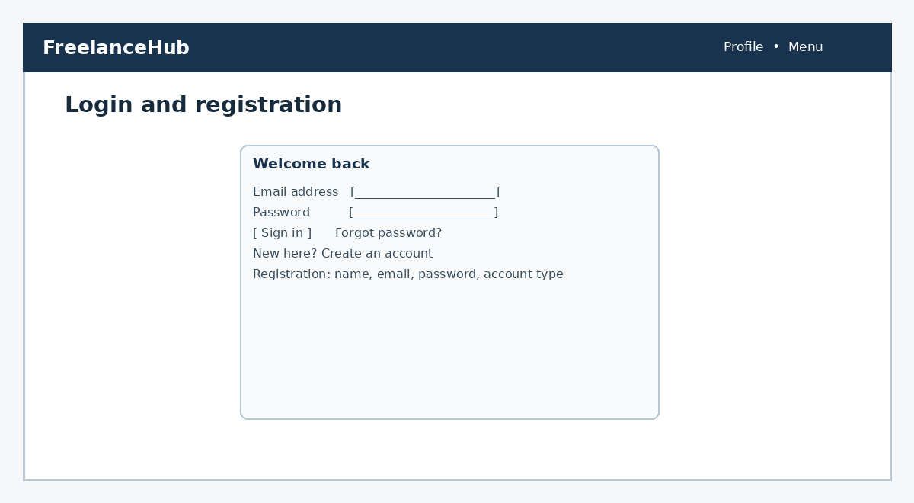
Figure 1. Login and registration view.

2 Freelancer dashboard
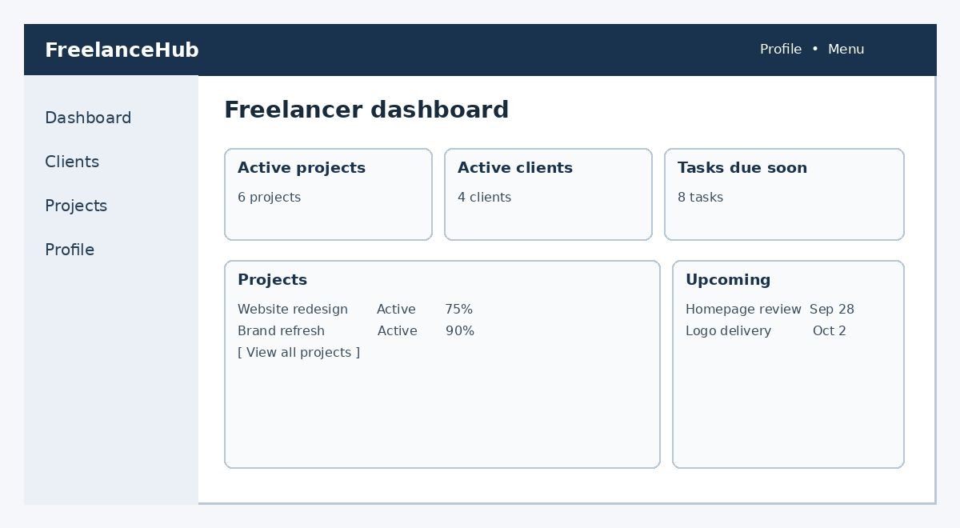
Figure 2. Freelancer dashboard view.

3 Clients
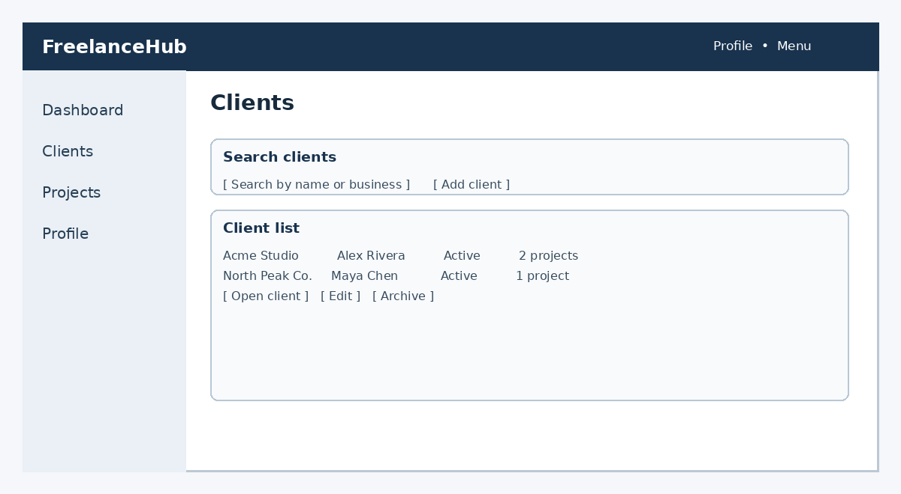
Figure 3. Clients view.

4 Projects
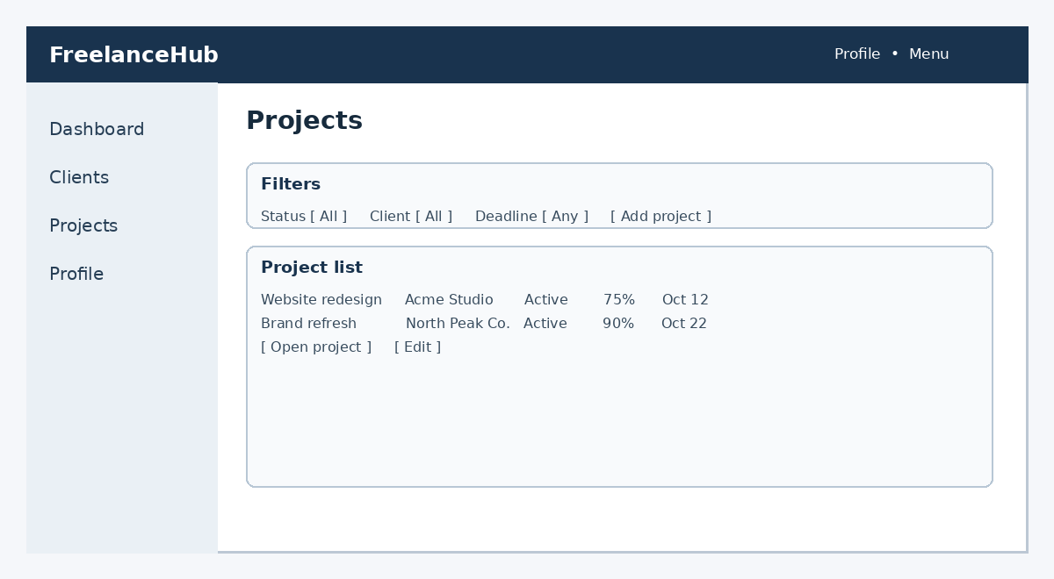
Figure 4. Projects view.

5 Project details
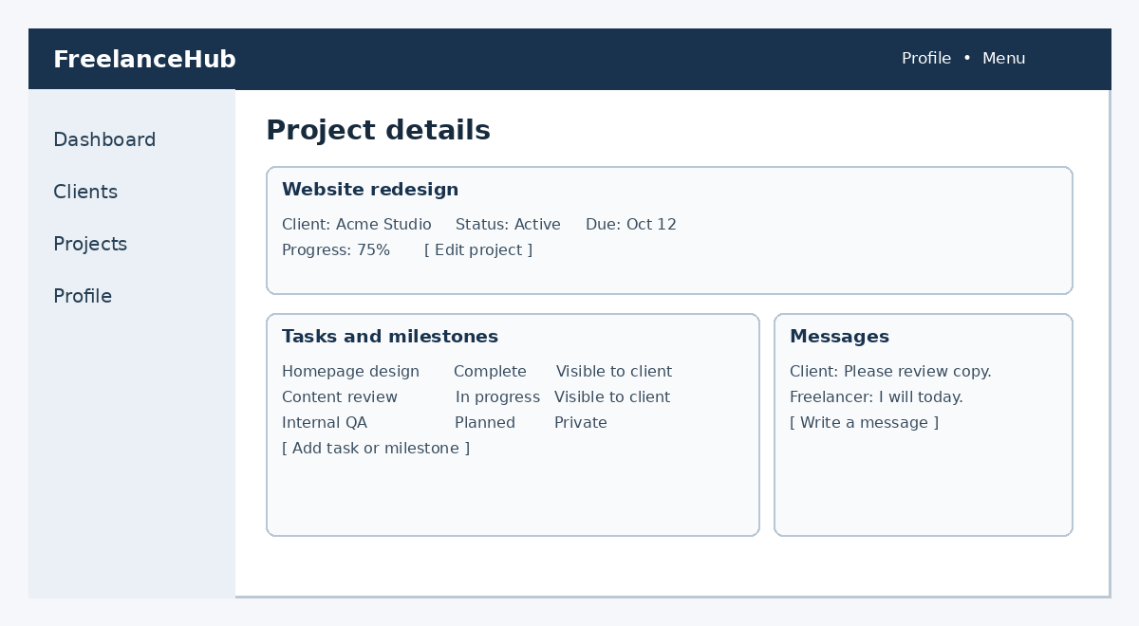
Figure 5. Project details view.

6 Client dashboard
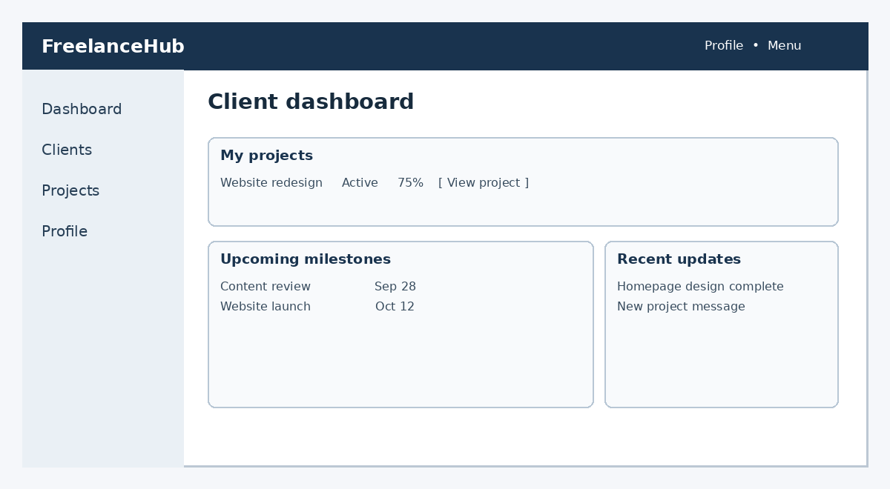
Figure 6. Client dashboard view.

