Feature 1: Application Styling
In order to provide pleasant user experience
As a developer
I want the application to start up with the default Windows Forms theme and colors

Scenario 1
Given application launch
When the form renders
Then display the default background

Scenario 2
Given application launch
When the textboxes render
Then display those fields with white background

Scenario 3
Given application launch
When buttons are rendered
Then display those buttons with the default gray color
Example - 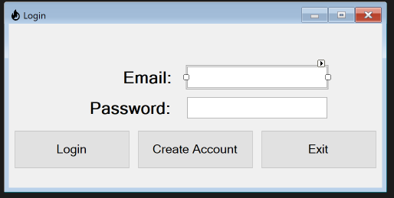

Feature 2: Login Screen
In order to provide the functionality of tracking calories
As a developer
I want fields with which to capture user data, create an account, and authenticate

Scenario 1
Given application launch
When the login screen renders
Then provide fields to authenticate the user
Example -

Scenario 2
Given a user wanting to login
When a user provides login credentials and clicks “Login”
Then capture the inputs and validate against the database
Example - 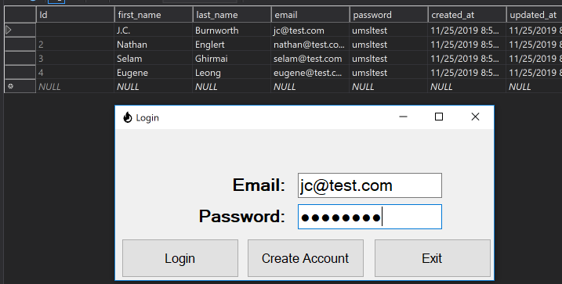

Scenario 3
Given a user wanting to login
When a user is authenticated
Then launch the main screen form
Example - 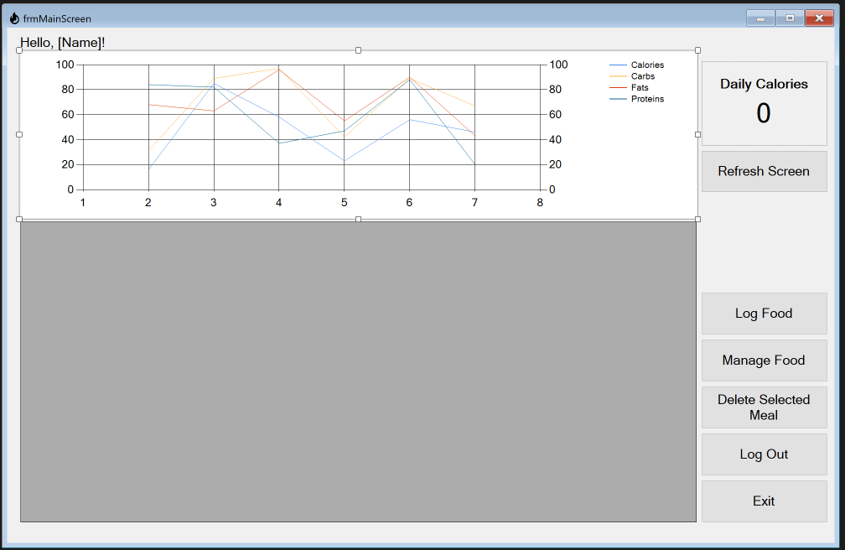

Scenario 4
Given a user without an account
When a user clicks “Create Account”
Then launch a new form where a user can enter their personal details
Example - 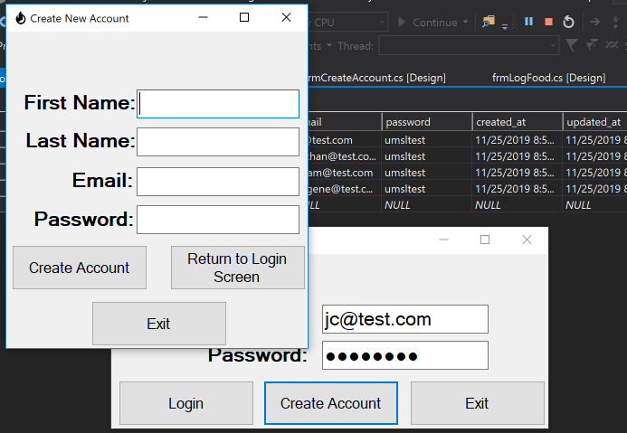

Feature 3: Create Account Screen
In order to allow a new user to create an account
As a developer
I want fields with which to input new user information

Scenario 1
Given a new user wanting to create an account
When the create account screen renders
Then provide fields to allow a user to capture user account information
Example - 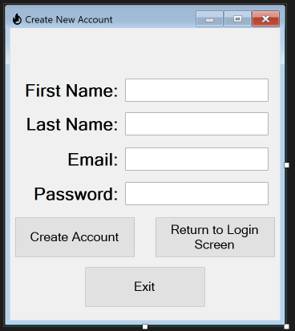

Scenario 2
Given a new user wanting to create an account
When a user clicks “Create Account”
Then load the data into the database
Example - 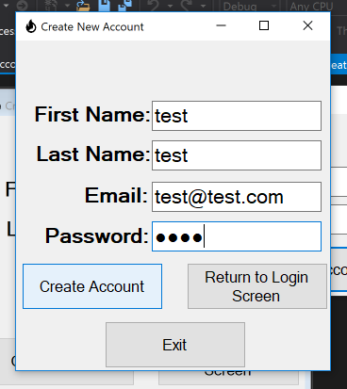

Feature 4: Main Screen
In order to allow user to track the calories
As a developer
I want fields with which to input new user information

Scenario 1
Given a user wanting details on their calorie data
When the main screen renders
Then provide a chart, table, and sum of daily calories
Example - 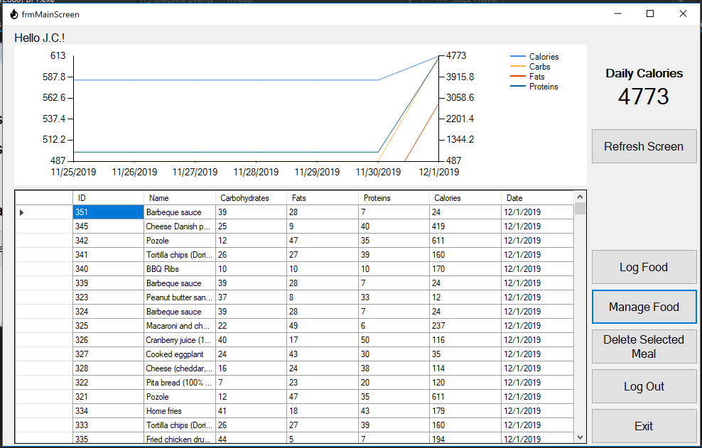

Scenario 2
Given a user wanting to delete a previously logged food
When the given food is selected
Then delete that food log record when “Delete Selected Meal” is clicked

Scenario 3
Given a user wanting to add a food for future logging
When the “Manage Food” button is clicked
Then render a screen that allows a user to add and edit foods
Example - 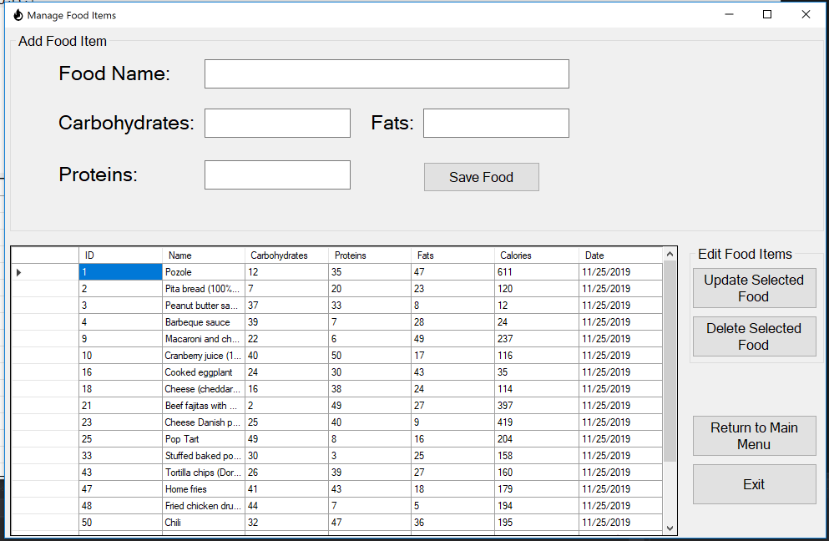

Scenario 4
Given a user wanting to log a food
When the “Log Food” button is clicked
Then render a screen that allows a user to log foods
Example - 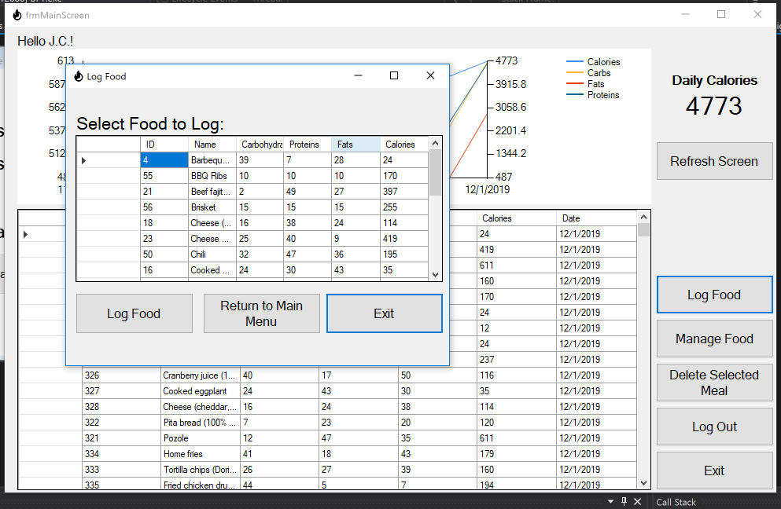

Feature 5: Manage Food Screen
In order to allow user to track the calories
As a developer
I want fields with which a user can enter new foods

Scenario 1
Given a user entering a new food
When a food name, carbohydrates, fats, and proteins are entered
Then validate those values for consistency prior to loading to the database
Example - 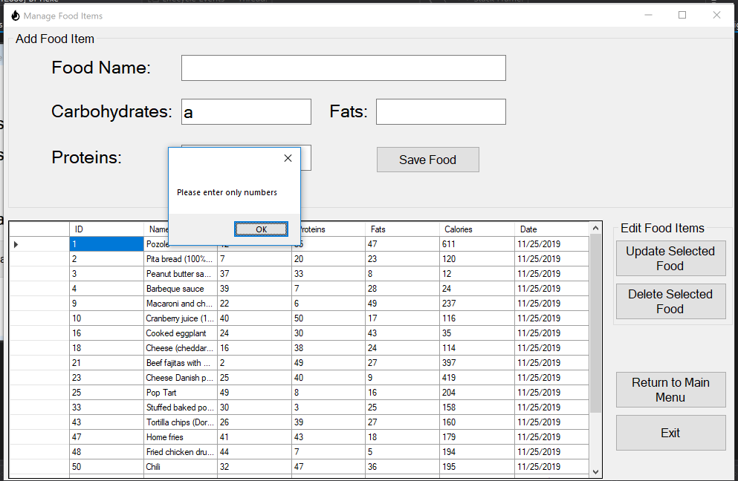

Scenario 2
Given a user entering a new food
When data entered is valid and “Save Food” is clicked
Then insert that data into the database and reload the food data grid
Example - 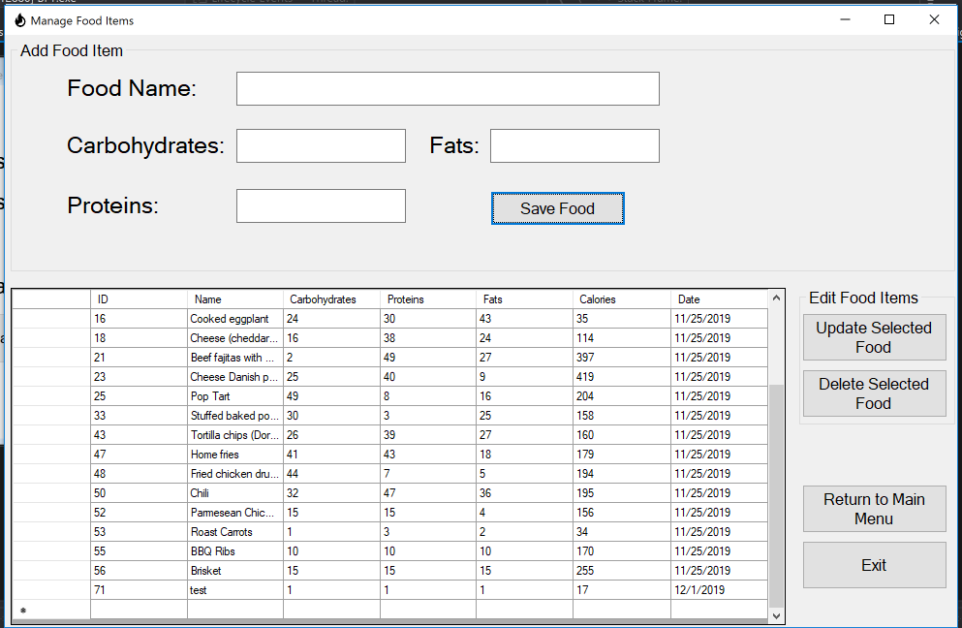

Scenario 3
Given a user editing food data
When a row is changed and “Update Selected Food” is clicked
Then update that data in the database and reload the food data grid
Scenario 4
Given a user deleting food data
When “Delete Selected Food” is clicked
Then soft delete that data in the database and reload the food data grid and delete any associated records in the food log table

Feature 6: Log Food Screen
In order to allow user to track the calories
As a developer
I want fields with which a user can log foods consumed

Scenario 1
Given a user logging a food consumed
When a food is highlighted and “Log Food” is clicked
Then record the user, food, and time in the database
Example - 