Nathaniel Fenoglio

1001634050

Lemuel Rivera

1000842851

**General Process Outline for Project 1 Process and Thread Including Problems and Solutions Encountered Along the Way**

* We used Virtual Box and installed Ubuntu 18.04.5.
* We chose to install linux version 4.14.127 as the second kernel image to boot to. We weren’t sure if it was a good idea to install a release 4 version instead of a release 5 version, because of the discussion about the greater size of a release 5 version.
* Went through make menuconfig process to generate .config file.
* Executed make -j4 command
  + The time that it takes to recompile the kernel was a challenge in that we were not able to get feedback from code changes for around 3 hours. We took the advice to adjust the settings in Virtual Box to allow 4 cores to be used and this cut down the kernel compiling time.
* Executed make modules, make modules_install, and make install commands.
* Created init ramdisk successfully
  + We learned that we needed to have sudo permission when executing some processes to compile the kernel. Otherwise, certain files would not be built and we would receive errors.
  + Changing to sudo, from the beginning, solved the problem and we had no issue with successfully compiling.
* Changed the grub configuration file to allow to select which boot image to boot to in order to select the different kernel version.
* Rebooted to have changes take place and booted into new linux version 4.14.127 kernel.
* Created directory my_source in new kernel top level directory where we added the 3 c programs to make the system calls.
  + We learned that when writing the system calls, the number at the end of the SYSCALL_DEFINE# macros indicated the number of parameters that would be passed to the system call and that the syntax is (systemcall_name, parameter_1_type, parameter_1_name, parameter_2_type, parameter_2_name, etc)
  + We learned about task_struct structure and the “current” macro to get a pointer to the task_struct of the currently running process. We learned that the tasks are connected as a double linked list and each process has a pointer to its parent process allowing us to traverse the list to the initial process.
  + We learned the different attributes to find information on the various processes accessed through the task_struct structure
    - pid - process id
    - state - state
    - comm - program name
    - real_start_time - start time
    - virtual runtime - se.vruntime
  + We were able to search for a process id provided as a command line argument by accessing the pid attribute and traversing the linked list back to the initial process and comparing the process ids for a match.
* Added Makefile inside of my_source directory to create the object files to be built from the 3 c programs.
  + When adding our second system call, we had an error caused by an error in our Makefile syntax.
  + We fixed the syntax to be obj-y := sys_helloworld.o sys_print_self.o sys_print_other.o changing the object files to be built to be all on the same line as the target to fix the error.
* Edited Makefile in the top level directory to also search in the new my_source directory when compiling the kernel.
* Added the system call entries to the arch/x86/entry/syscalls/syscall_64.tbl file to include our new system calls.
  + We initially tried using “common” and the “__x64_” prefix, but that led to errors.
  + Instead, we changed “common” to “64” and dropped the “__x64_” prefix to avoid the errors.
  + We think that the need to change the syntax was due to having installed a version 4 kernel.
* Added the asmlinkage lines to the include/linux/syscalls.h file
* Executed make, make modules, make modules_install, and make install commands and rebooted every time that we added a new system call or made any changes to kernel level code in order to have the changes incorporated into the kernel build and take effect.
* Wrote user-level programs in home directory, outside of kernel, in user space. Used c function syscall and the system call # of the various system calls to trap to the kernel from user space.

Below are screenshots of the output of the 3 system calls:

test_syscall.c

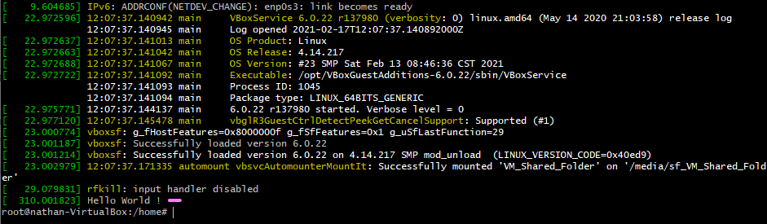

test_print_self.c

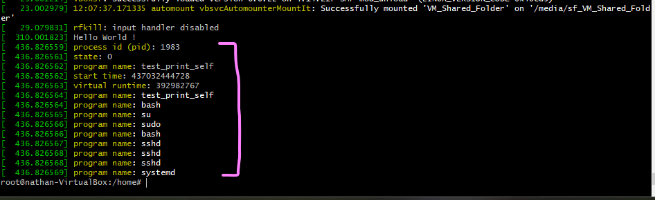

test_print_other.c

(process id 11 entered as command line argument)

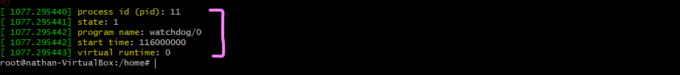

Honor Code

I pledge, on my honor, to uphold UT Arlington’s tradition of academic integrity, a tradition that values hard work and honest

effort in the pursuit of academic excellence. I promise that I will submit only work that I personally create or contribute to

group collaborations, and I will appropriately reference any work from other sources. I will follow the highest standards of

integrity and uphold the spirit of the Honor Code.

Nathaniel Fenoglio

Lemuel Rivera