

Company Reception User Manual

Polytechnic University of Puerto Rico

Nathan Galarza Bonilla

#104586

October/16/2018

Contents

Abstract-------------------------------------------------------------------------------------------------------3

Login Screen-------------------------------------------------------------------------------------------------4

Main Screen--------------------------------------------------------------------------------------------------5

Add Visitor---------------------------------------------------------------------------------------------------6

Search---------------------------------------------------------------------------------------------------------7

Modify Visitor-----------------------------------------------------------------------------------------------8

Visitor History------------------------------------------------------------------------------------------------9

Display Visitor----------------------------------------------------------------------------------------------10

Help Content------------------------------------------------------------------------------------------------11

About---------------------------------------------------------------------------------------------------------12

Abstract

In the following program I show a project completely developed in Java with an IDE known as Eclipse with WindowBuilder plugin which is used for the frames of this program Graphical User Interface known as GUI. The program is used for a company reception, as a way to store visitor’s data and also keep track of who they visit. Making the company safer and making the company aware of who’s entering the building and who is visiting who. I myself think this is a really helpful program for companies whose visitors they can’t keep track of.

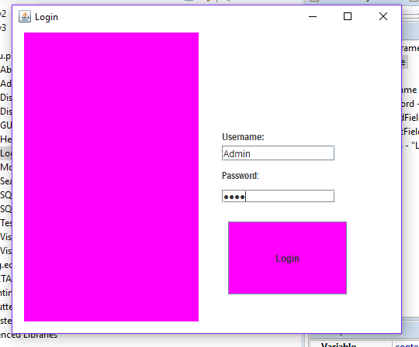Log In Screen

The login screen asks for the Username and password for the program to be accessed. The default username is always going to be “admin” and the password is “1234”. Without the correct data provided the user cant access the database.

Main Screen

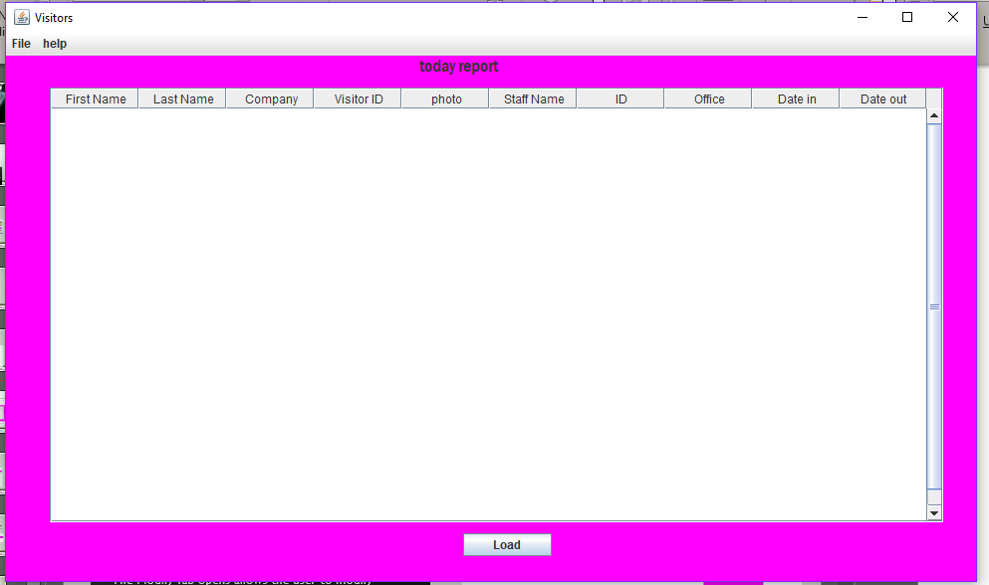

Main screen is “Today Report”, where the user press “load” button the data will be provided by the database connection. Making the user aware of who inside the database by just pressing “load” As shown in figure bellow.

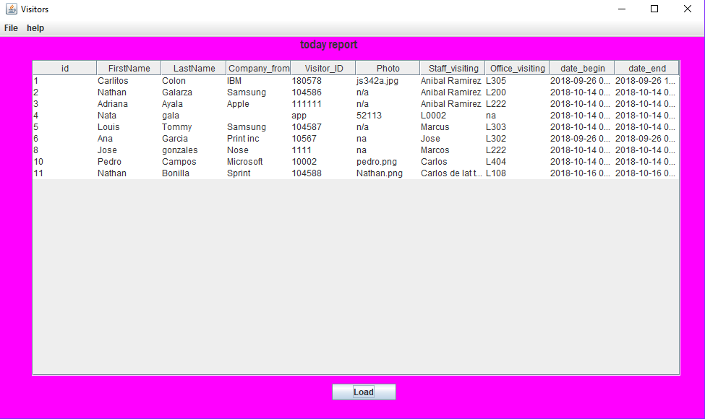

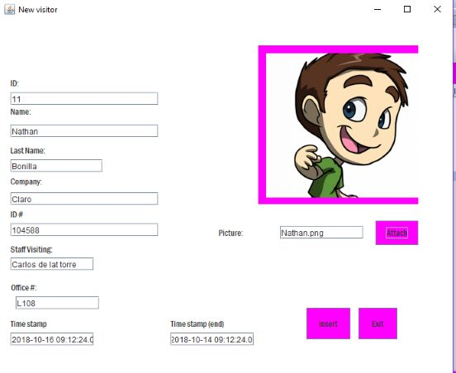Add Visitor

The add visitor tab was programmed so that the new visitor can provide all their information and keep track of the time that the user signed in the reception. Once the “insert” button is pressed the user will save the data into the database and provide a “Data Saved” message on screen.

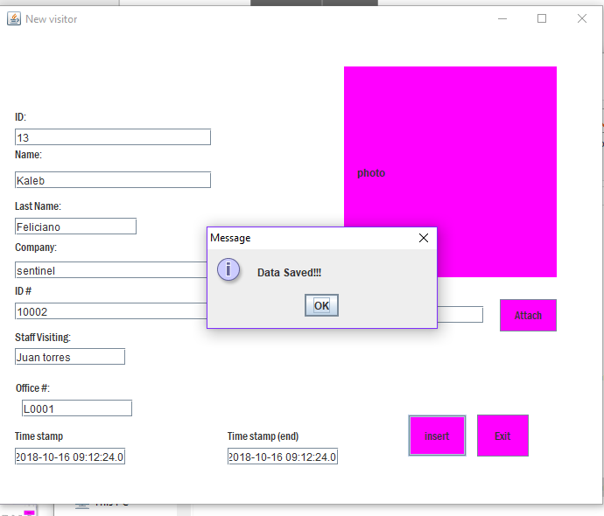

Search

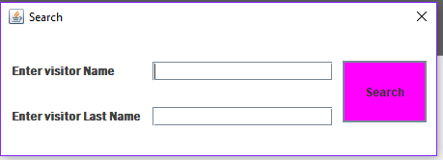

The search frame will be prompted when the user wishes to modify visitor or to see visitors history. This will be used for both tabs with the same function to search the desired visitor. Once the data of the first name and last name are filled in the Admin can hit search to open either the modify visitors tab or the view visitors history tab.

Modify Visitor

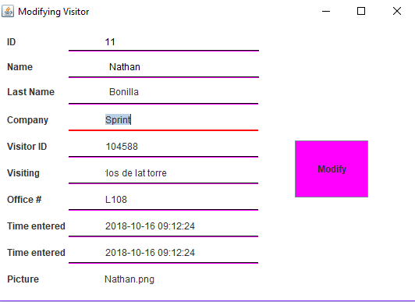

When search is completed the Modify Visitor will be prompted with the values of the searched visitor. Once the admin is satisfied with modifying the data then she or he can press the “modify” button which will update the query with the corrected data.

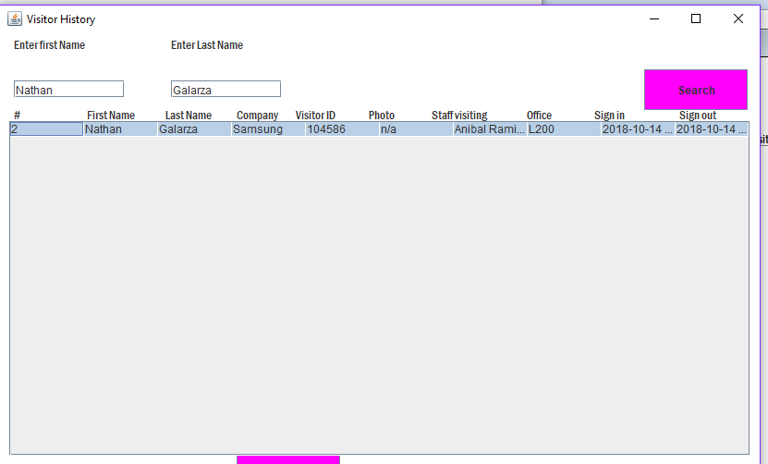Visitor history

Once the Admin pressed the Visitor History tab the frame will ask for the users first name and last name, once the data is provided the desired visitor will show the data and the history of the visitor in the company.

Display visitor

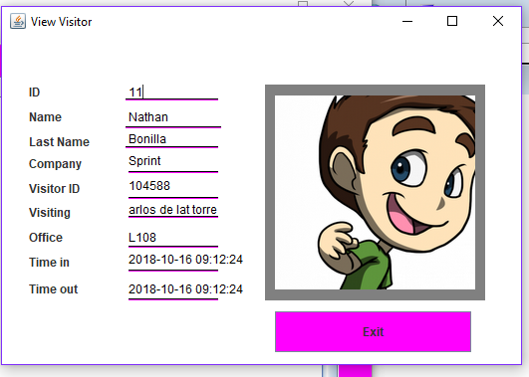

Once the admin presses the “View Visitor” tab the program will prompt the admin with the search frame which it will use to search the data within the database and then assign it to the view visitor frame as shown in the figure.

Help content

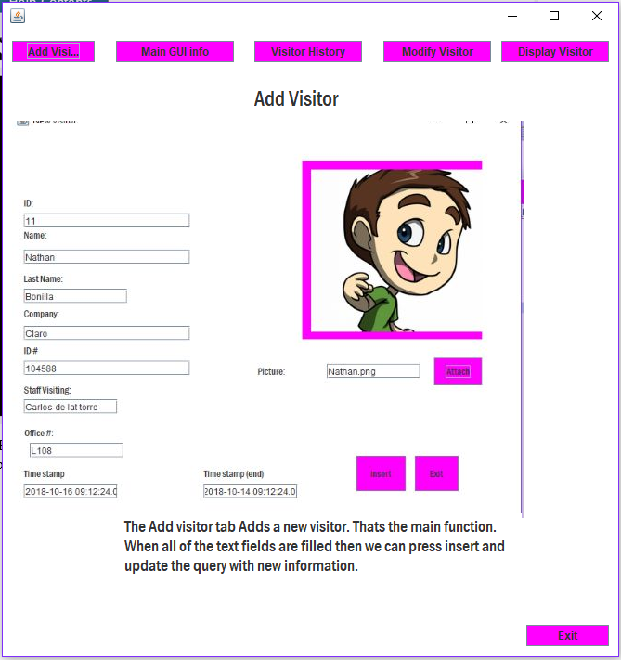

Help content will provide information of all the functions inside the programs and how to use them properly. With full description of the functions; Add Visitor, Main GUI info, Visitor History, Modify Visitor, and display visitor.

About

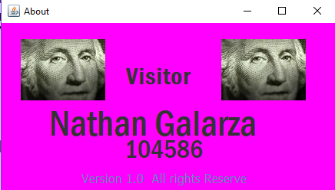

The last tab option is About. Which will provide the Admin information of the Developer that created the program.