**Client**

Our Client is anyone who may have a web design need. Whether it be an entrepreneur, or even a more established business who would appreciate a more personal approach to website building.

This is an informative website with lots of potential to improvement. Made from scratch. Clients are Tirath, Mohmmed, Hussein and Nathan. Its sole purpose is to make everyone aware of our potential and get job or work as a developer to make some extra pocket money. Simple website for now to look for basic information and detailed website further down the road with lots of dynamic content as we progress through the course and learn on the go. Project Name: Script Overlord Logo: (Text type) Script Overlord

**Style**

Style: Full responsive website implemented and made from the scratch with concepts in mind as a user and developer perspective. It has sliders for each developer with their details and a resume to download. Two themes that can be switched using a “Toggle” button literally. It is a very simple and informative website that gives vide of good UX design and responsive layout. In future the website will have MVC architecture implemented using the same code as it is coded as a component. Being developer and clients both our self we have implemented every learning aspects on to the project. It has cookies that store the data locally for now every time a form is submitted. Customized media queries to handle different devices. Although target device is 1024 X 768 and grater. We have made sure it can support a few smaller devices also. That way client can get best value for the money and in future when there is more room for the budget, we can have a proper responsive layout. Contact form is validated with the simple JS so that it is not left blank. Next step will be to implement more advanced validations with specific constraints on each field.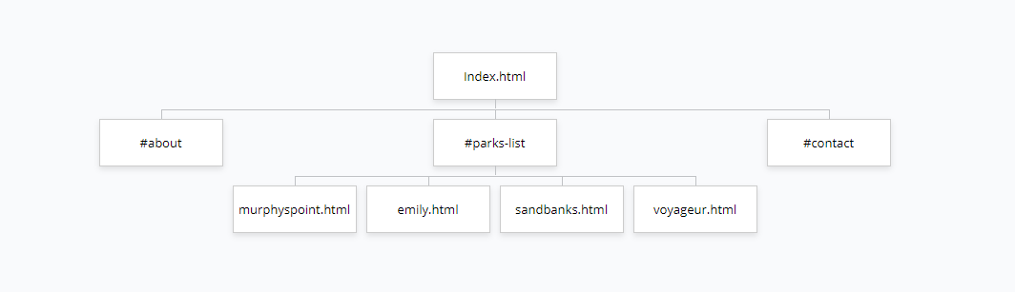

**Colour Palette:**

The site uses a mix of black, white, and red. The black surrounds the page and allows the other colours to help draw the eye towards those elements.

The red is used to wrap various buttons to draw the eye to the colour that pops out in comparison to the flatter colours used within the rest of the webpages.

**Typography:**

The font used is a default font set meant to be fairly easy on one’s eyes. The font is kept at a fairly standard font size to help prevent the users eyes from becoming strained from staring at a larger font size.